**BIOLOGY 2011**

***TOPICS HIGHLIGHTED***

1. Classification I & II………………………………………………………………………..4
2. The cell – structure & functions of organelles…………………………………….………5
3. Cell physiology – osmosis, diffusion and active transport………………………………..9
4. Nutrition in (a) plants (b) animals………………………………………………………13
5. Transport in (a) plants (b) animals………………………………………………………24
6. Gaseous exchange in (a) plants (b animals………………………………………………30
7. Respiration………………………………………………………………………………..34
8. Excretion and homeostasis………………………………………………………………37
9. Ecology…………………………………………………………………………………..45
10. Reproduction in (a) plants (b) animals…………………………………………………53
11. Growth and development in (a) plants (b) animals……………………………………61
12. Genetics…………………………………………………………………………………68
13. Evolution…………………………………………………………………………………75
14. Irritability and sensitivity in (a) plants (b) animals……………………………………..77
15. Support and movement in (a) plants (b) animals………………………………………82
16. Human health………………………………..…………….……………………………..85.

**SECTION I & II QUESTIONS**

* + *This section deals with paper one and two questions. In paper one you will find simple questions requiring simple answers, single answer and/or a sentence.*
  + *In paper two structured data based questions and essay questions.*

**1. Classification I &II**

1. Name **two** classes of phylum arthropoda with cephalothorax.

2. List any **three** distinguishing features of class mammalia.

3. Give **two** characteristics that distinguish scientific names of organisms from the ordinary

names

4. (a) In which kingdom do bacteria belong?

(b) Give any **two** benefits of bacteria to man

5. Name the phylum whose members possess notochord

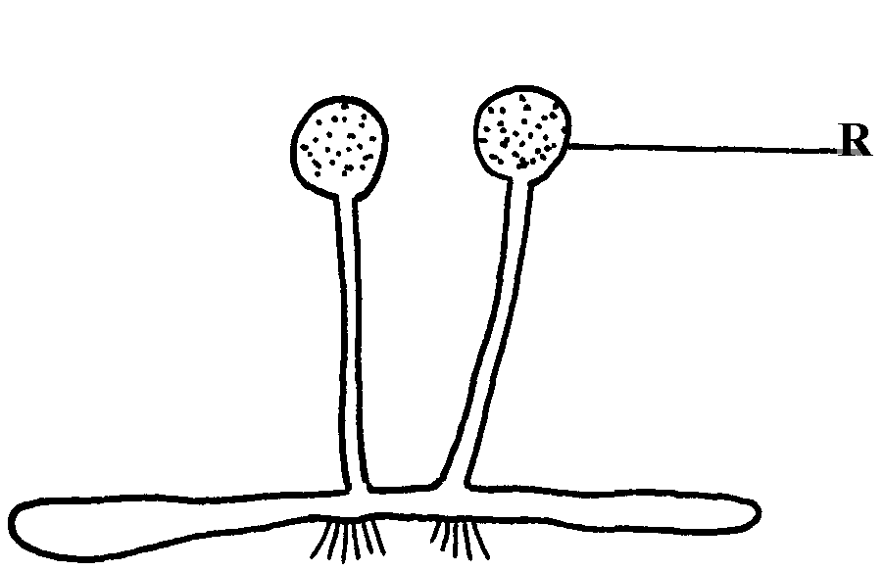6. The diagram below represents a bread mould:-

(a) Identify the kingdom to which the organism belongs:-

7. Give a reason why no moulting occurs during the adult stages of insects

8. Name the branch of Biology that deals with the study of animals

9. State **four** ways in which some Fungi are beneficial to human

10. During a class practical form four students came across a plant whose flower floral parts were in

multiples of fours and fives. To which sub-division and class does the plant belong?

11. A student caught an animal which had the following characteristics:-

* + - Body divided into two parts
    - Simple eyes
    - Eight legs
    - The animal belongs to the class

12. The diagram below represents a bread mould.

(a) (i) Name the Kingdom to which bread mould belongs.

(ii) Give **two** distinguishing characteristics of the Kingdom named in **(a)(i)** above.

(b) State the function of the part labelled **R**

13. (a) What is meant by the term taxonomy?

(b) The scientific name of a rat is Rattus norvegicus

(i) Write the name correctly

(ii) Identify the genus and species names

14. List **three** features that distinguish arthropods from other organisms

**2. The cell – structure & functions of organelles**

1. Name the organelles that perform each of the following functions:

a) Digestion and destruction of worn out organelles.

b) Osmoregulation

2. Explain why the following processes are important during the preparation of temporary

slides :- (a) Staining

(b) Use of a sharp cutting blade

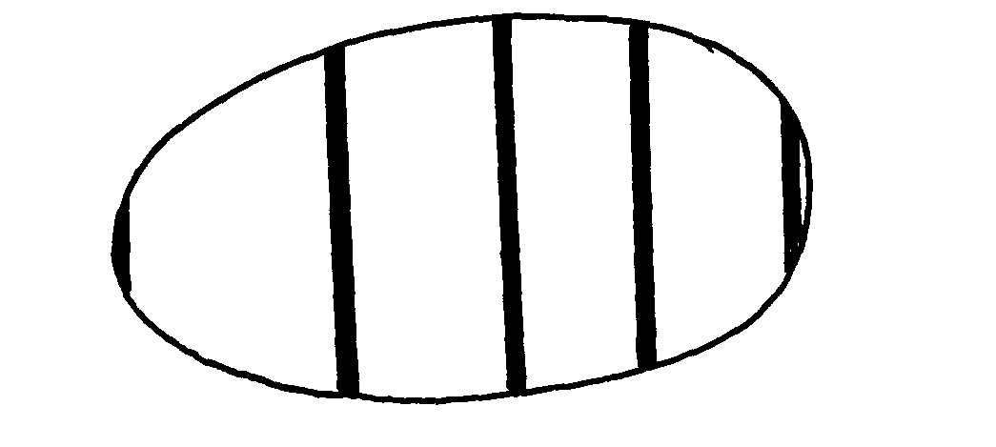3. In a class experiment to establish the size of an onion cell, a leaner observed the following on

the microscope field of view.

If the student counted 20 cells across the diameter of this field of view, calculate the size of one

cell in micrometers.

4. State the functions of the following cell organelles: (a) Nucleolus. (b) Plasma membrane

5. What is the of nucleus of a cell made up of?

6. (a) In a laboratory exercise a student observing a drop of pond water under a microscope saw

and drew a spirogyra. If the magnification of the eye-piece was x5 and that of the objective

lens was x100, what was the magnification of the spirogyra?

(b) If the spirogyra has a length of 5cm at the above magnification, calculate the actual length

in micrometers

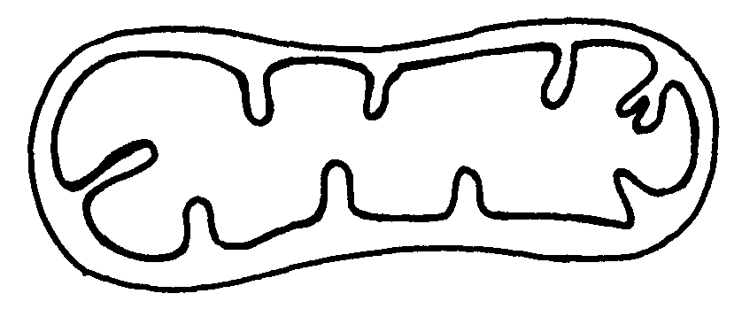7. (a) Identify the organelle shown below:-

(b) How is the organelle you have identified in **(a)** above suited to its function

8. Identify the structures of the cells that perform the following functions:- (a) Synthesize ribosomes

(c)Regulate exchange of substances in and out of the nucleus

9. (a) State the roles of enzyme catalase in living cells

(b) Which factor inactivates enzyme?

10. The figure below represents a certain cell organelle:-

**A**

(a) (i) Identify the cell organelle

(ii) What is the function of the part labelled **A**

(b) Name the organelles that perform each of the following functions;

(i) Osmoregulation in amoeba

(ii) Carries out digestion and destruction of worn out cell organelles

11. State **three** properties of the cell membrane

12. The diagram below represents a plant cell

(a) Name a carbohydrate which forms part of the structure labelled **S**

(b) State **two** functions of the part labelled **R**

(c) Name **two** structures present in the diagram but absent in the animal cell

13. What do you understand by the following terms

a) Anatomy

b) Biochemistry

14. State the function of the following parts of a cell a) Ribosome

b) Chloroplasts

15. a) What is the formula for calculating linear magnification of a specimen when using a

hand lens

16. State the function of the following cell structures:-a) Ribosome ;

b) Centrioles ;

17. What is the main structural component of:- a) Cell wall

b) Cell membrane

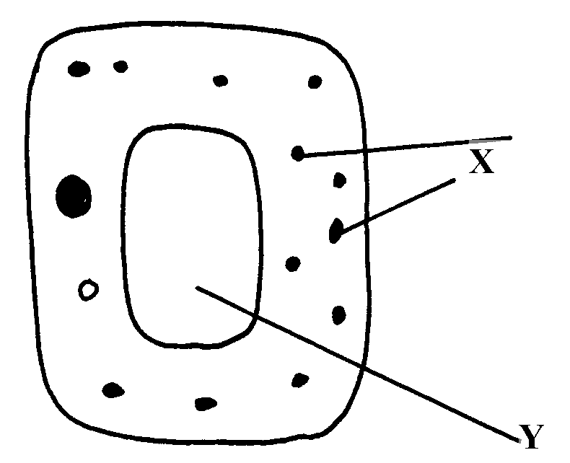18. State **two** characteristics of the kingdom monera which are prokaryotes

19. The diagram below represents a cell

(a) Name parts labelled **X** and **Y**

b) Suggest why the structures labelled **X** would be more on one side than the other

20. During a practical class, form fours estimated the field of view to be 3.5mm. Using the low

power objective, they observed spirogyra cells across the same field of view and counted 8cells.

Calculate the size of each cell and give your answer in micrometer

21. A student caught an animal which had the following characteristics:-

* + - Body divided into two parts
    - Simple eyes
    - Eight legs

a) To what class does the animal belong?

b) State **two** distinctive characteristics of members of the phylum from which the animals in this

question (15) belongs

22. Distinguish between the following terms :-

a) Magnification and resolution of a microscope

b) Mounting and staining of a specimen

23. Name the organelle that performs **each** of the following functions in a cell.

(a) Transport of packaged glycoproteins

(b) Destruction of worn out cell organelles

(c) Synthesis of proteins

24. Why are the following procedures done when preparing sections to be observed under a light

microscope?

(a) Making of thin sections

(b) Using a sharp blade to make the sections

(c) Staining

25. What are the functions of the following parts of a light microscope?

(a) Eye piece lens (b) Condenser

(c) Diaphragm

26. Given that the diameter of the field of view of a light microscope is 2000um. Calculate the

size of a cell in mm if 10 cells occupy the diameter of the field of view

27. State the importance of the following processes in microscopy:

(a) staining

(b) sectioning

28. A cell was found to have the following under a light microscope; cell membrane, irregular

in shape, and small vacuoles. Identify the type of the cell above

29. State the functions of the following organelles;

(a) Lysosomes

(b) Golgi apparatus

30. Name the class in phylum arthropoda which has the largest number of individuals

31. State the functions of each of the following parts in a microscope.

(a) The eye piece lens

(b) The objective lens

32. The figure below represents an electron micrograph of an organelle that is found in many

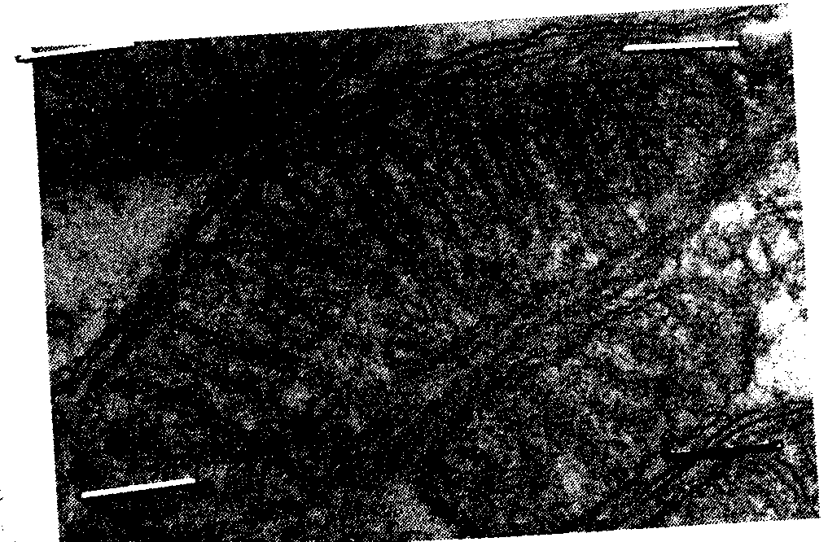cells;

(a) Identify the organelle

(b) State the function of the organelle

(c) What is the importance of infoldings in the inner membrane.

(d) Give **two** examples of tissues where you would expect many such organelles in animal body.

**3. Cell Physiology – Osmosis, Diffusion and Active transport**

1. Two equal strips **A** and **B** were from a potato whose cell was 30% of sugar. The strip **A** was placed in a solution of 10% sugar concentration while **B** was placed in 50% sugar concentration

a) What change was expected in strip **A** and **B**

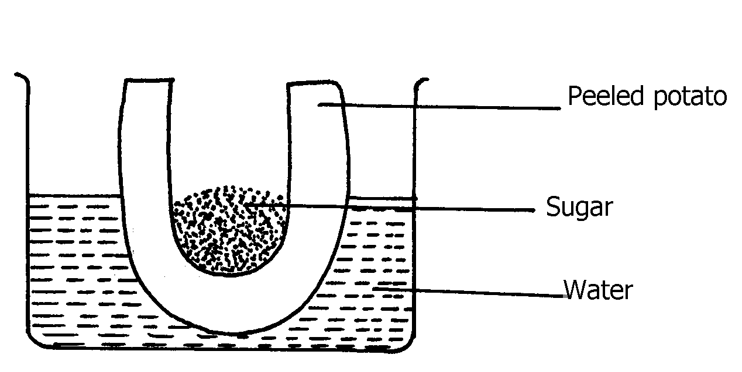 b) Account for the change in strip **A**

2. An experiment was set-up as shown below and left for one hour

(a) State the expected result at the end of one hour

(b) Explain the observations made in this experiment

3. State what would happen in each of the following:-

(a) A plant cell placed in: ***-***  (i) Strong salt solution

(ii) Distilled water

4. State **three** physiological processes that are involved in movement of substances a cross the cell

membrane

5. Potato cylinders were weighed and kept in distilled water evernight. They were then

reweighed.

2.5 g 2.4g 2.7g 3.0 g 3.1 g 3.2g

At the beginning of the Experiment. At the end of the experiment

a) Calculate the average mass of a potato cylinders after reweighing. Show your working.

b) Explain why mass of the cylinders hand increased.

6. The diagrams below show a red blood cell that was subjected to a certain treatment.

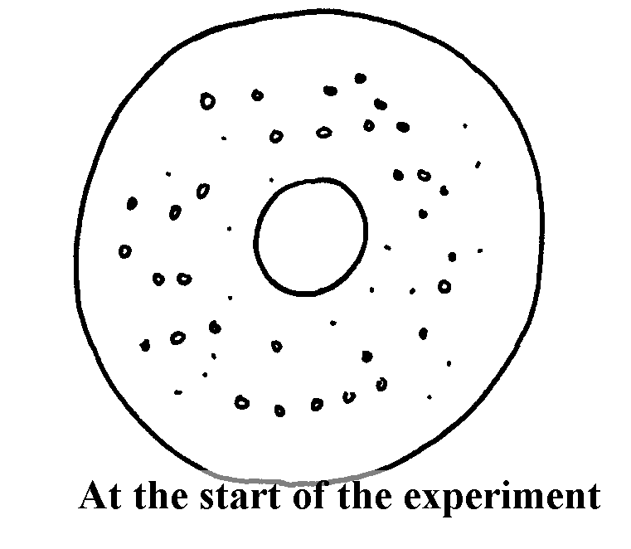

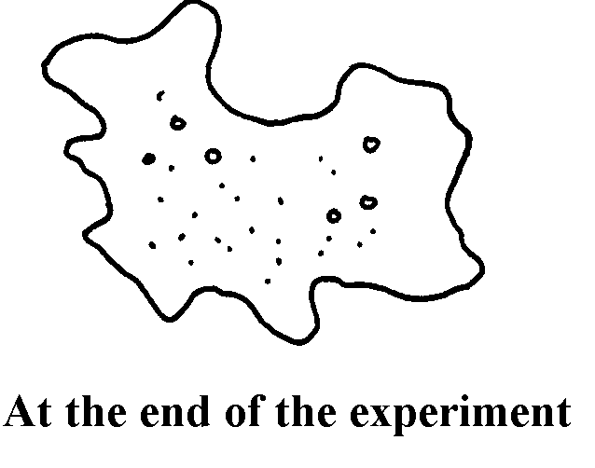

a) Account for the shape of the cell at the end of the experiment.

b) Draw a diagram to illustrate how a plant cell would appear if subjected to the same treatment

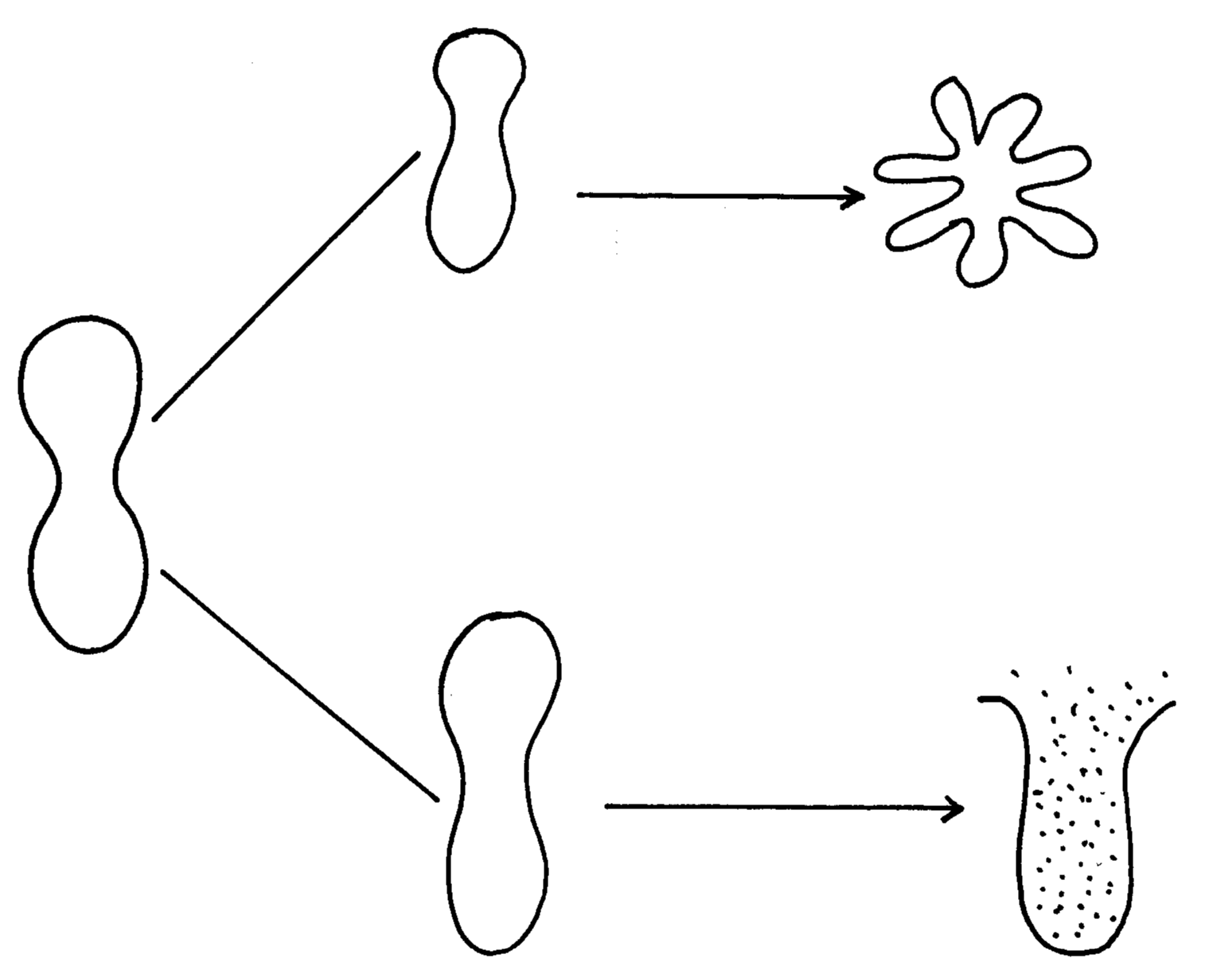7. The diagram below shows the results obtained when red blood cells are placed in different

solution:

Solution X

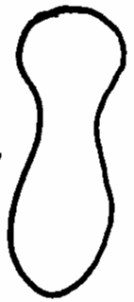

Solution Y

(a) What name is given to the process that occurs when the cell is placed in solution **Y**?

(b) Describe the process that would occur in a plant cell when placed in a similar solution as that

of solution **X**

8. The figure below shows the results obtained when red blood cells are put in different solutions:-

Placed in

solution

**A**

Placed in

solution

**B**

(a) What is the name given to the process that occurs when the cell is put into solution **B**?

(b) Compare the results obtained when the cell is put in solution **B** to the results that would be

obtained if a plant cell was put in the same solution

9. Briefly state **two** adaptation for each of the following cells to their functions

(i) Spermatozoon

(ii) Palisade mesophlly cell

10. The diagram below represents a cell at a certain stage in meiotic cell division

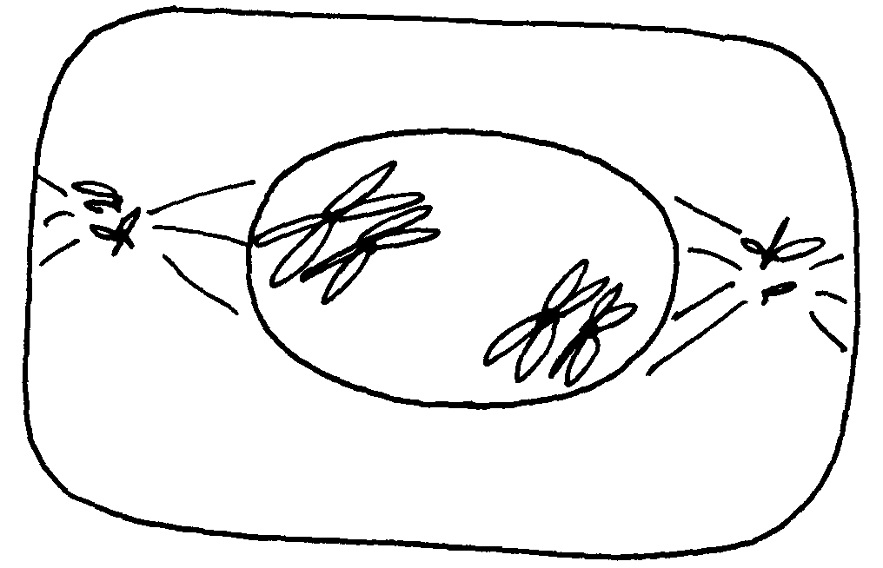

a) Name the stage at which the cell drawn above represents

b) Give a distinguishing reason for your answer in **21(a)** above

c) State any **two** differences between mitosis and meiosis

11. What are **two** differences between tropisms and tactic movement

12. An experiment was carried out to investigate the effect of different concentrations of sodium

chloride on human red blood cells. Equal amounts of blood were added to equal volumes of the

salt solution but of different concentrations. The results are shown in the table below:

|  |  |  |  |
| --- | --- | --- | --- |
| **Set -up** |  | **Number of red blood cells** | |
|  | **Sodium chloride concentration** | **At start of experiment** | **At the end of the experiment** |
| A | 0.9% | Normal | No change in number |
| B | 0.3% | Normal | Fewer in number |

(a) Account for the results in the set-up

(b) If the experiment was repeated using 1.4% sodium chloride solution, state the expected

results with reference to:

(i) the number of red blood cells

(ii) the appearance of red blood cells if viewed under the microscope

13. Name support tissues in plants characterized by the following

(i) Cells being turgid

(ii) Cells being thickened by cellulose

(iii) Cells being thickened by lignin

14. The diagram below illustrates the behaviour of red blood cells when placed into two different

solutions **X** and **Y**.

(a) Suggest the nature of solutions **X** and **Y**.

(b) Name the process **A** and **B**.

(c) What would happen to normal blood cell if it were placed in a solution isotonic.

15. Name **two** plant processes in which diffusion plays an important role

16. Two fresh potato cylinders of equal length were placed one in distilled water and the other in

concentratedsucrose solution:

(a) Account for the change in length of the cylinder in:

(i) Distilled water

(ii) Sucrose solution

(b) (i) What would be the result in terms of length if a boiled potato was used?

(ii) Explain your answer in**(b)(i)** Above

(c) State **two** uses of the physiological process being demonstrated in the experiment

17. The two cells shown below are obtained from two different potato cylinders which were

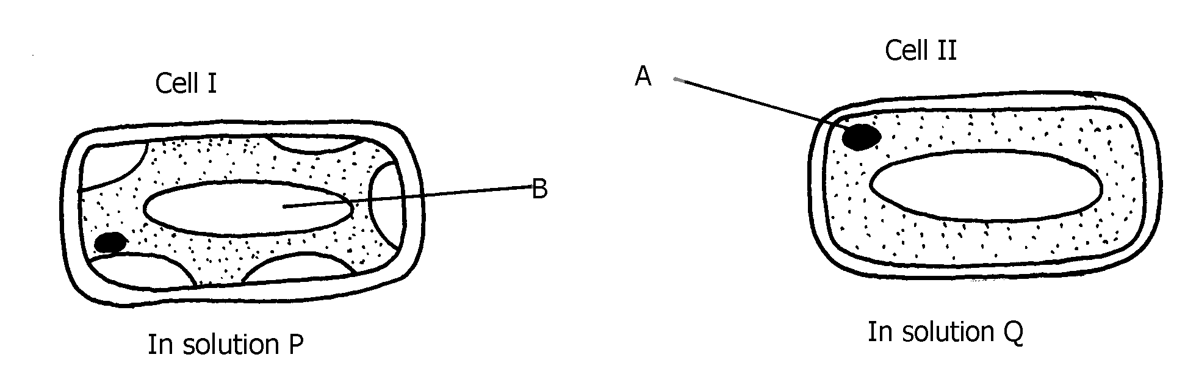immersed in tow different solutions **P** and **Q.**

a) i) Name the structure labelled **A**.

ii) State the function of structure B.

b) If eight of cell I were observed across the diameter of the filed of view of 0.5 mm.

Work out the actual diameters of each cell in micrometers.

c) Suggest the identity of the solution Q.

d) Account for the change in cell I above.

e) State any **one** importance of the physiological process being demonstrated above in animals.

18. An experiment shown below was set-up to investigate a certain physiological process

in plants:-

(a) What process was being investigated?

(b) Give the role of the oil layer in this experiment

(c) (i) What observation did the students make after leaving the set-up in bright sunlight for

two hours?

(ii) Explain the observation in **(c)(i)** above

(d) What effect will the following have on the observation made?:-

(i) Fanning the shoot

(ii) Removing all the leaves from the shoot

(iii) Placing the set-up in the dark

(e) Suggest a suitable control for this experiment

19. Study the following food web and answer questions that follow:

(a) (i) Name the organisms that occupy the second trophic level

(ii) What is the other name for the second trophic level

(b) Write down **two** food chains from the food web that:

(i) End with hawks as tertiary consumer

(ii) End with hawks as quaternary consumer

(c) Giving reasons state;

(i) the organism with largest biomass

(ii) the organism with least biomass

**4. Nutrition in (a) plants (b) animals**

1. The chemical equation below represents a physiological process that takes place in living

**R**

organisms:

C6H12O6 + C6H12O6 C12H22O11 + **Q**

(a) Name the process **R**

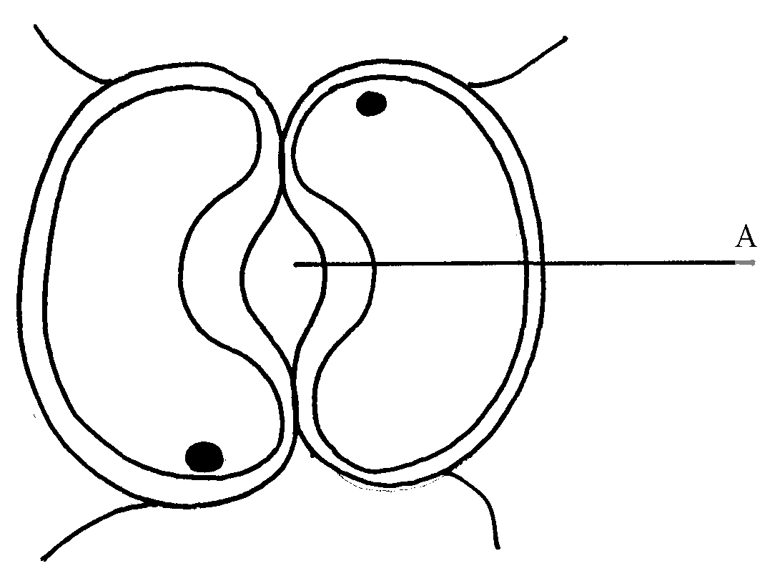 (b) Name the substance **Q**

2. The diagram below shows cells in plants:-

(a) Identify the cells shown above

(b) Explain how the cells are adapted to their function

(c) Explain how accumulation of carbon (IV) Oxide in the cells above would lead to the closure

of structure **A**

3. (a) A leaf of a potted plant kept in darkness for 48hours was smeared with Vaseline jelly then

exposed to sunlight for 8hours. Explain why the test for starch in the leaf was negative

(b) Name **two** other processes that were interfered with in the plant

4. List **two** functional differences between plants and animals.

5. Explain how the guard cells are adapted to perform their function.

6. The diagram below shows chemical reactions **A** and **B** which are controlled by enzymes **x** and **y**

respectively.

(a) Name: (i) Reaction **A**.

(ii) Enzyme **y**

7. What are the **two** functions of bile salts during the process of digestion?

8. State **three** adaptations of aquatic plants to photosynthesis

9. A biological washing detergent contains enzymes which remove stains like mucus and oils

from clothes which are soaked in water with the detergent:-

(a) Name **two** groups of enzymes that are present in detergent

(b) Explain why stains would be removed faster with the detergent in water at 35oC rather

than at 15oC

10. Name the diseases caused by deficiency of : (a) Iodine

(b) Vitamin C

11. Name **two** enzymes and **one** metal ion that are needed in the blood clotting process

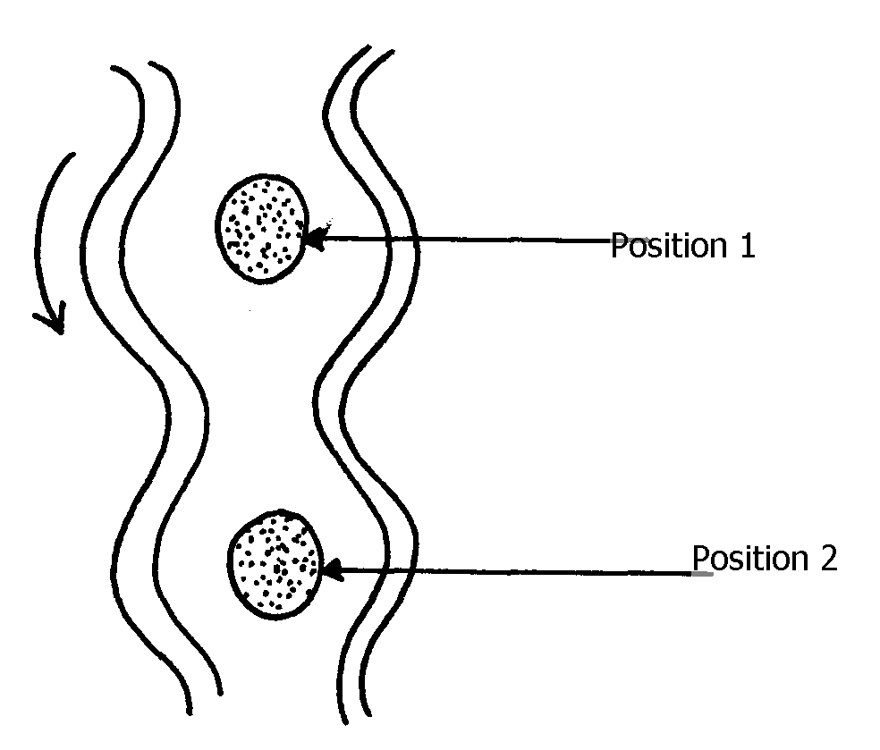12. The diagram below shows how food boles move along the human oesophogus and the

Intestine

(a) Identify the process illustrated in the diagram

(b) Briefly **state** how the movement of food boles from position 1 to position 2 is achieved

(c) Name **one** component of a persons diet that assists in the movement of food described in

(b) above

13. State **two** adaptations of herbivores which enable them to digest cellulose

14. State **two** factors that affect the rate of osmosis

15. A certain organ **K** was surgically removed from a rat, later drastic increase in glucose level in the

blood was reported but when substance **Q** was injected into the animal the whole process was

reversed.

Identify: (i) Organ **K**

(ii) Substance **Q**

16. a) Name the component of a persons diet that is essential for peristalisis

b) Give **two** groups of food which are reabsorbed along the mammalion digestive system

without undergoing digestion

17. State **three** roles of light in photosynthesis

18. State **two** ways in which the guard cells differ their adjacent epidermal cells

19. One of the components of bile is a chemical left over from destruction of red blood cells

i) Identify the chemical substance

ii) What is the role of bile in digestion

20. (a) What is peristalsis?

(b) Explain how the process above is brought about.

21. The following reaction may occur in a forward and backward direction.

Water + Carbon (IV) Oxide Glucose + Oxygen + Energy

1. Name the organelle where the reaction occurs in:

(i) Forward direction

(ii) Backward direction

(b) Give **one difference** and **one similarity** for the two organelles named in **(a)** above

22. A solution of sugar cane was boiled with hydrochloric acid and sodium hydrogen carbonate was

added to the solution, which was then boiled with benedicts solution. An orange precipitate was

formed.

(a) Why was the solution boiled with hydrochloric acid and then sodium hydrogen carbonate

added in it

(b) To which class of carbohydrates does sugar cane belong?

(c) State the form in which carbohydrates are:

(i) Transported in animals

(ii) Transported in plants

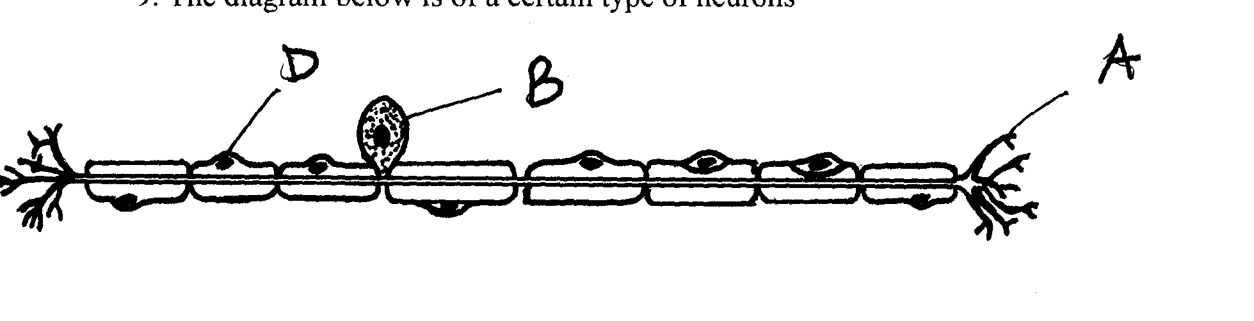23. The diagram below is of a certain type of neurons

(a) Identify the type of neuron

(b) Give a reason for your answer in **(a)** above

(c) Give the functions of the parts labeled **A, B**, and **D**

24. a) The mitochondria organelle has cristae structure on the inner membrane. State the function of

the cristae

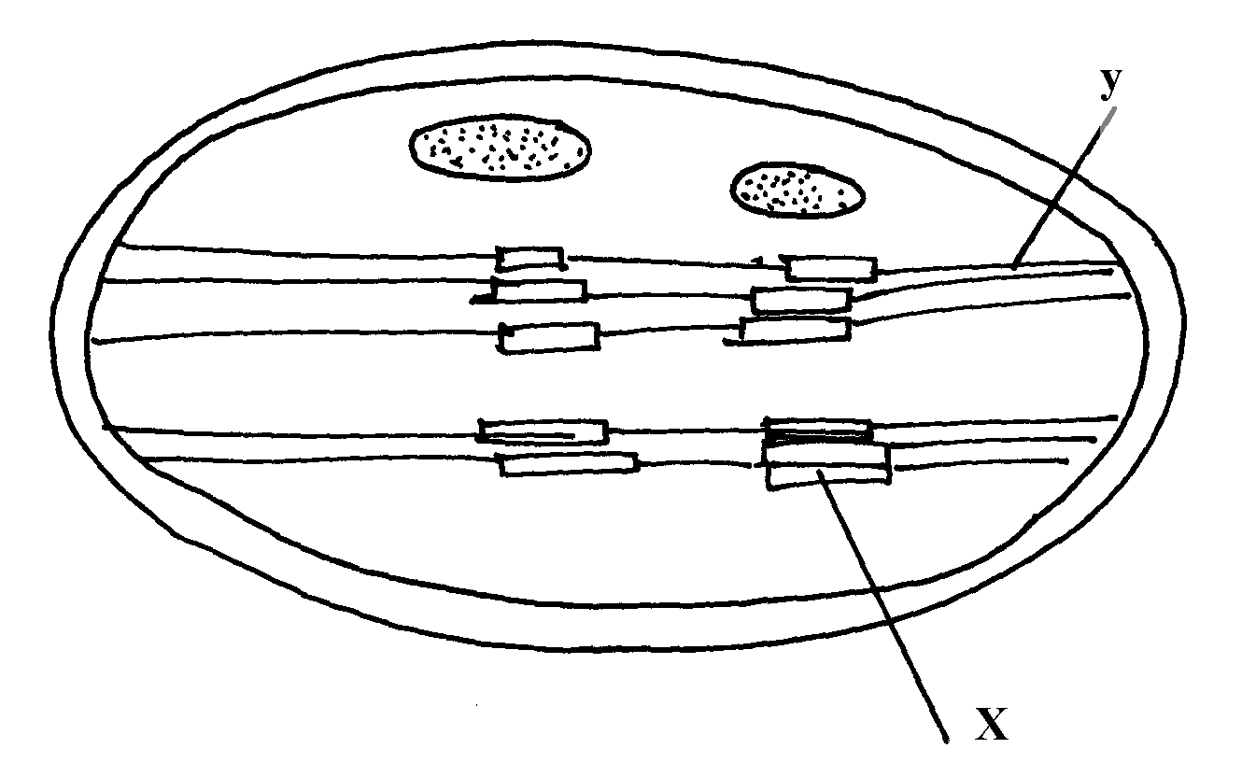 b) The diagram below represents a cell organelle

i) Name the part labeled **Y**

ii) State the function of the part labeled **X**

25. a) State the role of emulsification in the digestion of fats in the alimentary canal

b) What is the function of hydrochloric acid in the alimentary canal

26. Briefly explain the effect of poisoning the roots hair on the uptake of nitrate by plants

27. Briefly explain the symbiotic relationship in the root nodule of a leguminous plant

28. Explain how saliva is important in digestion

29. What is the fate of excess glucose in plants?

30. State **two** ways in which guard cells differ from other epidermal cells

31. Briefly explain the fate of the following products from the light stage of the process of

Photosynthesis: (a) Oxygen (b) Hydrogen (c) ATP

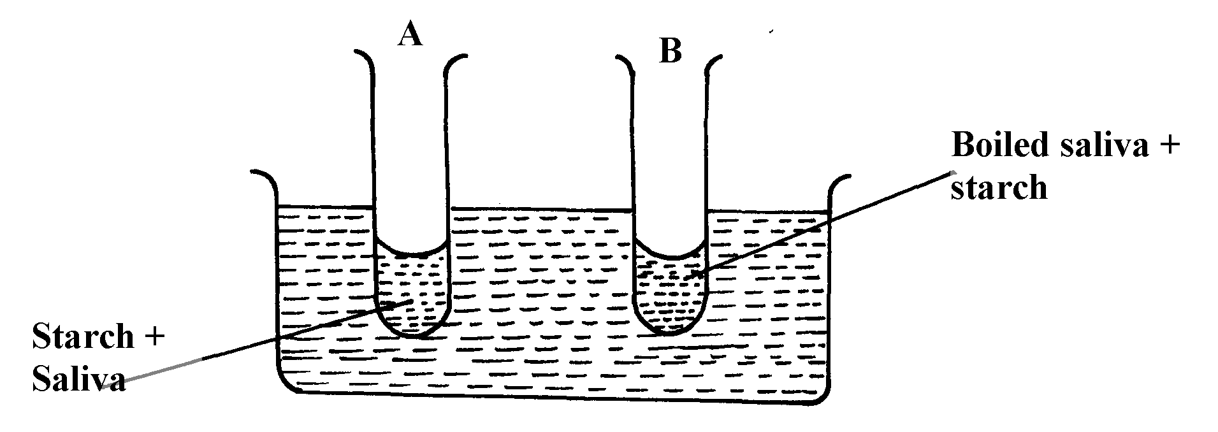32. In an experiment to investigate on aspect of digestion, two test tubes A and B were set-up as

shown in the diagram below;

The test tubes were left in the bath for 30minutes.The content of each test tube was then tested for

starch using iodine solution:-

(a) What was the aim of the experiment?

(b) What results were expected in test-tube **A** and **B**

(c) Account of the results you have given in **(b)** above in test tube **A** and **B**

33. Below is a process that takes place along the mammalian digestive system:

(a) Name the processes represented by **A** and **B**

(b) Name part of the alimentary canal where the process **B** takes place

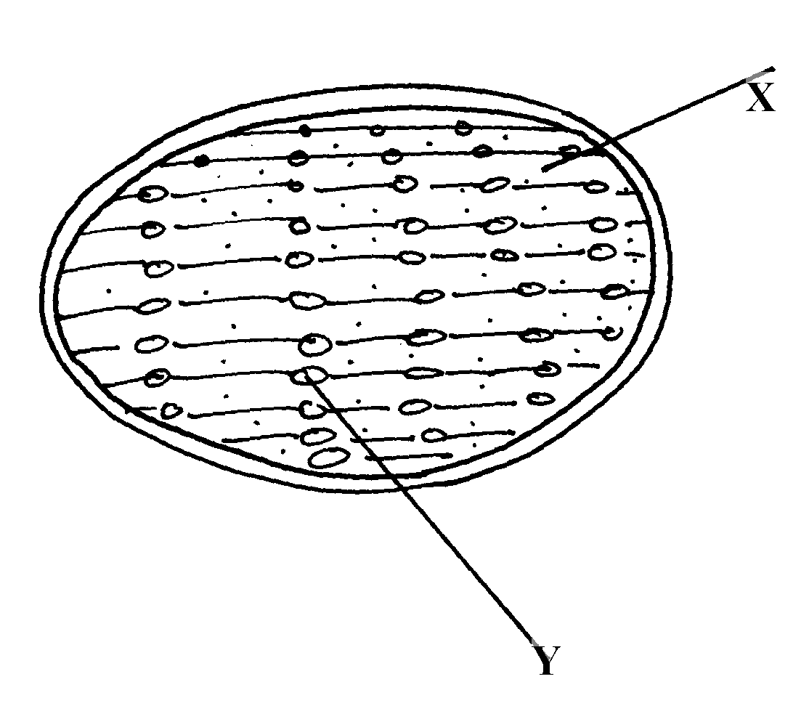34. The diagram below represents a cell organelle

(i) Name the part labeled **y**

(ii) State the function of the part labeled **X**

(ii) State the function of the vitamin named in (**i)** above

36. (a) Name the disease caused by **schistosoma** parasites in man.

(b) How is **schistosome** adapted to its parasitic mode of life?

37. The table below shows **three** enzymes **A, B** and **C** and their respective optimum pH.

|  |  |
| --- | --- |
| **Enzyme** | **Optimum pH** |
| A | 6.8 |
| B | 2.0 |
| C | 8.0 |

(a) (i) Name the most likely region of the alimentary canal of a mammal where enzyme

**B** would be found.

(ii) Give a reason for your answer in (a) (i) above

38. In an experiment to investigate an aspect of digestion, two tubes A and B were set up as shown

in the diagram below.

The test tubes were left in the water bath for 30 minutes. The content of each tube was then tested

for starch using iodine solution.

(a) What was the aim of the experiment?

(b) Explain the expected in the tube.

39. (a) Name the specific part of the chloroplast where the following processes occur.

(i) Carbon IV oxide fixation

(ii) Photolysis

(b) State **one** way in which the dark reactions of photosynthesis depends on light reaction.

40. The concentration of carbon IV oxide in a tropical forest was measured during the course of 24

hour period from mid-night. The graph below shows the results obtained.

Account for the results obtained at: (i) Midnight. (ii) At 12.00 noon.

41. State **three** ways by which the rate of enzyme controlled reactions can be increased.

42. Study the dental formula given below:

**I 0; C 0 ; PM 3; M 2**

**4 0 3 3**

(a) Identify with reasons the mode of feeding of the animals whose dental formula is

given above

(b) Calculate the total number of teeth in the mouth of the above animal

43. Explain why small mammals such as moles feed more frequently than larger ones such

as elephants

44. State **three** ways by which plants compensate for lack of the ability to move from one place

to another

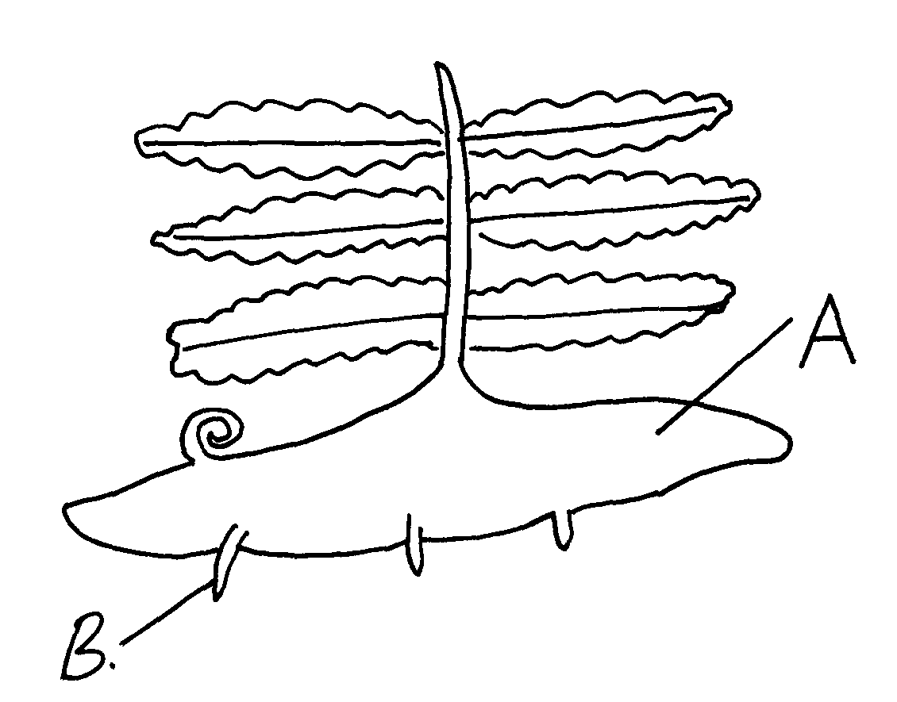45. Study the diagram below and answer the questions that follow

(a) Label the parts **A** and **B**

(b) State **one** observable difference between the structure above and the liverwort

46. What is glycolysis?

47. (a) State **two** difference between monosaccharide and polysaccharides

(b) Name the bond found in proteins

48. Name t**wo** products of light reaction used in the dark reaction

49. State **two** functions of the large intestine in humans.

50. The diagram below shows a leaf of a growing plant partly covered with aluminium foil.

The plant was placed in the sun from morning to midday and then tested for starch.

(a) What was the aim of the experiment?

(b) State the observation made when the leaf was tested for starch

51. The figure shows the effect of temperature on an enzyme catalyzed reaction.

(a) Explain what happens between **A** and **B**

(b) What is **X**?

52. Name **two** mineral elements that are necessary in the synthesis of chlorophyll.

53. The figure below is a diagram of the anterior portion of the tapeworm. **Taenia solium.**

A

B

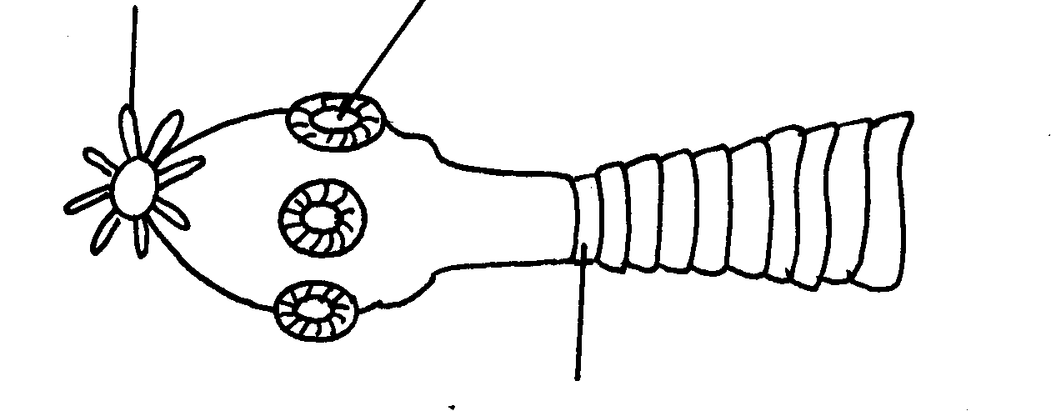

C

(a) Name the parts labeled **A, B**, and **C**

(b) What is the intermediate host of Taenia Solium?

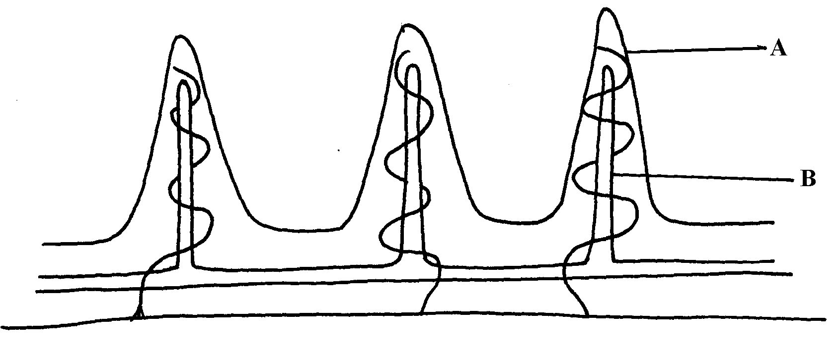54. The diagram below represents a longitudinal section through the ileum wall

a) Identify the structure labeled **A** and **B**

b) State **one** function of **A** and **B**

c) State **two** functions of the ileum

d) Explain the role of the liver in digestion

e) State the endocrine role of the pancreas in a mammal

55. The chart below shows the relationship between concentration of CO2 around the plant and the

rate of photosynthesis

(a) Account for the rate of photosynthesis between **D-E**

(b) Account for the rate of photosynthesis between **F-G**

(c) Briefly describe the reactions during the light stage of photosynthesis

56. The diagram below shows the effect of varying light intensity on the exchange of carbon IV

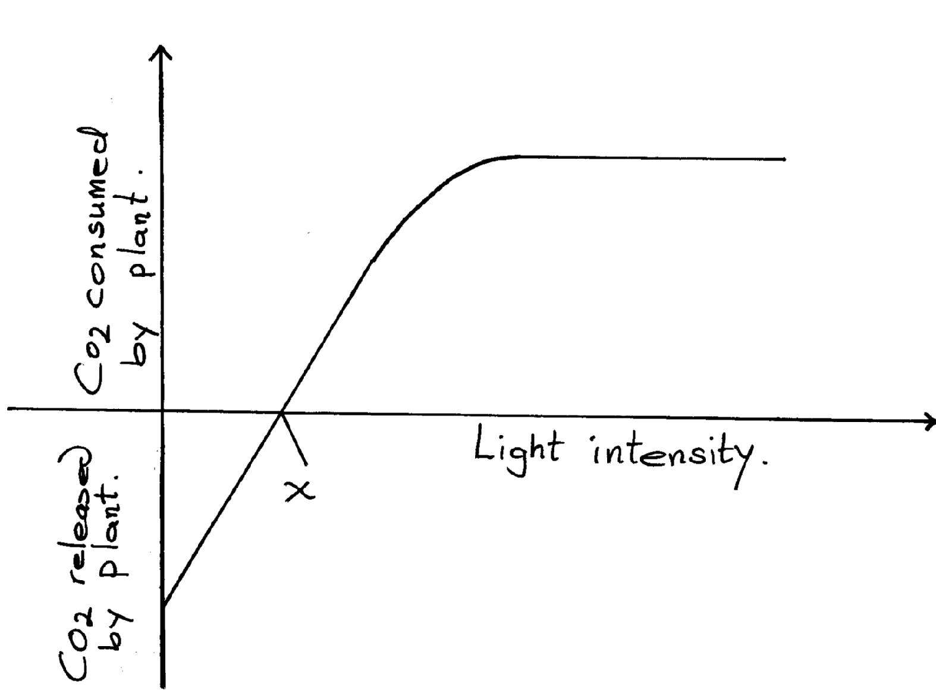oxide between the leaves of a green plant and the atmosphere.

***Co2 Consumed***

***by plant***

Light Intensity

***Co2 released***

***by plant***

a) What is the name given to the point marked x?

b) i) With reference to carbon IV oxide exchange state what happens at point **x**.

ii) Explain how the effect observed at point x occurs.

c) Explain why there is a net uptake of carbon IV oxide at light intensity above **x**.

d) What would happen to the plant if light intensity falling on it were maintained at **x**

throughout?

e) What can you say about the exchange of oxygen between the plant and the surrounding air at

intensities below **x**?

57. The following diagram of a leaf shows what happens in a pant leaf during photosynthesis:-

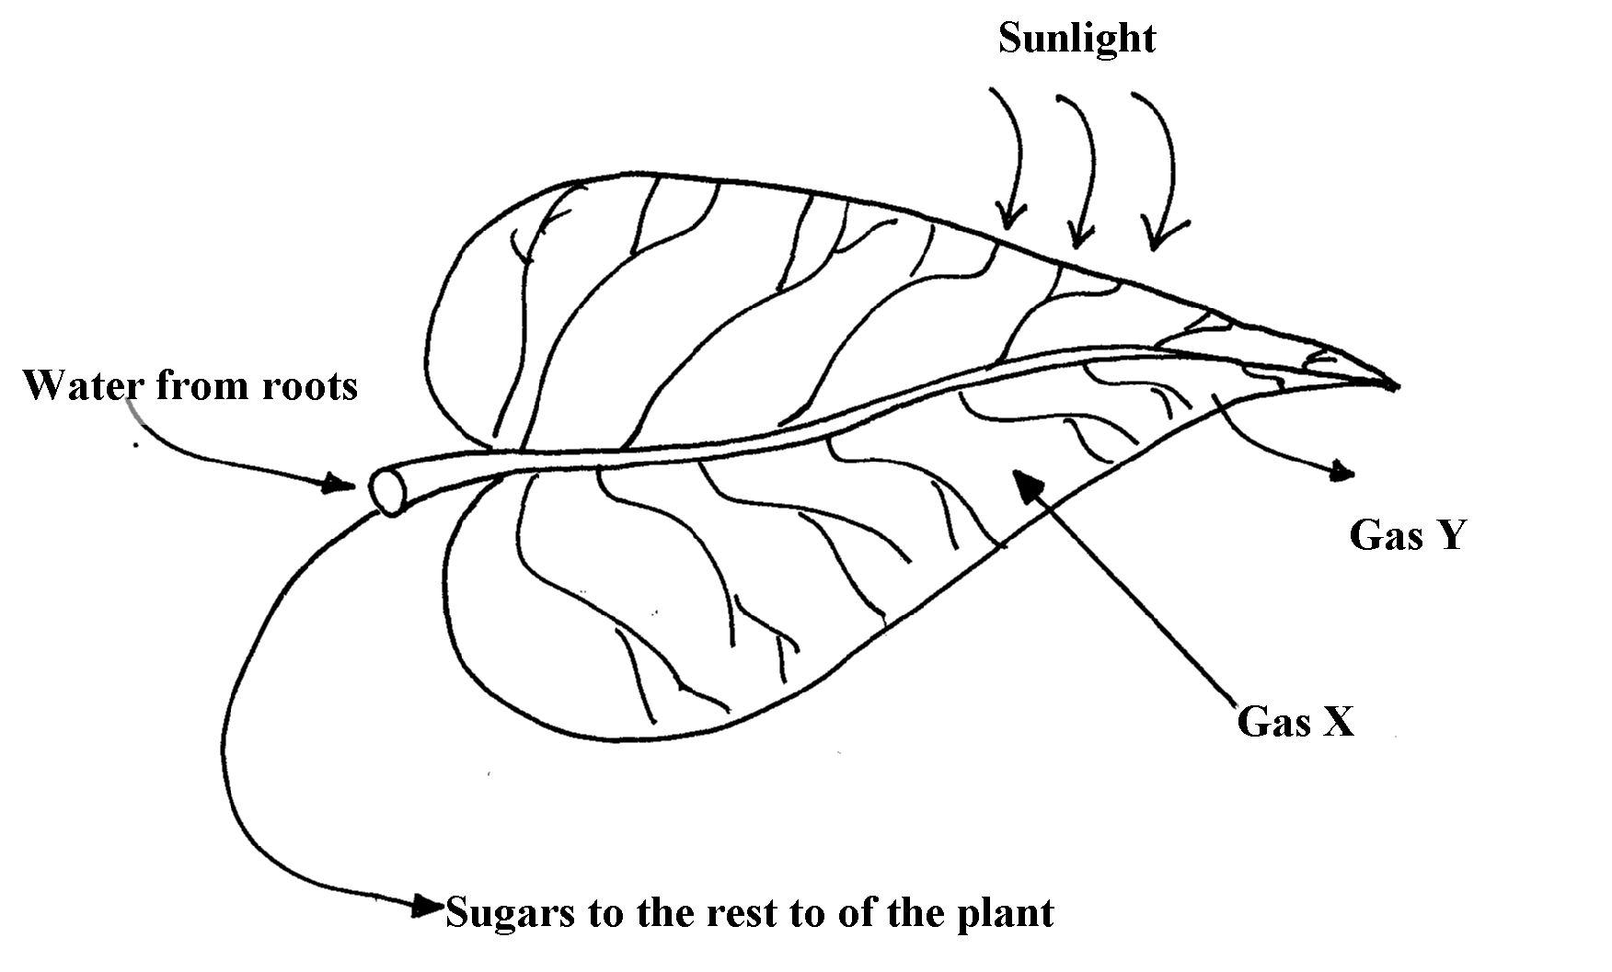

(a) Give **two** ways in which leaves are adapted to absorb light

(b) Name the gases labelled **X** and **Y**

(c) Name the tissue that transports water into the leaf and sugars out of the leaf

(d) Explain why it’s an advantage for the plant to store carbohydrates as starch rather than as

sugars

58. (a) What is meant by digestion?

(b) Describe how mammalian small intestine is adapted to its function

59. Form one students from Inungo school arranged their apparatus as shown below, to investigate a

certain phenomenon. The set up was placed in light.

(a) State the likely aim of the set up

(b) State the role of the syringe in the set-up above

. (c) (i) Name gas **X**

(ii) Write an equation to show how gas **X** was formed in the set-up

(d) State **three** factors that increase the rate of enzyme activity

(e) Give a reason why the test tube is immersed in a beaker of water

60. A student was culturing E. coli (a bacterium) in a Petri-dish. He placed the Petri-dish in an

incubator at 30oC.He removed it from the incubator the following day and found that five

colonies of bacteria had grown. He decided to return it into the incubator to give it more time.

When he removed it fourteen days later, he could not observe any colony.

a) Why was there no colony on the fourteenth day?

b) Explain how bacteria cause spoilage of stored food in warm moist conditions.

c) Name other organisms which also cause food spoilage.

d) State their economic importance to nature.

61. The table below shows the results of an experiment carried out to determine the rate of photosynthesis at different light intensities and varying Carbon (IV) oxide concentrations. The rate was determined by counting the number of bubbles per minute. The temperature was kept constant

|  |  |  |  |  |  |  |  |
| --- | --- | --- | --- | --- | --- | --- | --- |
| **Light intensity in lux** | **% carbon(IV)oxide concentration** | | | | | | |
|  | 0.0% | 0.3% | 0.6% | 0.9% | 1.2% | 1.5% | 1.8% |
| 1500 | 0 | 16 | 30 | 38 | 40 | 40 | 40 |
| 6000 | 0 | 52 | 80 | 96 | 100 | 98 | 100 |
| 10000 | 0 | 80 | 100 | 115 | 120 | 122 | 120 |

a) On a graph paper provided, draw a graph for each of the light intensities. All the three graphs

should be plotted on the same axis (rate of photosynthesis on vertical axis and carbon (IV)

oxide concentration on horizontal axis b) What is the effect of an increase in carbon (IV) oxide concentrations and light intensities

c) Briefly explain how aquatic green plants meet light intensities and carbon (IV) oxide

requirement

d) Using the data provided in the table state **two** factors required by the green plants for food

production

62. Explain how the mammalian intestines are adapted to perform their function.

63. A healthy plant was kept in the dark for 24hours following which two of its leaves were enclosed

in glass flasks as shown below. The set up was the exposed to sunlight for a number of hours.

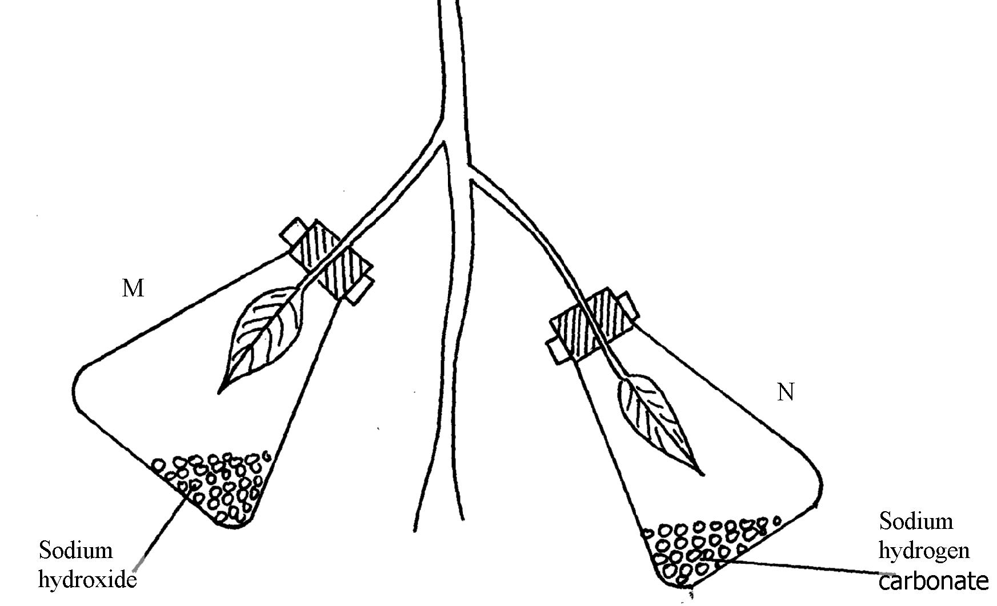

**M**

**N**

(a) Why was it necessary to keep the plant in the dark for 24 hours?

(b) Give the function of each of the following in the experiment

(i) Sodium hydroxide

(ii) Sodium hydrogen corbonate

(c) Explain the expected results in leaf.

(i) **M** when tested for starch

(ii) **N** when tested for starch?

(d) Suggest a suitable control for this experiment

64. The diagram below shows an experiment that was carried out to measure how fast a were

plant such as Elodea photosynthesizes

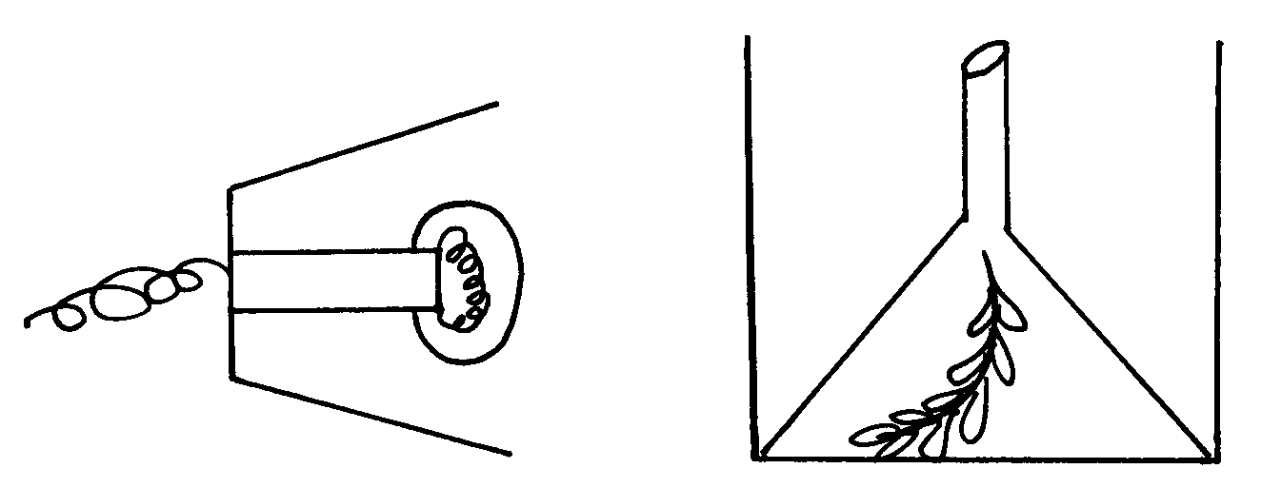

The shoot was exposed to different light intensities and the rate of photosynthesis estimated by counting the number of bubbles of gas leaving the shoot in a given time. the results are given below;

|  |  |  |  |  |  |  |  |  |
| --- | --- | --- | --- | --- | --- | --- | --- | --- |
| **Number of bubbles per minute** | 7 | 14 | 20 | 24 | 26 | 27 | 27 | 27 |
| **Light intensity (Arbitrary units)** | 1 | 2 | 3 | 4 | 5 | 6 | 7 | 8 |

a) Plot these data on apiece of graph paper provided

b) At what light intensity did the shoot produce ;

i) 18 bubbles per minute

ii) 25 bubbles per minute

c) Give **two** better ways of measuring the rate of photosynthesis than counting bubbles

d) What is the role of light intensity in photosynthesis

e) Account for the expected results of doing this experience at the following temperature;

i) 4ºC

ii) 34ºC

iii) 60ºC

f) Other than light intensity and temperature, name other factors that affect the rate of

photosynthesis

65. In an experiment, a leaf from a plant which had been kept in the dark overnight was boiled in water for a minute. It was then boiled in alcohol and washed in warm water. Iodine solution was then added onto the leaf:

(a) Why was the loaf boiled in;- (i) Water

(ii) alcohol

(b) (i) What observation was made on the leaf after adding iodine solution

(ii) Give a reason for your answer in **(b)** above

(c) What was the aim of the experiment

(d) Why was it necessary to wash the leaf in warm water

(e) What is a variegated leaf?

(f) Write a word equation for the process of photosynthesis

**5. Transport in (a) plants (b) animals**

1. Explain why a fresh wound on the skin bleeds more on a hot sunny day than on a cold

chilly day

2. State **three** adaptations of red blood cells to their functions.

3. How are sieve tube elements adapted to their function

4. Name the **polysaccharides** found in the following structures:- (a) **Exoskeleton**

(b) **Xylem vessels**

5. State **three** factors that maintain transpiration stream

6. (a) List **three** forces that facilitate the transport of water and mineral salts up the stem.

(b) Name the tissue that is removed when the bark of a dicotyledonous plant is ringed.

7. Study the dental formula of an organism below..

**I 3/3, C 1/1, Pm 3/2, M 1/1 = x**

(a) (i) What is the total number of teeth this organism possess?

(ii) What is the mode of feeding of the organism?

(b) State **two** functions of mucus produced along the alimentary canal.

8. The diagram below shows a bone obtained from a mammal.

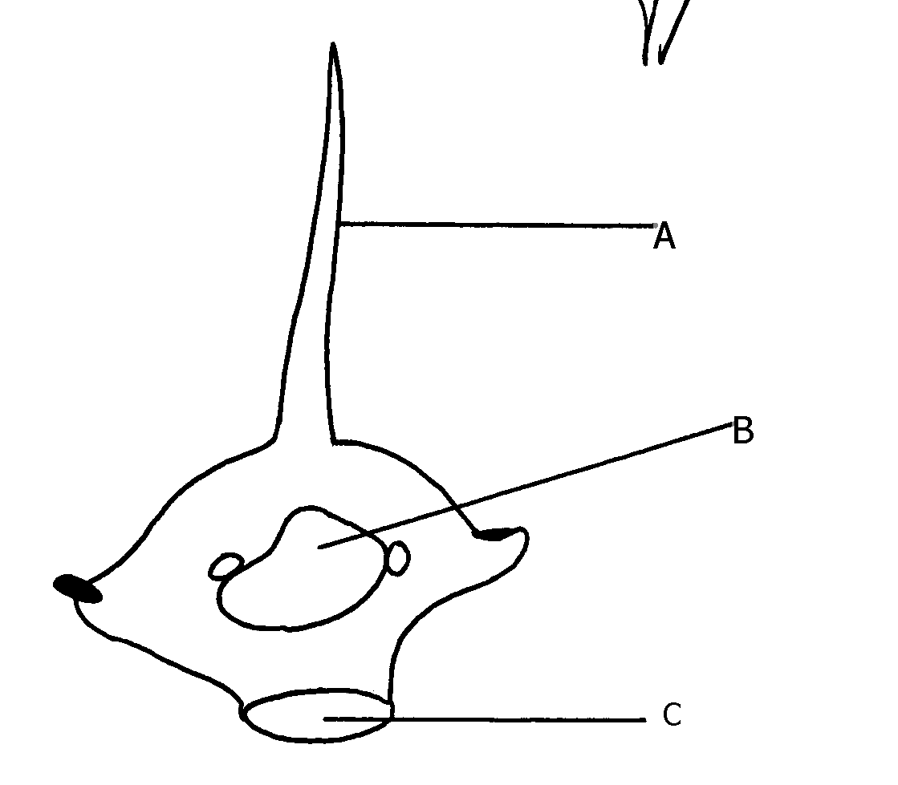

(a) Name the part of the skeleton from which the bone has been taken.

(b) Label the parts **B** and **C**.

(c) State the functions of part **A**.

9. What is the destination of materials translocated in plants.

10. A person whose blood group is **AB** requires a blood transfusion, name the blood groups of the

donors.

11. Explain why capillaries are: (i) Thin walled (ii) Branched

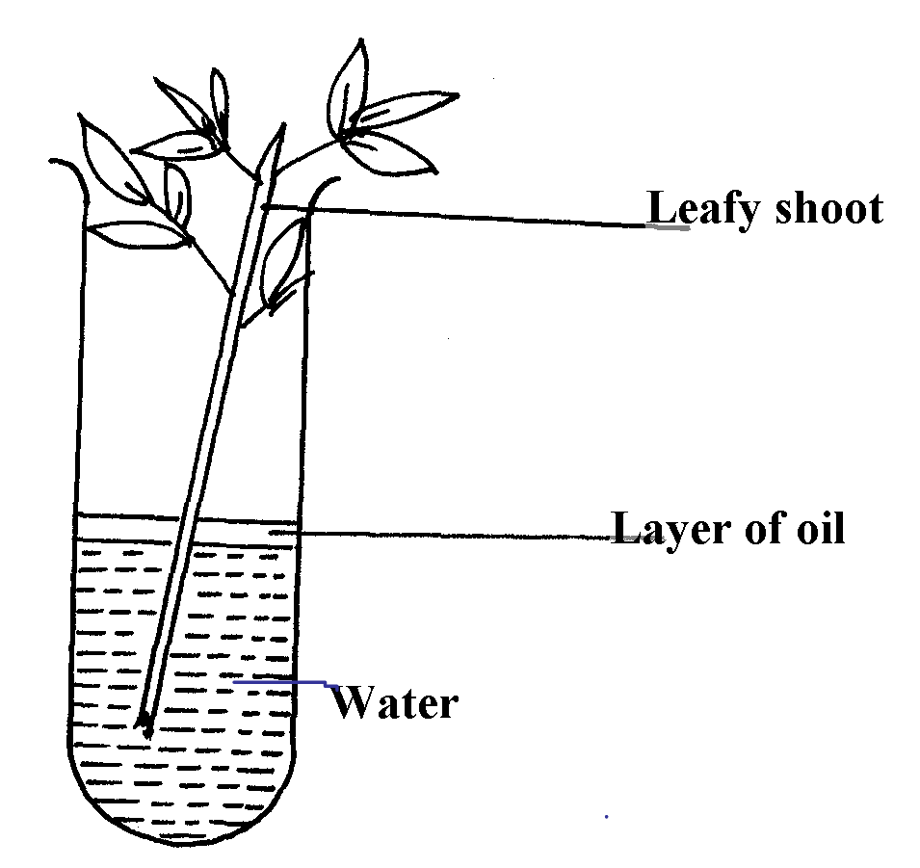12. An experiment was set-up as shown below to investigate a certain plant process:

(a) What process was being investigated above?

(b) What observation was made if;

(i) The experiment was left in strong wind for one hour?

(ii) All the leaves were removed from the plant?

13. How is aerenchyma tissue adapted to its function

14. (a) State **three** structural differences between arteries and veins in mammals

(b) Name a disease that causes thickening and hardening of arteries

15. Identify **two** forces that help in upward movement of water in plants

16. State **three** ways in which red blood cells are adapted to their functions

17. (a) Distinguish between tissue fluid and lymph

(b) Explain why deficiency of vitamin **K** leads to excessive bleeding even from small cuts

18. Name the type of circulatory system found in the phylum Arthropoda

19. Name the blood vessel that nourishes the heart

20. a) In which form is oxygen transported in the blood.

b) Why do plants not take in oxygen during the day although they need it for respiration

21. Name a disease of the blood characterized by excessive production of white blood cells

22. Laboratory analysis of a patient’s urine revealed the following concentration of various

substances:

Blood proteins 0.00%

Water 50%

Glucose 48%

Salts 0.8%

Urea 1.2%

a) From the analysis above, which disease is the patient suffering from

b) Name **two** symptoms of the disease in **3(a)** above

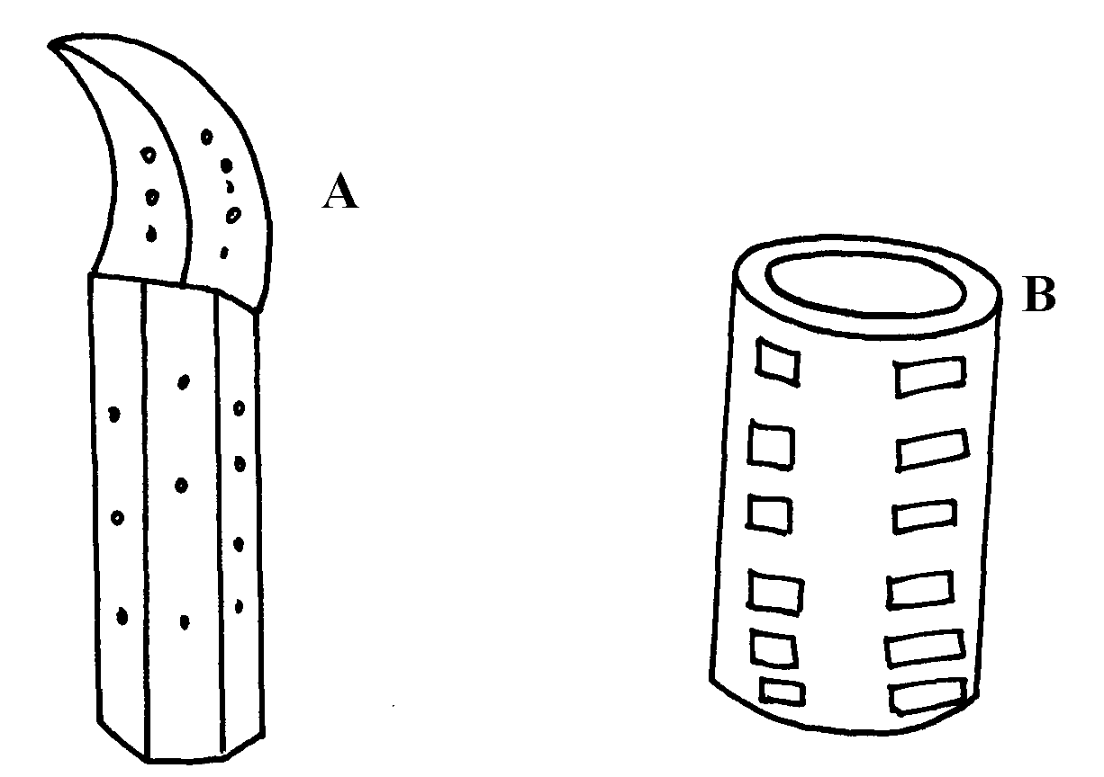 23. The diagrams below show two conducting elements of the xylem tissue

a) Identify each of them A and B

b) What makes the cellulose side walls of both A and B able to prevent collapsing?

24. Explain why the rate of transpiration is reduced when humidity is high

25. (a) State **two** functions of the xylem vessels,

(b) List **two** structural adaptations that make xylem vessels suitable to their function

26. (a) What is peristalsis?

(b) Explain how the process above is brought about.

27. The diagram below shows a part of a circulatory system. The arrows indicate the direction of the

flow of blood;

(a) Identify the blood vessels labeled **A** and **B**

(b) Explain why it is important to transport food substances to organ **C** before being released

for circulation to the rest of the body

28. Name **four** methods plants employ to remove excretory waste products

29. a) State the form in which oxygen is transported in the mammalian blood

b) Why is it dangerous to sleep in an enclosed room with a burning jiko

c) Why do plants not take in oxygen during the day although they need it for respiration

30. Name a disease of blood characterized by excessive – production of white blood cells

31. The table below is a representation of a chromosomal mutation

|  |  |  |  |  |  |  |
| --- | --- | --- | --- | --- | --- | --- |
| **Before mutation** | L | M | N | O | P | Q |
| **After mutation** | L | O | N | M | P | Q |

(a) Name the type of chromosomal mutation represented above

(b) Name **one** mutagenic agent

32. The diagram shows a section through a plant organ.

(a) (i) Name the class of the plant from which the section was obtained belong.

(ii) Give a reason for your answer in **(a)(i)** above

(b) How is the part labelled **C** adapted to its functions?

33. State **two** roles of transpiration to a plant

34. Uptake of water by plants is not affected by metabolic poisons. Explain.

35. The diagram below represents a plant tissue.

(a) Identify each of them.

(b) What property makes **B** to be more efficient in function?

(c) What makes the walls of both **A** and **B** impermeable to water and solutes?

36. A woman gave birth to a child of blood group B+ (B positive). Name the two antigens that

determined her child’s blood group.

37. A transfusion of RH+ blood was given to a patient with Rh- blood. After one week a similar

transfusion was given to the same patient. What was likely to be the effect of the second

transfusion?

38. The diagrams below show stages in the process of feeding shown by amoeba.

(a) Name the part labeled **A**.

(b) Name the process illustrated in the diagram above.

(d) Name the type of cell in human beings that exhibit this process.

39. (a) Why are xylem vessels more efficient in the transport of water than tracheids?

(b) What is the significance of xylem vessels being dead?

40. Distinguish between guttation and transpiration

41. Other than transport, state one other function of xylem tissue in plants

42. State **two** functions of aerenchyma tissue in plants

43. (a) What is sickle-cell anaemia?

(b) Identify the part of the heart that initiates the heart beat

44. (a) Give a reason why the left ventricle muscles are thicker than the right ventricles muscles

(b) State the forms in which carbon (IV) oxide is transported in the blood

45. Explain how the following adaptation reduce transpiration in xerophytes

(a) Sunken stomata

(b) Thick waxy cuticle

46. Name the: (a) Material that strengthens xylem tissue

(b) Tissue that is removed when the bark of a dicotyledonous plant is ringed

47. The diagram below shows the traverse section of a young stem.

(a) What are the functions of the structures labeled **A, B** and **C**

(b) What type of cells are fonjd in the parts labeleld **D**

(c) Name the tissue labeled **E**

48. Name the components of blood that do not enter the renal tubule in mammals

49 Outline the route taken by a molecule of glucose from the ileum up to the kidney.

50. The flow chart below shows a blood transfusion pathway

(a) What **three** conclusions can you draw from the flow chart?

(b) State **two** precautions that must be observed during blood transfusion

(c) Explain how blood clot is formed once a blood vessels is injured

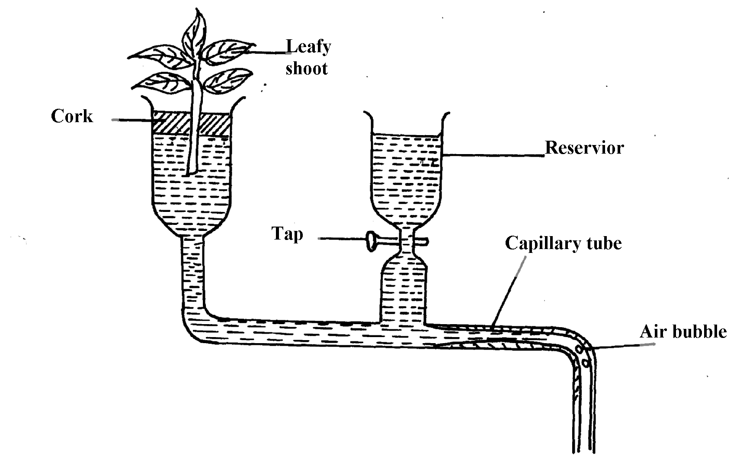51. The figure below represents a diagram of a photometer;

(a) What is the photometer used for ?

(b) State the precautions which should be taken when setting up a photometer

(c) Explain what you will expect if set up was placed under the following environmental

conditions;

(i) Dark room

(ii) Leafy shoot enclosed in polythene bag

(iii) In a current of air created by a fan

52. The amount of blood flow through various parts of the body of a mammal was measured in

cm3 per minute at rest and during different physical activities. Results are shown below.

|  |  |  |  |
| --- | --- | --- | --- |
|  | **Blood flow in cm3/min** | | |
| **At rest** | **During light Exercise** | **During strenuous Exercise** |
| Heart muscles | 200 | 300 | 1050 |
| Gut | 1300 | 1000 | 400 |
| Skeletal muscles | 1100 | 5050 | 23000 |
| Kidneys | 900 | 650 | 250 |
| Skin | 400 | 1300 | 600 |

a) Calculate the percentage change in blood flow through the skeletal muscles and gut when the

mammal was exposed to strenuous exercise.

i) Skeletal muscles

ii) Gut

b) Account for the differences in amount of blood flow through the gut and skeletal muscles;

i) At rest

ii) During streneous exercise

c) Account for the result obtained for the skin during light exercise

d) Name **two** substances which are removed from the body by the kidney

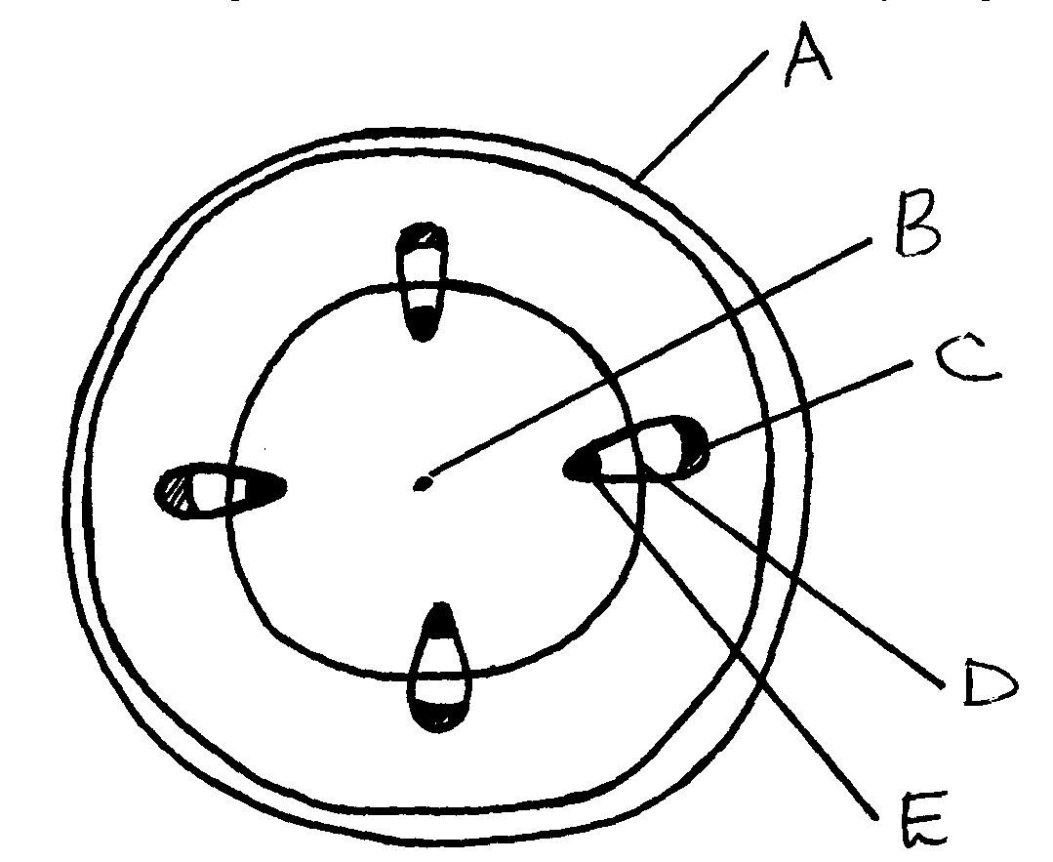 53. The diagram below represents a transverse section of a young stem.

(a) Name the parts labeled **A, B** and **D**

(b) State the functions of the parts labeled **C** and **E**

(c) List **three** differences between the section above and the one that would be obtained from

the root of the same plant

54. Describe the functions of the various components of the mammalian blood

**6. Gaseous exchange in (a) plants (b animals**

1. a) Name the site of gaseous exchange during breathing in mammals.

b) State **three** characteristics of the site named in **(a)** above.

2. Why would carboxyhaemoglobin lead to death?

3. State **two** causes of coronary thrombosis

4. What adaptation do red blood cells have for transportation of carbon (IV) oxide?

5. (a) What is Respiration Quotient (RQ)?

(b) (i) Calculate the RQ of the food substance shown by the equation below.

2C51H98O6 +145 O2 102CO2 + 98H2O + Energy

(ii) Name the food substance being oxidized in b (i) above.

6. Outline **three** ways in which the gills of Tilapia fish are modified to perform their function.

7. Identify the surfaces of gaseous exchange in the following:-

(i) Paramecium;

(ii) Roots;

(iii) Frog;

8. (a) Name **two** gaseous exchange

(b) Explain how oxygen gets into the haemolymph of an insect

10. (a) Outline **two** physiological changes that occur in the body to lower the level of Carbon (IV)

Oxide after vigorous physical exercise

(b) Name the site of respiration in a cell

11. What is the importance of counter current flow in the exchange of gases in a fish

12. State **four** ways in which red blood cells (**RBC**) are adapted to the their function

13. (a) (i) Where in a cell does glycolysis take place?

(ii) Name the product of the above process

(b) Briefly explain Kreb’s cycle in a plant cell during anaerobic respiration

14. Describe the changes that occur to the rib cage and the diaphragm during inspiration

15. a) What is translocation b) Name **two** forces that maintain transpiration stream

16. Most carbon (IV) oxide is transported form tissues to the lungs within the red blood cells and

not in the blood plasma. Give **two** advantages of this mode of transport

17. Give a reason why halophytes have pneumatophores

18. Give **two** characteristics of respiratory surfaces in animals

19. Give a reason for each of the following on mammalian Red blood cells

(a) Absence of the nucleus

(b) Biconcave shape

20. State **two** ways in which bodies of people living in high altitude areas respond to low oxygen

concentration.

21. Explain what would happen to a mammalian Red blood cell 30 minutes alter being placed in

distilled water.

22. (a) State **two** ways in which the surface area of the fish filaments is increased for efficient gaseous

exchange.

(b) What is the importance of counter flow system in the filaments of a fish.

23. The apparatus below illustrates breathing in mammal.

Describe what happens if the rubber plug is pulled in the direction shown by the arrow.

24. Describe the path taken by oxygen gas from atmosphere to the tissues of an insect.

25. Why should respiratory surfaces be: (i) Moist (ii) Thin

26. The set up below represents an experiment to investigate the process of photosynthesis.

The set up placed in sunlight for six hours.

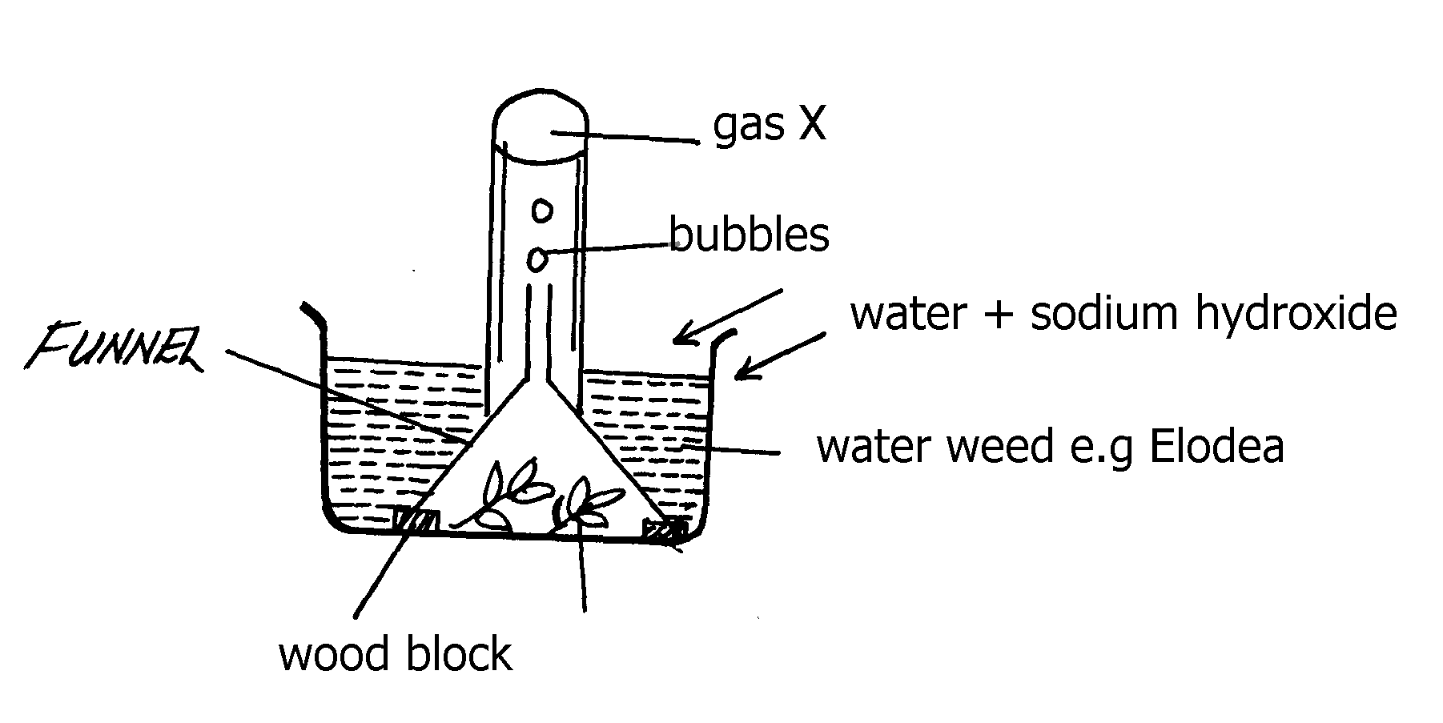

(a) Why was sodium hydrogen carbonate added to water in this experiment?

(b) Explain why the number of bubbles reduced by evening

(c) Explain why the water was used in this experiment

(d) Explain why the water was used in this experiment

27. (a) State **two** adaptations of red blood cell to its functions

(b) Name **two** ways in which carbon (IV) Oxide is transported in mammalian blood

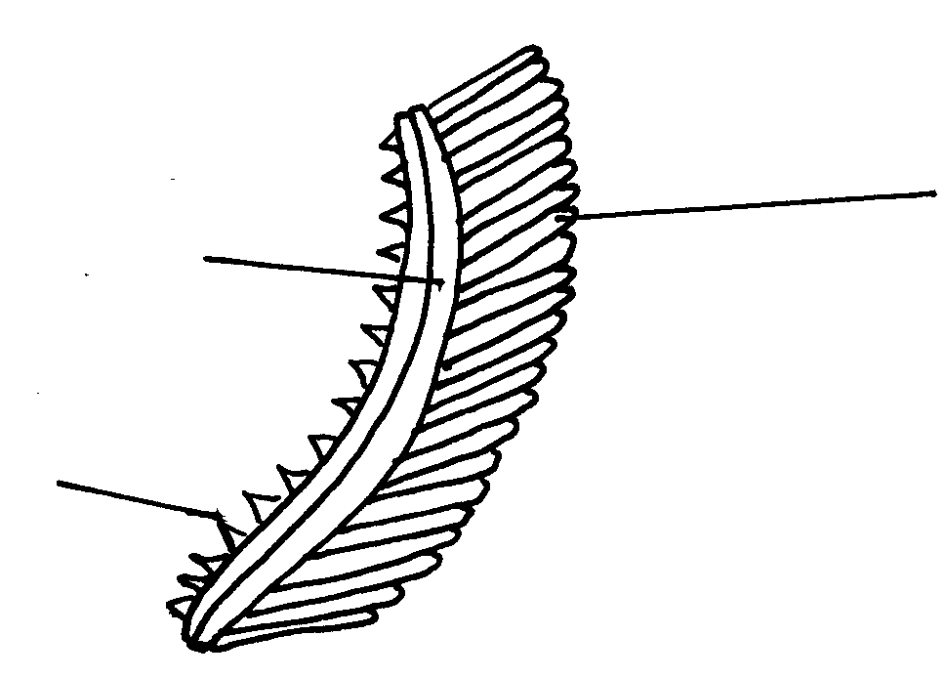28. The diagram below represents an organ from a bony fish. Study the diagram and answer the

questions that follow:

(a) State the functions of each of the following:

(b) How is the structure labeled **C** adapted to its function?

29. State how the tracheal system in insects is adapted for gaseous exchange.

30. Differentiate between active immunity and passive immunity

31. Name **three** sites where gaseous exchange takes place in terrestrial plants.

32. An athlete training to take part in an international competition moved to a high attitude area where

he was to train for twelve days before the competition. He took his pulses per minute daily and

tabulated them as shown below:-

a) Other than pulse rate, name **one** other process which was affected by change of altitude

b) Account for the change in pulse rate from:- i) Day 1 to day 7

ii) Day 8 to day 12

c) Explain the advantage this athlete has over the one who trains in a lower altitude area

d) The equation below represents a reaction which takes place during rapid muscular movements

in humans.

Glucose Lactic acid + 150KJ

i) State **two** effects of this reaction to an individual

ii) How is lactic acid finally eliminated from the muscle tissues of the human after the muscle

33. a) State any **two** structures used for gaseous exchange in plants.

b) Name any **two** sites where gaseous exchange takes place in a leaf of a terrestrial plant.

c) State any **two** types of leaves and their respective functions.

d) Briefly describe how stoma opens.

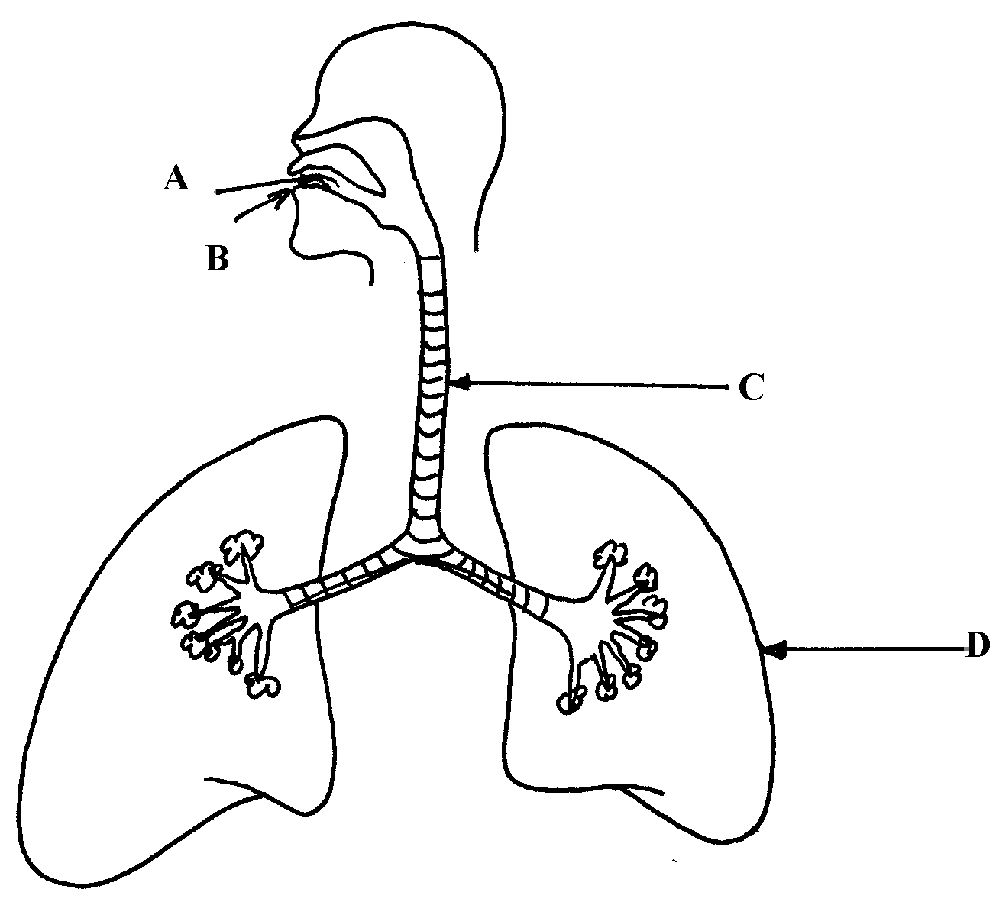34. The diagram below represents a section of the human respiratory system:

(a) One can inhale through path **A**, or **B**. Giving reasons, state the more appropriate path.

(b) How is the part labbelled **C** adapted for its function?

(c) Explain the effect of regular tobacco smoking to the functioning on the organ labelled **D**

35. (a) How is the structure of mammalian gaseous exchange system adapted to its functions

(b) Describe the mechanism of opening and closing of the stomata using the photosynthetic

theory

36. (a) Describe the mechanism of inhalation in man.

(b) Using photosynthetic theory explain the mechanism of opening of stomata.

37. In an experiment to investigate a certain processes in a given plant species, the rate of carbon (IV)

oxide consumed and released were measured over a period of time of the day. The results of the

investigation are shown in the table below:

|  |  |  |  |  |  |  |  |  |  |  |
| --- | --- | --- | --- | --- | --- | --- | --- | --- | --- | --- |
| Time of the day (hours) | 6 | 8 | 10 | 12 | 14 | 16 | 18 | 20 | 22 | 24 |
| Carbon (IV) oxide consumed in mm3/min | 10 | 43 | 69 | 91 | 91 | 50 | 18 | 0 | 0 | 0 |
| Carbon (IV) oxide released in mm3/min | 38 | 22 | 10 | 3 | 3 | 6 | 31 | 48 | 48 | 48 |

b) Name the biochemical processes represented by;

(i) Carbon (IV) oxide consumption

(ii) carbon (IV)oxide release

(c) Account for the shape of the curve for carbon (IV) oxide consumption between;

(i) 6-16 hours

(ii) 20-24 hours

(d) Account for carbon (IV) oxide released between 12-16 hours

(e) (i) What is compensation point?

(ii) From the graph state the time of the day when the plant attains compensation point

(f) Explain how high temperature above optimum affects the rate of carbon (IV) oxide

consumption in the plant.

**7. Respiration**

1. (a) Distinguish between gaseous exchange and respiration

(b) Name the products of anaerobic respiration in plants

2. (a) State **two** phases of aerobic respiration

(b) With a reason, state the phase that yields more energy

3. A process that occurs implants is represented by the equation below:-

C6H16O6 2C2H5OH + 2CO2 + Energy

(Glucose) (Ethanol) (Carbon (IV) Oxide)

(a) Name the process

(b) State the economic importance of the process named in **(a)** above

4. Give a reason why it is difficult to calculate respiratory quotient (RQ) in plants

5. a) Explain what is meant by the term oxygen debt in human beings

b) What are the end products of anaerobic respiration in animals

6. The apparatus below was set up by a student to find out the changes in gases during

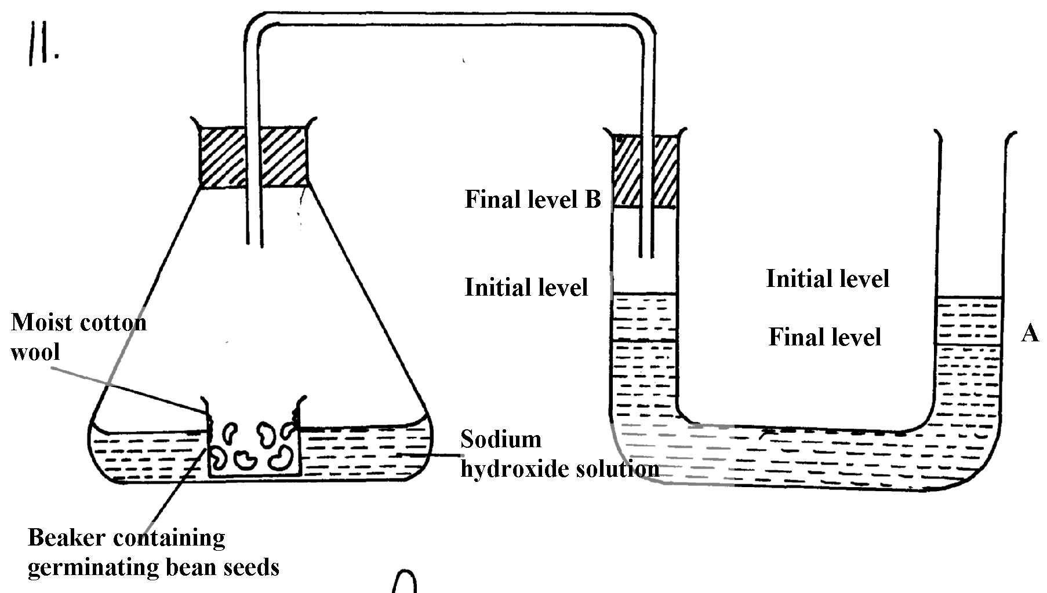germination

a) After 48 hours the level of water in the U-tube at **A** and **B** was as shown. Explain the

observation

b) Calculate the respiration quotient (**RQ**) from the equation below:-

2C51H98O6+145O2 102 CO2 + 98H2O + Energy

c) Identify the substrate being respired in the above equation

7. One molecule of lipid gives more energy than one molecule of glucose when respired aerobically

but it is NOT always used as a respiratory substrate

a) Give **two** reasons for this

b) Name **two** disaccharides which are reducing sugar

8. (a) (i) Where in a cell does glycolysis take place?

(ii) Name the product of the above process

(b) Briefly explain Kreb’s cycle in a plant cell during anaerobic respiration

9. How is the mammalian skin adapted to its protective function?

10. The oxidation state of a certain food is represented below by a chemical equation:-

2 C3H2O2N + 6O2  (NH)2CO2 + 5CO2 +5H2O

a) Calculate the respiratory quotients (RQ) of the food substrate

b) Identify the food substrate

11. Whooping cough is a disease of the respiratory system name the causative agents and give **two**

symptoms

12. How does the sunkness of stomata help in minimizing the rate of transpiration in plants

13. State **two** roles of adrenaline in man

14. Explain why a rat, though small eats more frequently than an elephant

15. Active yeast cells were added to dilute sugar solution in a container. The mixture was kept in a

warm room. After a few hours bubbles of a gas were observed escaping from the mixture

(a) Write an equation to represent the chemical reaction above

(b) State **two** economic importance of this type of chemical reaction in industry?

16. (a) Give **two** reasons why fats are not the main respiratory substrates in the body of a mammal

and yet they give a lot of energy when oxidized.

17. The equation below summarizes a metabolic process in plants.

Glucose Ethanol + carbon (IV) oxide+ Energy

State **two** industrial applications of the above equation.

18. (a) Differentiate between respiration and respiratory surface.

(b) Why is an effective respiratory system often associated with a circulatory system.

19. State **two** reasons why lipids are rarely used as a respiratory substrate compound to

carbohydrates.

20. The equation below shows respiration for a certain food substrate. Study it and answer questions

that follow:

2C51H98O6 + 145O2 102CO2 + 98H2O

(a) Calculate the respiratory Quotient, RQ

(b) Suggest with reasons the possible food substrate

21. The apparatus below was used to investigate anaerobic respiration:-

(a) How would you remove dissolved oxygen from the glucose before the experiment

commencing?

(b) State what happens to the lime water as the experiment proceeds to the end

(c) Describe the reactions in the experiment

(d) Explain what would happen if the temperature of glucose solution and yeast was raised

beyond 45oC?

**8. Excretion and homeostasis**

1. Explain the following:- i) Fresh water fish excrete ammonia

ii) Glucose is absent in urine yet present in glomerular filtrate

2. (a) State **two** functions of the kidney

(b) Name **two** substances that are not found in urine of a healthy person

(c) Name **two** diseases that affect the kidney

3. (a) State **two** structural modification of the kidneys of deserts animals like kangaroo rat.

(b) Describe how ingestion of very salty food may reduce the amount of water excreted in urine.

4. A student mixed a sample of urine from a person with Benedict’s solution and heated, the colour

changed to orange.

(a) What was present in the urine sample?

(b) What did the student conclude on the health status of the person?

(c) Which organ in the person may not be functioning properly?

5. (a) If the human pancrease is not functional:-

(i) Name the hormone which will be deficient

(ii) Name the disease the human is likely to suffer from

(b) What is diuresis?

6. State **one** structural adaptation of nephron in the kidney of a desert mammal

7. Name the nitrogenous wastes excreted by the following organisms:-

**Animal Nitrogenous Waste**

(i) Desert mole

(ii) Marine fish

(iii) Tilapia

8. The table below shows description of sizes of glomeruli renal tubules of two animals which are

living in different environments

|  |  |  |
| --- | --- | --- |
|  | **Animal X** | **Animal Y** |
| Glomeruli | Large and few | Small and many |
| Renal tubules | Short | Long |

(a) Name the likely environment in which each animal lives : (i)Animal X

(ii) Animal Y

(b) What role does vasoconstriction play in thermoregulation?

9. The table below shows the approximate percentage concentration of various components in blood

plasma entering the kidney, glomerular filtrate and urine of a healthy human being

|  |  |  |  |
| --- | --- | --- | --- |
| **Component** | **Plasma** | **Glomerular filtrate** | **Urine** |
| Water | 90 | 90 | 94 |
| Glucose | 0.1 | 0.10 | 0.00 |
| Amino acids | 0.05 | 0.05 | 0.00 |
| Plasma proteins | 8.0 | 0.00 | 0.00 |
| Urea | 0.03 | 0.03 | 2.00 |
| Inorganic ions | 0.72 | 0.72 | 1.50 |

(a) Name the process responsible for the formation of glomerular filtrate

(b) What process is responsible for the absence of glucose and amino acids in urine?

(c) Explain why there are no plasma proteins in the glomerular filtrate?

10. What is the importance of sebaceous glands in the human skin?

11. Explain why sweat accumulates on a person’s skin in a hot humid environment

12. Distinguish between diabetes mellitus and diabetes inspidus

13. State **two** processes through which plants excrete their metabolic wastes.

14. The figure below shows a vertical section through a mammalian kidney.

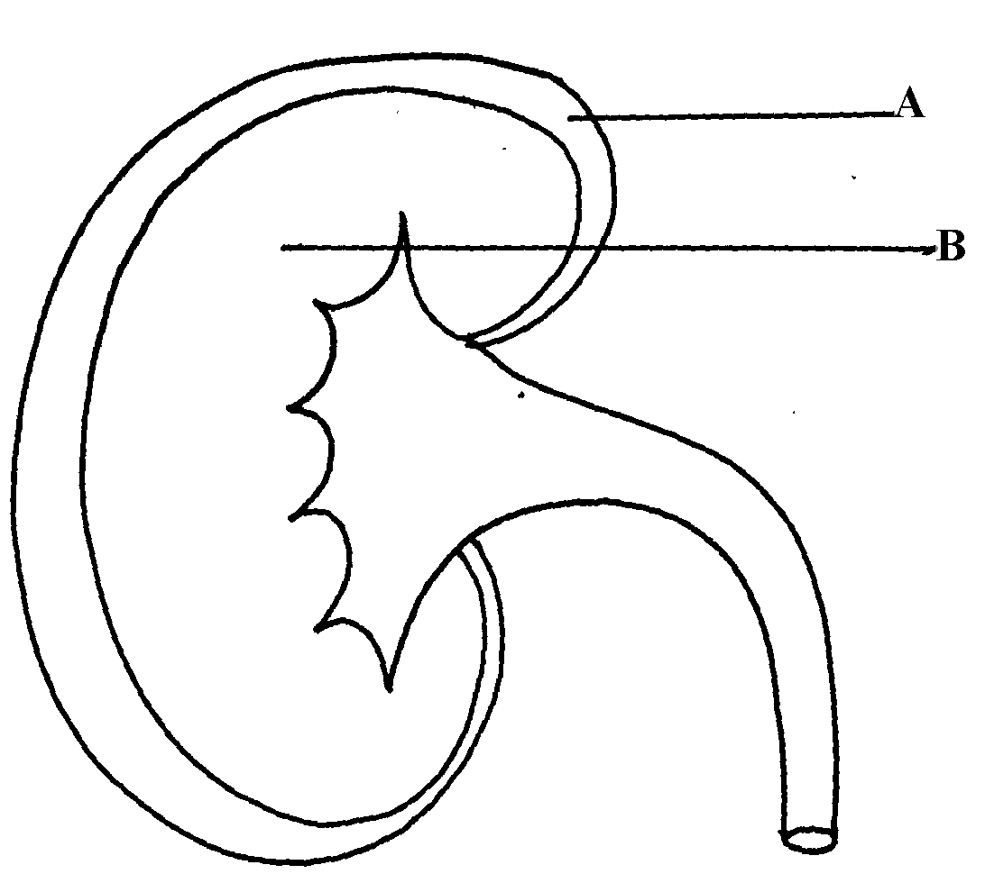

(a) Label the parts A and B

(b) Which part is the Bowman’s capsule found?

15. (a) Explain the effects of the production of large amounts of Antidiuretic hormone in the human

body

(b) State **two** functions of the loop of Henle

16. Study the homeostatic scheme below:

C

(a) Identify the hormone labeled **A**

(b) Name the site of action of hormone **A**

(c) Identify the feedback labeled **D**

17. State **three** importance of Osmosis in plants

18. A patient was complaining of thirst most of the times. A sample of the patient’s urine was found

not to contain a lot of sugar but was dilute:-

(a) Name the hormone the person’s body was deficient of

(b) Which gland produces the above hormone

(c) Name the disease that the patient was most likely suffering from

19. State **two** features in the nephron that facilitate ultra filtration

20. The table below shows a description of size of glomeruli and renal tubules of two animals

which are adapted to living in different environment:-

|  |
| --- |
| **Animal A Animal B** |
| Glomeruli large and few small and many |
| Renal tubules short long |

a) Name the likely environment in which animal **A** lives b) Suggest the main nitrogenous waste produced by animal **B**  c) Name the organelle of osmoregulation in each of the following animal: i) Paramecium

ii) Insects

21. What role is played by the liver in excretion?

22. The equation below represents a metabolic process that occurs in the mammalian liver: Amino acids organic compound + urea

a) Name the process

(b) What is the importance of the process to the mammals?

23. A person was found to pass out large volume of dilute urine frequently. Name the:-

(a) disease the person was suffering from?

(b) hormone that was deficient

24. Explain the effects of the following on the quantity and composition of urine

(a) Drinking large amount of clean water

(b) Drinking very salty soup

(c) Removal of pancreas

25. (a) Distinguish between **excretion** and **egestion**

(b) State the importance of excretion in the bodies of living organisms.

26. The diagram below shows simplified structures of kidneys from two different animals.

Animal **M**

Animal **N**

(a) Suggest possible habitat in which animal **N** is found.

(b) Give **two** reasons for your answer in (a) above.

27. (a) What is poikilotherm?

(b) State **two** classes of phylum chordata where all members are poikilothermic .

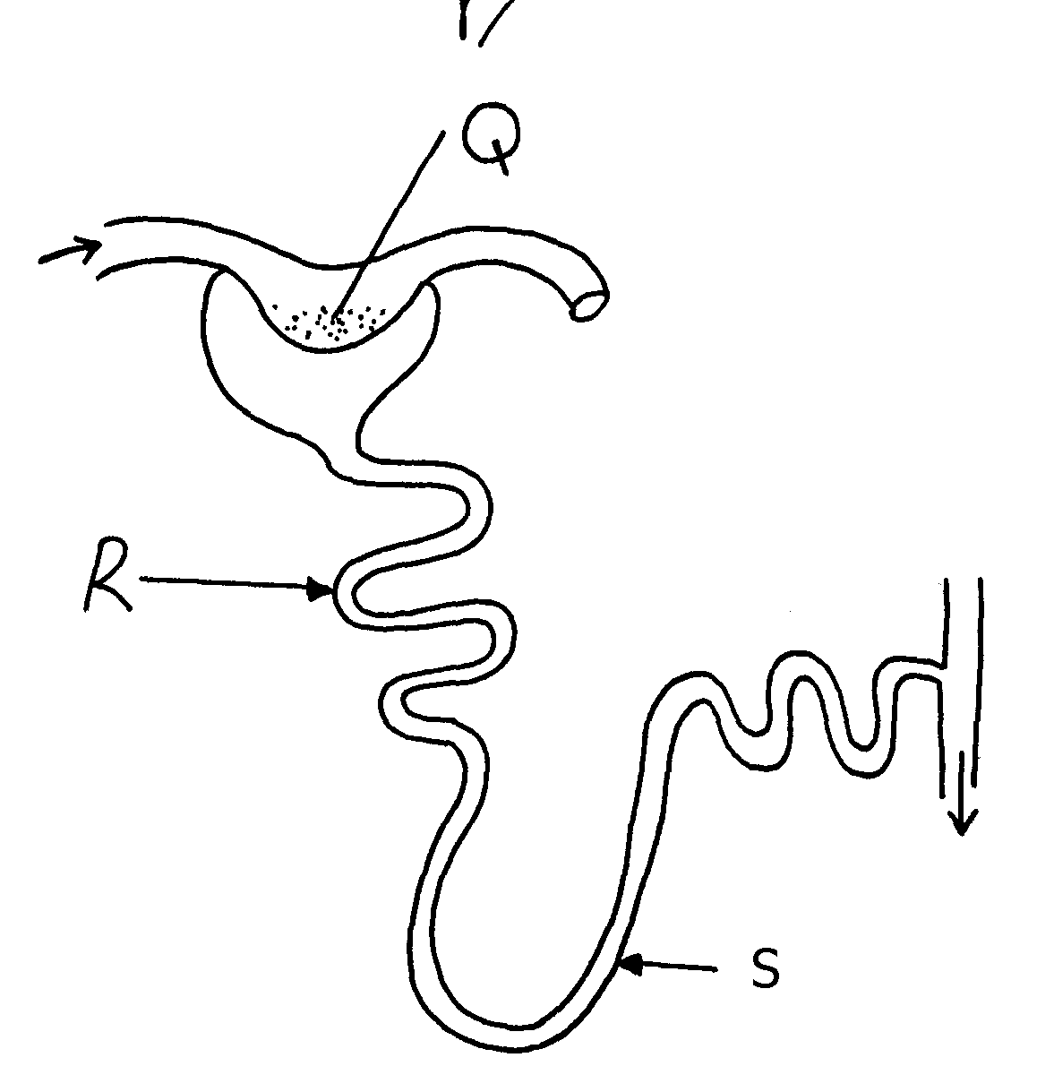28. The diagram below represents a mammalian nephron

(i) Name the structure labelled **Q** ....................................................................................

(ii) State **two** adaptations of part labeled **R**

29. Distinguish between internal environment and external environment as used in

30. The diagram below represents a nephron of a mammal:

(a) Name the parts labeled **A, B** and **D**

(b) Name a major substance in glomerular filtrate whose concentration remains the same

between **A** and **C**

31. Name the parts of the flower that are responsible for the production of gametes

32. The equation below represents a metabolic process that occurs in a certain organ in the m

mammalian body:-

Ammonia enzymes Organic compound **Q** + water

Carbon (IV) oxide

a) Name the process represented in the equation.

b) Name the organ in which the process occurs.

c) Why is the process important to the mammal?

d) Identify the organic compound **Q.**

e) Explain the source of ammonia in the organ named in **(b)** above. f) What happens to organic compound **Q**?

33. Kosgei and Onyancha collided during a football match and each got bruised. Kosgei’s bruise stopped bleeding after ten minutes while Onyancha’s bruise continued bleeding and he had

to be taken to hospital for treatment.

(a) Explain the process which brought about stoppage of Kosgei’s bleeding

(b) Distinguish between blood clotting and haemagglutination.

(c) Name the disease, that Onyancha could be suffering from.

34. The table below shows the percentage of some substances in the glomerular filtrate and urine

of a certain mammal:-

|  |  |  |
| --- | --- | --- |
| **Substances** | **Contents in glomerular filtrate** | **Contents in urine** |
| Water | 90 | 90 |
| Sodium ions | 0.3 | 0.35 |
| Chloride ions | 0.37 | 0.60 |
| Glucose | 0.1 | 0.0 |
| Urea | 0.03 | 2.0 |
| Proteins | 0.0 | 0.0 |

(a) From the above table, account for ; (i) The absence of glucose in urine (ii) The absence of protein in both glomerular filtrate and urine

(b) Explain the significance of the flow system in the nephron where the glomerular filtrate

flows in opposite direction to that of blood in the surrounding capillaries

(c) Name the hormone that controls the percentage of water in urine and that which control the

amount of salts Percentage of water

Amount of salts

(d) List any **two** diseases /disorders of the kidney

35. Study the diagram below and answer the questions that follow

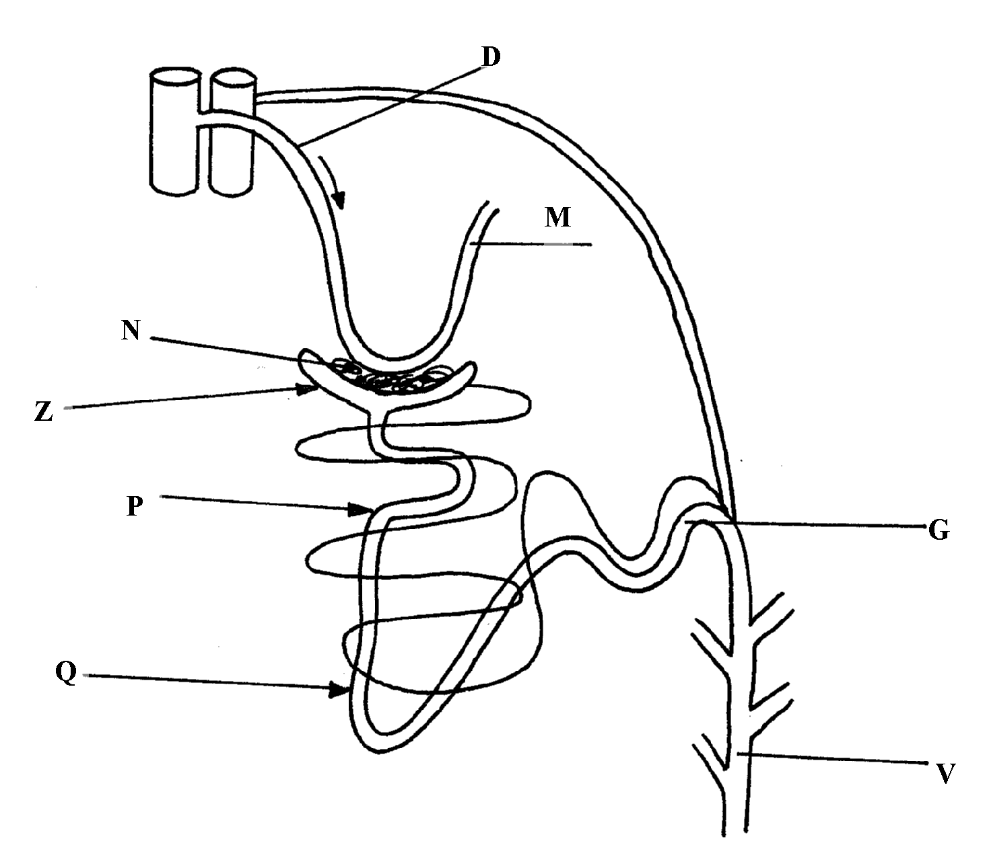

(a) Name the structure represented by the diagram

(b) (i) Name the parts labelled **D** and **M**

(ii) Name the hormones whose sites of action are Q and G (c) Name **one** substance that is present in part **N** but absent in part **Z**

(d) The contents of part **V** were boiled with Benedicts’ solution and an orange precipitate was

formed. Account for the results

36. In an investigation, two persons **A** and **B** drunk the same amount of glucose solution. Their blood

sugar levels were determined immediately and thereafter at intervals of one hour for the next six

hours.

The results were as shown in the following table:-

|  |  |  |
| --- | --- | --- |
| **Time (hrs)** | **Blood glucose level (mg/100ml)** | |
|  | **Person A** | **Person B** |
| 0 | 90 | 120 |
| 1 | 220 | 360 |
| 2 | 160 | 370 |
| 3 | 100 | 380 |
| 4 | 90 | 240 |
| 5 | 90 | 200 |
| 6 | 90 | 160 |

(a) Draw a graph of blood sugar levels of persons **A** and **B** against time on the same axis

(b) Explain each of the following observations;-

(i) Blood sugar level increased in person **A** between 0 and 1 hour

(ii) The blood sugar level dropped in person **A** between 1 and 4 hours

(c) From the graph, what is the normal blood glucose sugar level for human beings

(d) Suggest a reason for the high sugar level in person **B**

(e) How can the high blood sugar level in person **B** controlled?

(f) What is the biological significance of maintaining a relatively constant sugar level in a human

being

(g) Account for the decrease in the blood glucose level of person **B** after 4 hours

37. An experiment was carried out to determine the effect of drinking on excess amount of water on

the flow of urine. A person drinks one litre of water and urine was collected at intervals of 15minutes.

The results were as shown below:

|  |  |  |  |  |  |  |  |  |  |  |
| --- | --- | --- | --- | --- | --- | --- | --- | --- | --- | --- |
| Time in minutes | 0 | 15 | 30 | 45 | 60 | 75 | 90 | 105 | 120 | 135 |
| Urine output ml/min | 1.6 | 1.6 | 1.6 | 5.4 | 9.0 | 9.0 | 7.6 | 3.0 | 0.8 | 0.8 |

(a) Plot a suitable graph to represent urine output with time.

(b) Explain the rate of flow of urine between the following times;

(i) 15 and 60minutes.

(ii) 60 and 75minutes.

(iii) 75 and 135 minutes.

(c) Name **two** hormones responsible for regulation of relative amount of salts and water in man.

38. a) Explain how urea is formed in the human body

b) Describe the path taken by urea from the organ where it is formed until it is released from

the human body

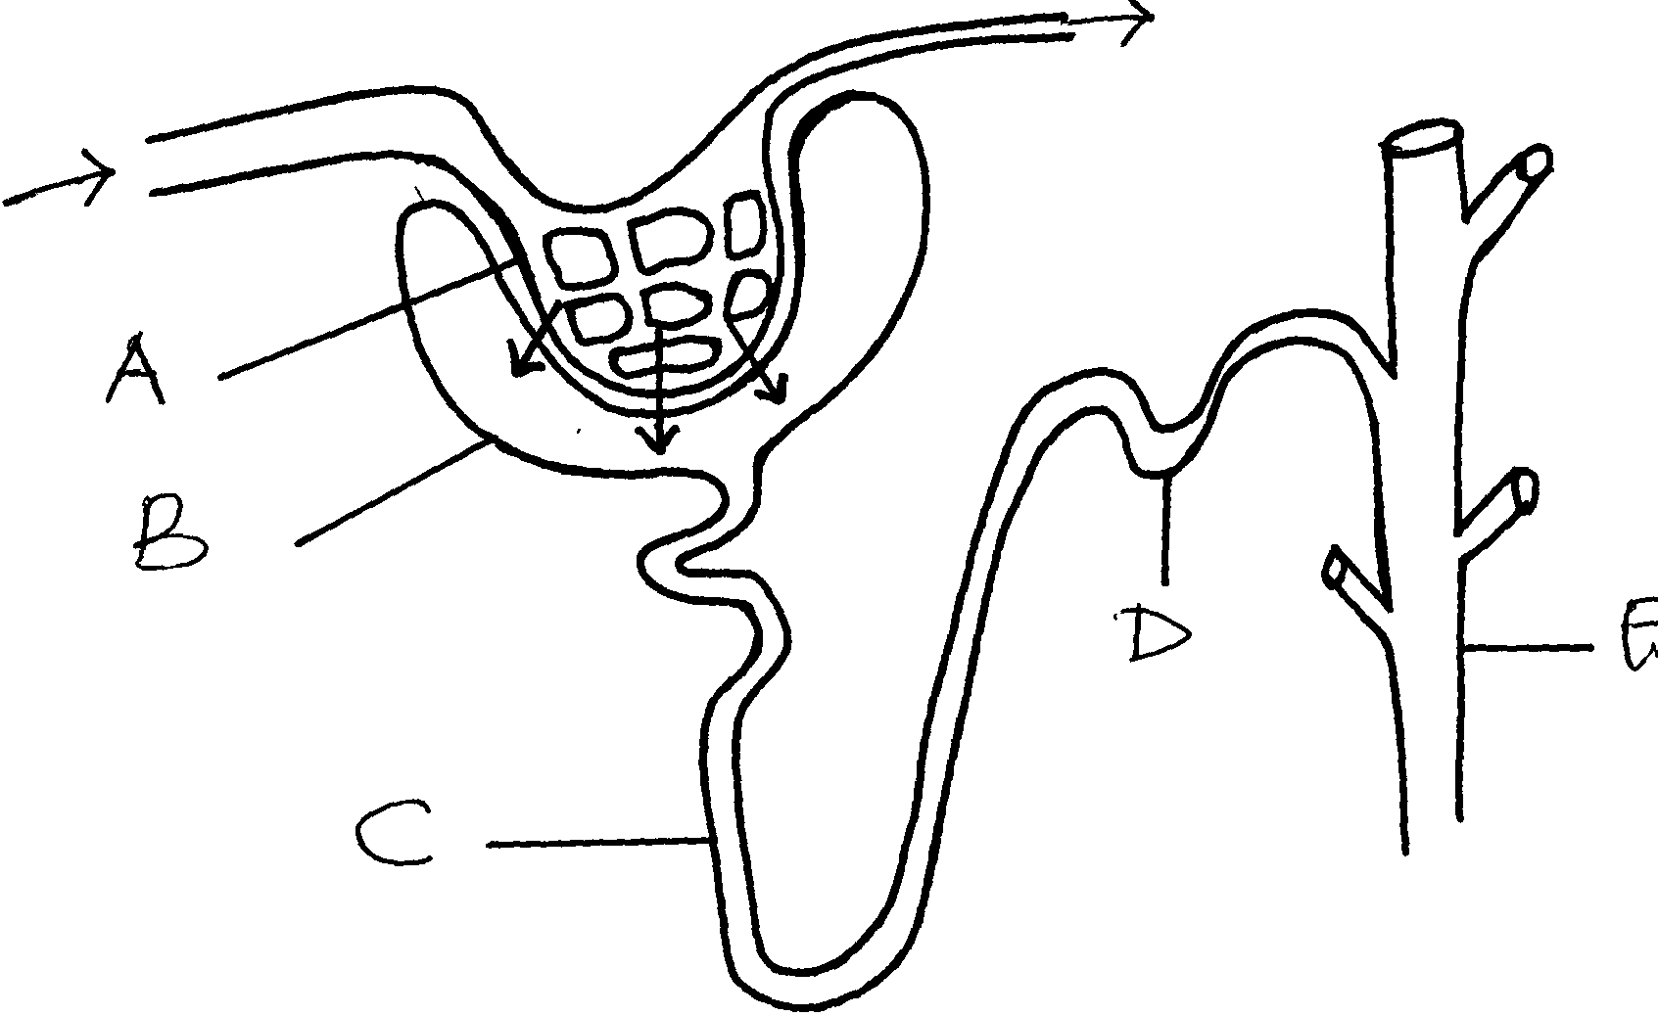39. The diagram below represents a mammalian nephron.

(a) Name the structures labeled **B,C** and **D**

(c) Name the process by which substances are reabsorbed from structure **C** into blood capillaries

(d) How is the pressure in structure **A** achieved?

40.

a) Identify **substance X**

(c) Give the end products of the process labelled **H**

(d) Give **three** other functions of the liver

41. The flow diagram below represents blood clotting process

a) Name the proteins represented by the letters; V, Y, Z b) State the importance of blood clotting

c) Why doesn’t the physiological process above occur in undamaged blood vessels

42. How does an Endotherm respond to both heat gain and heat loss?

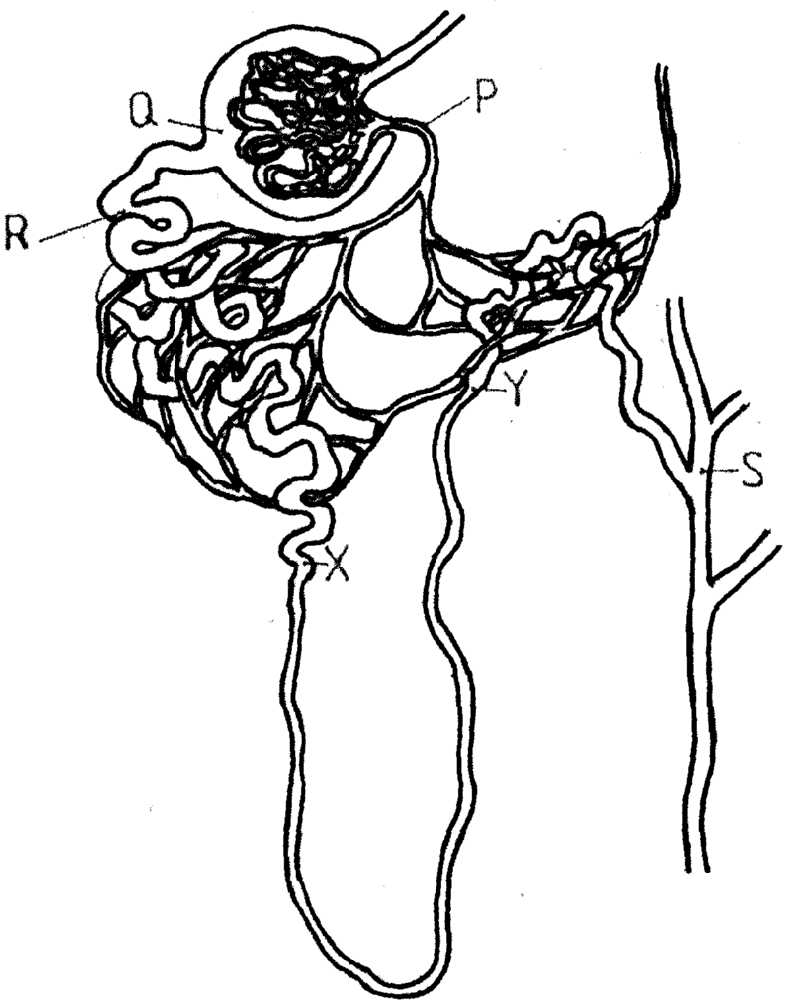43. The diagram below represents a mammalian nephron

(a) Name the: (i) Structure labelled **P**

(b) State the structural modifications of the part label led **Q** for

(i) Desert mammals

(ii) Fresh water mammals

(c ) (i) Name **one** substance present at point **R** but absent at point **S** in a healthy mammal.

(ii) The appearance of the substance you have named in **(c)(i)** above is a symptom of a

certain disease. Name the disease

44. Describe how the mammalian skin regulates body temperature

**9. Ecology**

1. A student wanted to estimate the number of grasshoppers in 5km2 grass field near the school compound.

Using a sweep net he captured 36 grasshoppers. He used a red felt pen to mark the thorax of each insect before releasing back into the field. Three days later he made another catch of grasshoppers. He collected 45 grasshoppers of which only 4 had been marked with red mark.

a) Name the above method used in the population estimation b) Calculate the population of grasshoppers using the above data

2. What is the significance of the following in the ecosystem?

a) Decomposers

b) Predators

3. Birds feed on grasshoppers that feed on grass.

a) Draw a possible food chain from the above information

b) Explain why the biomass of organisms decreases at each preceding trophic level.

4. Define the following terms:-

(i) Autecology ;

(ii) Biomass;

5. State **two** most important factors that favour exponential growth of a population of gazelle

in a park

6. (a) Distinguish between habitat and niche.

(b) Explain why Biomass of producers is greater than that of primary consumers in a balanced

ecosystem.

(c) State **two** advantages of a biological control method over the chemical control method of

pests and parasites

7. Explain how oil as a pollutant may affect aquatic plants and animals?

8. The diagram below shows part of a food relationship in an ecosystem:-

(a) Name the food relationship above

(b) How many trophic levels are shown in the diagram above?

(c) State main source of energy in the ecosystem

9. Use the food web below to answer the questions that follow:-

(a) Construct a food chain ending with crocodile as a quartenary consumer

(b) Name the organisms in the food web hat has only one predator

10. 50 black mice and 50 white mice were released in an area inhabited by a pair of owls. After

four months, the mice in the area were recaptured and only 38 black mice and only a white mice

remained.

(a) How would you explain these results?

(b) Name the theory of evolution that support the results in **(a)** above

11. In a certain school Form three class did an experiment to estimate the number of Tilapia

in their fish pond. 725 tilapia were netted marked and released.

a) State the method used in this exercise

b) Calculate the tilapia population.

c) State **two** assumptions made by the students during the investigation

12. An investigation was carried out on a terrestrial ecosystem. The population sizes and species

biomass were determined and recorded as shown in the table

|  |  |  |
| --- | --- | --- |
| **SPECIES** | **POPULATION SIZE** | **SPECIES BIOMASS** |
| **A** | 1x103 | 1x103 |
| **B** | 1x103 | 1x10-1 |
| **C** | 1x105 | 1x10 |
| **D** | 1x10 | 1x104 |

1. If these organisms had a feeding relationship, construct a simple food chain involving all the organisms
2. Construct pyramid of numbers using the data provided above
3. State **one** disadvantage of using pyramid of number in expressing feeding relationships in ecological ecosystem

13. The figure represents a feeding relationship in an ecosystem

(a) Write down the food chain in which the Guinea Fowls are secondary consumers

(b) What would be the short term effects on the ecosystem if lions invaded the area

(c) Name the organism through which energy from the sun enters the food web

14. Outline **three** roles of active transport in human body

15. Distinguish between community and population

16. Describe how the belt transect can be used in estimating the population of a shrub in a

grass land

17. A fish farmer wanted to know the number of fish in a pond. He collected 10 fish from the pond

and labeled each, by a tag label on its fin and returned the ten fish to the pond to mix with

other fish . When he later collected 50 fish from the pond, he found only four of them had labels

a) Estimate the total number of fish in the pond (show your workings)

b) What **two** assumptions are being made in this methods of estimating population

18. What is the importance of saprophlic fungi and bacteria in an ecosystem

19. i) Name **one** main cause of global warming

ii)What are the effects of global warming

20. Explain how saliva is important in digestion

21. Give a reason why two species in an ecosystem cannot occupy the same niche

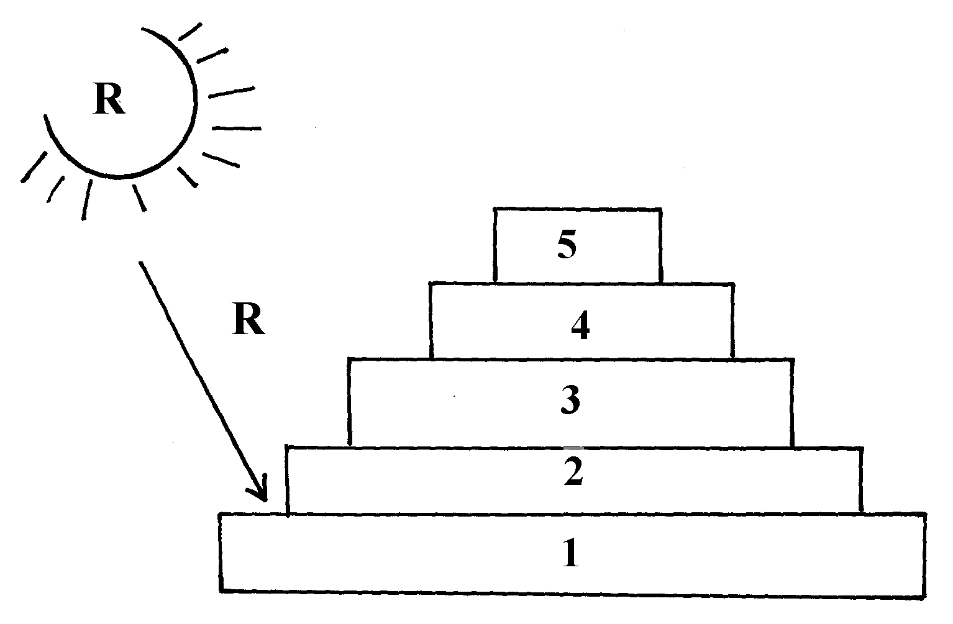22. Below is a pyramid of numbers indicating trophic levels:-

(a) What do you understand by the term trophic level?

(b) Name the trophic level numbered 5 on the pyramid

(c) Name **Q**

(d)What is the significance of the arrow **R**

23. Two populations of the same species of birds were separated over a long period of time by an

ocean. Both populations initially fed on insects only. Later, it was observed that one population

fed entirely on fruits and seeds, although insects were available. Name this type of evolutionary

change

24. To estimate the population size of crabs in a certain lagoon, traps were laid at random. 400 crabs

were caught, marked and released back into the lagoon. Four days later, traps were laid again and

360 crabs were caught. Out of the 360crabs, 90 were found to have been marked

(i) Calculate the population size of the crabs in the lagoon

(ii) What is the name given to this method of estimating the population size

25. State the function of each of the following apparatus:

(a) Pooter …

(b) Sweep net …………

26. State the role of the following apparatus in the study of living things.

(a) Sweep nets.

(b) Pooter.

(c) Pit fall trap.

27. Name **three** density dependent factors in an ecosystem.

28. (a) What are the **two** main components of an ecosystem?

(b) Apart from mere observation of actual feeding suggest **two** methods that can be used

to determine the type of food eaten by animals

29. The chart below represents a simplified nitrogen cycle.

Nitrogen in Air

Nitrogen fixation

**Y**

Lighting

Plants

**X**

Nitrogen fixing bacteria in root nodules

Egestion

Excretion

Death

**Z**

Nitrates in soil

What is represented by **X, Y** and **Z**?

30. In an ecological study, a locust population and that of crows was estimated in a grassland area

over a period of one year. The results were tabulated as shown below.

|  |  |  |  |  |  |  |  |  |  |  |  |
| --- | --- | --- | --- | --- | --- | --- | --- | --- | --- | --- | --- |
| **Months** | **J** | **F** | **M** | **A** | **M** | **J** | **A** | **S** | **O** | **N** | **D** |
| **No. of Adult locusts x 102** | 90 | 20 | 11 | 25 | 200 | 652 | 15 | 10 | 35 | 192 | 456 |
| **Number of crows** | 4 | 2 | 0 | 1 | 8 | 22 | 2 | 1 | 1 | 5 | 15 |
| **Amount of rainfall** | 20 | 0 | 55 | 350 | 520 | 350 | 10 | 25 | 190 | 256 | 350 |

a) Draw a graph of population of locusts and crows against time

b) i) State the relationship between rainfall and locust population

ii) Account for the relationship you have stated in **b (i)** above

c) What happens on the populations of locusts and crows in the months of January to March?

Give a reason.

d) If the area of study was one square kilometer, state **one** method used to estimate the

population of :- i) Locusts

ii) Crows

(e) (i) State the trophic levels of the (i) Locusts and (ii) crows

(ii) Construct a simple complete food chain involving these organisms

(f) If the locust were removed from the food chain, what would be its effect?

(g) Define **biomass**

31. Two species of antelopes were introduced into an ecosystem at the same time in equal numbers.

The graphs below show their relative numbers during the first eight years of their co-existence.

Study the graphs carefully and answer the questions that follow.

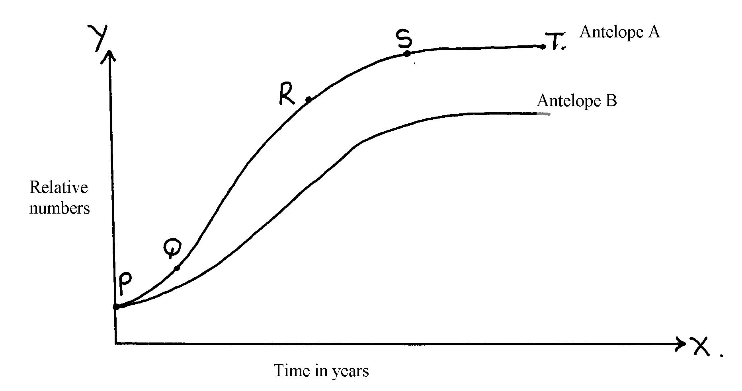

a) i) Which species of antelope has better survival adaptations.

ii) Give a reason for your answer above.

b) i) Name the type of curves shown.

ii) Name the phases labeled PQ, QR, RS, ST

c) Explain the shape of the curve for the species of Antelope **A** between

i) **Q** and **R**.

ii) **S** and **T.**

d) i) State the type of competition shown by the two species of antelopes.

ii) State any **two** symptoms of intraspecific competition in plants.

e) Suggest how the species B avoid competitive exclusion..

f) State any **three** adaptations that enable the antelopes to overcome predation.

g) State any **two** possible methods by which populations of the two antelopes’ species were

determined.

32. Explain **five** abiotic factors that affect the ecosystem

33. The data shown below was taken from Savannah grassland habitat. Examine it carefully and then

answer the questions that follow:-

(a) Draw **three** food chains

(b) Draw a pyramid of numbers for a food chain with four trophic levels and indicate the trophic

levels at which each member feeds

(c) State the effect of removing the hunting dogs

(d) Why is it advisable to feed 100kg of grain to man instead of using it to fatten steers then

supply beef to human population?

|  |  |
| --- | --- |
| **Organism** | **Population** |
| Grasses | 1000 |
| Caterpillars | 500 |
| Squirrels | 300 |
| Frogs | 200 |
| Gazelles | 300 |
| Elephants | 100 |
| Snakes | 50 |
| Hunting dogs | 40 |
| Vultures | 40 |
| Lions | 40 |
| Hawks | 10 |

34. Study the following food web and answer questions that follow:

(a) (i) Name the organisms that occupy the second trophic level

(ii) What is the other name for the second trophic level

(b) Write down **two** food chains from the food web that:

(i) End with hawks as tertiary consumer

(ii) End with hawks as quaternary consumer

(c) Giving reasons state; (i) the organism with largest biomass (ii) the organism with least biomass

35. (a) Explain how food as a factor regulates the population of animals in an ecosystem

(b) Describe the flow of energy from the sun through the different trophic levels in an ecosystem

36. (a) Describe how a population of grasshoppers in a given area can be estimated

(b) Describe how the belt transect can be used in estimating the population of a shrub in

a grassland

37. The flow chart below represents a feeding relationship in an ecosystem

(a) Name; (i) The producers in the ecosystem

(ii) Two organisms which are both secondary and tertiary consumers

(b) State **two** short term effects of immigration of insects in the ecosystem.

(c) Which organism has the least Biomass in the food web. Explain.

(d) State **three** disadvantages of using synthetic pesticides over Biological control.

(e) State the role of each of the following in an ecosystem;

(i) Saprophytes

(ii) Leguminous plants

(iii) Explain the role of producers in an ecosystem

(f) Name **one** method that would be used to estimate the population of small fish in the

ecosystem

38. How are leaves of mesophytes adapted to their functions?

**10. Reproduction in (a) plants (b) animals**

1. a) Name the part of an ovule that develops into each of the following parts of a seed after

fertilization i) Testa ii) Endosperm

b) What is parthenocarpy?

2. State **three** roles of placenta during pregnancy.

3. Name **three** **main** methods through which HIV/AIDS is transmitted

4. (a) Name the processes that lead to fruit formation without fertilization

(b) Name the hormone that causes leaf, flowers and fruit abscission

(c) What is the role of ecdysone hormone in insects

5. State the roles of oviduct in female reproductive system

6. The diagram below represents a mature embryo sac. Study it carefully and answer the questions

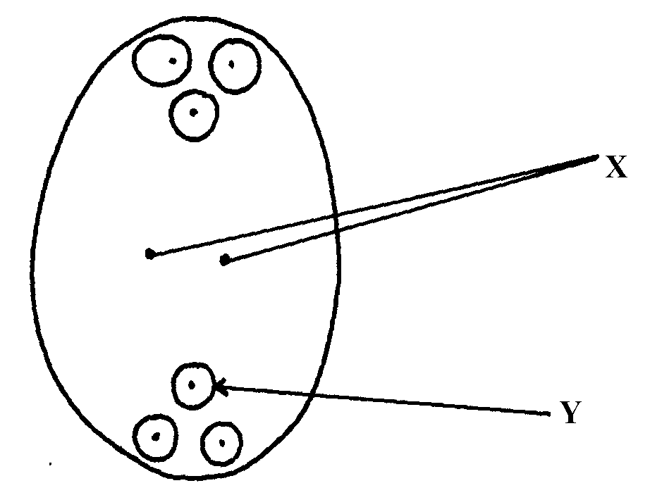 that follow:

(a) Identify structures **X** and **Y**

(b) Why is cross pollination more advantageous to a plant species than self pollination?

7. The diagram below shows a phenomenon which occurs during cell division.

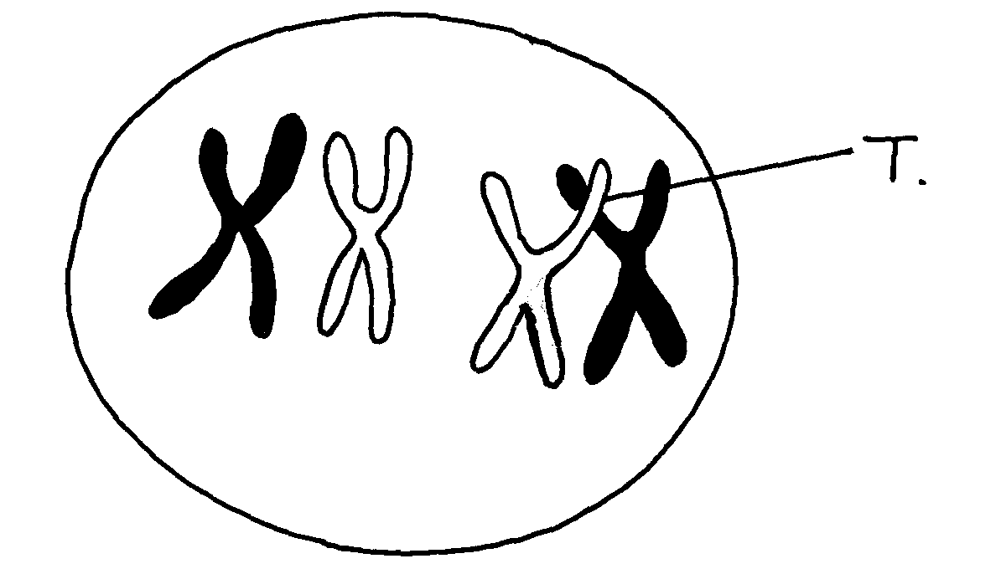

(a) Name the part labeled **T**.

(b) (i) State the biological importance of the part labelled **T**.

(ii) Identify the type of cell division in which this phenomenon occurs.

8. (a) When are the **two** organisms considered to belong to the same species.

(b) Explain the term **alternation of generations.**

9. (a) Explain why Larmack’s Theory of evolution is not accepted by biologists today.

(b) State the significance of mutation in evolution.

10. (a) Give **two** roles of the placenta.

(b) Explain why hormone testosterone still exerts its influence even when vas deferens have

been cut.

11. Name **two** mechanisms that hinder self fertilization in flowering plants

12. State **three** ways in which plants compensate for lack of movement

13. (a) What do you understand by the term double fertilization?

(b) State **two** adaptations of animal dispersed fruits

14. Name the hormone that;

(a) Stimulate the contraction of uterus during birth (b) Stimulates the disintegration of the corpus inteum when fertilization fails to take place

15. State **three** ways in which flowers parent self pollination

16. The diagram below represents a stage in the development of human foetus

(a) State **one** function of each of the structures labelled **A** and **B**

(b) Apart from the size of the foetus what else from the diagram illustrates that birth was going to

occur in the near future

(c) Explain why a pregnant woman is supplied with doses of iron tablets regularly

17. Name the type of placentation where;

(i) Placenta appears as one ridge on the ovary wall

(ii) Placenta appears at the centre of the ovary with ovules on it and the dividing walls of carpels

disappear

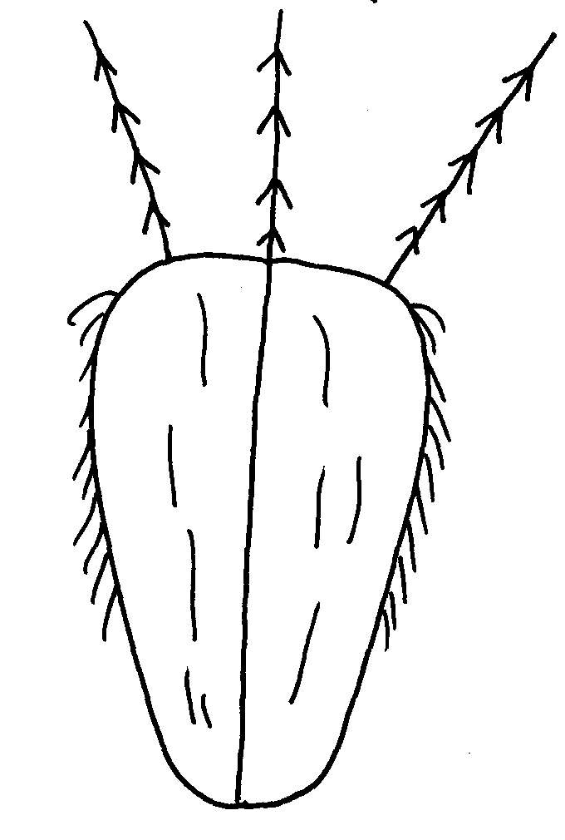18. The diagram below represents a mature fruit from a dicotyledonous plant, observe it and

answer questions that follow

Hook

a) To what group of fruits does the specimen belong?

b) Suggest the possible agent of dispersal of the fruit

19. Explain why menstrual periods stop immediately after conception?

20. a) Why is sexual reproduction important in evolution of plants and animals

b) The calyx cells of a certain plant has 22 chromosomes. State the number of chromosomes

present in the plant’s

i) Endosperm

ii) Ovule cell

21. The diagram below shows a pollen – tube entering the ovule of a flowering plant

B

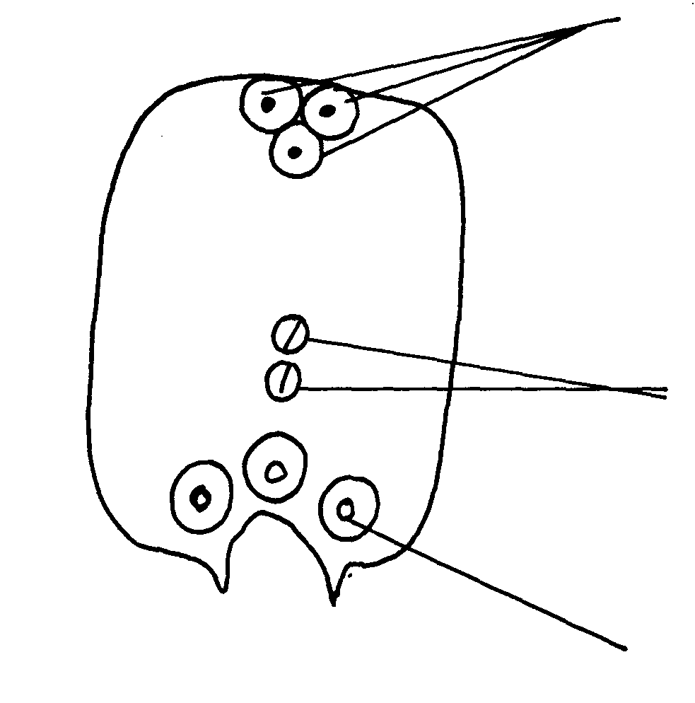

A

D

a) Name the parts labeled **A, B** and **D**

b) Name the kind of fertilization exhibited by the above flowering plant.

22. Donkey and zebra are closely related yet not of the same species. Explain

23. Name **two** factors in the environment which organisms respond to

24. What is meant by the terms:- a) i) Epigynous flower

ii) Staminate flower

b) Name the protective membranes surrounding the brain

25. The diagram below illustrate a process in a given species of organism

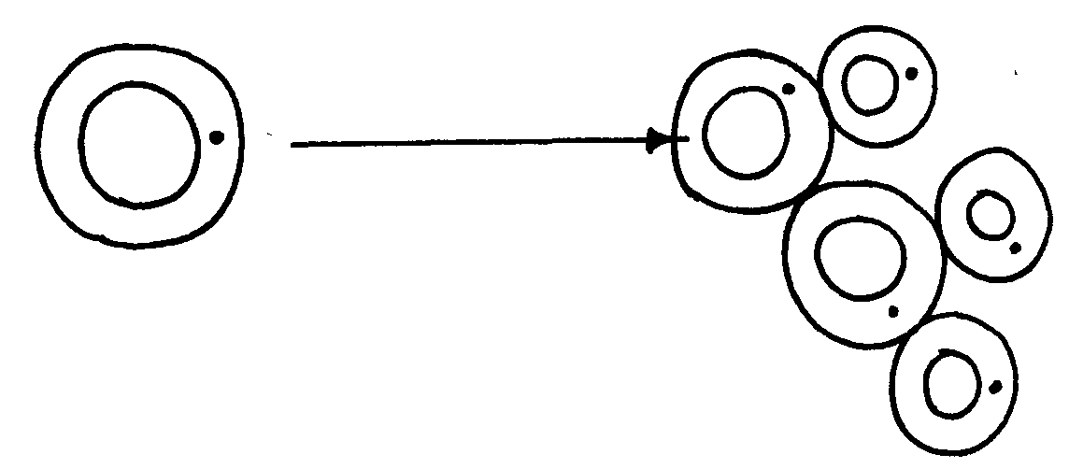

a) Name the organism that undergoes the process above

b) Identify the process shown to be taking place

26. State **two** ways by which HIV/AIDS is transmitted from mother to child

27. (a) State the role of centrioles during cell division

(b) (i) Explain the role of chlorophyll in photosynthesis

(ii) What is the **main** product of the dark stage of photosynthesis?

28. (a) At what stage of meiosis is the chiasmata formed?

(b) (i) What is the significance of the above part in living organisms?

(ii) State **two** importance of meiosis in living organisms?

29. (a) State **two** ways in which the male parts of a wind pollinated flower are adapted to

their mode of pollination

(b) Differentiate between monoecious and dioecious plants

30. (a) What is seed dormancy?

(b) State **two** ways in which seed dormancy can be broken

31. (a) Explain **two** importance of the adult stage in metamorphosis in insects

(b) What is the importance of the juvenile hormone in insects?

32. Describe the possible effects of discharging hot effluent from a factory into a slow flowing river

33. State **two** disadvantages of external fertilization in animals

34. State **three** roles of placenta in mammals

35. (a) The diagram below shows a stage during cell division

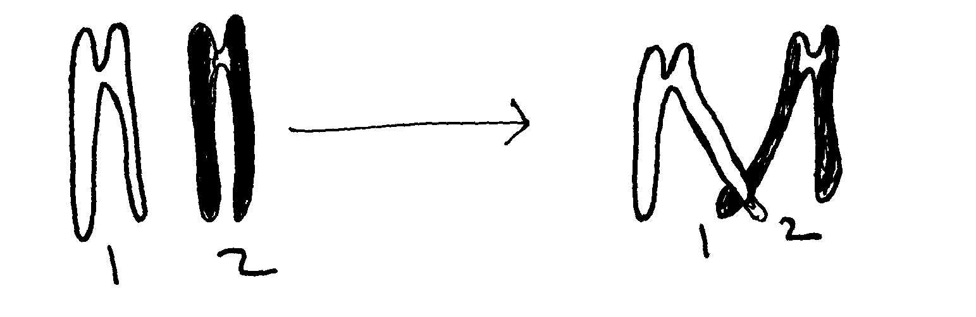

(i) Name the stage of cell division

(ii) Give a reason for your answer

(b) Name **two** structures in plants where male and female gametes are produced

36. State **two** advantages of metamorphosis to the life of insects

37. List **four** differences between Mitosis and Meiosis

38. Give a reason why two species in an ecosystem cannot occupy the same niche

39. State the functions of the following hormones in the menstrual cycle :

(i) oestrogen

(ii) luteinizing hormone (L.H)

(iii) Follicle stimulating hormone (FSH)

40. The diagrams below represent two gynoecia **A** and **B** obtained from two different plants.

(a) What name is given to; Gynoecium **A?**

Gynoecium **B?**

(b) State the observable difference between the gnoecia **A** and **B**

(c) State the role played by Heterostyly in plants.

41. State the difference between the sperm cell and the ovum.

42. (a) Name the parts of the flower in which pollen grains area formed.

(b) Name **two** nuclei found in pollen grains.

43. The diagram below represents a stage in cell division.

(a) Name the stage of all division shown in the diagram above.

(b) Give reasons for your answer.

44. Name the hormone that:

(a) Stimulate the contraction of uterus during birth.

(b) Stimulate the disintegration of corpus luteum when fertilization fails to take place.

45. State t**hree** ways in which seed dormancy benefits a plant

46. (i) State **two** major structural differences between fruit and a seed

(ii) Why is it advisable to use biological control of pests?

47. State the functions of the following parts in the male reproductive system

(a) Somniferous tubules

(b) Sertoli cells

48. (a) Name the parts of a flower responsible for gamete formation

(b) State **one** feature of pollen grains from a wind pollinated flower

49. Name the mechanisms that hinder self-fertilization in flowering plants

50. The eggs of birds are relatively much larger than those of mammals. Explain

51. Distinguish between the following terms:

**Pollination** and **fertilization**

52. a) Describe the various mechanisms of fruit and seed dispersal.

b) Describe the varying events that follow a flower after fertilization.

53. Describe how fruits and seeds are suited to their mode of dispersal

54. The diagram below represents some hormones, their sources and functions in a mammal:

(a) Identify the master gland described above

(b) Name hormones **(ii), (iii), (v)** and (**iv)**

(c) Explain the consequences of deficiencies of hormone **(ii)** in man

(d) Other than stimulating the development of uterine wall, suggest one other function

of hormone **(vi)**

55. The diagram below represents some hormones, their sources and functions in mammals.

a) Name the hormones **I, II** and **III**

b) Name hormones **IV** and state its function

c) Name the control labelled **A & B**

d) Name **one** secondary sexual characteristic common to both males and females

56. (a) State the role of spleen in human defense mechanism

(b) State **two** ways by which the HIV spread may be controlled through patients in hospitals

(c) What do you understand by the word Acquired Immunity Deficiency Syndrome (AIDS)

(d) Why is immunization against diseases encouraged by the government

(e) State how natural active acquired immunity is attained by an individual

57. Explain how seeds and fruits are adapted to the various methods of dispersal

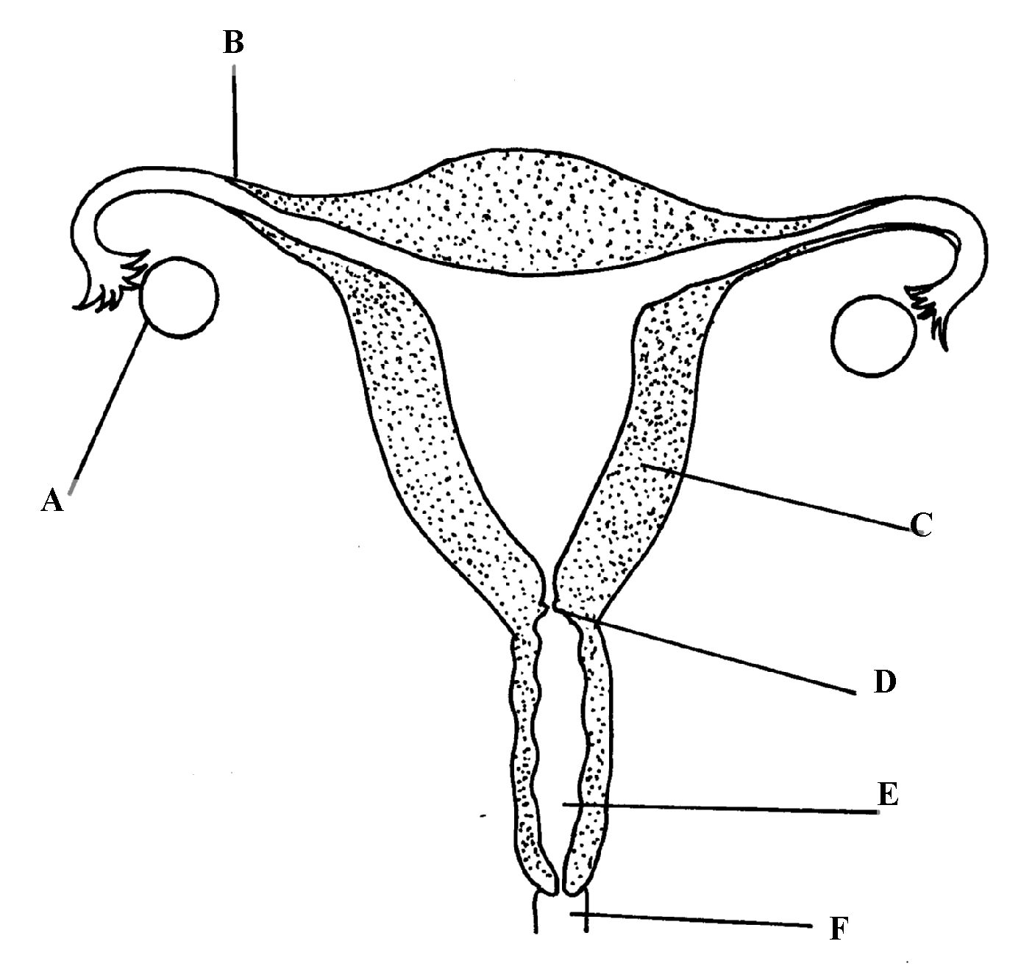58. The diagram below represents female reproductive system;

a) Name the part labeled; A, B, C and D

b) State **two** functions of structure **A**

c) How is part **C** adapted to its function?

d) Of what significance is part **E** to reproduction?

59. The diagram below represents a human foetus in a uterus

(a) Name the part labelled **S**

(b) (i) Name the blood vessels labelled **A** and **B**   
 (ii) State the difference in composition of blood found in vessels **A** and **B**

(c) Name **two** features that enable the structure labelled **P** carry out its function

(d) State the role of the part labelled **R**

60. An experiment was carried out to investigate the rate of growth of pollen tube against time.

The results are shown in the table below:

|  |  |
| --- | --- |
| **Time in minutes** | **Growth of pollen tube in millimeters** |
| 0 | 0 |
| 30 | 4.0 |
| 60 | 9.8 |
| 90 | 15.2 |
| 120 | 20.0 |
| 150 | 21.6 |
| 180 | 22.4 |

(a) (i) On the grid provided draw a graph of the pollen tube growth against time.

(b) (i) At what intervals was the growth of the pollen tube measured?

(ii) What was the length of pollen tube at; 130 minutes

(iii) At what time was the length of the pollen tube 18mm?

(iv) With reasons, describe the growth pattern of the pollen tube between:

* + - * 0 to 120minutes
      * Reason
      * 120 to 180 minutes
      * Reason

(v) State the importance of the growth of pollen tube to the plant

(c) State the changes that take place in a flower after fertilization

**11. Growth and development in (a) plants (b) animals**

1. a) Name the hormone which controls moulting in insects.

b) State the importance of moultng in insects.

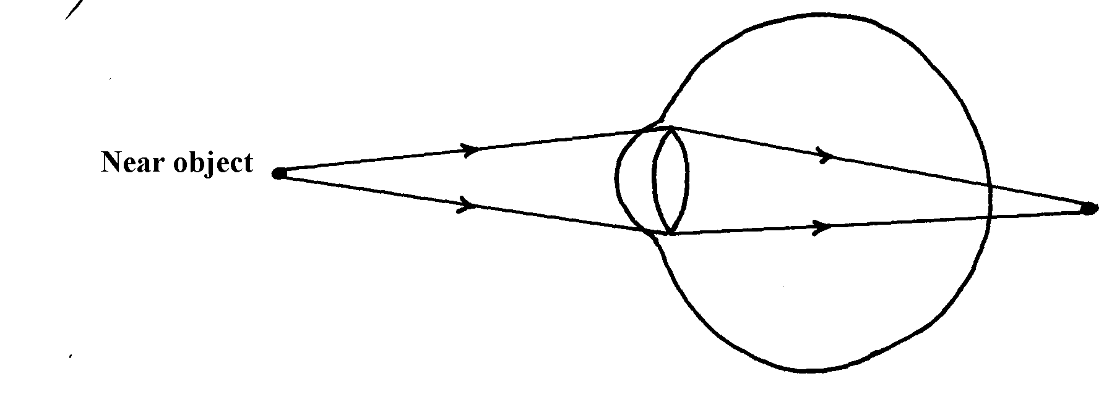2. The illustration below represents an eye defect

a) Name the eye defect .

b) Name the lenses that can be used to correct the defect.

3. (a) State **two** functions of the kidney

(b) Name **two** substances that are not found in urine of a healthy person

(c) Name **two** diseases that affect the kidney

4. The diagram below represents a growth pattern of arthropods.

Time (days)

(a) Name the type of growth pattern represented on the graph.

(b)Identify the process represented by **X**.

(c) Which hormone is responsible for process at **X** in 15 (b) above?

5. Distinguish between natural and acquired immunity.

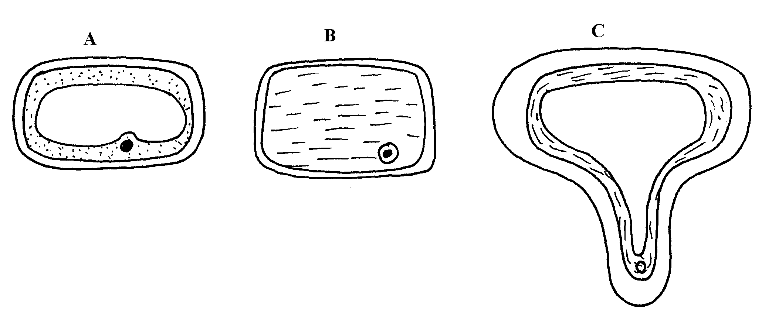6. The cells shown below were obtained from different parts of a young root tip:

Give the name of the zone from which each cell was obtained A, B and C

7. Differentiate between continuous and discontinuous variations

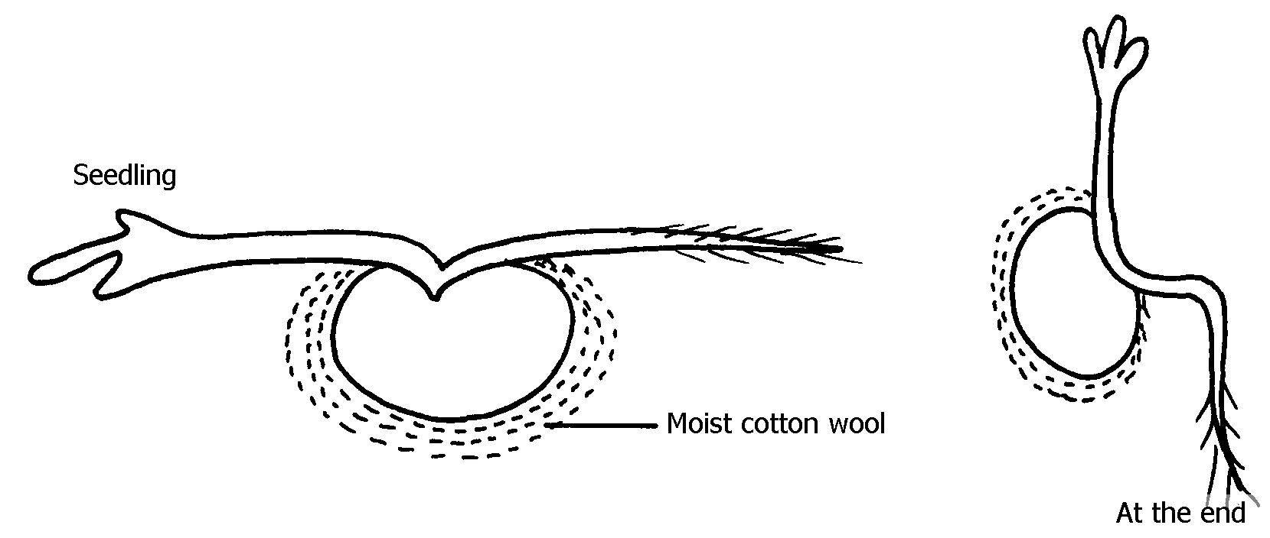8. An experiment was set-up as shown in the diagram below:-

(a) Suggest the possible aim of this experiment

(b) Account for the observation at the end of the experiment

9. State the location of **each** of the following plant meristematic tissues:-

(i) Vascular cambium

(ii) Intercalary meristem

10. Define the following terms: a) Growth

b) Development

11. State **two** advantages of metamorphosis in the life insects

12. State **one** disadvantage of exoskeleton in insects.

13. Distinguish between primary growth and secondary growth in a flowering plant

14. What is the role of the following to a germinating seed: (i) Oxygen

(ii) Cotyledons

15. Give **three** applications of plant growth hormones in agriculture

16. State **two** functions of calcium in the human body

17. State the biological importance of ecdysis in arthropods

18. The diagram below represents a stage during the process of germination.

(a) (i) Name the type of germination illustrated in the diagram

(ii) Give a reason for your answer in **(a) (i)** above.

(b) Give **two** functions of the part labelled **X**

19. In an experiment young potted seedlings were placed in a dark box with unilateral light source

as shown below:

(a) What was the aim of the experiment?

(b) State the observations made on the seedlings after 3 days

20. The graph below represents the growth of animals in a certain phylum.

(a) Name the type of growth pattern shown on the graph.

(b) Identify the process represents by **x.**

(c) Name the hormone responsible for the process in B above.

21. (a) State the role of the vascular cambium in plant growth and development.

(b) Explain why monocotyledons plants do not undergo secondary thickening.

22. Explain how placenta is adapted to its functions

23. State the role of the following during germination:

(a) oxygen

(b) enzyme

24. Name the type of responses exhibited by:-

(a) (i) Marine crabs burrowing into the sand to avoid dilution of their body fluids

(ii) Chlamy domonas plant moving towards a region of high light intensity

(b) (i)What type of neuron is drawn above?

(ii) Using an arrow, show the direction of the nerve impulse

(iii) Name the part labelled **X**

(iv) State the function of part labelled **Y** . (c) Give **two** differences between reflex action and conditioned reflex action

25. The experiment set – up below was designed to investigate an aspect of germination.

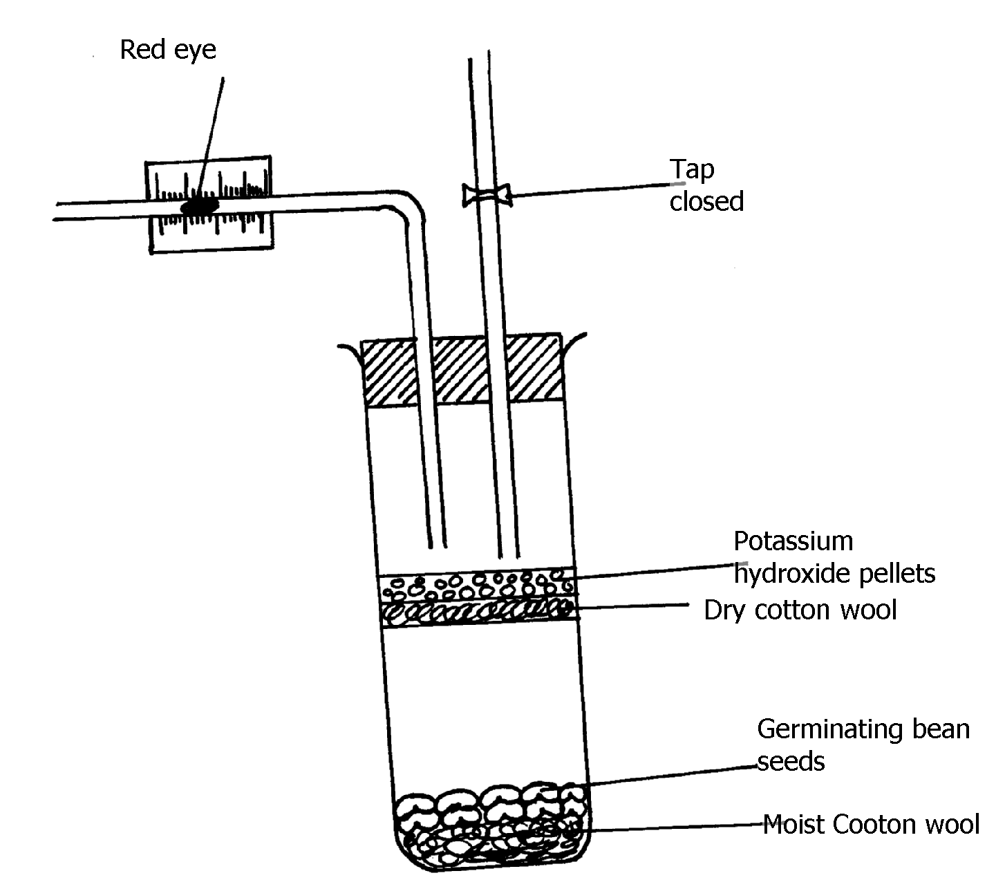

a) Why was potassium hydroxide pellets used in this experiment?

b) What was the role of moist cotton wool in this experiment?

c) i) By means of an arrow, indicate on the diagram the direction in which red dye would move

during the experiment.

ii) Give reason for your answer in c(i) above.

d) Other than the factor investigated above, state any other **one** factor necessary for germination

process.

26. The following data represents the development in dry mass of germinating seedlings within 18

weeks:

|  |  |  |  |  |  |  |  |  |  |  |
| --- | --- | --- | --- | --- | --- | --- | --- | --- | --- | --- |
| Time in weeks | 0 | 1 | 2 | 4 | 6 | 10 | 13 | 15 | 16 | 18 |
| Dry mass in grammes | 0.1 | 2 | 3.2 | 10 | 18 | 32 | 44 | 45 | 44 | 38 |

(a) Using suitable scales plot a graph of dry mass against time

(b) Write reference to the graph, explain the changes in dry mass between:-

(i) Week 0 to 2

(ii) Week 5 to 13

(iii) Week 16 - 18

(c) (i) What is the significance of time zero?

(ii) What difference would be expected from the above results if the experiment started with

the seeds? Give a reason for your answer

(d) (i) Describe how you carry out the experiment to obtain dry mass in the respective weeks

(ii) State **one** advantage of using dry mass instead of fresh weight in estimating growth of an

organism

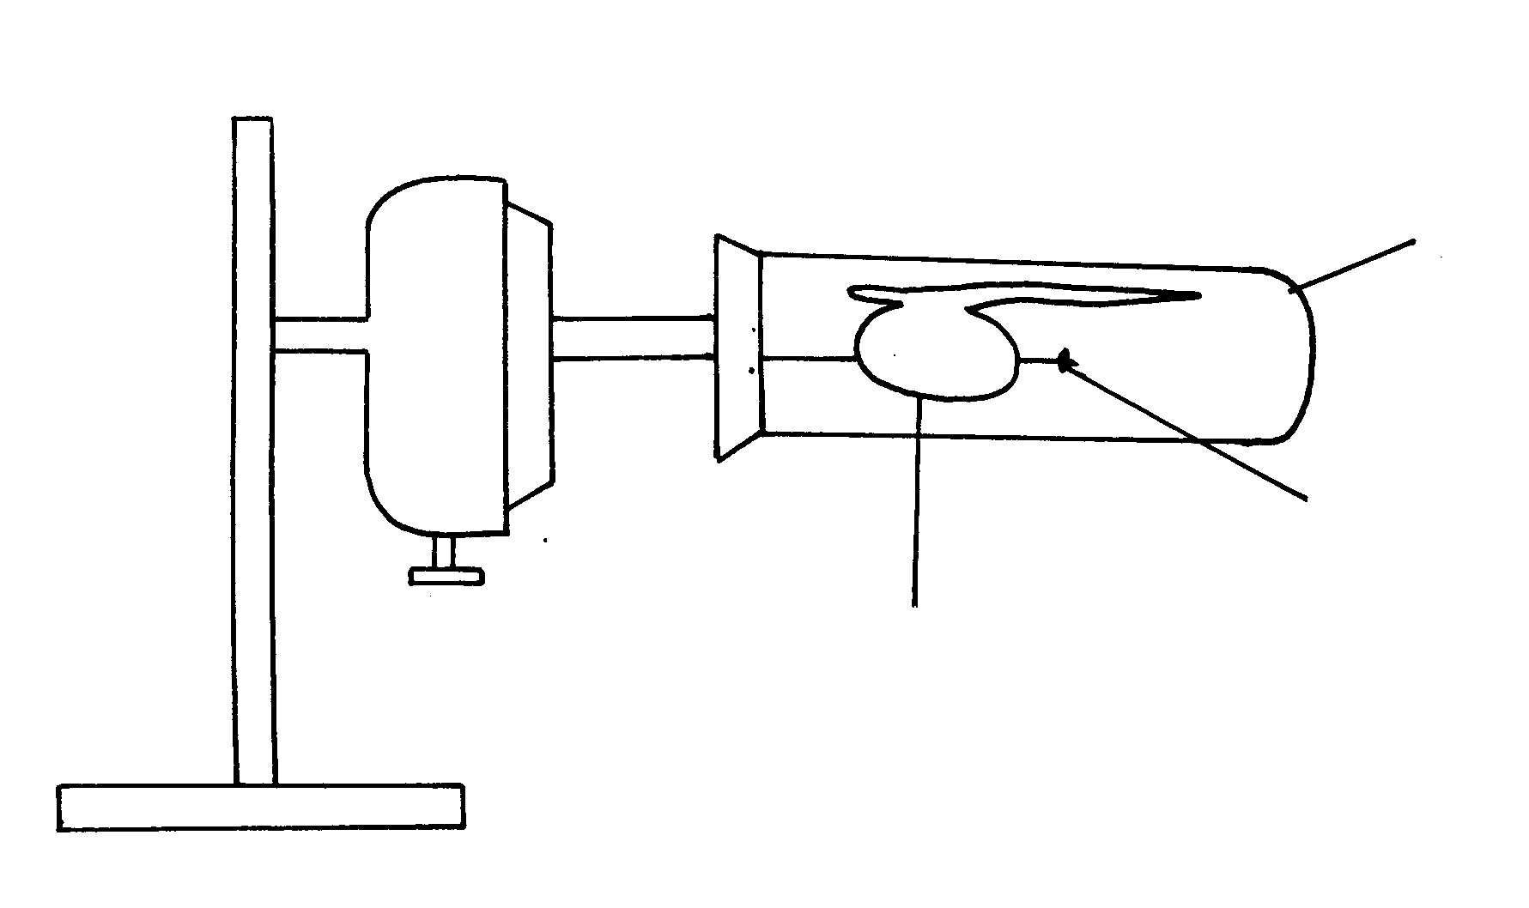27. The diagram below represents a set-up that was used to investigate the effect of rotation on the

growth of a bean radicle. The set-up allowed the seedling to rotate slowly and continuously for

seven days

(a) Name the piece of apparatus illustrated

(b) (i) State the observation made on the shape of the radicle after seven days

(ii) Explain the observation in **(b) (i)** above

(c) Suggest a suitable control for this experiment

(d) Give any **four** importance of tropism in plants

28. An experiment was carried out to determine the growth rates of variety of bamboo and a variety of maize in two adjacent plots. The average height and average dry weight of plants from the two

populations were determined over a period of twenty weeks. The data is as shown below:-

a) On the same axes, plot a graph to show the changes in average weight of the bamboo and maize

plants over time

(b) (i) Which of the two plants had a higher productivity by the end of the experiment?

(ii) Give a reason for your answer in **(b)(i)** above

(c) Explain the following:

(i) Between weeks 14 and 18 the average height of maize plants remained constant while the

average dry weight increased

(ii) Dry weight was used instead of fresh weight in this experiment

(iii) Describe how the average height and average dry weight of plants were determined in

this experiment;

(d) Why was it appropriate in this experiment to use both weight and height?

(e) Give a reason why secondary thickening does not occur in bamboo and maize plants

29. (a) What is meant by the term **fertilization** ?

(b) (i) Name the type of cell division that produces gametes

(ii) Where does the type of cell division mentioned above occur in mammals?

(c) What happens to the wall of the uterus;

(i) before the release of an egg ?

(ii) if no fertilization occurs?

(b) How is the placenta adapted to its functions?

30. The relationship between seed fresh mass in the lupin *lupinus* and percentage seed germination,

percentage seedling survival and seedling fresh mass is shown in the table;

|  |  |  |  |
| --- | --- | --- | --- |
| **Seed fresh**  **Mass mg-1** | **Percentage**  **germination** | **Percentage of seedlings surviving 2 leaf stage** | **Mean seedling fresh mass 5 weeks after germination/mg** |
| Below 16  17-25  26-35  36-45  Above 45 | 41.9  90.2  95.6  97.5  100.0 | 84.6  96.8  98.8  100.0  100.0 | 24.3  44.2  60.7  86.4  106.4 |

a) How was percentage germination in column two of the table calculated?

b) Why was seed fresh mass preferred to seed dry mass to take measurements of the seed weight

in the experiment

c) i) Explain why the measurements of mean seedling fresh mass (5) weeks after germinated

may not have been an accurate measurement of growth that had occurred

ii) How could more meaningful and accurate measurement been obtained in **c(i)** above?

d) With reference to the figures in the taste indicate the relationship between seed fresh mass

and percentage seed germination, percentage seedling survival and seedling fresh mass

e) Suggest an explanation why seedling produced from large seeds grow more rapidly than the

seedling produced from small seeds

31. The diagram below illustrate enzyme controlled reaction

a) State the relationship between rate of reaction and enzyme concentration

b) Account for the rate of reactions between; i) **Q** and **R**

ii) **R** and **S**

iii) **U** and **V**

c) Name **one** other factor that affects enzyme action, not illustrated above

32. Carefully study the figure below and answer the questions that follow:-

The seedling with straight radicle and plumule was attached to a machine horizontally as shown

above. The machine rotates making one revolution in 15minutes.

(a) Draw how the seedling would look like after one week

(b) Explain your drawing in **(a)** above

(c) Name the machine used in the experiment above

(d) What would happen if the seedling was put horizontally outside the machine

(e) Name the stimuli investigated and type(s) of response expected in the experiment

33. (a) Give the form in which each of the following substances ate transport in mammalian blood:

(i) Carbon (IV) oxide

(ii) Oxygen

(b) Give **two** functions of pleural membrane

(c) Explain why formation of carboxyhaemoglobin in the blood of a mammal results in death

(d) Other than stomata, name **two** other gaseous exchange surfaces in plants

34. In an experiment the radicle of a seedling was marked equidistant using Indian ink as shown

in the diagram below:

(a) What was the aim of the experiment?

(b) On the diagram below mark on the radicle to show the appearance of the marks after 3days

(c ) State **three** characteristics of cells found just behind the root cap of a radicle

(d) Give **two** factors inside a seed that causes seed dormancy

**12. Genetics**

1. A woman with blood group **A** gave birth to twins both having blood group **AB**.

Determine the genotype of:

a) Father

b) Mother

2. 50 black mice and 50 white mice were released into an area inhabited by a pair of owls. After four

months, the mice in the area were recaptured and only 38 of the black mice and 9 of the white

mice were remaining.

a) How would this observation be explained ?

b) Name the theory of evolution that supports the results in **(a)** above.

3. State **three** mechanisms that prevent self pollination in a flower that has both male and female

Parts.

4. (a) Distinguish between complete and incomplete dominance

(b) State **two** sources of variation

5. Part of one strand of a DNA molecule was found to have the following base sequence.

G – T – C – A – G – T

(a) What is the sequence on m-RNA strand copied from this DNA portion?

(b) State **two** roles of DNA molecule.

6. State **three** ways by which plants compensate for lack of ability to move from one place to

another.

7. A student mixed a sample of urine from a person with Benedict’s solution and heated, the colour

changed to orange.

(a) What was present in the urine sample?

(b) What did the student conclude on the health status of the person?

(c) Which organ in the person may not be functioning properly?

8. Differentiate between continuous and discontinuous variations

9. Members of the same species of organism tend to differ due to variation. State **three** causes of

variation in organisms

10. Identify the type of gene mutations represented by the following pairs of words:-

(i) Shirt instead of skirt

(ii) Hopping instead of shopping

(iii) Eat instead of tea

11. A DNA stand has the following base sequence: GCCTAGATCAC  
 What is the sequence of the : (i) Complementary DNA strand?

(ii) M-RNA strand coped form this DNA strand

12. The figure below represents the distribution of height of pupils in a school

(a) Name the type of variation represented by the curve

(b) Outline **two** possible causes of variation in height of individuals in man

13. a) Wekesa and Wanjiku who are siblings are both normal as their parents but have a hemophilic

brother. Give the Genotype of their parents.

b) i)What are linked genes?

ii) What do you understand by the phase a test cross?

14. There are at least 205 known sex – linked recessive disorder

a) Name **any two** of them.

b) State a reason why sex – linked recessive why traits tend to effect the male child.

c) State why if a mother has the trait all her sons will have it

15. The table below is a representation of a chromatide with genes along its length. It undergoes

mutation to appear as shown below:

|  |  |  |  |  |  |  |
| --- | --- | --- | --- | --- | --- | --- |
| Before mutation | L | M | N | O | P | Q |
| After mutation | L | O | N | M | P | Q |

a) Name the type of chromosomal mutation represented

b) Name **one** mutagenic agent

16. The figure below is a structural diagram of a portion from a nucleic acid strand

a) Giving a reason, name the nucleic acid to which the portion belongs

b) Write down the sequence of bases of a complementary DNA strand

17. In an experiment, plants with red flowers was crossed with plants with white flowers.

All the plants in the **F1** generation had pink flowers.

a) Give a reason for the appearance of pink flowers in the **F1** generation

b) If plants in **F1** were selfed, state the phenotypic ratio of the **F2** generation

c) Explain; i) Why women should drink extra milk during pregnancy

ii) A pregnant women might want to urinate more often in late pregnancy

18. State the meaning of the following terms giving an example in each case:

(a) Sex-linked genes

(b) Multiple alleles

19. In a certain breeding experiment, a plant species with red flowers was selfed. It produced **119**

**red** flowered and **41 white** flowered offsprings.

(a) Using letter **R** to represent allele for the red flowers, state the genotype of the red flowered

parent plant

(b) Determine the phenotypic ratio of red and white flowered plants. Show your working

20. Give an example of a sex-linked trait in human on: (i) **Y** – Chromosome

(ii) **X** – Chromosome

21. Explain why growth of long hair on the pinnae of the ears in human occurs in males only

22. Explain why **prophase 1** of meiosis contributes towards genetic variation in living

organisms.

23. A pure Red flowered plant was crossed with a pure white flowered plant. All the F1 generation

plants had pink flowers.

(a) Give an explanation for the absence of Red and white flowered plants in the F1 generation. (b) If the F1 generation pea plants were selfed, state the phenotypic ratio of the F2 generation

plants.

24. (a) Name a genetic disorder due to gene mutation that affects the malpighian layer of the

skin in man.

(b) Give **two** functions of the fluid produced by sebaceous glands.

25. (a) Define the term “Gene mutation.”

(b) Name the genetic disorders that result from gene mutation in human beings.

26. (i) What are mutations

(ii) Name **two** mutagens

27. A section of a DNA strand contains the following sequence CGGATAC

(a) Write the; (i) Complementary DNA strand

(ii) MRNA strand

(b) Name the site for protein synthesis in a cell

28. In a certain bird species, red flight feathers is controlled by gene **R** while white flight feathers is

controlled by gene **r**. The heterozygous condition **Rr** results into pink flight feathers. The two

genes are also sex linked and transmitted on x-chromosome.

a) By use of fusion lines, find the genotypes of across between a male with pink flight

feathers and a female with white flight feathers

b) Which type of dominance is illustrated here?

c) i)Identify the nucleic acid whose base sequence is shown below:

G-A-C-U-A-G-A-C-G

ii) Give a reason for your answer in **c (i)** above

iii) If the nucleic acid was involved in protein synthesis, how many amino acids would be

present in the protein synthesized? Give a reason

29. Study the genetic chart below showing the inheritance of the gene responsible for haemophilia

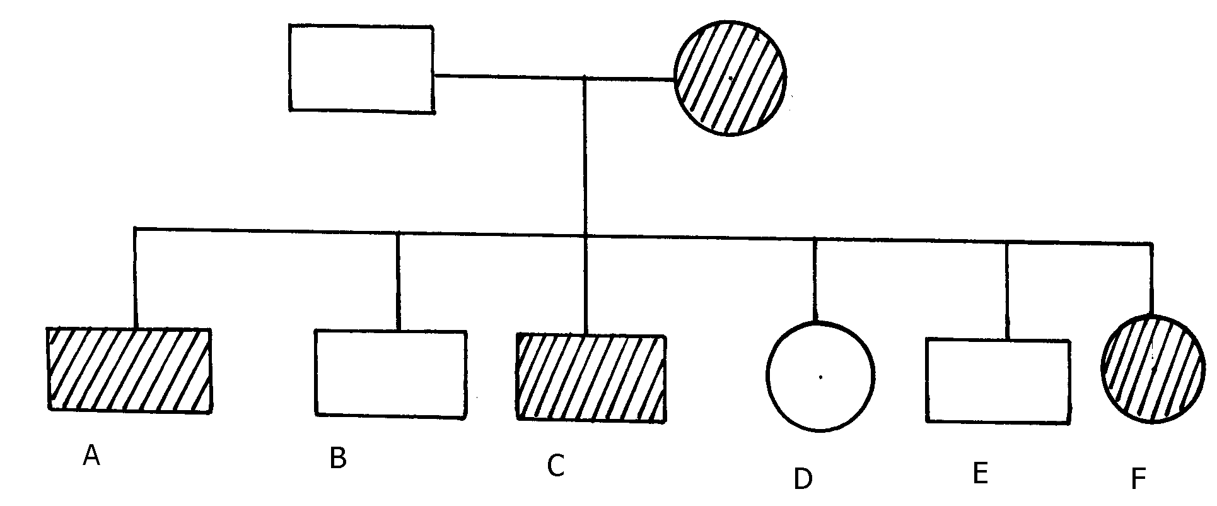in a family.

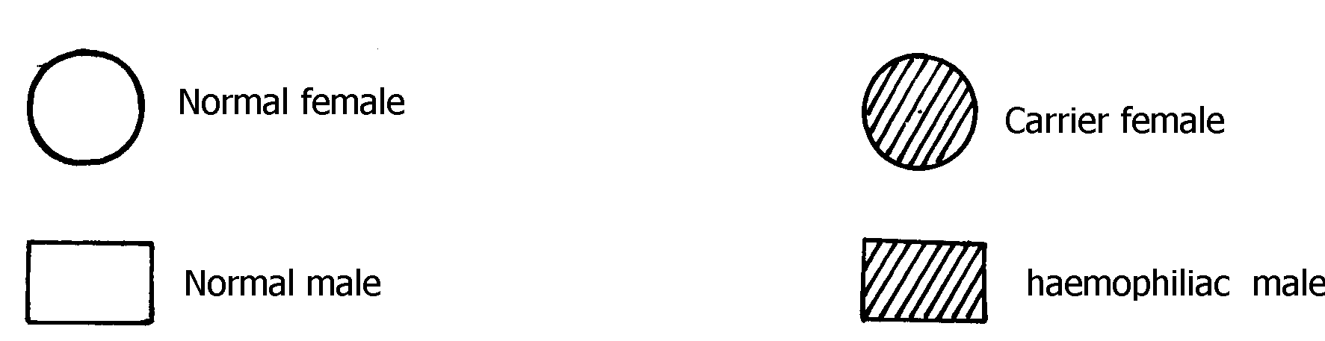

a) Write the genotype of individuals A, B, F

b) A member of this family labelled **F** marries a haemophiliac male. What will be the phenotypic

ratio of the offspring? Show your workings

c) Other than the condition stated above, state any other **two** common genetic disorders that

result from gene mutation.

30. Haemophilia is due to a recessive gene. The gene is sex-linked and located on **X** chromosome.

The chart below represents the offspring of parents who are phenotypically normal for

haemophillia

(i) What are the parental genotypes?

Explain your answer in **(i)** above

(ii) Work out the genotypes of the offspring

31. A cross between a red-flowered and a white flowered plant produced only pink –flowered

F1 plants

(a) There was neither a red nor white –flowered F1 plants. Explain

(b) The F1 offspring were selfed to get F2 generation. Using appropriate letter symbols, work

out the genotypes of F2 generation

(c) Give the genotypic and phenotypic ratios of F2 generation

(d) Distinguish between dominant and recessive genes

32. A true-breeding purple maize variety was cross-pollinated with a true-breeding yellow

maize variety.

The offspring produced all purple fruits.

The plants grown from these F1 grains were interbred among each other.

A typical cob of F2 generation is shown below:

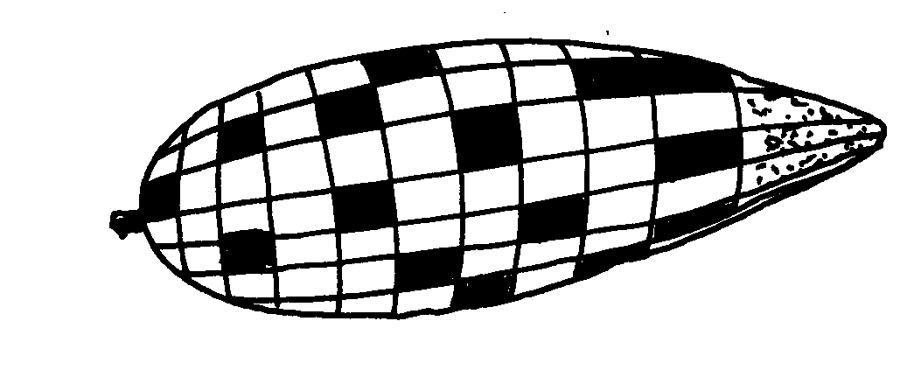 The yellow fruits are shaded while the purple ones are un-shaded.

(a) (i) In terms of flowers only, state why it is easier to work out genetic crossings using maize

(ii) Count separately the yellow and purple grains and therefore find the rations of purple

grains to yellow grains

(b) Using appropriate symbol, work out a genetic cross for F2 generation

(c) From the above information, give the dominant gene

(d) State **two** practical applications of genetics in identity determination

33. The figure below is a pedigree chart showing incidence of albinism which is transmitted through a

recessive gene-a. Study and answer questions that follow;

(a) Write down the genotype of persons 1 and 2. Give a reason for your answer

(b) Giving your reason state the most likely genotype of person 3

(c) The cross between person **15** and **16** represents mating between first cousins. Comment

why it is not advisable for close relatives to marry

(d) Apart from albinism name **two** other effects of gene mutation

34. The table below shows results of test to determine blood groups of persons **Y** and **Z**.A tick (**√**)

Represents, agglutination while a cross (**x**) represents no agglutination;

|  |  |  |  |  |
| --- | --- | --- | --- | --- |
| **Person** | **Test with**  **antibody (a)** | **Test with**  **antibody (b)** | **Test with**  **Rhesus antibody** | **Blood group** |
| **Y- (male)** | √ | X | √ |  |
| **X- (female**) | X | √ | X |  |

(a) Fill the blank space in table to show the blood group of the persons **Y** and **Z**

(b) In order to investigate the inheritance of Rhesus factor, work out a cross between a male

with Rh**+**and female with Rh**-** .Let **D** represent the presence of Rhesus factor and **d** to

represent the absence of the Rhesus factor

(c) Determine the genotype of the cross in **(b)** above.

(d)Which of the children can donate blood to their mother?

35. Describe the behavioural adaptations of animals to temperature

36. In man blood group inheritance is controlled by multiple alleles in which allele **A** is co dominant

to allele **B**. a woman laterozygous for blood group **A**  married a man heterozygous for blood

group **B**

a) State the genotype of both parents

b) Using a pun net square, show the genotypes of F1 generation

c) State **one** application of knowledge of blood group inheritance in man

d) The nitrogenous bases in nucleic acids are Adenine (A), cytosine(C), Guanine (G),

Thiamine (T) and uracil (U). Input of a molecule of DNA the sequence of bases is CTT.

Using the letters **A, C, G, T, U** where appropriate, write down the base sequence in;

i) Corresponding part of the complementary strand of DNA molecules

ii) Corresponding part in mRNA

iii) A change in the DNA molecules caused the base sequence in the triplets to change from

CTT to CAT. State **one** factor which could have caused the change

37. In an investigation plants with red flowers were crossed with plants with white flowers. All the

plants in the F1 generation had pink flowers when the F1 plants were crossed, he counted 480

plants in F2 generation

(a) Using appropriate letter symbols, work out the cross between the F1 plants to get the F2

generation

(b) Give the phenotypic and genotypic ratios for the F2 generation

Phenotypic ratio

Genotypic ratio

(c) How many plants in the F2 generation had pink flowers? (show your work)

38. In an experiment, a black mouse was mated with a brown mouse. All the off springs in F1

generation were black. The off springs grew and were allowed to mate with one another. The total

number of F2 generation offspring were 96.

(a) Using letter **B** to denote the gene for black colour. Work out the genotype of the F1 generation.

(Use a punnet square)

(b) State the following for the F2 generation

(i) Genotypic ratio

(ii) Phenotypic ratio

(iii) The total number of brown mice

39. (a) Distinguish between Homologous structures and analogous structures. Give an example

in each case.

Homologous structures

Example

Analogous structures

Example

(b) Explain why parasites develop resistance to certain drugs after a long time of exposure.

(c) (i) What is non— disjunction?

(ii) Give **one** example of a genetic disorder associated with non-disjunction .

**13. Evolution**

1. a) Distinguish between homologous and analogous structures in evolution. b) Name **one** vestigial structure in mammals.

2. a) Give **two** examples of adaptive radiation in animals.

b) State **two** disadvantages of using fossils as evidence of evolution

3. Distinguish between camouflage and mimicry.

4. State the role of light in photosynthesis

5. (a) Name the region of the **gut** where digestion of cellulose takes place.

(b) State role of **cardiac sphincter** in the stomach.

6. (a) Give **two** limitations of fossil records as evidence of evolution

(b) State any **two** similarities in structure between **Homo erectus** and **Homo** **Sapiens**

7. (a) (i) What is meant by vestigial structures?

(ii) Give an example of a vestigial structure in human

8. Distinguish between the struggle for existence and survival for the fittest as used in the theory of

natural selection

9. Give **two** factors that determine water reabsorption in the distal convulated tubule

10. Distinguish divergent and convergent evolution

11. (a) What are the advantages of natural selection

(b) All insects are believed to have arisen from a common ancestor. However, modern insects

differ widely in a variety of ways such as in the adaptation of their mouthparts for different

modes of feeding. What kind of evolution is this?

12. Explain why Lamacks theory of evolution is not accepted by Biologists today.

13. a) i) What is meant by vestigal structures

ii) Give an example of vestigal structure in human

b) Explain why certain drugs become ineffective in curing a disease after many years of use

14. (a) What is organic evolution?

(b) Briefly explain the term “***survival for the fittest***” as used in Darwin’s theory of natural

selection

15. Explain why insecticides become ineffective against insects if used for several years in succession

16. State **three** limitations of fossils records as an evidence of organic evolution

17. State **three** pieces of evidence that support the theory of organic evolution

18. What is meant by natural selection?

19. (a) Explain why Lamarcks theory of evolution is not accepted today

(b) State **two** limitations of fossils records as evidence of organic evolution

20. In a breeding experiment, plants with red flowers were crossed. They produced 123 plants with red flowers and 41 with white flowers:

(a) Identify the recessive trait

(b) Give a reason for your answer

(c) If white flowered plants were selfed, what would be the genotype of their offspring?

Show your working using appropriate symbols **(R, r**)

(d) What is a test cross?

21. a) What is organic evolution?

b) Describe the various evidences which support the theory of organic evolution.

22. (a) What is meant by the term natural selection

(b) Describe how natural selection brings about the adaptations of a species to its environment

(c) Distinguish between convergent and divergent evolution

(d) Discuss **four** evidences to show that evolution has taken place

23. Explain the various evidence for organic evolution

24. (a) What is organic evolution

(b) Explain why resistance to antibiotics is considered as an example of evolution

(c) List and explain various evidences of organic evolution

25. Pure breed red flowered plants were cross pollinated with pure breed white flowered plants.

The resulting Fl offspring’s had pink flowers.

(a) Using letter **R** to represent the gene for red colour and letter W to represent gene for white

colour of flowers. Work out the genotype of the **F1** generation

(b) If seeds from the **Fl** generation plants were planted and allowed to self pollinate. Work out

the phenotypic ratio of the **F2** generation

**14. Irritability and sensitivity in (a) plants (b) animals**

1. Give **two** functions of the exoskeleton in arthropods.

2. When shoots of young plants are exposed to unidirectional light they bend towards light;

a) Name the type of response exhibited by the young shoots

b) Explain the cause of the observation above

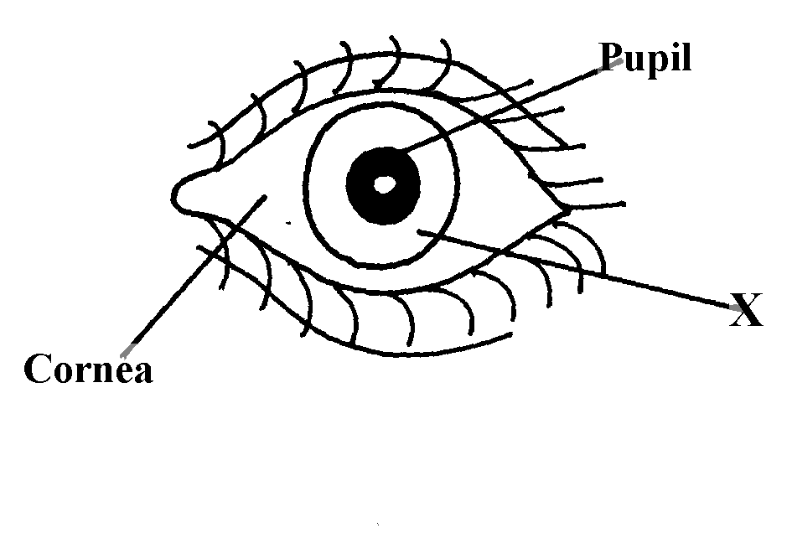3. Study the drawing below and use it to answer the questions that follow :-

a) Name the part labeled **X.**

b) Describe the changes that occur in the structure **X** in dim light.

c) What is meant by the term **accommodation** with reference to the eye?

4. (a) State **two** differences between taxes and tropisms

(b) Give **two** survival values of tactic movements to organisms

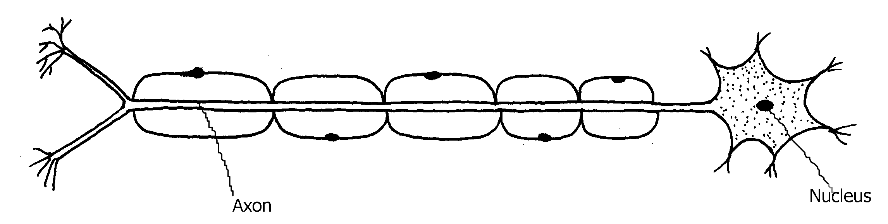5. The diagram below represents a type of neurone.

(a) (i) identify the neuron above.

(ii) Give a reason for your answer in a (i) above.

(b) With an arrow, indicate on the diagram the direction of an impulse through the neurone.

(c) Name the chemical substance that brings about transmission of impulse across a synapse

6. A student was traveling from Nairobi to Mombasa. As the bus descended down hill he felt an

unpleasant sensation in the ear.

(a) How did the sensation come about? ***\****

(b) How can the unpleasant sensation be relieved?

7. An experiment was carried out to investigate a growth response in maize seedling as shown

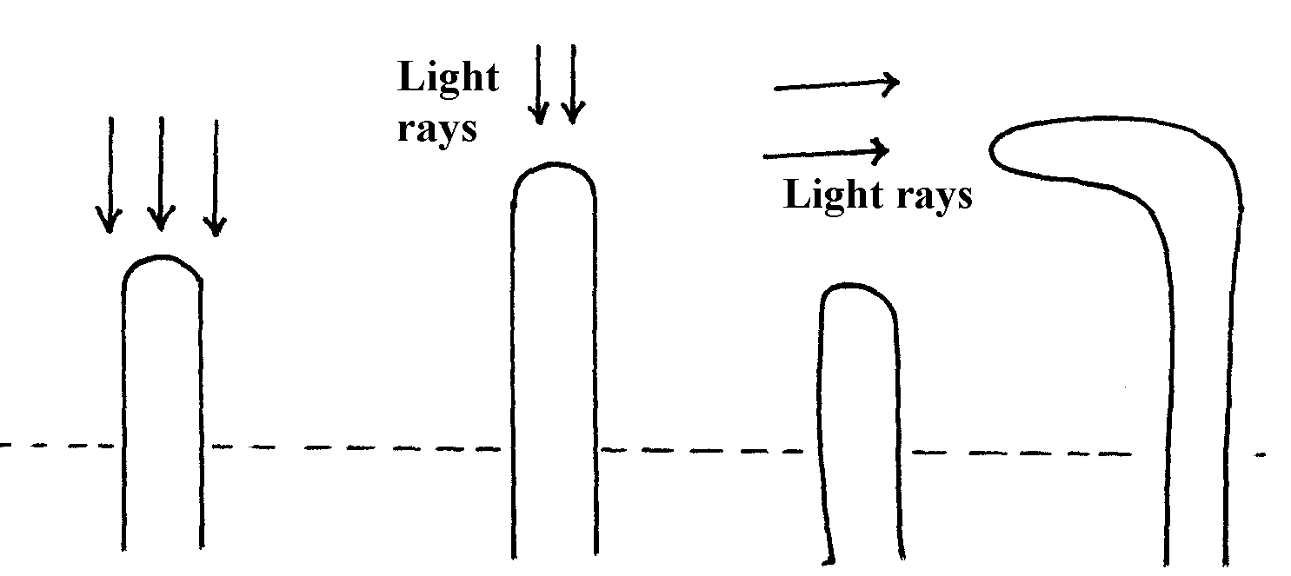 in the diagram below:

(a) State the type of response that is being investigated ...........

(b) Explain the response exhibited by the shoot

8. State **three** genetic disorders caused by gene mutations

9. The diagram below shows the position of an image formed in a defective eye:-

(a) Name the defect

(b)Explain how the defect named in **(a)** above can be corrected

10. (a) State **three** structural differences between arteries and veins in mammals

(b) Name a disease that causes thickening and hardening of arteries

11. (a) Name the part of the eye in which the light sensitive cells are located

(b) List the **two** types of sensory cells found in the part named in (a) above

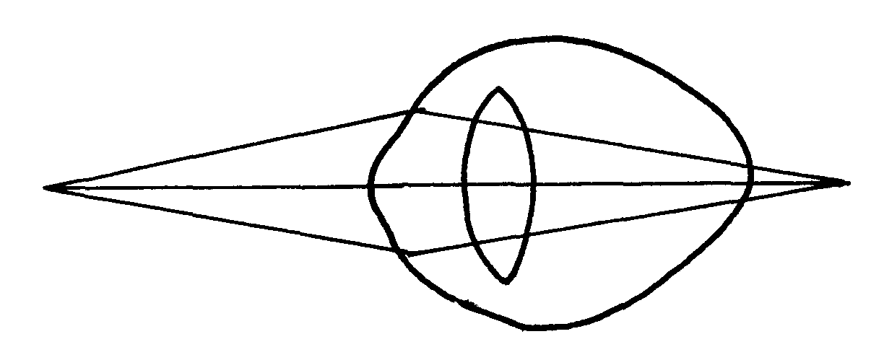12. The diagram below illustrates a certain eye defect

(a) State the defect

(b) On the diagram illustrate how the defect can be corrected

(c) State **one** advantage of having two eyes in human beings

13. Briefly explain the role of the following part of skin

a) Cornified layer

b) Malpighian layer

14. State the functions of the following structures of the mammalian ear

a) Eustachian tube

b) Essicles

15. a) Distinguish between conditioned and simple reflexes

b) State how the nerve cell structure is suited to its function of impulse transmission

16. (a) Name the part of the mammalian eye that:

(i) Transmits impulses to the brain

(ii) Regulates the amount of light entering the eye (b) State the changes that occur in the part of the eye named in **(a) (ii)** above when one moved

from bright light to dim light conditions

16. Name the type of response exhibited by the following:

(a) A pollen tube growing towards the embryo sac

(b) Maggots moving from lit side of a box to the dark side

17. A response exhibited by a certain plant tendril is illustrated below:

(i) Name the type of response

(ii) Explain how the response named in **(i)** above occurs

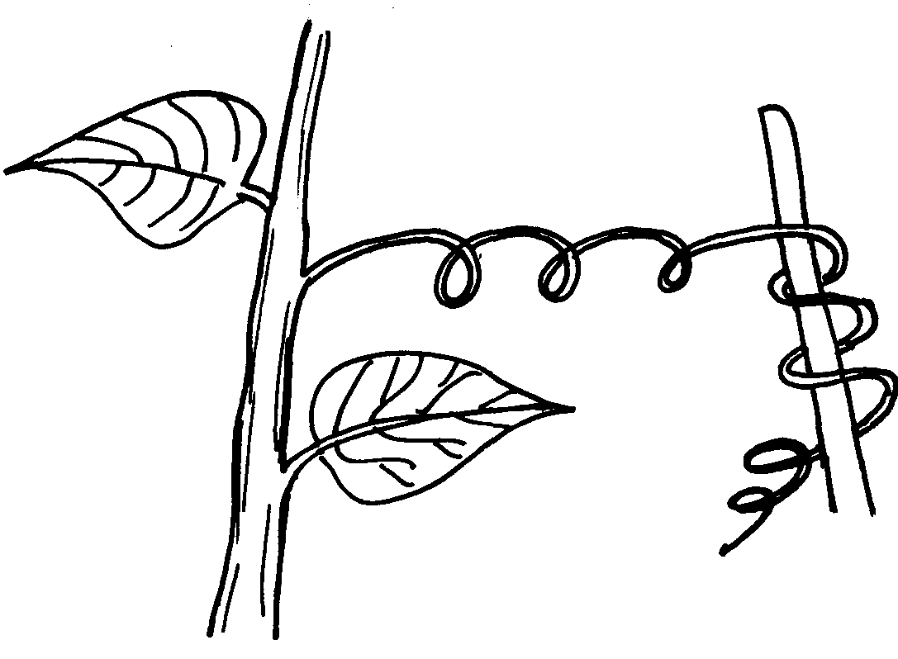18. A response exhibited by a certain plant tendril is illustrated below:-

Name the type of response

19. Removal of the apical bud from a shrub is a practice that results in the development of many

lateral buds which later form branches

(a) Give reasons for the development of lateral branches after the removal of the apical bud

(b) Suggest **one** application of this practice?

20. In an accident a victim suffered brain injury. Consequently he had loss of memory which

part of the brain was damaged?

21. A person was able to read a book clearly at arm’s length but not at normal reading distance (a) State the eye defect the person suffered from

(b) Why was he unable to read the book clearly at normal distance?

(c) How can the defect be corrected?

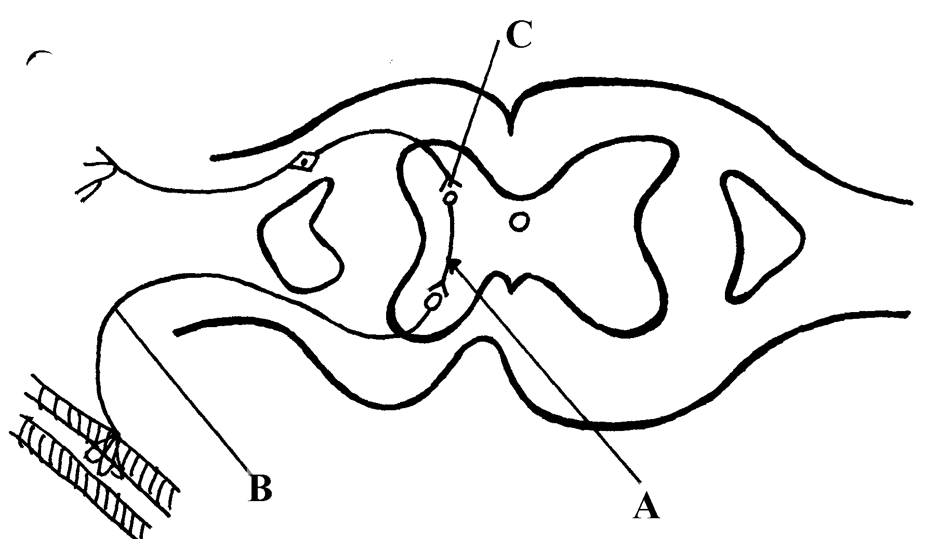22. The diagram below represents a simple reflex arc;

(a) Name the parts labeled **A** and **B**

(b) Explain how an impulse is transmitted across the gap labeled **C**

23. (a) State **two** functions of a mammalian ear

(b) How is the cochlea suited to its function

24. State **one** function of potassium ions in the human body.

25. State **two** functions of vitamin B5 (pantothenic acid).

26. (a) What is the biological importance of tactic responses?

(b) A person had an accident and had problems with his vision, hearing and memory.

Identify the part of the brain that was affected

27. Identify the following responses shown by plants:- (a) Shoots grow towards light

(b) Roots grow towards gravity

(c) Tendril intertwine around an object

28. Name the type of responses exhibited by:-

(a) (i) Marine crabs burrowing into the sand to avoid dilution of their body fluids

(ii) Chlamy domonas plant moving towards a region of high light intensity

(b) (i)What type of neuron is drawn above?

(ii) Using an arrow, show the direction of the nerve impulse

(iii) Name the part labelled **X**

(iv) State the function of part labelled **Y** .

(c) Give **two** differences between reflex action and conditioned reflex action

29. In an experiment to investigate the effect of heat on germination of seeds, 12bags each

Containing 60 pea seeds were placed in a water bath maintained at 85oC .

After every two minutes a bag was removed and seeds contained in it planted. The number that

germinated was recorded. The procedure used for pea seeds was repeated for wattle seeds. The

results were as shown in the table below:-

|  |  |  |
| --- | --- | --- |
|  | **Number of seeds that germinated** | |
| **Time (min)** | **Pea seeds** | **Wattle seed** |
| 0  2  4  6  8  10  12  14  16  18  20  22 | 60  60  48  42  34  10  2  0  0  0  0  0 | 0  0  0  2  28  36  40  44  46  48  49  47 |

(a) Using a suitable scale and same axes, draw graphs of number of seeds that germinated against

time in hot water for each plant

(b) (i) At what time would number of seeds that germinated for each plant be same?

(ii) How many wattle seeds would have germinated if the 13th bag was available and was

removed and seeds contained in it planted at 24minutes?

(c) Explain why the ability of pea seeds that germinated declined with time of exposure to heat

(d) Explain why the ability of the wattle seeds to germinate improved with time of exposure

to heat

(e) Account for the shape of the graph for the wattle seeds which germinated between 20-24

minutes (f) Some of the pea seeds were allowed to germinate and placed in a large air tight flask

and left for four days:-

(i) Suggest the expected changes in the composition of gases in the flask on the fifth day

(ii) Give reasons for your answer **in (f)(i)** above

(g) Name **three** factors other than those investigated in **(a)** above which would affect dormancy

30. How is the mammalian skin adapted to its functions?

31. Explain how the mammalian skin is adapted to it’s functions

32. Explain the structure and functions of the human eye.

33. The diagram below shows the position of an image in a defective eye.

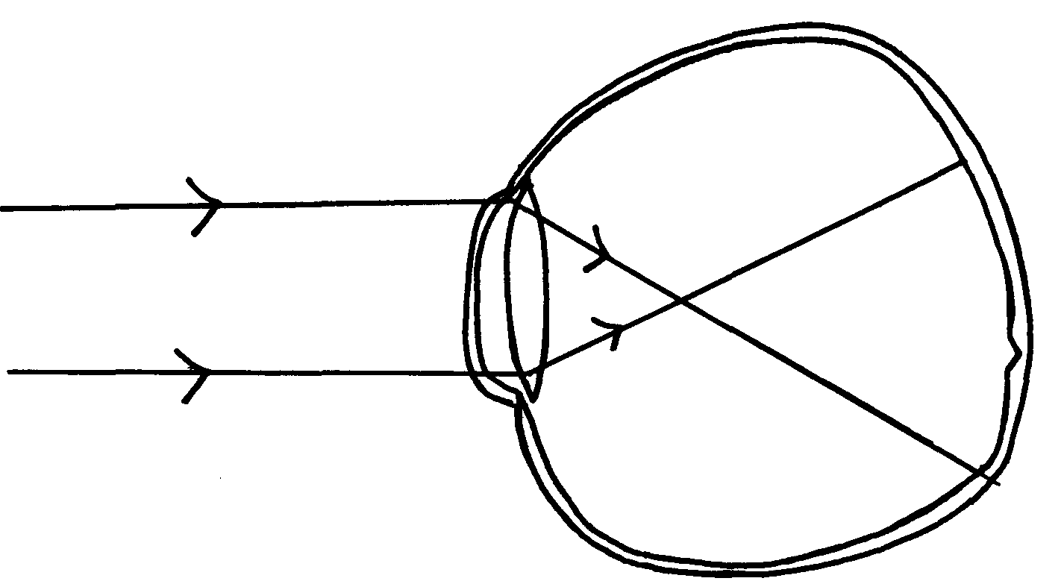

(a) (i) Name the defect

(ii) State the causes of the defect

(b) Explain how the defect in **a(i)** above can be corrected.

(c) State the functions of cones

(d) How are nocturnal animals adapted to seeing?

**5. Support and movement in (a) Plants (b) animals**

1. Explain how the following tissues are adapted to provide mechanical support in plants:-

a) Parenchyma

b) Collenchyma c) Selerenchyma

2. The diagram below represents a bone in the mammalian skeleton

a) Identify the bone with a reason

b) State the function of the part labeled **D**

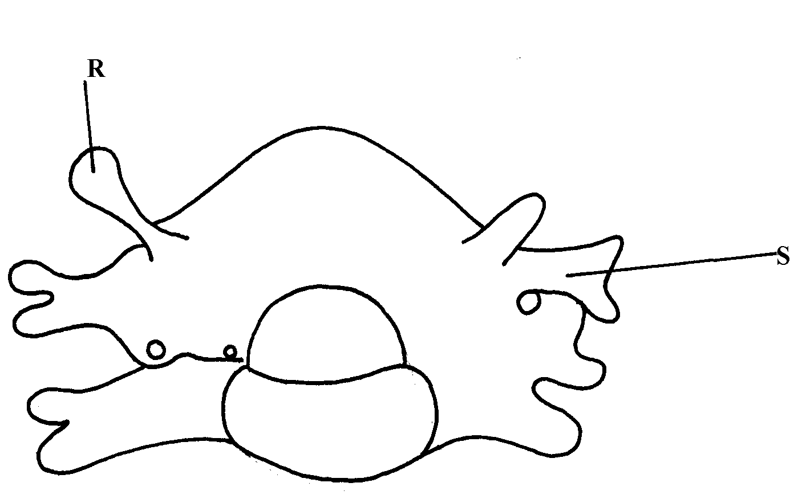3. The diagram below represents a mammalian bone

(a) Identify the bone shown above

(b) State the function of the parts labelled **R** and **S**

(c) State the region of the body in which the bone is found

4. (i) Name **two** bones that form the ball and socket joint in the fore limb of a mammal

(ii) Name the fluid that is found in the above mentioned joint and its function

5. State **three** types of skeleton found in Kingdom animalia

6. State **three** differences between an animal’s muscle cell and plant’s palisade cell

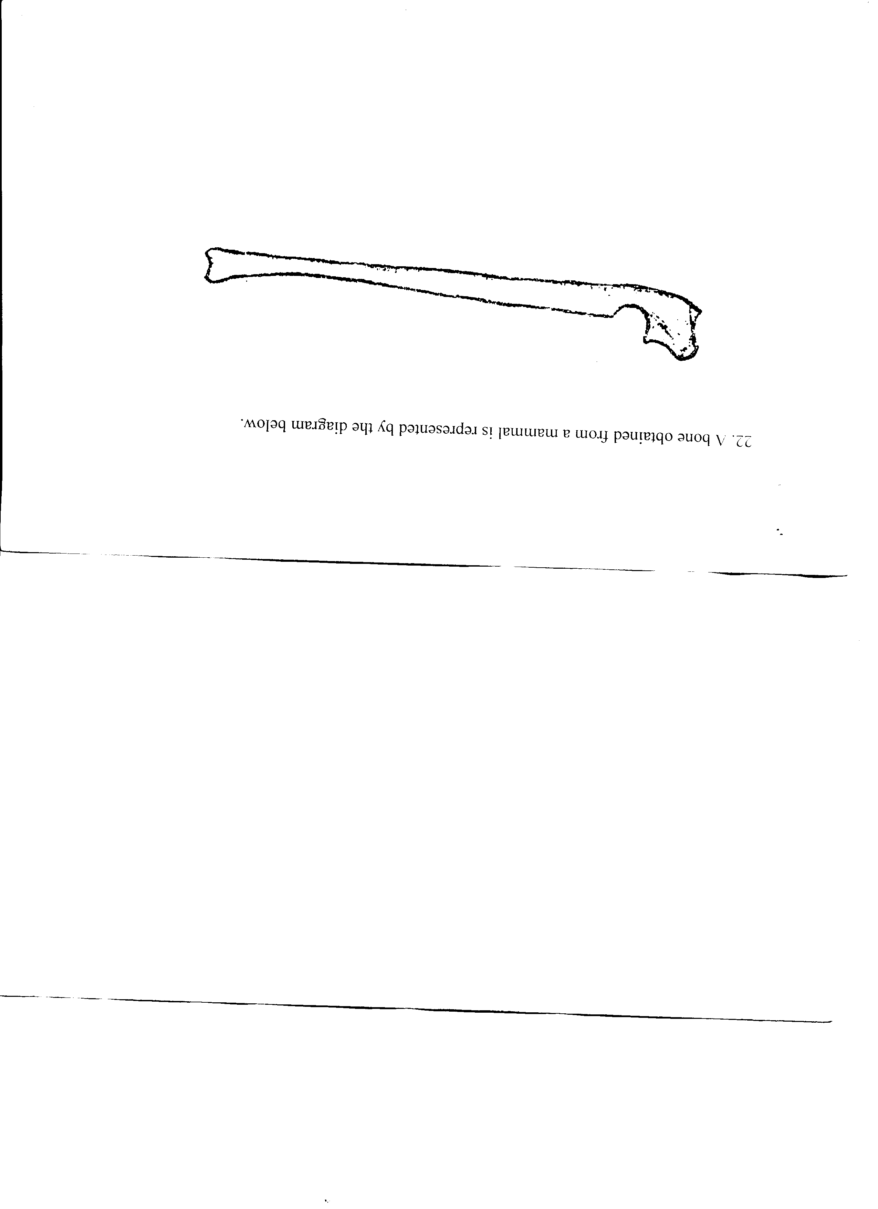7. The diagram below represents a mammalian bone

(a)Name the bone

(b) (i) Which bone articulates with the bone shown in the diagram at the notch

(ii) Name the type of joint formed when the bones in **b(i)** articulate

8. (a) Name the hard outer covering of the members of the phylum Arthropoda

(b) State **two** roles played by the structure named in **(a)** above

9. (a) State the role of lignin in the wall of the xylem vessel

(b) How does vascular bundles contribute to support in plants

10. (a) Distinguish between tendons and ligaments

b) State **one** way through which herbaceous plants achieve support

11. Name the ;

a) i) Material used to strengthen the xylem tissue

ii) Tissue that is removed when the bark of a dicotyledonous plant is ringed

b) State the areas of the plant where translocated materials are taken

12. Give **three** importance of mammalian skeleton

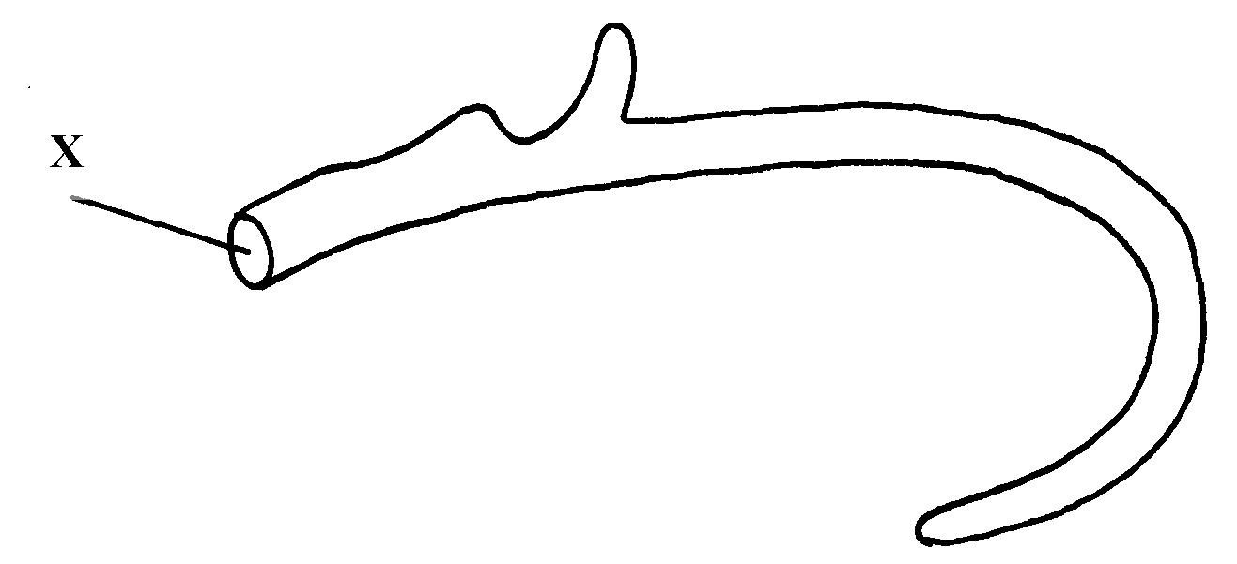13. The diagram below represents the anterior view of a rib

Name the part labelled X

14. The diagram below represents a bone obtained from a mammal

a) Name the bone

b) Name the:

i) Bones which articulate with the bone named in **(a)** above at the cavity labelled **K**

ii) Joint formed by the two bones at **K**

c) State functions of part labelled **J**

15. The diagram below represents a bone obtained from a mammalian skeleton:

(a) Identify the bone

(b) Name the:

(i) Bone it articulates with at point **A**

(ii) Type of joint that forms at point **B** in articulation with other bones

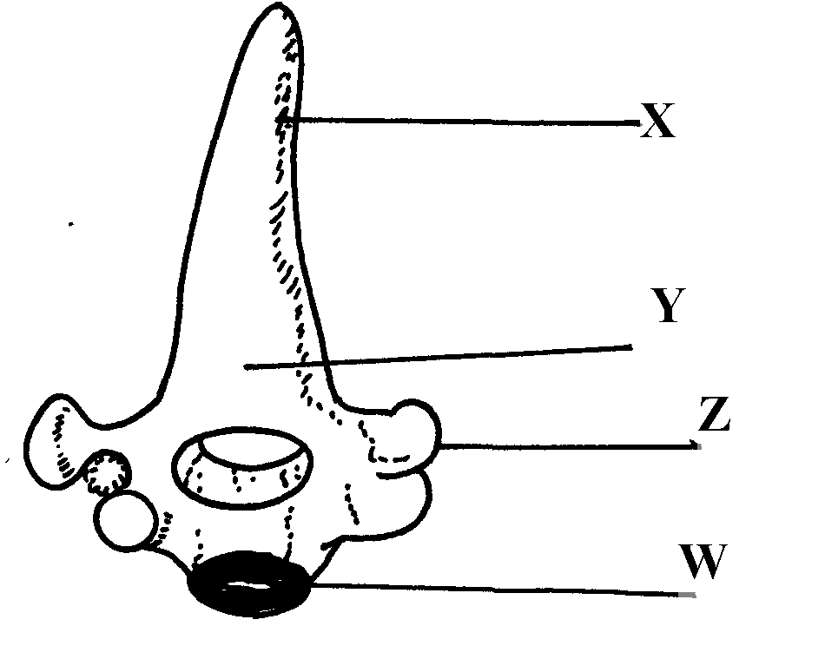16. The diagram below represents a bone obtained form a mammal

(a) Identify the bone

(b) Name the structures labeled **X** and **W**

(c) Name the bone that articulate with structure labeled **Z**

17. (a) Name the vertebra in a mammalian body that is characterised by presence of **odontoid**

**process**.

(b) State the function of the **odontoid process**

18. a) Name **three** supporting tissues in plants

b) Study the diagram below and answer the questions which follow:

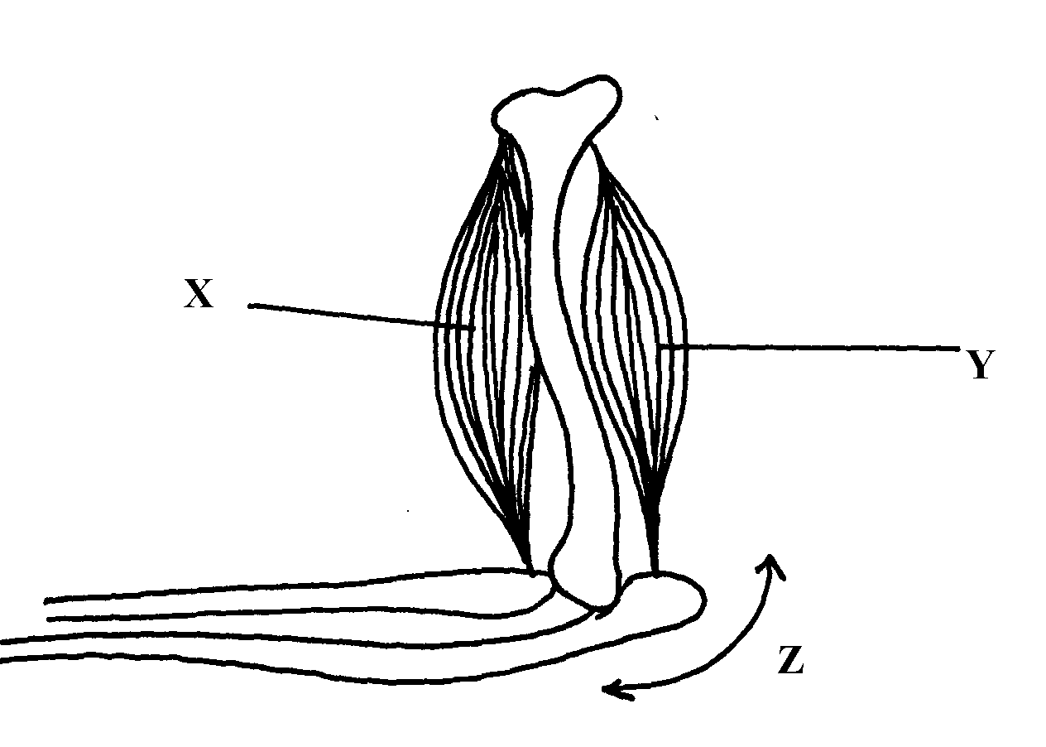

i) Identify the muscle represented by **X** and **Y**

ii) Describe how muscles **x** and **y** cause straightening of the joint **z**

c) Name the joint **z**

19. (a) What is the importance of locomotion in animals? (b) Explain how a bony fish is adapted for movement in its habitat

**16. Human health**

1. a) Name the causative agent of cholera.

b) Name the intermediate hosts in the life cycle of the following parasites;

i) *Ascaris lumbricoides.*

ii) *Schistosoma haematobium.*

c) How does the parasite *plasmodium* *vivax* gain entry into its host?

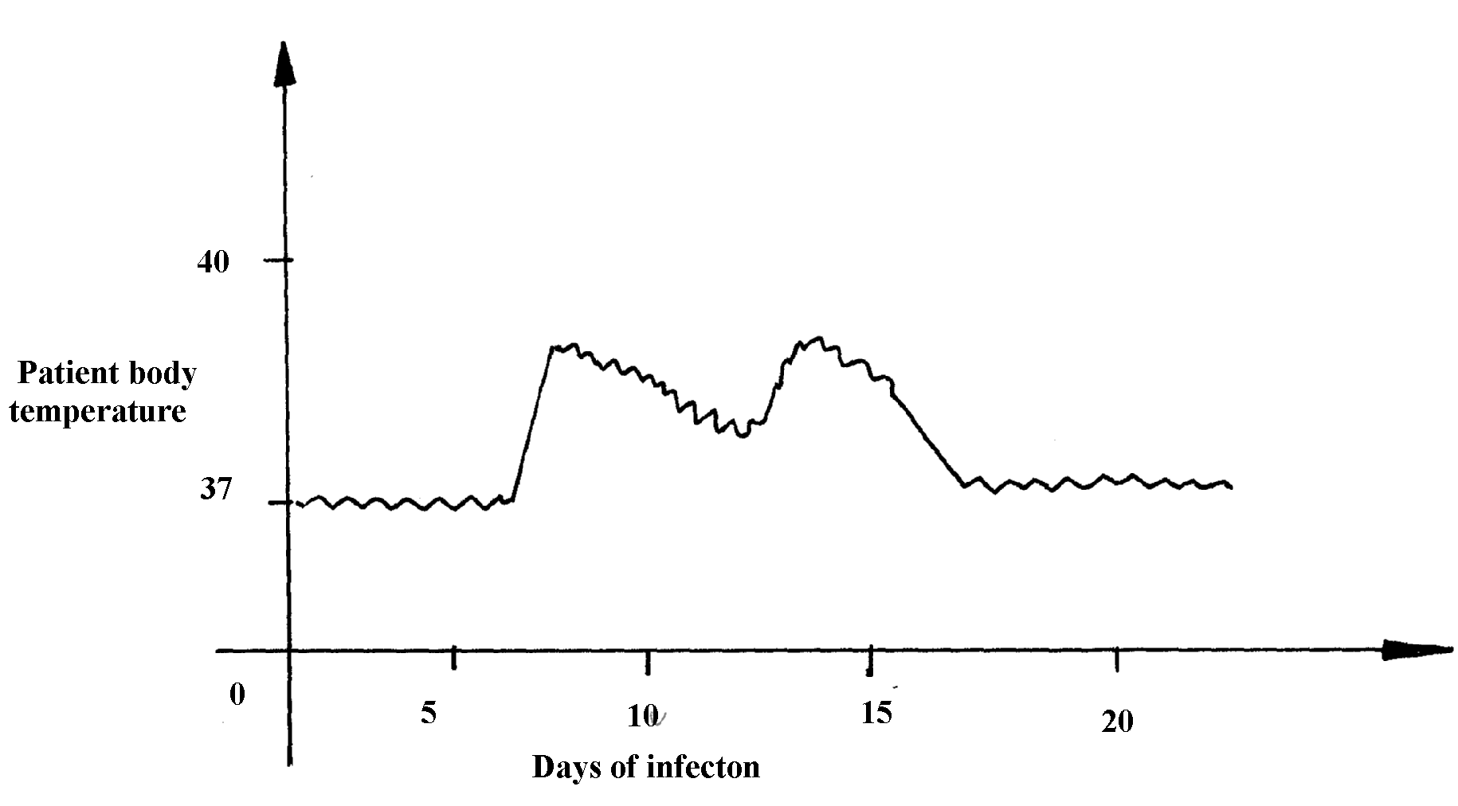2. The graph below shows body temperature of a patient suffering from malaria

(a) What symptom of the disease is shown in the graph?

(b) Name the organism that causes malaria

(c) Suggest **one** method of controlling spread of malaria

3. Name the causative agent of typhoid

4. Malaria is a common disease in Kenya:-

(a) What causes the disease?

(b) State **one** control measure of the disease

5. a) Name the causative agents of the following disease in humans:-

i) **Typhoid;**

ii) **Amoebic dysentery;**

b) Name the disease in human cased by plasmodium falciparum

6. Below are diagrams of disease causing micro-organisms. Use them to answer the questions that follow:

(a) State the kingdom to which they are found.

(b) Name the diseases caused by the organisms: A and B (c) State **one** way in which the disease named for organism B can be prevented

7. Explain why it is important to go for voluntary counseling and testing (VCT) on HIV/AIDS

8. Name **one** human disease caused by each of the following parasites.

(a) Plasmodium falciparum……………………………………………………

(b) Entamoeba histolytica …………………………………………………….

**SECTION I & II MARKING SCHEME**

**1. Classification I &II**

1. arachnida; crustacean;

2. - Body is covered by fur or hair;

- Have mammary glands (for milk production);

- Have external earlobes;

- Have highly developed brain;

- Have muscular diaphragm that have sweat glands;

- Have muscular diaphragm (that thoracic cavity from abdominal cavity); (first three)

3. – Two names i.e first genus and second species;

- Genus names starts with capital letter while species starts with small letter;

- Both names are written in italics, when printed or underlined when types or handwritten;

4. (a) Kingdom Monera;

(b) Producing antibiotics; vaccines; hormones and in producing transigenic organisms in modern

technology;

5. Chordata;

6. a) Fungi;

b) Sporulation;

7. Prothoraic glands disintegrates hence no production of ecdysone / moulting hormone

8. Zoology;

- Mushrooms used as food;

9. - penicilium are used to make antibiotic;

- Yeast is used in brewing and bread baking;

10. Sub-division – Angiospermaphyta;

Class – Dicotyledonae;

11. arachnida;

12. (a) (i) Fungi/mycophyta:

(ii) Non— green/ lacks chlorophyll;

- Body made up of hyphae/ mycelia;

(b) (Asexual) reproduction: OW WTE

13. (a) taxonomy is the classification of living organisms on their similarities and difference observed

(b) (i) Rottus norvegicus (1mk) (Genus name MUST begin with capital letter and be underlined

separately)

(ii) Genus – Rattus;

Species – norvegicus;

14. - A segmented body;

- A hard exoskeleton;

- Jointed legs;

**2. The cell – structure & functions of organelles**

1. a) Lysosomes;

b) Contractile vacuoles;

2. (a) Make cells visible;

(b) Prevent distortion of cells;

3. Diameter of field of view

= 4mm x 1000mm = 4000µm;

Size of each cell = 4000

20

= 200µm;

4. a)Manufacture of ribosomes;

b) encloses cell contents; regulate movement of materials in and out of the cell;

5. Protein:

Nucleic acid (DNA – RNA);

6. (i) Mg = O.L.M x E.L.M;

= 100 x 5

= x500;

(ii) x 500 = 5 x 10,000 = 50000mµ

x 1 = ?

= 1 x 50,000;

500

= 100micrometer;

7. a) mitochondria;

b ) -has cristae/inner membrane highly folded to increase surface area; for respiration.

-Has matrix medium for respiratory activities; (reject (b) if (a) is wrong.)

-Has matrix medium for respiratory activities; (reject (b) if (a) is wrong.)

8. a) nucleolus;

b) Centrioles;

c) nuclear membrane/pore;

9. a) catalyses the breakdown of toxic hydrogen peroxide; to harmless water and oxygen in

active tissues;

b) Low temperature;

10. a) i) Nucleus.

ii) Formation of RNA / ribonucleic acid;

Formation of ribosomes;

b) i) Contractile vacuole;

ii) Lysosomes;

11. Sensitive to change in temp; sensitive to changes in PH; has both negative and positive

charges;

12. a) Cellulose;

b) Store sugars, salt and food; carry out osmoregulation by inducing osmotic gradient that

bring about water movement; maintain the shape of the cell;

c) Cell wall; and chloroplast;

13. Study of internal and external parts of the body of an organism; Study of the living organisms and their chemical composition;

14. a) Synthesis of proteins;

b) Site for photosynthesis;

15. a) Length of drawing ;

Length of object

16. (a) Ribosomes:- Protein synthesis(1mk);

(b) Centrioles – Spindle formation during cell division ;

- Form cilia and flagella

17. (a) cellulose;

(b) Lipoproteins/lipids and proteins;

18. - No organized nucleus;

- Organelles not bound by membranes;

- Lack mitochondria;

19. (a) X : Chloplasts;

Y : Vacuole /sap vacuole;

(b) More on the upper side to obtain optimum light intensity/ in bright light, they move away to

avoid bleaching/ in dim light they move towards the source of light for maximum

absorption of light;

20. Cell diameter = field of view in menometer

Number of cells under the field of view

3.5x1000 ; 3500;

8 8

= 437.6mm = 438mm;

21. i) Arachnida

ii) - Exoskeleton

- Jointed appendages

- Segmented body

- Moulting;

22 a) Magnification – Ability of a microscope to enlarge tiny objects

Resolution – Ability of a microscope to separate between two tiny structures under

magnification to appear distinct

b) Mounting – The placing of prepared slide on stage of a microscope;

Staining – Use of chemical stain on specimen for clear observation

23. (a) Golgi bodies/Golgi apparatus;

(b) Lysosome(s):

(c ) Ribosomes;

24. (a) Make the sections transparent:

(b) To produce thin sections/ Not to distort the cells:

(c ) To distinguish between different parts/organelles of the cells:

25. - Magnify the object further;

- Concentrates light onto the object;

- Controls amount of light illuminating the object;

26. Size of one cell = diameter of field view

No. of cells arranged across the diameter

= 2000mm;

10cells

200mm = 0.2mm

N/B = 1mm = 0.001mms;

27. (a) To make the specimen /section more visible

(b) To allow light to pass through for easy viewing

28. Animal cell;

29. a) Stores hydrolytic enzymes for destruction of worn out organelles/ cells/ tissues/ digestion

of bacteria/ pathogens; Acc digestion of food/ accept autolysis

b) Processing/ packaging synthesized and transporting of packaged cell materials; production

of lysosomes/ secretions of packaged material;

30. Insecta; Reject insects/ exopoda

31. a) magnifying the image of the specimen;

b) Objective lens brings the image into focus and magnifies it;

32. a) Mitochondria

b) early production/ respiration;

c) Increases surface area; for attachment of respiratory enzymes;

d) Nerve cells; skeletal muscles; cardiac muscles

**3. Cell Physiology – Osmosis, Diffusion and Active transport**

1. a) A- The strip increased in length/ size; B - Decreased in length/ size;

b)The sugar solution was hypotonic to the cell sap strip A; it gained water by osmosis

hence increasing in length;

2. (a) The potato cup will be filled with solution;

(b) The solution in the potato cells is hypertonic to the water; hence water moves into the cell by

osmosis; this makes the solution in the neighbouring cells to be hypertonic to the outer cells;

hence water moves from cell to cell until it eventually enters the potato cup;

3. (a) (i) Will lose water by osmosis and become plasmolysed;

4. Diffusion;

Osmosis ;

Active transport ;

5 a) 3.0 + 3.1 + 3.2 = 9.3 g;

Average = 9.3 = 3.1g;

3

b) The cell sap had a higher concentration of solutes than distilled water, water therefore

moves from the environment to the cell by osmosis ;

6. (a) red blood cells placed in a hypertonic solution and as a result lost water to the surrounding

thorough osmosis hence shrunk/crenated ;

(b) Appearance of that cell if subjected to the same condition

7. a) Haemolysis

b) Plant cell will lose water the cell sap to the outside solution by osmosis; the cell

becomes plamolysed/ flaccid; but it will retain its shape due to rigid cell wall;

8. a) Haemolysis ;

b) The plant cell will draw in water molecules by osmosis; it will swell and become turgid; but it

will not burst because of the presence of cellulose cell wall;

9. i) Spermatozoon

- Tail – For swimming in vagina tract

- Numerous mitochondria – for provision of energy for swimming

- Streamlined – to reduce friction during movement

- Haploid nucleus – for fertilization of haploid ovum

Palisade mesophyll cell

- Numerous chloroplasts for photosynthesis

- Narrow and cylindrical – packed in small space

- Large sap vacuole for storage of manufactured food;

10. a) Prophase I Reject prophase alone

b) Homologous Chromosomes side by side or Bivalency

c_)

|  |  |
| --- | --- |
| Mitosis | Meiosis |
| One phase | Two phases |
| Diploid daughter cells | Haploid daughter |
| No chiasmata formation | Chiasmata formation; Any two correct |

|  |  |
| --- | --- |
| Trophism | Tactic response |
| Growth is involved or brought about cell division | Locomotary |
| Slow | Fast |

|  |  |  |  |
| --- | --- | --- | --- |
| Set -up |  | Number of red blood cells | |
|  | Sodium chloride concentration | At start of experiment | At the end of the experiment |
| A | 0.9% | Normal | No change in number |
| B | 0.3% | Normal | Fewer in number |

11. A-no change in; number because 0.9% sodium chlorine solution is isotonic to RBC/blood;

B-fewer in number because 0.3% sodium chloride solution is hypotonic to RBC/blood

therefore some water was drawn in to RDC by osmosis ;leading to haemolysis/boosting of

RBCs

b)i)number will not change;

ii)RBC will appear small in size/wrinkled/crenated/shriveled/shrink; 1mk

Rej. Flaccid/flabby/plasmolysed

12. (i) Paranchyma;

(ii) Collenchyma;

(iii) Xylem: and sclerenchyma

13. (a) X – hypotonic solution; p

Y – hypertonic solution; p

(b) A – haemolysis; p.

B – crenation /laking; p

(c) The cell will maintain/retain its normal shape.

14. Absorption of mineral salts by root hairs from the soil; Translocation of food from

leaves to other parts of the plant; movement of salts from one cell to the next;

15. (a) (i) Increased in length, absorbed water through osmosis, ( since cylinder cells were

hypertonic/ at higher concentration) and become turgid.

(ii) Reduced in length, cylinder host water to the hypertonic sucrose solution/become flaccid.

(b) (i) No change in length

(ii) Cells are dead and cannot carry out osmosis.

(c) - opening and closing of stomata

* Support in plants
* Movement of water from cell to cell
* Feeding in insectivorous plants
* Absorption of water by root hairs
* Absorption of water in the intestines
* Reabsorption of water in kidney nephron.

16. (a) (i) Nucleus

(ii) Maintain the shape of he cell providing support to herbaceous plants; stores sugar

and salts; (mark first one)

(b) 0.5 x 100 ; 62.5µm;

8

(c) Hypotonic solution;

Accept -highly concentrated salt/sugar solution

(d) The potato cell sap were lowly concentrated than the surrounding solution; hence lost water

molecules by osmosis through the semi permeable membrane to become plasmolysed;

(e) Re-absorption of water from the kidney tubules/ hence important in osmoregulation;

17. a) transpiration

b) prevent evaporation of water from the surface

c) the level of water dropper

d) i) faster drop in water level ii) no change in water level;

iii) slower/very slow drop in water level;

e) another set up using a leafless twig;

**4. Nutrition in (a) plants (b) animals**

1. a) Condensation;

b) water;

2. (a) Guard cells;

(b) Cells walls are thicker on the inner side then the outer side; which enables them to pull

inwards when the cells are turgid; contains chloroplasts that are able to phosynthesize

and produce sugars which enable them to absorb water; (any two points)

(c) Accumulation of carbon (IV) oxide in the leaf forms a weak carbonic acid; lowering the pH

which favours conversion of sugar to starch; causing the guard wells to lose turgidity; and

close;

3. (a) Stomata on the epidermic were blocked; thus no carbon (IV) oxide entered the heat;

therefore photosynthesis did not take place;

(b) Respiration; Excretion/ transpitation;

4. (a)

|  |  |
| --- | --- |
| Etiolated plant | Normal plant |
| - Yellow leaves/stems  - small leaves  - long inter-nodes and thin stems  - weak stem/feeble stem | - green leaves/stems;  - large leaves;  - short internodes and thick stem;  - strong /firm stem; |

(b) Enables plants to grow faster towards light for photosynthesis;

5.

|  |  |
| --- | --- |
| PLANTS | ANIMALS |
| - Make their own food through the process of photosynthesis | - Depend on plants and other animals for food; |
| - They do not move from one place to another | - They move from one place to another; |
| - Respond slowly to stimuli | - Respond faster /quickly to stimuli; |

6. They have thick inner membrane and thin outer membrane to allow them to bulge

outwards when turgid to open stomata; Have numerous chloroplasts, to carryout photosynthesis, forming sugars to control opening and closing of stomata;

7. Reaction A – condensation;

Enzyme Y – Sucrose;

8. - To emulsify fats;

- To provide an alkaline condition for enzyme activities;

- To provide an alkaline condition for enzyme activities;

9. Have stomata on upper surface;

- Large leaf surface to increase surface are for absorption of light;

- Presence of aerenchyma tissues, allows them to float on water hence accessing sunlight;

10. (a) – Protease;

- Lipase

(b) At 35oC optimum temperature for enzyme to act; at 15oC enzymes in active since

temperature is low;

11. a) Goiter;

b) Scurvy;

12. Enzymes – Thrombin; Thromboplastin/ Thrombokinase;

Metal ion – Calcium ions;

13. a) Peristalsis;

b) Circular and longitudinal muscles on the wall of oesophagus and intestines contract

alternately;

c) Roughage;

14. Long gut / many chambers to provide large surface area for digestion; bacteria in rumen has

enzyme cellulase which digest cellulose (to glucose/ sugars).

15. Concentrated of the solutions separated by a semi-permeable membrane; existence of

concentration gradient; temperature of the solution;

16. i) Pancreas; ii) Insulin;

17. a) Roughage; b) Water, vitamins, mineral salts;

18. Photolysis – Splitting water into H+ and oxygen gas;

- Synthesis of ATP to be used during dark stage;

- Synthesis of chlorophyll necessary for photosynthesis;

19.

|  |  |
| --- | --- |
| **Guard cells** | **Other epidermal cells** |
| - Have chloroplasts/photosynthesize  - Have thick inner walls/thin outer walls  Bean shaped | * No chloroplasts/do not photosynthesize * Walls uniformly thickened   block shaped (any correct pair ) |

20. (i) Biliverdin ; Bilirubin ;

(ii) Emulsify fats;

21. a) Involuntary movement of food along the alimentary canal

b) Rhythmic contraction and relaxation of the circular and longitudinal muscles along the gut;

22 . a) i) Chloroplast;

ii) Mitochondrion;

b) Similarity — Both have a double membrane;

Difference Chloroplast Mitochondrion;

- Grana Cristae;

- Stroma Matrix;

23. a) HCl — to hydrolyse complex sugar to simple sugar

NaHCO3 — To neutralize the HC1

b) Disaccharides;

c) i) Glucose;

ii) Sucrose;

24. a) Sensory neuron;

b) Cell body is off the axon;

c) A — Conduct coming signals / Receives impulses;

B — Receives impulses rough dendrites / coordinates the nerve cell;

D — produce myclin sheath that protects and insulates the axon;

25. a) Increases surface area for attachment of respiratory enzymes;

b) i) Intergrana;

ii) Accept site 4 photolysis; contains chlorophyll pigment absorbs light;

26. a) Increases surface area of fats for purpose of digestion;

b) Accept any two correct

- Destroys any ingested pathogens;

- Provides acidic media for protein digesting enzymes (pepsin);

- Converts/ activates pepsinogen inactive form to pepsin;

27. Poison acts as competitive inhibitor for active site of respiratory enzymes; energy production

for active transport of nitrates is impaired;

28. Rhizobium bacteria benefits by getting Shelter & carbohydrates;

- Leguminous plant obtains nitrates fixed by the bacteria;

29. - Enzymes amylase digests starch to maltose

- Mucus lubricates food

30. They are converted to starch; then stored in organs and tissues;

31. -Guard cells have chloroplast;

-They are bean shaped;

32. Oxygen-releases to the atmosphere or used by plants for respiration;

Hydrogen-enter dark stage, where it combines with CO2 to form simple sugar;

ATP- provide energy during the combination of hydrogen a toms with CO2in dark stage;

33. a) to investigate the effect of boiled saliva on starch/to show the effect boiled/denature

enzyme amylase has on starch;

b) A-brown colour/colour of iodine persists;

B- blue black/blue/dark colouration;

c) A-starch has been digested/starch has been broken down/amylase hydrolyses starch hence

no colour changes;

B-enzymes/amylase denatured hence no starch digested;

34. a)A-condensation;

B-hydrolysis;

b)Duodenum; (any correct Rj .wrong spelling)

-ileum;

35 i)stroma

ii)side of light reaction of photosynthesis /site of water photosynthesis and adenosine

triphosphare production (ATP)

36. (i) (Vitamin D/calciferol;

(ii) Prevents rickets/Osteomalacia;

37. a) Schistosomiasis/ Bilharzia:

b) -Has suckers for attachment to the host:

* Has secondary host/snail to increase its chances of survival:/increase chances of transfer to several hosts;
* Its larvae/Eggs produces lytic enzyme to soften the hosts tissues hence allow prevention into the host:
* Larva covered with cysts to remain dormant for a long time;
* Goes through various forms of lifecycle/miracidia. cercariae and redia to make it difficult to eradicate/increase chance of survival/transmission;
* Adult produces chemical substances to cover the body to protect it against hosts defence mechanism;
* Separate sexes to ensure dispersed eggs are fertilized before shed into blood vessels.

38. (a) (i) Stomach

(ii) Presence of hydrochloric acid to provide acid conditions

39 (a) To investigate the effect of heat on salivary amylase.

(b) A – The brown colour of iodine was retained because the starch was digested by enzyme

amylase in the saliva; p 1.

B – The colour changed to blue black/black; because amylase in the saliva was denatured

by heat;

40. (a) (i) stroma; p

(ii) Granum; p

(b) – Provide energy – ATP;

- Provide H+ - ves H2 GAS /atoms;

41. Midnight – There was no photosynthesis at night; and carbon IV oxide was not used hence the

high concentration;

Noon - Carbon IV oxide was used in photosynthesis and therefore CO2 concentration dropped.

42. - By increasing the enzyme /substrate concentration;

- By increasing the temperature below the optimum upto the optimum temperature;

- Providing suitable /favourable /optimum pH.

43. (a) - Mode of feeding is herbivorous. Reject Herbivore

- Absence of upper incisors but have hony pad

(b) 30

44. Small mammals have large surface area to volume ratio; hence lose heat quickly to environment; to replace the heat , lost, their metabolism is high making them to feed more frequently

45. - Plants are able to synthetize their own food

- Plants are able to use pollination rather rhan moving to seek mating partners

- Use seed and fruits dispersal to colonize new habitats (3x1=3mks)

46. a) A- Rhizome

B- Adventitious roots

(b) The liverwort body form is thalloid while the fern has 3body parts, roots, stem and leaves

47. The break down of glucose into pyruvic acid

48. (a)

|  |  |
| --- | --- |
| Monosaccharide | Polysaccharides |
| - Are soluble in water | - Are insoluble in water |
| - Form sweet tasting solution | - Do not have a sweet taste |
| - Reduce Copper(II) ions in benedicts solution to  Copper (I) ions when heated together | - They do not reduce |
| - Are crystalizable | - Are not crystallizable |

(b) Peptide

49. H+/H atom; rej H2/Hydrogen gas

- ATP/energy

50. Absorption of water; accept absorption of salts/ calcium/ iron; secretion of mucus;

51. a) To show that light is necessary for photosynthesis;

b) Only the uncovered areas turned blue- black with iodine; the part covered with aluminum

foil did not receive light and thus could not carry out photosynthesis;

52. a) As the temperature increases, the rate of the reaction also increases; this happens because

an increase in temperature increases molecular movement, thus increasing the chances of

collision between the enzyme and substrate molecules;

b) X – is the optimum temperature/ It is the temperature at which the reaction proceeds

53. Nitrogen;

Magnesium;

Iron;

54. a) A- Hook;

B – Sucker;

C – Youngest proglottid;

b) Intermediate host – pig;

55. a) A – Villus

B- Lacteal

b) A __ Increases surface area for maximum digestion and absorption;

B – Absorption of fatty acid and glycerol;

c) - Final digestion of undigested foods;

- Absorption of soluble end products of digestion;

d) Produces bile juice which contains bile salts that emulcify fat;

e) Produces insulin and glucagons hormones;

Reject if only one hormone is mentioned

56. (a) Rapid increase (in water of photosynthesis) due to increase in concentration of CO2

(b) Constant rate/no increase rate and no decrease, other factors /light/temperature water

become limiting/inadequate.

(c) chlorophyll traps energy.

Light energy react water into hydrogen ions and oxygen/photolysis.

Hydrogen is picked by hydrogen.

Acceptor/NAD/NADP (and becomes reduce, * ACCEPT NADPH,NADPH

ATP adenosine triphosysbate formed.

57. (a) Compensation point

(b) (i) There is no net uptake or release of Carbon (VI) oxide by the plant;

(ii) The rate of respiration and photosynthesis in the plants are equal; therefore all the

Carbon (VI) Oxide released during respiration is used in photosynthesis;

(c) At light intensity beyond/above X, the rate of photosynthesis is higher than the rate of

respiration; and this requires a net uptake of Carbon (IV) Oxide (to sustain the increasing

rate of photosynthesis);

(d) Growth would cease because all the products of photosynthesis would be utilized in

respiration;

(e) The plant will take up oxygen from the surrounding air since the rate of respiration is

higher than the rate of photosynthesis;

58. (a) Broad and flat to absorb maximum light

Have chloroplast with chlorophyll to trap light.

Transparent cuticle to allow light to pass through

(b) X – Carbon (IV) Oxide

Y – Oxygen

(c) Xylem – Transports water

Phloem – Sugars out of the leaf

(d) Starch is insoluble in water, hence osmotically inactive; This reduces effect on absorption of

water.

59. a) breakdown of complex food, substance; into simple diffusible substances; b)intestines relatively long/coiled /folded ;this allows food enough time for absorption.

Intestines long /have villi; to increase the surface area for absorption and digestion ;

The walls have glands which secrete enzymes for digestion;(examples of correct enzymes

e.g. Maltose, sucrose lactose etc).some glands /goblet cells also produce mucus; which protects

The intestinal wall from autodigestion/being digested; and reduce friction;

Intestines have opening of ducts which allows bile pancreatic juice into the lumen;

The intestines have circular and longitudinal muscle, whose contraction and relaxation/peristalsis;

Leads to mixing of food with enzymes/juice; facilitating rapid digestion and help push food along the gut; the intestines are well supplied with blood vessels to supply oxygen/ remove digested food from an efficient absorption and transporting system to move the food away from the small intestines;

Have lacteal vessels for transport of fat/lipid; have thin epithelial lining; to facilitating fast absorption /diffusion;

Note. Allow increases in surface are for absorption only once

60. (a) To investigate the rate of photosynthesis;

(b) It is used to draw the bubbles of gas through the apparatus;

(c) (i) Oxygen gas;

Light energy

(ii) 6 CO2 + 6H2O C6H12O6 + 6O2;

Chlorophyll

Acc. Either word or chemical equation

If chemical, must be balanced, symbols capital.

Light

Chlorophyll

or Carbon (IV) Oxide + water Glucose + Oxygen;

1. - Optimum

- Optimum PH

- Absence of inhibitors.

- Presence of co-factors or co-enzymes.

- Low substrate concentration.

(e) - To minimize temperature changes.

61. a) A- Rhizome

B- Adventitious roots

(b) The liverwort body form is thalloid while the fern has 3body parts, roots, stem and leaves

62. The break down of glucose into pyruvic acid

63. (a)

|  |  |
| --- | --- |
| Monosaccharide | Polysaccharides |
| - Are soluble in water | - Are insoluble in water |
| - Form sweet tasting solution | - Do not have a sweet taste |
| - Reduce Copper(II) ions in benedicts solution to  Copper (I) ions when heated together | - They do not reduce |
| - Are crystalizable | - Are not crystallizable |

(b) Peptide

64. H+/H atom; rej H2/Hydrogen gas

- ATP/energy

65. Absorption of water; accept absorption of salts/ calcium/ iron; secretion of mucus;

66. a) To show that light is necessary for photosynthesis;

b) Only the uncovered areas turned blue- black with iodine; the part covered with aluminum

foil did not receive light and thus could not carry out photosynthesis;

67. a) As the temperature increases, the rate of the reaction also increases; this happens because

an increase in temperature increases molecular movement, thus increasing the chances of

collision between the enzyme and substrate molecules;

b) X – is the optimum temperature/ It is the temperature at which the reaction proceeds

68. Nitrogen;

Magnesium;

Iron;

69. a) A- Hook;

B – Sucker;

C – Youngest proglottid;

b) Intermediate host – pig;

70. a) A – Villus

B- Lacteal

b) A __ Increases surface area for maximum digestion and absorption;

B – Absorption of fatty acid and glycerol;

c) - Final digestion of undigested foods;

- Absorption of soluble end products of digestion;

d) Produces bile juice which contains bile salts that emulcify fat;

e) Produces insulin and glucagons hormones; Reject if only one hormone is mentioned

71. (a) Rapid increase (in water of photosynthesis) due to increase in concentration of CO2

(b) Constant rate/no increase rate and no decrease, other factors /light/temperature water

become limiting/inadequate.

(c) chlorophyll traps energy.

Light energy react water into hydrogen ions and oxygen/photolysis.

Hydrogen is picked by hydrogen.

Acceptor/NAD/NADP (and becomes reduce, * Accept NADPH, NADPH

ATP adenosine triphosysbate formed.

72. (a) Compensation point

(b) (i) There is no net uptake or release of Carbon (VI) oxide by the plant;

(ii) The rate of respiration and photosynthesis in the plants are equal; therefore all the

Carbon (VI) Oxide released during respiration is used in photosynthesis;

(c) At light intensity beyond/above X, the rate of photosynthesis is higher than the rate of

respiration; and this requires a net uptake of Carbon (IV) Oxide (to sustain the increasing

rate of photosynthesis);

(d) Growth would cease because all the products of photosynthesis would be utilized in

respiration;

(e) The plant will take up oxygen from the surrounding air since the rate of respiration is

higher than the rate of photosynthesis;

73. (a) Broad and flat to absorb maximum light

Have chloroplast with chlorophyll to trap light.

Transparent cuticle to allow light to pass through

(b) X – Carbon (IV) Oxide

Y – Oxygen

(c) Xylem – Transports water

Phloem – Sugars out of the leaf

(d) Starch is insoluble in water, hence osmotically inactive; This reduces effect on absorption of

water.

74. a) breakdown of complex food, substance; into simple diffusible substances; b)intestines relatively long/coiled /folded ;this allows food enough time for absorption.

Intestines long /have villi; to increase the surface area for absorption and digestion ;

The walls have glands which secrete enzymes for digestion;(examples of correct enzymes

e.g. Maltose, sucrose lactose etc).some glands /goblet cells also produce mucus; which protects

The intestinal wall from autodigestion/being digested; and reduce friction;

Intestines have opening of ducts which allows bile pancreatic juice into the lumen;

The intestines have circular and longitudinal muscle, whose contraction and relaxation/peristalsis;

Leads to mixing of food with enzymes/juice; facilitating rapid digestion and help push food along the gut; the intestines are well supplied with blood vessels to supply oxygen/ remove digested food from an efficient absorption and transporting system to move the food away from the small intestines;

Have lacteal vessels for transport of fat/lipid; have thin epithelial lining; to facilitating fast absorption /diffusion;

Note. Allow increases in surface are for absorption only once

75. (a) To investigate the rate of photosynthesis;

(b) It is used to draw the bubbles of gas through the apparatus;

(c) (i) Oxygen gas;

Light energy

(ii) 6 CO2 + 6H2O C6H12O6 + 6O2;

Chlorophyll

Acc. Either word or chemical equation

If chemical, must be balanced, symbols capital.

Light

Chlorophyll

or Carbon (IV) Oxide + water Glucose + Oxygen;

1. - Optimum

- Optimum PH

- Absence of inhibitors.

- Presence of co-factors or co-enzymes.

(e) - To minimize temperature changes.

76. (a) The bacteria ad exhausted the available food materials and they died;

(b) They multiply very fast as they feed on the substances; release toxic waste on food then die

there causing food spoilage

(c) fungi;

(d) – Speed up recycling of matter in the ecosystem;

- Breaks down /decompose dead complex organic matter

77. (a) Graph:

title -1mk

labelled axes) –

plotting –)

curve – (free hand) ( Continuous not dotted - Rej. curve if joined with a ruler

(b) As carbon dioxide concentration increase rate of photosynthesis also increases up to a limit

beyond which there is no increase even of CO2 concentration is increased.

- Increase in light intensity increased also rate of photosynthesis up to a limit

(c) - Have a darker colour/ light sensitive chlorophyll which to maximumly absorb any light

rays penetrating water

- They either float next to water surface to be exposed /closer to light or floats on water surface.

- Have thin or no cuticle to allow easier diffusion of dissolved CO2

(d) – Carbon (IV)- Oxide concentration;

- Light intensity ;

78.

* Is relatively long/ cooled/ folded to allow food (enough) time/ increase surface area for absorption of digested food and for digestion
* Lumen has projection called villi; villi has projections called microvilli; to increase surface area for absorption
* Walls have glands which secret enzymes for digestion; e.g. maltase/ sucrose/ lactase/ enterokinase/ peptidases
* Some glands/ goblet cells produce mucus; which protects the intestinal wall from being digested and also reduce friction
* Have openings of ducts which allow bile/ pancreatic juice into the lumen
* The intestines have circular and longitudinal muscles; whose contraction and relaxation/ peristalsis leads to mixing of food with enzymes/ juices; facilitating rapid digestion; and helps push food along the gut
* Intestines are well supplied with blood vessels/ highly vascullarized; to supply oxygen/ remove digested food
* Lacteal vessels; transport fats/ lipids
* They have thin epithelia; to facilitate fast/ rapid absorption/ diffusion

79. (a) To destarch the plant leaves;

(b) (i) To absorb carbon (iv) oxide in the flask;

(ii) To enrich the air in the flask with carbon(iv) oxide;

(c) (i) leaf M – Sodium Hydroxide absorbed Carbon (IV) oxide in the flask;

- No photosynthesis occurred and so the leaf retained the brown colour of Iodine;

(ii) Leaf N – Sodium hydrogen carbonate enriched the flask with carbon (IV) oxide;

* Photosynthesis occurred and starch formed reacted with iodine to give the leaf the characteristic blue-black colour;

(d) Conical flask covered with aluminium foil and no sodium hydroxide or sodium hydrogen

carbonate;

80. a)Graph

b) i) 2.5 – 2.7; i.e. 2.6 + 0.1

ii) 4.5 + 0.1

c) - Volume of CO2 consumed/ volume of O2 liberated

- Change in dry mass (due to photosynthesis);

d) - Photolysis of water

ATP synthesis

e) i) Rate of photosynthesis very low

Enzymes inactivated

ii) Rapid rate of photosynthesis

Optimum temperature for enzyme reaction

iii) Very low rate of photosynthesis

Enzymes denatured

f) Chlorophyll concentration (in leaves)

CO2 concentration

Water availability

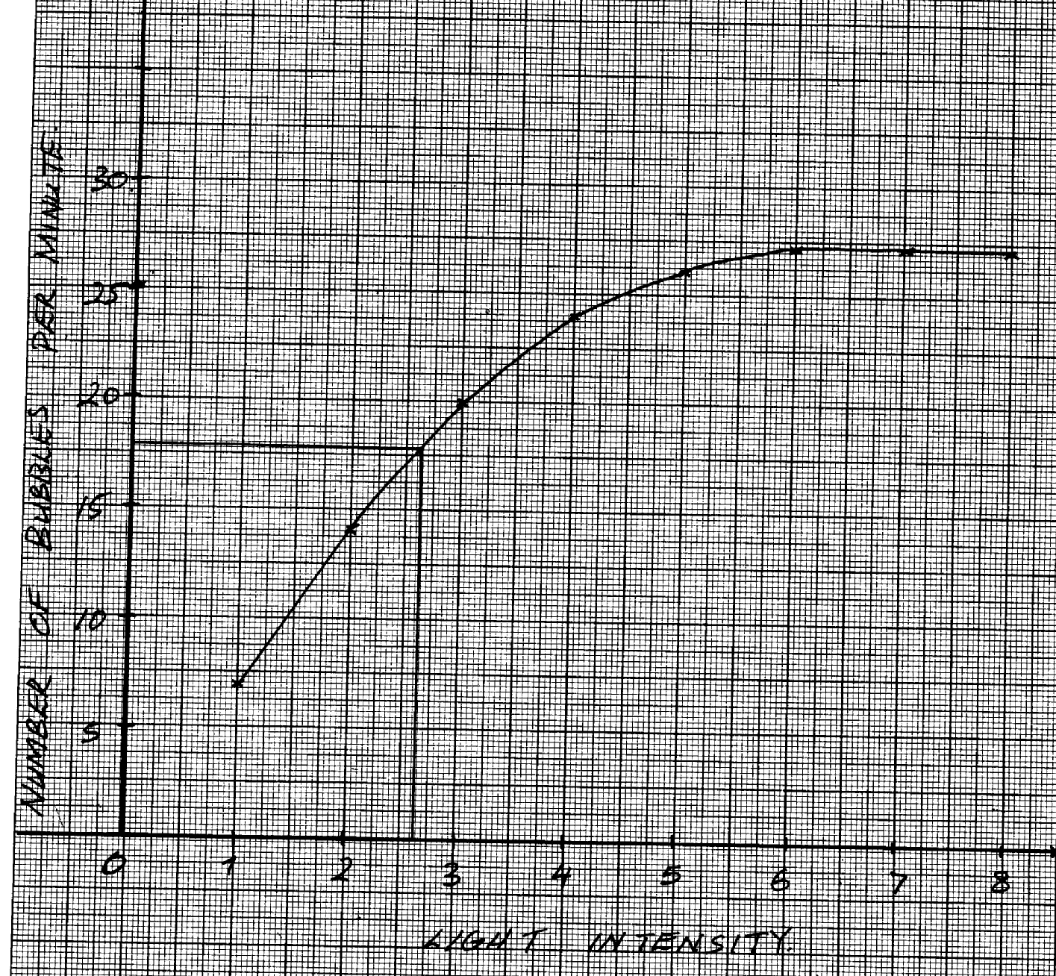

***NUMBER OF BUBBLES PER MINUTE***

***LIGHT INTENSITY***

79. a) i) to kill cells/expose starch graduals/stop biology processes;

ii) to decolourise the leaf/to dissolve chlorophyll;

b)i) leaf retained brown colour of iodine;

ii) starch was absent (since no photosynthesis had taken place);

c) to investigate the necessity of light in the process of photosynthesis;

d) to soften the leaf and wash off alcohol;

e) leaf with some parts/patches looking chlorophyll;

f) water + carbon(iv)oxide light Glucose +oxygen;

chlorophyll (carbohydrate)

**5. Transport in (a) plants (b) animals**

1. On a hot sunny day blood vessels are dilated hence more blood is lost; on a cool chilly day the

blood vessels have constricted hence less blood flows on the surface of the skin;

2. - Biconcave disc shaped to increase surface area for gaseous exchange;

- Have no nucleus to increase room for the package of red blood cells;

- Numerous in number to increase surface area for the transportation of oxygen

- Have haemoglobin which has a high affinity of oxygen;

. - Cytoplasmic filaments/strands along which food streams;

- Companion cells have mitochondria that provide energy for translocation;

- Sieve plates with sieve pores thorugh which cytoplasmic filaments pass.

- Photoplasmic material pushed on the sides to create lumen space for translocation;

4. (a) Chitin; (b) Lignin:

- Root pressure;

- Cohesion – adhesion forces

5. Transpiration pull;

6. (a) – transpiration pull;

- Cohesion and adhesion;

- Capillarity;

- Root pressure;

(b) Phloem;

7. (a) (i) (15 x 2 ) =30;

(ii) Carnivorous; reject carnivore

(b) – To lubricate the food;

- To protect the alimentary canal wall from digestion by protein digesting enzyme /protoelytic

enzyme;

- Make the food adhere together during swallowing;

8. (a) Thoraic vertebrae;

(b) B – Neural canal;

C – Centrium;

(c) For attachment of back muscles;

9. - Growing regions (e.g meristems); storage organs for storage (e.g stems, roots, fruits)

- secretory organs (e.g. flower nectarines);

10. A, AB, B, O; for all blood groups

11. (i) Efficient diffusion of substances e.g. food, gases and waste products;

(ii) Efficient transport of food/gases/waste products to and from cells;

12. (a) Transpiration;

(b) (i) The level of water in the boiling tube reduced significantly;

(ii) The level of water did not reduce;

13. Aerenchyma tissues have large and numerous air spaces; hence facilitation buoyancy;

|  |  |
| --- | --- |
| Arteries | Veins |
| - Thick muscular  - No valves (except pulmonary artery and aorta  at the base  - Narrow (small) lumen | - Thin muscular walls  - valves present;  - Wide lumen (large) lumen; |

14. a)

b) Arteriosclerosis; reject Artheroma

15. Transpiration pull; Capillarity;

Cohesion and adhesive forces; Root pressure;

16. -numerous to increase surface area

-Biconcave to increase surface area for packaging hemoglobin alter shape to fit narrow

lumens of capillaries;

-No nucleus to increase surface area for oxygen leading;

-Have hemoglobin which has high affinity for oxygen;

17. a) Tissue fluid is a fluid / liquid found surrounding cells/ between cells formed as a result of

ultra filtration from blood while lymph is inter cellular fluid which nutrients and oxygen have

been taken and is rich in waste materials (mark as a whole)

b) Vitamin K is needed for formation of prothrombin which is activated to thrombin which

helps in clotting of blood.

18. Open circulatory system

19. Coronary Artery;

20. a) Oxyhaemoglobin;

b) Use oxygen released from photosynthesis process;

21. Leukemia (acc. blood cancer)

22. (a) Diabetes mellitus

(b) - Symptoms of diabetes mellitus

- Passing urine frequently;

- Constantly feeling thirsty;

- Dehydration;

- Loss of weight;

- Poor resistant to infection;

23. (a) A – Tracheid; B – Vessel;

(b) - Side walls are impregnated wit lignin/deposited with lignin /walls are lignified/pressure of

lignin nucleus not enclosed by a membrane ;

24. There is high concentration of water vapour around the leaf/less space for water vapour form the leaf to occupy low saturation deficit /low diffusion gradient / the diffusion between the

concentration of water vapour in the atmosphere and the air spaces is greatly reduced.

25. a) Transports water and dissolved mineral salts; provides mechanical support due to

lignification of cells

b) Narrow lumen of vessels and tracheids – enhances capillarity forces;

Presence of pits on lignified walls follows for lateral movement of water;

They are hollow to allow uninterrupted/ continuous flow of water from roots to leaves;

26. a) Involuntary movement of food along the alimentary canal

b) Rhythmic contraction and relaxation of the circular and longitudinal muscles along the gut;

27. a) A – Hepatic portal vein; B- Hepatic artery;

b) Excess glucose must be converted to glycogen; for storage

c) Burning charcoal produces carbon (II) Oxide which combines with haemoglobin to

28. a) Oxyhaemoglobin

form carboxyhaemoglobin that is stable/ does not dissociate; reducing efficiency of

haemoglobin in carrying oxygen leading to death; Ref death alone

leaf fall;

exudation;

gutation;

transpiration

29. - Sebum – from sabaeceous glands – antiseptic ;

- Confined layer of dead cells- impenotratable by bacteria/ fungi/ viruses

- Sweat – saline and kills bacteria and viruses

30. Leukamia/ blood cancer;

31. a) inversion;

b) mustard gas/ gamma rays/ x-rays/ beta rays/colchicines;

32. (a)( i) Dicotyledonae;

(ii) Star shaped xylem/phloem between the arms o the xylem;

(b) Lignified walls to prevent it from collapsing/keep it hollow open throughout:

- Hollow/Lack cross walls for continuous flow of water and mineral salts any 1

- Narrow Lumen to enhance capillarity;

33. - Creates transpiration pull:

- Absorbs latent heat of vaporization hence cools leaves of the plant: (2marks)

34. Water absorption does not involve active transport that requires energy from respiration

facilitated enzymes ; hence no metabolic inhibition involved;

35. (a) A – Tracheids ; B – Xylem vessel; (b) B is hollow at the middle therefore the substance flowing through it gets to their destination

faster as compared to that of A; p

(c) – Lignification ; p

36. - Antigen B;

- Rhesus antigen / Rhesus factor /rhesus protein;

37. After the first transfusion the patient would produce rhesus antibodies; second transfusion

rhesus antigen would react with rhesus antibodies; causing agglutination;

38. (a) Pseudopodium; p

(b) Phagocytosis; p

(c) White blood cells.

39. (a) Xylem vessels are hollow (lack cross walls) , hence more efficient in transporting water

than tracheids which have trapped ends with perforation;

(b) Xylem vessels are dead due to heavy lignification on their walls hence provision of support

to the plant as well preventing collapse ;

40. Transpiration is the loss of water vapour, while gutation is loss or exudation of liquid water through hydathodes

41. Support

42. – Storage of air

- For buoyancy

43. (a) A blood disorder where red blood cells appear sickle shaped

(b) Sinoatrio node/pace maker

44. a) To generate high pressure to pump blood; to all parts of the body/ to furthest distance;

b) Hydrogen carbonate (HCO3)

Carbonic acid;

45. a) Sunken stomata form pits; in which water vapour accumulates reducing rate of

transpiration

b) Water proof to reduce the rate of transpiration;

46. a) Lignin;

b) Phloem;

47. a) A – Transport of organic food substances from sites of manufacture;

B – Formation of new xylem and phloem tissues;

C – Transport of water and mineral salts from the roots to the leaves;

b) Parenchyma cell;

c) Sclerenchyma;

48. - Blood cells;

- Plasma proteins;

49.

Acc. Descriptive form Rej. – From appoint of a mistake

50. (a) - Blood group O is a universal donor (as it donates to all other blood groups); *UGU*

- Blood group AB a universal receipient (as they receive blood from all other groups.

- Blood group A can receive blood from group O and A only.

- Blood group B can receive blood from O and B only.

- Blood group O does not receive blood from other blood groups except O.

- Compatibility of blood group

* + Absence of pathogens in blood.
  + The Rhesus factor matches.

(c)- When blood vessel is injured, exposed platelets rupture to release thromboplastin (enzymes); which converts prothrombin to thrombin; in presence of Ca2+ thrombin activates conversion of fibrinogen into fibrin; which forms mesh work of fibre in the cut surface;

51. a) Measure rate of transpiration; b) -Assemble apparatus under water;

- Apply vasectomy between cork shoot contacts;

- Open the reservoir tap;

c) i) The air bubble will not move

ii) Water droplets will be seen in he polythene;

iii) Air bubble will move faster

52. (a) (i) (23000 – 100) x 100 = 1,990%;

1100

(ii) (1300 – 400) x 100 = -6.92%;

1300

(b) (i) At rest, the gut is more active than skeletal muscles as this is the time when digestion is

taking place; more blood goes to gut to transport the absorbed food;

(ii) During strenuous exercise, skeletal muscles are more active; and a lot of blood is diverted

to help it contract and relax while very little blood flow through the gut which becomes

less active;

(c) During light exercise, the skin becomes more active; thus give the highest blood flow

compared to other times to release excess heat, sweat and wastes.

(d) – Excess water;

- urea, ammonia, uric acid; (OWTTE)

53. a) A- Epidermis

B- Pith

b) C- Transports manufactured food/ products of photosynthesis/ translocates food

E- Transports water and mineral salts

c)

|  |  |
| --- | --- |
| Section above | Section from root |
| Xylem/ phloem form around cambium | Xylem star shaped and centrally placed |
| Pith at the centre | No pitch |
| Roof hairs absent | Roof hair present |
| Epidermis has cuticle | Epidermis has no cuticle |

54. Geographical distributed of organism;

Theory supposes that at sometime the present day continents found a large single land mass; animals migrated freely all over the land mass; the land broke up into parts which drifted from one another forming the present day continents; this drive isolated animals from common ancestry; leading to the formation of new differed species distinct; from those found in other climatically similar but separate regions.

Comparative embryology;

Embryos of different groups have been found to have similar morphological feature during their early stages of development. This similarly suggest a common ancestry

Comparative anatomy;

When comparing the firm and structure of different organism; some groups shows basic structural similarities; which suggest a common ancestry as observed in homologous and analogous structures

Homologous structures are those that have common embryonic…. But are modified to perform different functions e.g. vertebrate fore limbs

Analogy structure those that have different embryonic origin bad have evolved to perform similar functions due to exploitation of similar environment e.g. bad and insect wing)

Cell biology;

Cells of all higher organism show basic similarities in their structure and functions; cell membrane and cell organelles such as ribosomes; biological chemicals in common e.g. ALP &DNA. This strongly indicate that all cell types have a common ancestral origin

-blood pigments among also show the same ancestral origin

Comparative serology;

Analysis of blood proteins and the antigens to reveal phylogenetic relationship. Those species that are more phylogenetical reacted contain more similar blood proteins

An immunological reaction between human beings and chimpanzees produces a lot of precipitate showing a close phylogenetic relationship

-red blood cells; carry oxygen; to all parts of the body/from lungs /to tissues; transport CO2; to lungs /from tissues;

-platelets/thrombocytes; produce in enzymes/thrumbokinace /thrumboplastin; necessary for blood clotting;

-leucozytes/W.B.C; produces antibodies for defense against disease; they also engulf foreign bodies/pathogens;

-plasma; transport nutrients; hormones; distribute heat; carbon(iv)oxide; nitrogenous waste/urea; mineral ions; fibrinogen; plasma bathes the tissues allowing for exchange of materials

Acc. Plasma proteins for fibrinogen (20)

**6. Gaseous exchange in (a) plants (b animals**

1. a) Alveoli

b) Thin walled/ epithelium highly vascularised, has large surfaces area; moist;

2. It does not easily dissociate; thereby reducing the capacity of haemoglobin to transport *KKE*

oxygen;

3. Smoking; Diet with lots of fats and carbohydrates/cholesterol fat; (2mks) *KKE*

4. - Carbonic anhydrase; facilitates formation of /ionization of carbonic acid;

- It has haemoglobin which readily combines with bicarbonate.

5. (a) The ratio of the amount/volume of Carbon (IV) Oxide produced to that of oxygen consumed

during respiration;

(b) (i) RQ = Vol. of CO2 produced

Vol. of oxygen consumed

= 102

145;

= 0.703;

(ii) Fats;

6. Gill filaments are thin/one cell thick to facilitate faster/rapid diffusion of respiratory

gases; the surfaces of the gill filaments are moist to facilitate dissolution of respiratory gases ; The gill filaments are numerous to prove a large surface area for gaseous exchange; the gills have numerous rakers that filter food/solid particles that may damage the gill filaments; The gill has a gill bar which is long and curved to provide a large surface area for attachment of gill filaments; the gill is highly vascularised to ensure efficient transport of respiratory gases;

7. (i) Cell membrane;

(ii) Lenticels;

(iii) Skin, lungs and mouth cavity;

8. a) (Moist) skin/ buccal cavity; lungs; mark the first two

b) – (oxygen) dissolves in the water film; in the tracheoles; and diffuses in to the haemolymph (along the concentration gradient)

9. a) Increased rate of breathing; increased rate of heart beat;

b) Mitochondrion;

10. - Importance of counter current flow in fish : - It maintains a steep concentration gradient

across the respiratory surface; thus ensuring there is a maximum exchange of O2 from water

to the blood;

11. Four adaptations of red blood cells

* -lack of nucleus to create large surface are for dense packing of haemoglobin required for oxygen transportation;
* Have biconcave shape to provide large surface are for oxygen transportation;
* have thin membrane to facilitate rapid diffusion of respiratory gases;
* have numerous /many haemoglobin densely packed to increase the rate of oxygen transportation;
* are pleumorphic /can change shape easily thus can squeeze through narrow capillaries;

12. a) i) Cytoplasm

ii) Pyruvic acid

b) Pyruvic acid is broken down; into ethanol and CO2

13. - Ribcage moves upwards and outwards;

- Diaphragm muscles contracts; hence;

- Diaphragm flattens;

14. a) Process of movement of food substances from site of manufacture to other storage

organs

b) - Capillarity

- Root pressure

- Transpiration pull

15. -PH of blood, plasma is not altered homeostasis maintained;

-Within RBC there is an enzyme (carbonic anhydrate) which helps in fast loading /

dissociation / combination and offloading/dissociation of CO2; (award 1st two2mks)

16. Have lenticels: for gaseous exchange: *

17. - Moist;

- Thin epithelium; Mark 1st two

- Highly vascularised:

- Large surface area;

18. (a) Create more room/space for packing of more haemoglobin:

(b) To provide a large surface area for diffusion of a lot of respiratory gases:

19. -Increase in Red blood cell count/Total number of red blood cells;

- Increase in haemoglobin content of RBC

20. Distilled water is hypotonic to RBC (OWTTE); hence water is absorbed by osmosis; the RBC

bursts haemolysis (due to absence of cell wall)

21. (a) Numerous/ many;

(b) Long:

(b) Blood in the gill filaments flow in the opposite direction to water over the gill filaments:

to create a deep diffusion gradient; for rapid ?faster diffusion of respiratory gases:(2marks)

22. When the rubber plug is pulled there is an increase in volume and decrease in pressure in the

syringe; Therefore due to this the atmospheric pressure exceeds the pressure in the syringe case

causing air to flow in the balloon; leading to the increase in size of the balloon;

23. - Air containing oxygen from the atmosphere gets to trachea; through spiracles; on to the tracheoles from where it diffuses; to the tissue;

24. (i) Moist to dissolve respiratory gases prior to diffusion;

(ii) Thin to reduce the distance through which diffusion has to take place/to facilitate

rapid diffusion;

25. (a) Adds carbon dioxide to the water

(b) At evening the light intensity has reduced hence reduction in the rate of hotosynthesis.

(c) Water plants are able to extract dissolved carbon(IV)oxide in water (1x1=1mk)

26. (a) - Red blood cells are biconcave in shape increase surface area to pack more haemoglobin

- They are numerous for efficient transport of oxygen

- Red blood cells lack nucleus, creating large surface area to more haemoglobin

(b) – In form of hydrogen carbonate by plasma, carboamino haemoglobin or carbonic acid in plasma

27. a) A – Ciil rackers act as a screen preventing entry of food and other particles that

might damage the delicate gill lamella;

B – Gill bar for attachment of gill rakers and gill filament

C – Gill filaments – the surface on which gaseous exchange take place

b) Filaments are supplied wit a dense network of blood capillaries for the efficient transport

of gases;

28. .- Ventilated through spiracles on either side of the insects body;

- Trachea branches too numerous tracheoles increasing the surface area for gaseous exchange;

- Tracheoles are moist to allow gases to diffuse in solution form;

- Tracheoles membrane is very thin to provide a short distance for diffusion

- Trachea has circular rings of chitin to prevent collapsing. This keeps the air passages always open;

- Spiracles have valves to enhance movement of gases into the trachea, and also to prevent drying of the trachea;

29. - Active immunity is immunity that is produced when an animal’s body reacts to an antigen

by producing antibodies;

- Passive immunity is immunity that is produced when antibodies are transferred from

one individual to another;

30. - Lenticels;

- Cuticles

- Mesophyll cells/ spongy mesophyll/ palisade mesophyll/ stomata/ substomatal chambers;

31. a) Ventilation

b) i) lower concentration of oxygen in high altitude areas; raises the demand of oxygen by

body cells

ii) Number of red blood cells has increased; hence enough oxygen is reaching all body

cells adequately

c) Has a higher capacity of transporting enough oxygen to body cells; due to higher number of

red blood cells; in the body (has lower oxygen demand)

d) i) Muscle crumps; Muscle fatigue

ii) It is completely oxidized by oxygen to form water, carbon IV oxide and energy;

32. a) Red Blood Cells

* Lacks nucleus to provide greater space for packing more haemoglobin; oxyhaemoglobin;
* Thinner membrane for faster diffusion of gases through a shorter distance
* Biconacave to increase the surface area for maximum transport of gases
* Shorter life cycle for increasing more efficiency in gass transport;
* Numerous to increase the surface area for maximum transport of gases;

White blood cells - Have a lobbed nucleus to carry out engulfing and digestion process of

pathogens more effectively

Platelets - Has thromboplastic enzyme which catalyses the activation of prothrombin to thrombin during blood clotting process;

FibrinogenIt is highly sensitive to thrombin whose presence changes it into insoluble fibrin;

Plasma - Has water with a high specific heat capacity which enables it to maintain the

temperature of the body within a narrow range

* Water also dissolves and act as a medium of transport of dissolved substances;

33. (a) Stomata; cuticle; lenticels; any two

(b) Spongy mesophyll layer; Palisade mesophyll; sub-stomatal air spaces/chambers;

(c) Foliage leaf – photosynthesis;

scale leaf v - protection;

floral leaf – attraction of agent of pollination/photosynthesis;

cotyledon leaf – storage of food / photosynthesis

(d) Guard cells photosynthesize food, accumulate monosaccharide and become osmotically

active; they absorb water from neighbouring epidermal cells and stoma opens as they

expand/swell;

34. (a) Path A (Nose) has mucous lining which trap foreign particles in air; has sensitive

cells to smell in nose limit inhalation of poisonous gases; air is warmed in the nose before

reading the lungs; hair in the nose filter solid particles in the air;

(b) Has a lumen/tubular for air passage; has mucous membrane to trap foreign particles and filter

dust; Has cartilage to prevent collapsing / to keep it open; Has elastic muscles to allow

compression and flexibility;

(c) Soot/smoke particles block the passage (bronchi/alveoli) of the gases; may cause cancer

/stimulate the epithelium membrane/lining to secrete a lot of mucus which may block the

passage;

35. (a) Adaptations of the air ways (trachea and bronchi)

- The walls of the trachea and bronchi are lined by rings of cartilage; which prevent them from

collapsing and keep them open for air passage;

- The inner passage of air ways is lined with mucous membrane; which contain ciliated cells;

whose movements to and from the pharynx cause a sweeping action that collects mucus

containing dust towards the pharynx hence preventing their entry into the air ways;

- The mucous membrane contains mucus secreting cells; which produce mucus that trap dust

and pathogenic particles which would find their ways into the air ways;

- The mucous membrane has a rich supply of blood; which helps to keep the incoming air

warm and moist for easy diffusion into the lungs;

- The epiglottis and other structures on top of the trachea prevent food, drinks and other soil

particles from gong into the trachea during swallowing;

Adaptations of the lungs

- It has numerous alveoli; that provide a large surface area for efficient gaseous exchange;

- Epithelial lining between alveoli wall and the blood capillaries is thin; to provide a shorter diffusion distance for easy gaseous exchange;

- The lung is spongy and has numerous air sacs; that accommodate large volume of gases (oxygen);

- It is highly supplied with blood capillaries that transports oxygen and carbon (IV) oxide to and from the body tissues respectfully;

- Its epithelial lining is covered by a thin layer of moisture; to dissolve oxygen for easy diffusion into the blood stream;

- The lung is connected to tree – like system of tubes (the trachea, bronchi and bronchioles); that supply oxygen and removes carbon (IV) oxide from the lung;

- The whole lung is covered with the pleural membrane which is gas-tight thus changes in pressure within the lungs can occur without external interference; N/B- Mark as a whole)

1. Opening

-In the guard cells there are chloroplasts; which carry out photosynthesis in the presence of light; (in the day)

-During photosynthesis glucose is produced in the guard cells; this increases osmotic pressure; compared to the neighbouring epidermal cells; water then moves into the guard cells by osmosis; and increases their turgidity;

-The inner walls of guard cells are thicker than the outer walls; so outer walls stretch more than the inner walls causing guard cells to bulge outwards causing the stomata to open;

Closing

-During the night when there is no light; no photosynthesis takes place in the guard cells; Glucose in the guard cells is converted into starch; this lowers the osmotic pressure of the guard cells than the neighbouring cells;

-Water is then drawn away from the guard cells by osmosis; into the neighbouring cells, making them to be flaccid;

- Thinner outer wall shrink and the curvature of the thicker inner wall reduces; then the stomata closes;

36. a) External intercostals muscles contract; internal intercostals muscle relax; Rib cage

move outwards; and upwards; Diaphragm muscles contract; diaphragm flatten; Volume

in thoracic cavity increases; pressure reduces;

Atmospheric air enters the lungs; lungs inflate;

b) Guard cells have chloroplast; which photosynthesis in the presence of light, to form sugar;

the osmotic pressure of guard cell increases; water move from neighboring cells into guard

cells; by osmosis. Guard cells become turgid; inner walls of guard cells being thicker than

outer walls. Causes the outer wall to stretch more resulting in guard cells budging outwards,

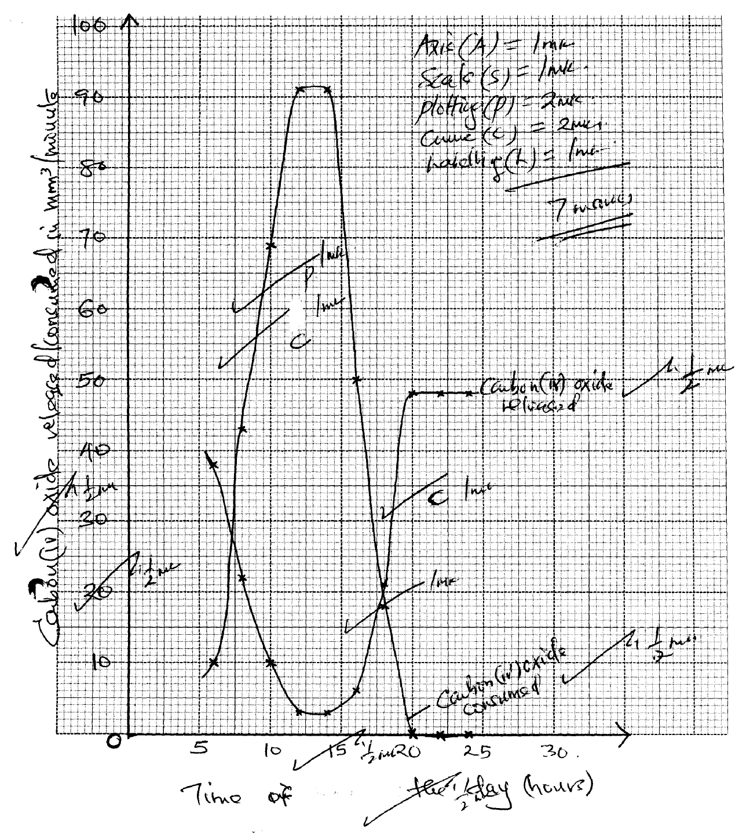 stoma opens

37. (a)

b) i) Photosynthesis;

ii) Respiration

c) i) Rapid increase in amount of carbon (iv) Oxide consumed; As time increase amount of

light increases’, thus increasing rate of photosynthesis

ii) No carbon (iv) Oxide consumed, No light hence no photosynthesis

d) Low amount of carbon (iv) oxide released, carbon (iv) Oxide consumed for

photosynthesis; respiration rate very low

e) i) Point when rate of photosynthesis equals rate of respiration

ii) At 18 hrs

f) It denatures enzymes/ stops photosynthesis; hence consumption of carbon (iv) Oxide

**7. Gaseous exchange in (a) plants (b animals**

1. (a) Gaseous exchange is the movement of gases across a respiratory surface; while

respiration is the biochemical breakdown of food molecules to produce energy (and carbon

IV oxide);

(b) Ethanol/Alcohol;

Carbon (IV) oxide; and energy; (any two )

2. (a) Glycosis;

Krebs cycle;

(b) Krebs cycle; became oxygen is used to oxidize acid to water, Carbon (IV) Oxide and energy;

3. a) anaerobic respiration/fermentation;

b) -baking of bread

-brewing industry

4. Carbon (IV) oxide produced in respiration is utilized in photosynthesis; oxygen produced

in photosynthesis is used in respiration;

5. a) Amount of oxygen required to get rid of lactic acid that accumulates in the body tissues when

oxygen available is lower than the demand

b) Energy/A.T.P/ Lactic acid

6. (a) Germinating seeds respired using oxygen in the conical flask and produced CO2, which was absorbed by the sodium hydroxide solution. A partial vacuum was created in the conical flask. The atmospheric pressure being higher pushes the water down to A and upto B.

(b) RQ – Vol of CO2 produced = 102 = 0.70;

Vol. of O2 used 145

(c) Lipids;

7. (a)

- Complete oxidation of lipids require a lot of oxygen;

- Lipids are insoluble in water hence difficult to transport in the body

- Complete oxidation of lipids take a longer time

(b) Maltose

Lactose

8. a) i) Cytoplasm

ii) Pyruvic acid

b) Pyruvic acid is broken down; into ethanol and CO2

9. a) RQ = CO2 produced

O2 consumed

= 5 ; = 0.83;

6

b) Protein;

10. Bacteria, bacteria/ Symptoms

- Prolonged coughing and vomiting

- Convulsions and coma

- Conjuctival haemorrhage

- Severe bronchopneumonia

Causative agents

Symptoms

11. - Lowers saturation deficit by trapping H2O moisture;

- Protects direct sunlight to the stomatal pore;

12. They form depressions such that when wind blows it does not carry away water molecules.

13. - Increase rate of respiration

- Speeds up the heart beat rate

14. A rat has a large surface area to volume ratio thus loses a lot of energy on form of heat therefore eats a lot to replace the lost energy;

15. a)Glucose water + carbon(iv) oxide + energy/210kj

Or

C6H12O6 H2O + CO2 + ATP (energy) (mark as a whole) 1mk

16. Insoluble hence not easily transported to respiratory sites;

- They require more oxygen to be oxidized;

17. - Making of beer/Brewing/Ethanol/alcohol;

- Baking industry/Raising of the dough:

18. (a) Respiration – Chemical breakdown of food to release energy. p

Respiratory surface – Surface across which respiratory gases exchange.

(b) Circulatory system transports the respiratory gases to and from tissues; hence maintains

steep concentration gradient around the respiratory surface;

19. - Not every soluble/not readily soluble therefore not easily transported to the site of respiration;

- A lot of oxygen is required to oxidize one gram of fat/liquid than one gram of glucose;

20. a) RQ = Volume of CO2 given out = 102 = 0.70;

Volume of O2 used; 145

b) Fats/ oil/ lipid;

Reason: RQ for lipids/ fats/ oils is always less than 0.8; more oxygen is used than

carbon IV produced;

21. (a) Boiling

(b) becomes milky/cloody /precipitate.

(c) Yeast produces enzyme amylase which catalyze breakdown of glucose anerosiccally into

energy (heat)

CO2 and Ethanol

CO2 makes lime water to become cloudy

(d) High temperature donators enzymes, reduces/stops respiration/stops the reaction.

**8. Excretion and homeostasis**

1. i) Ammonia is highly soluble in water and requires a lot of water for excretion hence assists in

the removal of excess ammonia;

ii) All the glucose is reabsorbed at the proximal convoluted tubule;

2. (a) – Excretion;

- Osmo-regulation;

(b) – Glucose

- Amino acids;

(c) – Nephritis;

- kidney stones /Gall stones;

- Hepatitis A and B;

3. (a) Extra long loop of henle; Have fewer and smaller glomeruli;

(b) Salty food increased the salt concentration in blood; Blood becomes hypertonic to kidney tubules; more water is reabsorbed from kidney tubules; hypertonic urine is thus produced;

4. (a) Glucose;

(b) The person was a sufferer of diabetes mellitus;

(c) Pancrease;

5. a) i)insulin;

ii) Diabetes mellitus;

b) Diuresis is a condition which is characterised by production of large volumes of dilute urine;

6. i) urea;

ii) Triethylamine;

iii) Ammonia;

7. a) i) Fresh water; reject water

ii) Desert/ Arid areas; reject land

b) Reduces blood flow to the skin as more blood is stored in the spleen, reducing heat loss

through the skin;

8. a) Ultra filtration;

b) Selective reabsorption;

c) Proteins have large molecular weights hence not ultrafiltrated;

9. Produces sebum to keep hair and epidermis supple and water proof; and protect skin against

bacteria (through antiseptic substances);

10. a) Sweat produced does not evaporate due to high humidity;

b) Body does not cool hence more sweat is produced leading to accumulation;

11. Diabetes mellitus

- Caused by failure of the pancreas to secrete enough insulin;

- High glucose concentration in the blood than normal;

Diabetes insipidus

- Inability of the pituitary gland to secret anti-duretic hormone;

- High concentration of solutes in blood ;

12. Two processes through which plants excrete metabolic wastes:-

-Gaseous exchange;

-Transpiration;

-Shading leaves;

-Production of resins and gums;

-Storage of wastes in seeds/bark/fruits;

13. Has got long loop of henle in order to maximize water reabsorption thus conserving it;

14 .i) urea;

ii) Triethylamine;

iii) Ammonia;

15. (a) i) Fresh water; reject water

ii) Desert/ Arid areas; reject land

b) Reduces blood flow to the skin as more blood is stored in the spleen, reducing heat loss through

the skin;

16. a) Ultrafiltration;

b) Selective reabsorption;

c) Proteins have large molecular weights hence not ultrafiltrated

17. Produces sebum to keep hair and epidermis supple and water proof; and protect skin against

bacteria (through antiseptic substances);

18. a) Sweat produced does not evaporate due to high humidity

b) Body does not cool hence more sweat is produced leading to accumulation

19.

|  |  |
| --- | --- |
| **Diabetes mellitus** | **Diabetus insipidus** |
| -Caused by failure of the pancreas to secrete enough insulin  -High glucose concentration in the blood than normal  - Caused by failure of the pancreas to secrete enough insulin  - High glucose concentration in the blood than normal | -Inability of the pituitary gland to secret anti-duretic hormone  -High concentration of solutes in blood  Inability of the pituitary gland to secret anti-duretic hormone  High concentration of solutes in blood |

20. Two processes through which plants excrete metabolic wastes:-

-Gaseous exchange

-Transpiration

-Shading leaves

-Production of resins and gums

-Storage of wastes in seeds/bark/fruits

21. a) A – medulla; B – Cortex;

b) Cortex;

22. a) Enhances more reabsorption of water; leading production little but conc urine;

b) Reabsorption of water; Na+/CL- ions;

23. a) Aldosterone;

b) Loop of Henle;

c) Positive feed back;

24. - Reabsorption of unuseful substances in the kidney;

- Absorption of digested food from the ileum;

- Removal of metabolic waste products from kidney;

25. a) A D H / Vasopression;

b) Pituitary gland;

c) Diabetes Inspidus;

26. a) - Afferent vessels are wider than effereal vessels;

- Presence of pores on capillary and Glomerula membrane;

- Highly coiled narrow capillaries to reduce speed of flow of blood and increase ;

pressure

27. a) Arid/ semi arid areas

b) Ammonia

c)i) Contractile vacuole

Malpigian tubules

28. - Deamination

- Detoxification

- Breakdown of haemoglobin

29. a)Deamination;

b)-Removal of excess amino acids;

-Availing of energy in the body;

-Formation of glycogen /fats for storage; (award any one)

30. a)diabetes insipidus;

b)antidiusetic hormones (ADH);

31. a) large quantities of dilute urine;

b) Small quantities of concentrated urine ;( renal failure if habitual)

c) Production of urine containing glucose/sugar;

32. (a) Excretion — Separation and elimination of waste products of metabolism from

bodies of living organisms:

Egestion; Removal of undigested materials from food vacuoles/alimentary canals of animals:

(b) Removes waste products metabolism to create/pro’. idea suitable internal environment for

best working of cells

33. (a) N – desert/arid/semi arid;

(b) Small sized glomeruli; to reduce ultra filtration longer loop of henle; to increase

reabsorption of water – conservation of water.

N.B – Reject 12(b) if 12 (a) is wrong.

34. (a) – Organisms whose body temperature varies with the environmental temperature; p

(b) – Reptilia - rej. Reptile;

- amphibia - rej. Amphibians;

35. Glomerulus;

Adaptations of part R

* Coiled to increase the surface area for re-absorption of some glomerular filtrate
* Presence of numerous Mitochondria to promote active transport of glucose, amino acids
* covered by dense network of blood capillary for absorption of useful glomerular filtrate

36. Internal environment is the immediate surrounding of the body cells while external environment is the immediate surrounding of the organism

37.

* Radiation;
* Conduction;
* Convection;
* Evaporation ;

38. a) A – capsular space/ Bowmans capsule;

B – Descending wing of loop of Henle;

D – Glomerula

b) Urea;

39. Ovary; accept ovules

Anthers;

40. a) Detoxification;

b) Liver;

c) Prevents ammonia from accumulating to toxic levels; which would affect body functions;

d) Urea;

e) Excess amino acids are broken down to form amino group; which is combined with

hydrogen atom to form ammonia;

f) It is transported to the kidney; through the renal artery where it is excreted

41. a) platelets exposed to air rupture on damage tissues to release thromboplastin/(enzyme) /thrombokinase; Thromboplastin neutralizes heparin; and activates prothrombin to thrombin;

throbin activates the conversion of fibrinogen to fibrin; which forms meshwork of fibres on the bruised surface;

b) blood clotting is the conversion of soluble blood protein into a mass of tangled threads of

insoluble protein; while haemogglutination is the clumping together of red blood cells; c)haemophilia;

42. a)i)glucose is completely reabsorbed at proximal convoluted tubule back to blood stream;

ii) Protein has molecules hence not ultrafiltered (from glomerulus) to proximal

convoluted tubule); b) Create a steep diffusion gradient; hence higher rate of reabsorption of useful

Substances-glucose/amino acids/sodium and chloride ions from the nephron tubules back to the blood stream;

c) -antidiuretic hormone;

-Aldosterone;

d) nephritis; kidney stones

43. (a) Nephron;

(b) (i) D = Afferent arteriole;

M = Efferent vessel;

(ii) Q = Aldosterone ; G - ADH/ vasopressin.

(c) Red blood cells/white blood cells/ plasma proteins;

(d) This shows that reducing sugar (glucose) was present in urine; the person is likely

to be suffering from Diabetes mellitus;

44. (b) (i) Blood sugar level increased as a result of the glucose being absorbed in the ileum; by

diffusion / or active transport;

(ii) – The blood sugar level dropped as a result of the conversion of glucose to glycogen;

(and fats) by influence of insulin;.

- There was also an increased rate of respiration reducing the blood sugar level;

(c) 90 mg/100ml of blood;

(d) Person B has a defect in the pancreas; He did not produce enough insulin to control the

blood sugar level;

(e) By administration of insulin;

(f) - A constant level of blood sugar ensures optimum levels of metabolism;

- High level will increase the osmotic pressure and that affect metabolism;

- Low levels reduce energy supply in the body tissues and affect metabolism;

(g) - Glucose is used for respiration;

- Glucose was lost in urine;

45. a) Axis

Scale

Plotting

b) i) The rate increases with time;

Because a lot of acid been drunk;

Very little ADH or No ADH produced yet;

No reabsorption taking place;

ii) The rate remain constant

Pituitary not stimulated to produce ADH

Nephrone, less permeable

No water being reabsorbed back to blood;

iii) The rate reduces with time;

Little water remaining in blood; due to a lot of water lost through urine;

No water being taken

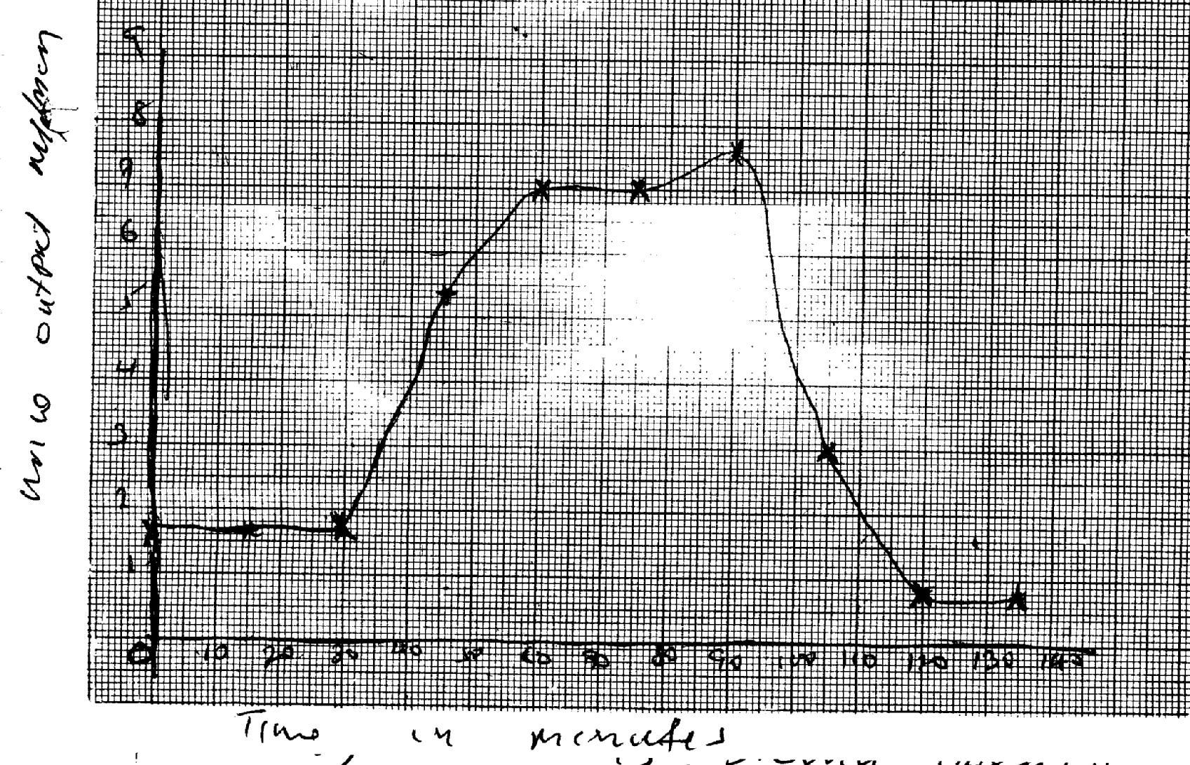 c) ADH; Adosterone

***Urine output ml/mcm***

***Time in minutes***

46. (a) Explain how urea is formed in the human body:

- Excess amino acids are deaminated and the converted into urea in the liver

(b) Describe the path taken by urea from the organ where it is formed until it leaves the human body

- Urea from the liver is carried through hepatic vein into post/in prior vena cava; right auricle,

right ventricle; pulmonary artery into lungs; Pulmonary vein , left auricle; left ventricle; aorta

renal artery; glomerulus’s; into Bowman’s capsule; kidney tubules ascending and descending);

collecting tubule ureter; into urinary bladder , urethra and out of the body in the form of urine.

47. a) B- Bowman’s capsule

C- Loop of Henle

D- Distal convoluted tubule

b)

- have numerous/ many microvilli; to increase surface area for reabsorption

- coded to slow down filtrate for reabsorption

- have many/ numerous mitochondria to provide energy for reabsorption

c) - Active transport

d) Afferent arteriole is wider than the efferent arteriole

(d) Storage of vitamins (e.g. vitamin A, B2 & D)

- Storage of mineral salts (e.g. Potassium and Iron)

- Storage of Blood

- Manufacture of R.B.C

- Manufacture of plasma proteins (Albumen, fibrinogen & Globulin)

- Regulation of amino acids (deamination)

- Regulation of lipids

- Regulation of body temperature (thermoregulation)

- Destruction of worn out R.B.C

- Elimination of sex cells

48. a) X- Thromboplastin

Y- Fibrin

Z-- Thrombin

b) Promotes wound healing; stops further loss of blood/ bleeding; prevents entry of

pathogens/ injection

1. Blood contain leparin/ anti clotting factor eight; that inhibits blood coagulation

49. a) Response of an endotherm to heat grain

i) Subcutaneous of fat little/ localized: to encourage heat loss/ not to impede heat loss

ii) Hair is lowered/ lies flat; by relaxation of erector pilli muscles; insulator reduced/

little air trapped; heat readily lost (by radiation and convector)

iii) Sweating/ panting occur

Evaporation of water absorbs latent heat of vaporization; leaving a cooling effect

iv) Cutaneous/ superficial blood vessels dilate;

Blood flows near skin surface facilitating heat loss

v) Metabolic rate falls/ BMR falls

Less heat generated to avoid overheating

b) Response of Endotherm to heat loss

i) Subcutaneous/ Adipose fat insulates; facilitating heat conservation

ii) Hair raised/ erects; by contraction of erector pili muscle; Insulator increased/ traps

air; facilitating heat conservation

iii) Cutaneous/ superficial blood vessel vasoconstrict blood flows deep in the

dermis; conserving heat

iv) Sweating/ panting stops; little heat is conserved

v) Extra heat is produced; by increase in metabolic rate of liver/ muscles/ shivering/

goose pimples/ animals become more active

50. (a) (i) Efférent arteriole/vessel; (I mark)

(ii) Loop of Henle: (Rj. Wrong spelling) (I mark)

(b) (i) Small sized; Few; (2mrks)

(ii) Large sized: Many: (2marks)

(c) (i) Glucose:

(ii) Diabetes mellitus: (Rej; wrong spelling)

51. High body temperature above normal: sweat glands: produce sweat: water in the sweat

evaporates/ sweat evaporates: absorbing latent heat of vaporization produces a cooling effect.

Hairs lie flat; due to relaxation of erector pilli muscles: no/little air is trapped: [fins increased heat loss from the body; Blood arterioles/vessels; vasodilate/dilates: more blood floss to the skin hence more heat is dispersed by radiation and convection: when the body temperature is low below normal; sweat glands produce less/no sweat: no latent heat is absorbed/more heat is retained in the body; The hairs stand upright/erect: to trap air between them: that insulates the body against at loss; more heat is retained in the body; Blood vessels/arterioles constrict/vasoconstrict: less blood flows to the skin: reduces heat loss/ more heat is retained in the body;

Subcutaneous fat/ adipose [issue; beneath the skin insulates the body against heat loss: more

heat is retained in the body: 22 marks

**9. Ecology**

1. a) Capture –recapture method;

b) Calculate the population of grasshoppers using the above data

FM x SC = 36 x 45; = 405;

MR = 4

2. a) Help to breakdown dead organic matter hence reducing bulk; in the recycling of Nutrients;

b) Regulate the predator – prey population;

3. a) Grass___________ grasshoppers ____________ birds;

b) Not all the energy is transferred from one trophic level to another; some is lost as heat, some

is used up during metabolism and some is lost when organisms die and decay;

4. Autecology is the study of population / study of members of a species;

Biomass is the quantity of matter of a given type of organisms at a given trophic level;

Or the dry weight of an organism;

5. – Availability / adequate food supply ;

- Absence of predations ;

- Absence of disease; (mark the first two pts

6. (a) Habitat – physical location with asset of condition where an organism lives; while

niche is the exact place where an organism occupy and its role in the habitat;

(b) Producers have a greater biomass than primary consumers since they start the food chain.

Inter-trophic energy losses occur in form of heat;

(c) It is non-toxic; It’s organism specific;

7. Reduce oxygen supply and hence suffocation and death of plants and animals, clog respiratory surfaces (gills and stomata) leading to death;

8. (a) Food web;

(b) Three;

(c) Sun

9. a) Microscopic plants- mosquito larvae- small fish- large fish- crocodiles

b) Large fish;

10. a) Owl is nocturnal , white mice are easily seen and predated on, black mice camouflaged/ not

easily predated on;

b) (Theory of) Natural selection;

11. a) Capture recapture method

b) i) P = FM x SC

MR

= 725 + 974;

139

= 5080;

Where FM – First marked

SC – Second recapture

MR – Marked recapture

P - Population

ii) – No fish moves in or out of the area between counts ;

- The marked fish mix freely with other fish populations;

- Marking does not expose the fish to predation ;

- No variation in population size ;

12. D A C B

(b) - Correct label;

- A,B same size;

- C-largest;

- D- smallest;

13. - Protects delicate internal parts from mage;

- prevents excess loss of water (desiccating);

- provides surfaces for attachment of body muscles / organs;

14. a) Grass Grasshopper Guinea Fowl;

Grass Termites Guinea Fowl;

b) - Leopards will decrease;

- Gazelles will also decrease;

c) Grass;

15. Population — all members of one species occupying a particular habitat at a given time;

Community — all organisms belonging to different species that interact in the same habitat;

16. - lay down two ropes parallel to each other a meter apart; count the number of shrubs between

the two ropes at marked points; and record the number; repeat the process several times;

Obtain average number; calculate area of the belt transect.

17. a) Population = FM X SC

Mr

P = 10 X 50 = 500;

4 4

= 125;

b) No entry or exit of fish;

Tags did not influence the general behavior of fish

18. - they decompose organisms; aid in nutrient circulation

19. i) Accumulation of CO2 in the atom

ii) Increase in environmental temperature

* Eratic weather changes

20. - Enzymes amylase digests starch to maltose

- Mucus lubricates food

21. Due to (stiff) competition for available resources which leads to elimination/exclusion;

22. a)feeding level;

b)quaternary consumer;

c)sun/source of energy;

23. Adaptive radiation/divergent evolution;

24. i)crab pop= number marked in 1st catch x total no. in 2nd catch

Number marked(recaptured)in second catch.

= 400x360

90

=1600;

ii) Capture mark release recapture/

Capture-recapture /capture release /recapture;

25. (a) Suck small crawling insects (from tree trunks):

(b) Catching (flying) insects in grass:

26. (a) Used for the collection of flying specimens such as butterflies;

(b) Used for sucking small insects from barks of trees and under stones; p

(c) Used for trapping crawling insects such as termites; p

27. 1. Competition; p

2. Emigration; p

3. Predation; p 4. Parasitism;

28. (a) Biotic and abiotic factors (2x ½ =1mk)

(b) - Feacal analysis

- Type of dentition type of beak (2 x1=2mks)

29. X – denitrifying bacteria/

Y – Animals/ herbivores; accept primary consumers

Z – Nitrogen fixing bacteria (in soil) accept Azotobacter

30. a) Check graph

* Labelling axes;;
* Scale
* Plotting;
* Joining (smooth contineas);
* Identifying the graph;

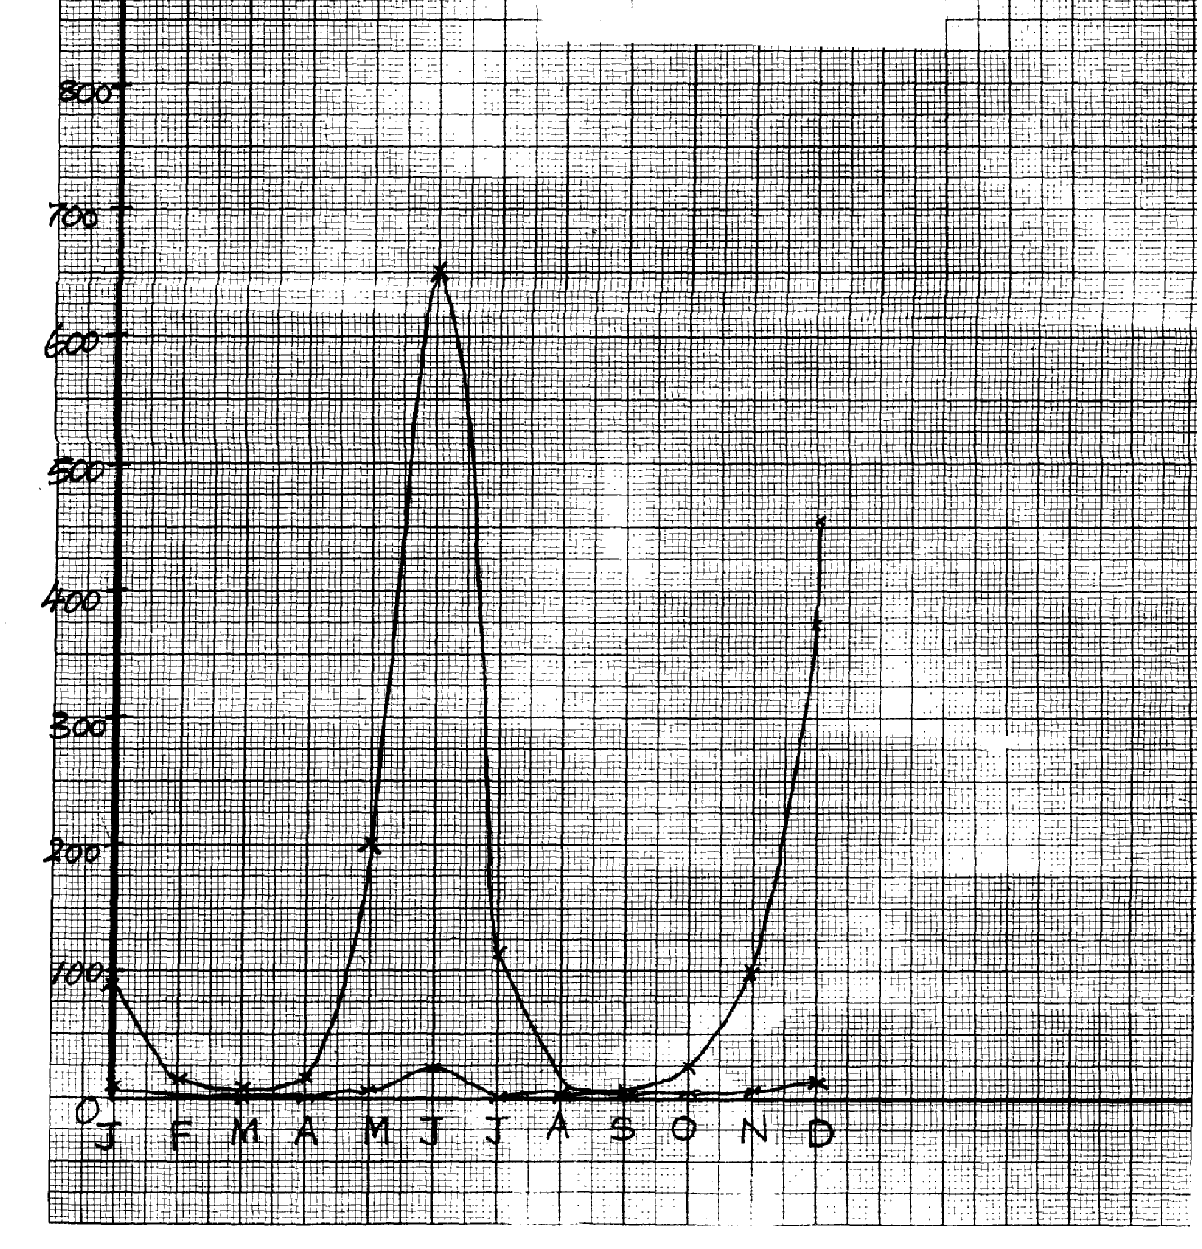

b) i) The population of locusts increase with increase in that the amount of rainfall;

ii) – Increased amount of food;

* Improve breeding conditions;

c) - The population of both decreases

- Less food availability for locusts and hence crows;

d) i) Quadrat method;

ii) total counts

e) i) locusts ____ primary consumers;

Crows ______ secondary consumers;

ii) Grass ____ Locusts ________ crows;

f) - Grass would increase;

- Crows would reduce;

g) Wild animals are browzers hence obtain food while cows are grazers hence lack grass

h) Biomass is the total dry weight of organisms at a particular trophic level;

31. (a) (i) Antelope A;

(ii) Reason- Rate of multiplication /reproduction is higher in species A than B;

(b) (i) Sigmoid curve /ogive/s-shaped curve;

Accept any one correct

(ii) PQ- Lag phase /slow growth phase; QR- Exponential/log / rapid growth phase;

RS – Deceleration phase ST- Stationary/constant growth phase;

(c) (i) Q and R

Marked with rapid population growth rate; many mature reproducing organisms/individuals/antelopes;

Absence of environmental resistance;

(ii) S and T - Growth rate stagnant/birth rate equals to death rate; the ecosystem has attained

its carrying capacity/environmental resistance (density dependent) have set-in;

(d) (i) Interspecific;

(ii) Thin and tall; yellow/pale green; low yield

(e) By occupying different (ecological) niches;

(f) Move swiftly to escape predators; camouflage to avoid noticed by predators; Eyes on the

side of the head to give them a wide field of view enabling them to keep track of their enemies;

(g) Capture –recapture method,; direct count,

Aerial photography

32. Water- The availability of adequate amounts of water lead to plant growth which

provides food for animals. In aquatic environment, wateris a medium in which gametes are released thus lead to continuity in procreation.

Temperature- Influences the rate of enzyme catalyzed reactions. Therefore, it exerts an influence on almost all activities of plants and animals such as respiration, photosynthesis, growth, transport e.t.c.

**Light**-Is necessary in plants for photosynthesis as it influences flowering of a wide variety

of plants, affecting opening and closing of stomata, affect the rate of transpiration.

**Salinity-** Is the salt content of eater. It varies in aquatic habitat. Fresh water organisms suffer the

risk of loosing water.

**Humidity** – Determines the amount of water loss from a bodies animals and organs of plants;

high humidity means less evaporation; and low humidity means high rate of

evaporation and transpirations;

**pH** – It determines if water habitat is acidic or alkaline; PH has a great influence on

physiological function of organisms affects enzyme concern reactions since

enzymes operate within a narrow pH ranges

**Wind**- Wind came physical damage to plants; increase rate of transpiration as air blows

away; causes migration of insects; wind having gases may acid rain in a region;

wind is an agent of pollination and dispersal;

33. (a)

Grasses Caterpillar Frogs Snakes Hawk

Grasses Squirrel Hunting dogs Hawk Vulture

Grasses Elephant Vultures

Grasses Caterpillar Snake Hawk

(b) Pyramid of numbers.

(i)

Or;

(ii)

(c) Effects of removing the hunting dogs.

- Increase in number of gazelles and squirrels due to reduced predation leading to

increased pressure upon the grass;

(d) During transfer of energy at each feeding level, some amount of energy in form of heat is

lost only about 10% would be transferred from the grains to steers and out of the 10 %

about 1 kg would be transferred to man. The rest would be lost as heat or ingestible

material.

34. a) i) Slugs; mice;/ Amphids/ caterpillar

ii) Primary consumers;

b) i) plants _________ mice _______ snakes __________ Hawks;

Plants ________ Caterpillar ________ insectivorous birds _______ hawks

c) Plants ;_________ directly obtain energy from the sun

Hawks – Loss of energy in form of heat; through process of respiratal/ defaecation/ excretion

35. a) A lot of food causes population increase due to high rate of reproduction and immigration resulting in completion for food/ death/ emigration; reducing population; little food leads to competition; leading to emigration/ death; reducing population

b) Energy from the sun is trapped by green plants; during photosynthesis; producing chemical energy/ carbohydrates/ food

Green plants are producers/ 1st trophic level; Green plants are eaten by herbivores which are primary consumers/ occupy the second trophic level, when plants dies and animals die organisms die; saprophytic fungi/ bacteria/ micro organisms feed on them; thus decomposing them into smaller/ simpler substances/ they are decomposers/ detritivores; At all levels some energy is lost; through respiration

36. a) A- Ovary

B- Oviduct/ fallopian tube

C- Uterus/ uterine wall

D- Cervix

b) Produce ova

Produce femme hormones/ Estrogen and progesterone

c) - Highly vascularized to supply nutrients to foetus/ drain away excretory wastes

- Inner wall lined with Endometrium for implantation of fertilized egg/ zygote

- Muscular for peristalisis to expel menses during menstruation/ parturition

- Great capacity to expand during gestation to accommodate developing foetus

d) -copulation/ Achieve orgasm in Human male followed by ejaculation

- birth canal

37. a) use the capture -recapture method; capture the grass hoppers; count; and mark using

permanent ink; record; releases; and allow time(1-24hrs);recapture and count the marked and unmarked;

Total population is equal to the number marked and unmarked grasshoppers in the second sample X number of marked grasshoppers in the first sample ; divided by number of grasshoppers marked in the second sample that were recaptured;

Acc P= FMxSC

MR

where FM-1st captured

SC-2nd capture(marked and unmarked

MR-marked recaptured

(rej. ½ mark i.e. 10/2=5) acc specified distance apart e.g. 3m apart

b. run two ropes parallel to each other a meter apart; counts of shrub are made between the two ropes at marked points/whole belt (and recorded);report the process severally(at least 3 times);calculate shrub area of the belt transect; calculate shrub population for whole area;

Rej all shrubs counted

NB shrub pop=average shrubs per transect x total area of grassland

Average area of belt transect (max 3)

38. (a) (i) Phytoplanktons:

(ii) Hawk; and water snake:

(b) - Decrease in phytoplanktons:

- Increase in population of small fish:

(c) Hawk;- Top predator amount of energy decreases in successive trophic level/energy is lost

through respiration; undigested/unconverted food:

(d) Residue is poisonous to man;

-Kill non- targeted organism / Beneficial organisms:

-Remains for along time in the ecosystem / pollutes environment:

(e) (i) Causes decomposition/Recycling of nutrients:

(ii) Root nodules: have bacterial / Rhizobium sp: to convert free nitrogen: into nitrates in the

soil;

(f) Capture - recapture: capture release recaptures:

(g) Manufacture food: (OWTTE) to be used by themselves: and all other organisms in the

ecosystem ( awls)

39. Broad/ wide lamina: to Provide a large surface area to trap maximum sunlight or

photosynthesis;

- Thin lamina; to reduce the distance covered b\ light and carbon (iv) oxide: to reach the

photosynthetic cells/ palisade cells;

- Cuticle; is transparent to allow light reach photosynthetic cells:

- Waterproof climatic cuticle: to reduce water loss/Transpiration:

- Numerous stomata: efficient gaseous exchange: palisade (mesophyll) cells: have numerous

chloroplasts: for maximum photosynthesis: spongy mesophyll cells: are irregular in shape

creating large air spaces between: for efficient /free circulating air; Lear veins; have x 1cm 1r

transport of water and mineral salts: and phloem for transport of manufactured food;

- Leaf mosaic: to maximum trapping of sunlight for photosynthesis:

- Guard cells: to control opening and closing stomata: Guard cells have chloroplasts for

photosynthesis:

**10. Reproduction in (a) plants (b) animals**

1. a) i) integuments ;

ii) Primary endosperm nucleus;

b) This is fruit development without fertilization;

2. - Secretion of progesterone and oestrogen;

- Controls exchange of material between maternal and foetal blood;

- Prevents entry of pathogens from the maternal to the foetal circulatory system;

3. – Sexual intercourse with infected persons;

- Transfusion with infected blood;

- sharing contaminated needles;

- Infected mother to child through breastfeeding;

- Contact with infected blood/body fluids through cuts or wounds; (mark the first 3 points)

4. (a) Par thenocapy;

(b) Ethylene;

(c) Promoted differentiation of adult features;

5. – Site for fertilization;

- Conducts on a from ovary to the uterus;

6. (a) X – Polar nuclei; Y – Egg cell;

(b) – Results to variation; that makes the plant to be adapted for survival;

7. (a) Chiasma; reject – chiasmata

(b) (i) Provide a chance for the exchange of genes (along the portion of chromosome);

(ii) Meiosis;

8. (a) When they can freely interbreed to produce fertile/viable offspring;

(b) Is the occurrence of two distinct reproductive forms in the life cycle of an organism; the

diploid sporophyte phase and the haploid gametophyte phase;

9. (a) Acquired characteristics are not inherited/inherited characteristics are found in

reproductive cells only;

(b) Mutations bring about variation which when advantageous can be passed on from one

generation to the next; and this can lead to emergence of new species;

10. (a) Gaseous exchange; means through which foetus get nutrients from the mother;

offers a means for elimination of wastes by the foetus; supplies antibodies to the embryo

from the mother; secrets progesterone hormone that maintains pregnancy;

(b) because testerrone is transported through the blood

11. – Protandry

- Protogyny;

- Self sterility/incompatibility

12. – Ability to pollinate;

- Ability to photosynthesis;

- Ability to disperse seeds/fruits;

- Ability to absorb water and mineral salts from the soil;

13. (a) Fusion of one male nucleus with an egg cell to form a diploid zygote; and fusion

of the other male nucleus with two polar nuclei to form tripoid endosperm;

(b) – Are brightly coloured to attract insects

- Have seed coat that is resistant to digestive enzymes

- Have hooks for attachment to passing animals

- Are freshly/succulent to attract insects

14. a) Oxytocin;

b) Progesterones;

on different individual plants;

-some plants are self –sterile in their pollen grains transferred to stigmas in the same plant fail to germinate;

-in some plants stamens and carpel on the same plant mature at different times;

-in many plants the stigmas are located higher than the anthers;

15. -some plants are dioecious which means that staminate and distillate flowers are borne

16. a) A – Has umbilical vein and artery to supply foetus with nutrients and removal of waste

products; √

B – Protects embryo from shock/regulate temp. of developing embryo/ suspends and supports

embryo;

b) Foetus head is turned towards the cervix; √

c) To supplement iron synthesized by the mother since it (iron) is needed for haemoglobin

formation in the foetus; √

17. i) Marginal; √

ii) Free central; √

18. a) Cypsela b) Animal

19. i) Production of the hormones progesterone and oesterogene continues;

ii) These hormones inhibit the production of follicles;

Stimulating hormone (FSH) and lutenising hormone (LH);

iii) This inhibits the maturation of more follicles;

20. a) It brings about useful variations which make the off springs better adapted for survival b) i) 33;

ii) 11;

21. a) A – Antipodal cells; B - Embryo sac; D- Synergid ; b) Double fertilization

22. They cannot freely interbreed to produce a viable /fertile offspring OR- do not have hereditary

distinction to interbreed to produce a fertile viable offspring;

23. Adverse temperature , wind/air current, pH, light noise ;

24. (a) (i) Epigynous –a condition where other floral parts arise/positioned above the ovary

/inferior ovary

(ii) Staminate flower – Male flower (accept – has stamen only / male parts only );

(b) Meninges;

25. (a) Yeast ; (b) Budding;

26. – Through breast feeding if mother’s nipple and baby’s mouth have rushes/wounds

- During delivery;

- During pregnancy;

27. a) Production of spindle fibres

b) i) Absorbs light energy; which is used to break down water molecules into O2 gas and

H+/ atoms ;

ii) Glucose;

28. a) Prophase I ; Reject prophase alone

b) i) There is crossing over of genes that leads to variations;

ii) Leads to formation of gametes;

Brings about genetic variation;

It helps retain a constant diploid chromosomal constitution in a species at fertilization;

29. a) Stamens hanging outside the flower; large anthers loosely attached to flexible filaments;

Large amounts of small; light and powdery pollen grains to be easily blown by the coid;

b) Monoecious plants have both male and female flowers bone on separate plants;

30. a) Inability of seeds to germinate despite all the conditions necessary for germination are

provided;

b) Scarification;

Increase the concentration of hormones which stimulate germination/ increase auxin conc;

Allow the embryo to mature before planting seeds;

Remove germination inhibitors;

31. a) Allows the adult to reproduce;

Allows the species to disperse in order to colonize new habitats;

b) Leads to the formation of the larval cuticle;

32. - Hot water kills organisms in the water;

- Reduces oxygen content in the water leading to suffocation;

- Chemicals in the element may lead to entrophication;

33. - Chances of fusion of gametes are low

- Large amounts of gametes are produced leading to wastage

- Changes of survival of the young ones are low since there is lack of parental care

34. - Allow nutrients to pass from mother to Foetus

- Allow diffusion of excretory products from Foetus to mother’s blood for excretion

- Produce hormones Oestrogen & Progesterone / that retains pregnancy.

- Prevents passage of foreign particles e.g. pathogens.

35 . a) i) prophase I

ii) Chiasmata Formation / cross over

b) _Ovary

- Anthers

36. - Ensures no competition for dispersal;

- Survival of pupa stage;

37. **Mitosis Meiosis**

- Two diploid daughter cells are formed - Four haploid daughter cells are formed;

- No crossing over - There is crossing over because of chiasmata; formation;

- Takes place in one cell division - takes place in two cell division;

- Leads to growth - leads to gamete formation

- Takes place in somatic cells - takes place in reproductive cells;

38. Due to (stiff)competition for available resources which leads to elimination/exclusion;

39. i) healing and repair of the uterine wall following menstruation stimulates the pituitary

Gland to secrete L.H; (award any one)

ii)-cause ovulation

-changes the remnants of graafian follicle to corpus uteum;

-initiates secretion of progesterone; (award any one.

iii)-accelerates growth and maturity of graafian follicle;

-stimulate the graafian follicle to secrete oestrogen; (award any one.)

40. (a) A - Syncarpous: B- Apocarpous; Rj: Wrong spellings

(b) A fused ovaries B — separate ovaries:

(c) Hinder self pollination? fertilization:

41.

|  |  |
| --- | --- |
| Sperm | Ovum |
| - Spear shaped.  - Posses a tail.  - Has acrosome .  No vitelline membrane. | * Spherical shaped * No tail * No acrosome * Has vitelline membrane. |

42. (a) anthers; (b) – tube nucleus; - Generative nucleus;

43. (a) – Metaphase 1; rej. Metaphase.

(b) - Homologous chromosome arranged on the equator;. p

- Spindle fibres formed and attached at the centromere of the chromosome;

44. Progesterone;

45. - Seed dormancy allows the plant to escape harsh conditions of the environment

- It also allows time for the seed to disperse;

- Seed dormancy allow time for the seed to fully mature (after ripening period);

46. (i) - A fruit has two scars while a seed has a single scar

- Fruits are covered by epicarp while seeds have seed coats/testa

(ii) Biological control helps to prevent pollution f the environment

47. (a) Site for sperm formation (b) For nourishment of sperm cells /support

48. (a) Ovary; anther (b) Small/light/smooth

49. - Self sterility;

- Dioecious plants;

- Protandry and protogyny;

50. In birds the embryo develops externally. It is totally dependent on food stored in the egg for

its nourishment; In mammals the embryo receives nourishment from the mother through the placenta

51. Pollination is the transfer of pollen grains from an anther to a stigma;

Fertilization is the fusion of the nucleus of a male gamete with the nucleus of a female

gamete to form a zygote;

52. a) Water dispersal

* Such seeds and fruits enclose air in them to lower their density for buoyancy;
* They are fibrous/ spongy to lower the density for buoyancy;
* Have impermeable seed coat or epicarp to prevent water from entering during flotation so as to avoid rotting;
* The seeds can remain viable while in water and only germinate while on a suitable medium;

Wind dispersal - They are light; and small; to be easily carried by wind currents due to lower

density;

* Have developed extension which create a larger surface area; so as to be kept afloat in wind currents e.g. * Parachute like structures;

* Wing like structures;

Animal dispersal - Brightly colored to attract animals

-Fleshy to attract animals;

- Some have hook like structures to attach on animals fur

Self dispersal - They have weak lines on the fruit wall along which they burst open to release

seeds, which get scattered. This occurs when temperature changes suddenly

b)

* The zygote formed when egg nucleus fuses with one male nucleus develops into the embryo of a seed
* The triploid nucli develops into the primary endosperm of the seed
* The inner and outer interguments develops into the seed testa
* The ovary wall differentiates into epicarp, mesocarp and endocarp forming a fruit
* The ovule then develops into a seed
* The corolla dries up and withers away
* The calyx may persists shortly as it photosynthesis but afterwards , shrivels, dries and withers away
* The Androecin shrivels,dries and withers away
* The stigma together with the style shrivels, dries and withers away

53. Wind dispersal.

* Parachute of hair, increase surface area to be carried by wind /float
* Wing like structures, increase surface area to be carried by wind /floats.
* Small/light, seed/fruits to be carried by wind have censor mechanism/split open particularly and shaken by wind to throughout the seeds.

Animal dispersal

* Juicy/succulent/fleshy, to attract animals; hooked; to stick on animals bodies and be carried away.
* Hard seed coat; to resists digestive enzymes. Hence come out a long with feaces/dropping of animals.
* Brightly coloured; to attract animals that carry them away.
* Scented; to attract animals that eat and scatter their seeds.

Water dispersal;

* Fibrous fruit wall/mesocarp with air spaces to store air hence make them buoyant/float in water;
* Air floats make them buoyant/float on water.
* Self dispense mechanism
* Fruits dry and crack/open violently along the lines of weakness throwing away the seeds.

54. (a) Pituitary gland

(b) (ii) Testerone

(iii) Follicle stimulating hormone

(v) Leutinising hormone

(c) Sterility/lack of spermatogenesis. Failure of secondary sexual characteristics.

(d) Inhibit production of F.S.H

Inhibit production of L.H

55. (a) I – F.S.H (Follicle stimulating Hormone);

II- Lutenizing Hormone (LH);

III. – Androgen/Testerone/male Hormone

(b) Progesterone;- brings about protogenetion/development/thickening of uterine wall;

(c) A – Inhibition of L.H

B – Stimulation of L.H

(d) – Growth of hair on the armpit and pubic region; - Development of pimples on the face;

56. (a) Role of spleen in human defense mechanism:-

- Form lymphocytes which ingest pathogens present in the blood;

- Produce antibodies; which neutralizes poisons produced by the pathogens

(b) Ways of controlling HIV spread:

- Testing and transfusing blood free form the HIV

- Avoid sharing of cutting instruments (OWTTE) any two

(c) Meaning of the word Acquired Immuno Deficiency Syndrome:

- Development of lack of immunity system resulting to various chains of infections

(d) Reason for encouraging vaccination prevent/control infection which is better/cheaper than

treatment

(e) Is acquired when an individual is infected and naturally produces immunity and recover

from the infection

57. Seeds and fruits are adopted to the various methods of dispersal:-

Water dispersed fruits and seeds;

* Mesocarp fruits has air spaces thus light/buoyant to float; therefore carried away by water; seeds are protected from soaking by water proof pericurp / testa;

Animal dispersed fruits/seeds;

Presence of hooks for attachment to animals thus carried away to other places; fruits are also brightly coloured;

-Succulent; aromatic /scented to attract animals; the seed coats are hard and resistant to digestive enzymes; the seeds are therefore dropped away in feaces/droppings’

Self dispersed seeds/fruits/explosive mechanism;

* The dry pods/fruits splits along line of weaknesses/sutures; scattering seeds away form parent plant;

Wind dispersed fruits/seeds;

* censer mechanism; open/split; to disperse the seeds. Perforated capsule is usually loosely attached to stalk / long stalk is swayed away by wind scattering seeds;
* Presence of hairs /wing-like structures/floss/extension which increase surface area for buoyancy; making it easy for fruits/ seeds to be blown away;
* Fruits /seeds are light due to small size; therefore, easily carried away by wind;

58. a) A- Ovary

B- Oviduct/ fallopian tube

C- Uterus/ uterine wall

D- Cervix

b) Produce ova

Produce femme hormones/ Estrogen and progesterone

c) - Highly vascularized to supply nutrients to foetus/ drain away excretory wastes

- Inner wall lined with Endometrium for implantation of fertilized egg/ zygote

- Muscular for peristalisis to expel menses during menstruation/ parturition

- Great capacity to expand during gestation to accommodate developing foetus

d) -copulation/ Achieve orgasm in Human male followed by ejaculation

- birth canal

59 . a) chorion; Rej Amnion/Amniotic membrane.

b) i) A: (umbilical Artery; Rej Arteriole

B: (umbilical vein; Rej venule

ii) More food nutrients; more oxygen in umbilical vein/less food nutrients; more excretory

products in umbilical Artery;

Rej.(ii)if (i) is wrong

Rej oxygenated/deoxygenated

c) highly vescularized;

-large surface area; acc. Numerous villi for large surface area

-presence of secretory cells/are glandular; any 2 Rej. Source of hormones.

d) cushion /absorbs shock/buoyancy;

]

60. (a)

b) i) 30min/aftter every 30min; Rej if no units

ii) 20.4 -20.8mm;

iii)105min-106min; Rej after 105/106 min.

iv) 0 + 120minutes

growth fast/growth rapid /rate of growth rapid/growth rate pattern rapid;

Rej. Exponential growth

reason: pollen tube young/has enough nutrients in culture;

to 180 minutes- grows slowly /rate of growth decline /decrease/growth rate pattern

decrease;

reason: pollen tube mature/old/has exhausted nutrients;

v) directs role gametes/nuclei/nucleus to ovules; Rej. Ovary/pollen grains for male gametes.

c) integument develop/changes to-seed coat/testa;

zygote-embryo;

triploid nucleus-endosperm;

ovary wall- pericarp;

ovary- fruits;

ovules-seeds;

corolla/petals/style/stamens/filament-dry out /fall off /wither(losing a scar);

calyx may persist(dry up &fall off) Rej. die/disappear.

**11. Growth and development in (a) plants (b) animals**

1. a) Moulting hormone/ ecdysone

b) It allows growth to take place; since growth can not take place in the presences of the

2. a) Long sightedness/ hypermetropia ;

b) Convex/ converging lenses;

3. (a) – Excretion;

- Osmo-regulation;

(b) – Glucose

- Amino acids;

(c) – Nephritis;

- kidney stones /Gall stones;

- Hepatitis A and B; (mark first 2 pts (2mks)

4. (a) Intermittent growth curve;

(b) Moulting;

(c) Ecdysone;

5. Natural immunity is inherited /transmitted from parent to offspring; Acquired immunity

is developed after suffering from a disease or through vaccination;

6. A – Cell elongation/expansion ;

B – Cell division/multiplication ;

C – Cell différentiation/maturation ;

7. Continuous variation shows gradation in characteristic with intermediate; discontinuous shows distinct characteristics between organisms with no intermediate groupings;

8. a) to investigate the effect of the force of gravity on the growth of a seedling

(shoot and root);

b) Force of gravity cause accumulation of auxins on the lower side of the seedling

- Higher concentration of auxin will promote growth in the shoot but inhibit growth in the

Roots;

- There will be more/ faster growth on the upper side of the root than on the lower side hence

the downward bending;

-There will be more/ faster growth on the lower side of the shoot than on the upper part hence

the upward curvature;

9. i) Between xylem and phloem;

10. Growth – Increase in size of an organism or its parts due to synthesis of protoplasm

Development – Differentiation and formation of various tissues to perform specialized

functions;

11. - Reduce competition between the young ones (larvae) ;

- Avoid predation of the young ones as they are different ;

- The pupa stage can withstand harsh environment by being inactive;

12. Disadvantages of exoskeleton;

– Limits growth

- heavy to the insect;

13. Primary growth results form the activity of primary/embryonic tissues/apical meristems and

lead to increase in height, while secondary growth result from activities of secondary meristems; /cambium and leads to increase of girth/diameter /circumference;

14. i) — Oxidizes food to release energy needed for germination;

ii) — Stores food for the seed;

- Stores enzymes;

15. .- Selective weeding

- Ripening of fruits

- Parthenocorpy

Reject Prunning of coffee and tea

16. - -Contraction of muscles

- Formation of bones

17. allow growth to the place;

(ii) Grain/cotyledon remains underground below the soil level: (I mark)

18. (a)(i) Hypogeal;

(b) Photosynthesis; OWTTE

-Gaseous exchange; accept. Transpiration.

19. (a) Effect of unilateral/unidirectional light on shoots:

(b) Seedling/shoots growth towards light’ growth curvature towards light;

20. (a) Intermittent growth;

(b) Moulting /ecdysis;

(c) Ecdysone rej. Moulting hormones;

21. (a) Divide giving rise to more vascular tissues – phloem and xylem; hence leading to secondary

growth/thickening of the stem;

(b) They lack vascular cambium;

22. - It has chondrionic villis to increase surface area for excahgne of materials

- Has thin epithelium for rapid exchange of exchanged substances

- Has counter current flow of foetal and maternal blood to enhance speed diffusion gradient.

- Highly vascularised (dense network of capillaries) for faster transport of exchanged material

23. (a) For oxidation of stored food;

(b) Breakdown and oxidation of food

24. (a) (i) osmotaxi/cremotaxis

(ii) phototaxis

(i)Sensory neuron

(ii) Direction of nerve impulse

(iii) Schwarn cell

(iv) insulate the axon/Speed up transmission of impulses

(c)

|  |  |
| --- | --- |
| Reflex action | Conditioned reflex action |
| Single stimulus to bring about response.  Simplest form of behaviouir and is independent of experience  Sensory and mother component are the same at all times | Repeatal stimulus to bring about response  Involves modifications of behaviour and dependent experience .  Primary sensory component is repeat by a sensory component bat the motor.  Component remains unchanged. |

25.

(a) To absorb carbon (IV) oxide;

(b) to provide moisture to germinating seeds;

(c) (i) (Left – right direction );

(ii) Oxygen in the tube is taken up by the seeds for germination; the Carbon (IV Oxide

Produced during respiration and the one in the tube reacts with potassium hydroxide

pellets; lowering the pressure inside the set-up; the higher pressure from outside the tube

forces the dye in the direction shown;

26. (i) Lag phases; Dry mass increases slowly; became in plant has not developed

leaves; for photosynthesis hence is depending on stored food;

(ii) Expontial phase; Rapid growth /increase in dry mass, leaves developed; photosynthesis taking place leading to accumulation of food and rapid cell division / plant adapted to the environment

(iii) Death phase/ senescence; Negative growth/decrease in dry mass as some tissues die after reaching maximum maturity; Fall in photosynthesis activity; toxic wastes poison tissues;

(c) (i) When dry mass was first recorded/at germination

(ii) Dry mass would decrease first because food is oxidized to produces energy; water and

carbon dioxide/utilized in respiration;

(d) (i) Harvest every week about five seedlings; dry in oven to a constant dry mass; Calculate the average mass for one seedling and record the results.

(ii) Advantage; Dry mass is not affected by environmental conditions while fresh weight is

dependent on the amount of water in the plant which fluctuate with environmental factors

affecting transpiration rate.

27. a)klinostat/clinostat;

b)i)the radicle remains /grow horizontally;

ii)rotation of klinostal causes uniform distribution of auxins/ indoleacetic acid; hence

uniform growth/clongations (no curvature formed); c)the experiment repeated but with stationary klinostat;

d)-(tropism)enable plants to get water-hydrotropism;

-chemotropism aids plants in fertilization and nutrients absorption;

-thigmotropism enable weak plants to obtain support

-phototropism enable plants to obtain light for photosynthesis;

-geotropism enables the roots grow down the soil towards the centre of the earth thus

providing support to the plant

28. a)graph

-axes have to be labelled- ½ mk@-1mk No axes marking stops there.

-scale-should be appropriate and workable- ½ mk @-1mk

-plotting correctly-1mk@*RCH*∗wrong scale stop marking.

-curve-smooth and not extrapolated beyond 3 small squares- ½ mk@-1mk

-identity- ½ mk each-*RCH*

Note/ -axes reversed-award only for identity

-no origin-award only for one scale/vertical one.

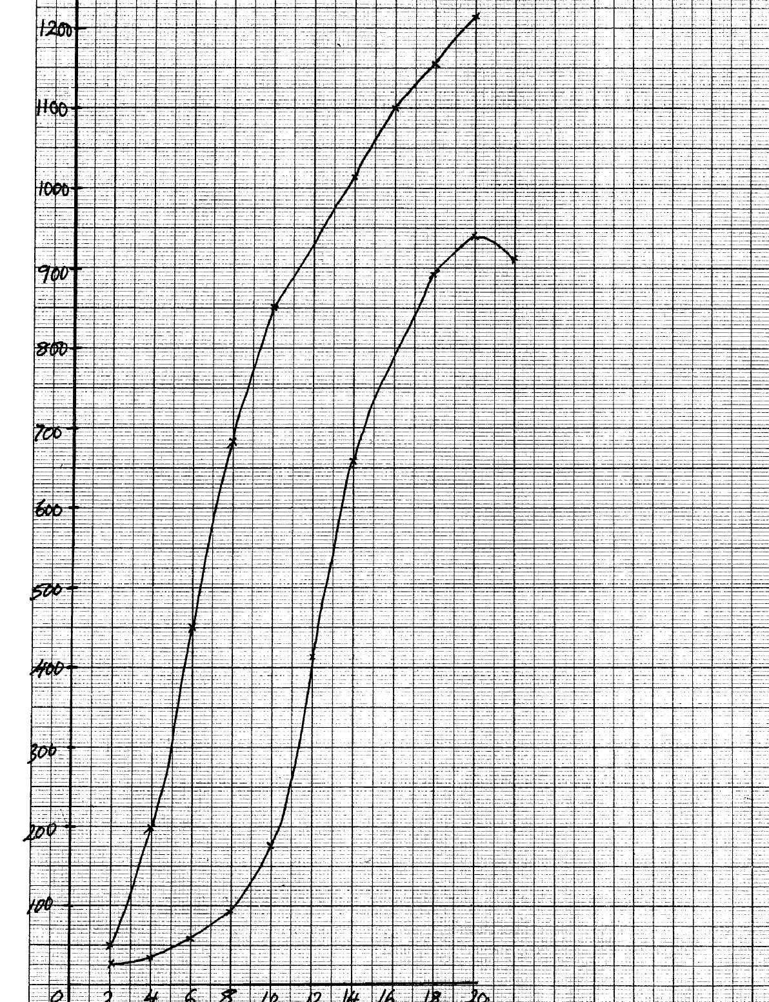

***Average dry weight in grammes***

**Bamboo**

**C**

**C**

Maize

**P**

**P**

***Time in weeks***

b) i)bamboo;

ii)(bamboo)have higher average weigh

c) i)average height of maize plant between weeks 14 and 18 constant (at 2.1m); maximum

height attained; average weight increased; because there was slight increased in the girth;

ii) dry weight represents the actual dry matter/fresh weight includes weight of water;

iii)-average height was determined by measuring the length; of the plants at various intervals;

-average dry weight was determined by heating the plants to exclude all the water; and then

taking their dry weights;

d) both height and weight are used to show rates of growth;

e) lacks cambium(tissue)hence no secondary thickening;

29. a) Fusion of an egg cell nucleus with sperm cell nucleus; to form a zygote

b) i) Meiosis

ii) In the testis/ testes/ ovary/ ovary

c) i) There is increased blood supply causing thickening of the uterine walls;

ii) Capillaries break up/ endometrium is lost with some blood/ menstruation occurs

d)

* Large number/ numerous blood vessels to increase surface area for exchange of materials
* Thin membrane for faster diffusion across it
* Has villi to increase surface area for diffusion
* Special cells to produce hormones
* Membrane selectively allows materials across it

30. a) Number of seeds that germinate X 100 = % seed germination

Number of seeds planted

b) Seeds dry mass would have resulted in death of embryo thus no germination

c)i) Mean seedling fresh mass include the mass of water that has not resulted from growth

ii) At regular intervals of time; uproot seedlings (say five each) dry to constant weight,

and record

d) Directly proportional / Increase in seed mass results in increase in % seed germination,

survival and seedling fresh mass

e) Embryo well developed/ Embryo very mature;

- Large food reserves for growth and development

30. a) Directly proportional/ increase in enzyme concentration results in increase in

reaction rate

b) i) Increase in substrate concentration results in increase in reaction rate

Increase in concentration results in more active sites occupied by substrate

molecules, resulting in higher turn over

ii)A rate of reaction constant/ does not change

Active sites fully occupied

iii) Sharp decrease in reaction rate

Enzymes denatured

c) PH/ Enzyme inhibitors/ Enzyme co- factors

31. a)

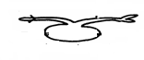

b) the rotation of the machines/ klinostat ensured equal distribution of Auxins in the

seedling (upper & inner) side;

c) Klinostat;

d) radicle grow dominants; plumule grow upwards;

e)

|  |  |
| --- | --- |
| STIMULI | RESPONSE (name) |
| light | Phototropism; |
| gravity | Geotropism; |

32. (a) (i) Carbam inohaemoglohin:

(weak) Carbonic acid: (2marks)

(ii) Oxyhaemoglobin; (I mark)

(b) Secretes pleural fluid:

- Makes lungs air tight:(OWTTE) (2marks)

(c ) Carboxyhaemoglobin doesn’t dissociate readily (OWTTE):

Hence its formation reduces the capacity of haemoglobin to carry oxygen to time lungs

hence resulting in death: (2marks)

(d) Cuticle: lenticels: (Both to be correct to score I mark) (I mark)

33. (a) Region of rapid growth / cell elongation in a radicle: root

(b)

(c ) Dense cy1oplasms

Lack cell vacuoles

Thin cell walls

(d) -Presence of germination inhibitors / abscicic acid:

- Low concentration of hormones / Enzymes/ gibberclic acid:

- Impermeable seed coats to water and oxygen:

- Embryo not fully developed:

**12. Genetics**

1. a) BB;

b) AA;

2. a) Black mice are better adapted camouflage with the environment hence less are eaten by the

owls compared to the white mice which are easily seen;

b) Theory of natural selection;

3. - Heterostly – stigma located above anthers;

- Self sterility or incompatibility – pollen grain from the same plant do not germinate

- Protandry – Male parts mature before female parts;

- Protogyny – Female parts mature before male parts;

4. (a) Complete dominance is when an alliele completely surprises another intermediate fruits;

Incomplete dominance is when heterozygous organisms show an intermediate trait;

(b) Genetic recombination’s of alleles reading to variations; Independent assortment of

chromosomes;

Random fusion of gametes; mutations;

Environment (may either enhance or suppress expression of a gene);

5. (a) C-A – G – U – C _ A ;

(b) – Stones genetic information (in a coded form);

- enables transfer of genetic information unchanged to daughter cells through replication);

- Translates genetic information into characteristic of an organism 9thorugh protein synthesis);

6. Ability to pollinate; response to stimuli (tactic) nastic or tropics); Ability to exploit localized nutrients an ability to photosynthesize; Ability to disperse seeds/fruits, propagation;

7. (a) Glucose;

(b) The person was a sufferer of diabetes mellitus;

(c) Pancrease;

8. Continuous variation shows gradation in characteristic with intermediate; discontinuous shows distinct characteristics between organisms with no intermediate groupings;

9. -mutation;

-intermixing of genes already in the population through sexual reproduction recombination;

-crossing over during prophase of meosis I

-interdependent assortment of chromosomes, during metaphase of meosis I

10. i) Substitution;

ii) Deletion;

iii) Inversion;

11. i) C G G A T C T A G T G;

ii) C G G A U C U A G U G;

12. a) Continuous ;

b) Nutrition/ environment; genes;

13. a) Father XHY ;

Mother XHXh ;

b) i) Genes found in the same chromosome and usually transmitted together;

ii) Across to determine an unknown genotype involving use of a recessive parent;

14. a) Colour blindness; haemophilia;

Sickle cell anaemia;

b) Part of X chromosome has homologous portion on the Y chromosome therefore if the X has

the recessive trait, it will show on the male phenotype ;

c) The son inherits the X chromosome from the mother while the daughter inherits the

X chromosome from the father;

15. (a) Inversion ;

* ustard gas;
* ionizing radiation;
* gamma rays;
* X- rays ;

16. (a) Ribonuclei acid /RNA

- Because it has uracil / presence of uracil;

/ G C A G

17. (a) Due to co-dominance /partial dominance/incomplete dominance/(Acc. equal dominance)

(b) Red: 2Pink : white – 1: 2:1 (Acc. 1RR: 2RW: 1WW) mark as a whole;

(c) Why women should drink extra milk;

(i) Bore formation for infants ;

(ii) pressure on bladder by the enlarging uterus;

18. a) Genes which are located on the sex- chromosomes and therefore are transmitted along with

them

Example Haemophilia; colour blindness;

b) Where more than two genes control a particular characteristic/ trait;

Example ABO blood group system;

19. a) Parental Genotype Rr, Rr ;

b) Red: white;

119/41; 41/41;

2.90: 1

3: 1;

20. (i) Y – Chromosome-hairy pinna, pre-mature boldness; ; (any one)

(ii) X – Chromosome- haemophilia (bleeders disease); colour blindness; (any one)

21. The Gene that determine the growth of long hair on pinna is sex linked and an Y-chromosomes; V hence can only be inherited by males as a single gene and it expresses itself out phenotypically

22. Due to crossing over: that results in exchange of genetic materials between homologous

chromosomes;

23. (a) Co dominance/ incomplete dominance:

(b) 1 Red flowered; 2 pink flowered; I white flowered: for ratio for phenotype)

24. (a) Albinism;

(b) Makes skin supple;

- Kills bacteria/ a mild antiseptic;

25. - Change in base sequence of the DNA; p 1.

26. (i) Sudden and spontaneous change in structure of chromosome and DNA which is inherited

(ii) Chemical ionizing radiations, Uv light, extreme temperature or some virus

27. (a) GCCTATG – DNA

GCCUAUG- MRNA

(b) Ribosome;

28. a) Parental phenotype Pink flight feathers X White flight feathers

Parental genotype XRxr X XrY

Parental gametes

Fusion

F1 genotypes

b) incomplete;

c) i) Ribonucleic acid;

ii) has uracil base;

ii) – 3;

* There are three codons;

29. A – XhY;

B – XHY;

F – XHXh;

XH Xh; X Xh;Y;

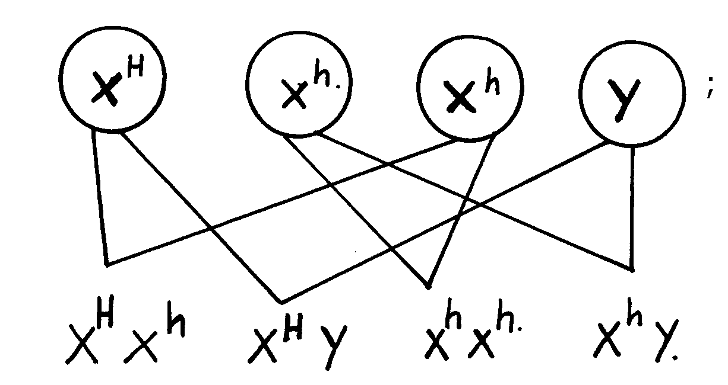

(b)

(c) Albinism; sickle cell anaemia; colour blindness; chondrodystrophic dwarfism;

30. (i) Father Mother

XHY XHYH

Since father cannot have the recessive gene ad fail to be affected. The mother must be a carrier

on her second X chromosome for a male son to be haemophiliac.

(ii) Parental phenotypes mother carrier, father normal

Parental genotypes XHXh XHY

31. a) the two genes that control flower colour ,that is the gene for red flowers and the

one for white are codominate; b) F₁ phenotype pink flowers pink flowers

F₁ genotype RW X RW ;

Gameter R W R W ;

Fussion

F₂ genotypes RR RW RW WW ;

F₂ phenotypes red

Flowered pink white flowered ;

Flowered

c)genotypic ratio= 1RR:2RW:1WW/RR:RW:WW=1:2:1 ;

Phenotypic ratio=1 red flowered:2 pink flowered:1white flowered ;

Notes: i) there must be cross on genotype

ii) gameter should be circled

d) recessive gene expressed it self only underlined homozygous condition while dominant gene expresses it self in both homozygous and heterozygous conditions;

32. (a) (i) Male and female flowers are separate hence cross pollination is made possible.

(ii) 1 Yellow : 3 Purple

Rej.: 15 yellow : 45 Purple

F1 genotype

Parental phenotype: Purple Yellow

Genotype: TT x Tt

Gametes:

F2 genotype

(b) Let letter T represents purple maize grain

Let letter t represent yellow maize grain

P1

Parental phenotype: Purple Yellow

Genotype: TT x tt

Gametes:

Tt

Tt

t

T

T

t

P1

tt

TT

(c) Gene for purple grain;

(d) (i) Finger prints are used to identify criminals;

(ii) Blood groups are used to settle parental disputes;

33. a) Aa; Aa; because of one child - 4

b) AA; Aa; because of cross between parent 1 and 2

c) Lethal genes easily inherited;

d) Sickle celled anaemia; colour blindness; haemophilia

34. (a) Y – Blood group A+;

Z – Blood group B-

(b)

|  |  |
| --- | --- |
| Parental phenotypes | Rhesus (+ve) Rhesus (-ve) |
| Parental phenotypes | Rh Rh X Rhd Rhd; |

Parental gametes

Fusion;

F1 offspring;

c) All Rhesus positive/ all RhDRhd;

(d) None

35. – By keeping their mouth open/panting; to lose heat over surface area of the tongue by evaporation;

-Basking; to gain heat by conduction;

- Shivering; to generate heat through increased metabolism;

- Physical activity (e.g. running); to generate heat through metabolism;

- Hibernation; to increase metabolism;

- Putting on warm clothes when it is cold; to retain the heat energy;

- Reduction of physical activity; to reduce the metabolic rate;

- Migratory behaviour to cooler environment; to reduce the body temperature;

- Moving into water when it is hot; to cool the body;

- Staying around fire place; to gain heat by convection;

- Taking hot drinks; to warm the body;

36. a) Parental genotypes

i) Woman/ OX - AO

ii) Man/ O - BO

b

|  |  |  |
| --- | --- | --- |
|  | A | O |
| B | AB | BO |
| O | AO | OO |

c) Cases of disputed paternity settlement

- Determining compatible blood groups in blood transfusion

d) i) Corresponding complementary DNA strand GAA;

ii) Corresponding RNA CUU

iii) Nitrates/ sulphites/ hydroquinone/ gamma/ beta/ alpha/ x-rays/ UV light/ hydrogen peroxide

37. let R rep. gene for Red flowers

W.rep gene for white flowers

a) parental phenotype Pink flowered Pink flowerd

genotype

gametes

red pink white

b) phenotypic ratio 1Red:2Pink:1White;

genotypic ratio: 1RR:2RW:1WW;

c) 2 x 480;=240

4

38.

Fl generation Award for punnet Square and genotypes

(b) (i) IBB : 2Bb: lbb

(1 mark for ratio, 1 mark Par genotype)

(ii) 3 B lack: I brown

(iii) 24;

39. (a) Homologous structures:

Structures of common embryonic origin modified to perform different functions;

Example: Eye structure in man and octopus/ wings in birds and insects (I mark)

Analogous structures Example

(b) They undergo mutations: resulting in new forms that rcsis selection resistant to drugs;

(c ) (i) Failure of chromosomes to separate during anaphase I resulting in gametes

with an extra chromosome and others with less chromosomes: (I mark)

(ii) Downs syndrome / Klinefelters syndrome/ Turners syndrome: any I ( 1mk)

40. a) Homologous structures have a common embryonic origin but are modified to

Perform different functions; while analogous structures have different embryonic origin but are modified to perform similar functions;

b) Nictitating membrane; post anal tail; body hair;

41. a) Pentadactyl limb structure of mammals; beaks of birds; feet of birds;

b) - Missing links between fossils because some parts or whole organisms were not fossilized

- Some parts were distorted during fossilization hence may give wrong impression

of structures;

- Some structures have been destructed by geological activities;

42. Camouflage is the conceal/ element of identity of an organism by resembling the color

of the environment while mimicry is the imitation of non- living organisms to conceal identity

43. Light energy splits water molecules; into hydrogen ions and oxygen atoms;

44. (a) Caecum/ Rumen/ pauch;

(b) Closes to prevent food from moving up the oesophagus;

45. (a) – the soft bodied organisms fail to fossilize;

- Human activities interfere with fossilization;

Earth movements e.g. volcanic eruptions interfere with fossilization; (mark any first2 pts

(b) – They resembled from neck downwards;

-They walked upright;

- The shape of the skull suggested they were able to speak;

46. a i)vestigial structures are those structures that have ceased to be functional over along

period of time and hence reduced in sizes

ii)-appendix;

-caecum

-coccyx or tail/tail bone;

- Nictitating membrane/semi - lunar fold at the corner of the eye;

-ear muscles

- Body hair;

b) Disease causing organism mutates; and became resistant;

47. Struggle for existence –environmental pressure on the population in order to survive;

Survival for the fittest-advantageous variations an individual possesses to make it survive;

48. Secretion of antidiuretic hormone; rearbsorption of salts at the loop of Henle;

49. -Divergent evolution refers to a situation where by organisms that are believed to have

had a common ancestral origin have homologous structures which have been modified to suit different environments;

50. a) Allows survival of organisms with better qualities / traits / characteristics; eliminates

organisms with unfavorable characteristics/ traits;

b) Divergent;

51. Evidence does not support Larmarks theory

Acquired characteristics are not inherited/;

Inherited characteristics are found in reproductive cells ;

52. (a) Vestigial structures

(i) Are those structures that have ceased to be functional over a long period of time hence

reduced in size;

(ii) Appendix/coccyx/tail/ nictitating membrane semilun fold at the corner of the

eye/caecum/ear muscles, body hairs;

(b) Disease causing micro-organisms mutate and become resistant;

53. a) The gradual emergence of complex life forms from pre-existing simple forms over along

period of time ;

b) Nature selects those organisms with structures that are well adapted to survival in

the environment. These structures are passed to their offspring; organisms with structures

that are poorly adapted perish ;

54. The insecticide kills most of the insects when introduced; those that survive; give rise to a new

generation of flies that are resistant to insecticide.

55. - Most organisms especially soft-bodied ones do not form fossils;

- Most fossils have not yet been discovered;

- Exposed fossils are usually destroyed by physical and chemical weathering;

- Earth movements e.g. volcanicity, earthquakes, tsunami do destroy fossils;

- Most animals are prayed upon;

56. -Fossil records/paleontology ;

-Comparative anatomy/taxonomy;

-Comparative embryology;

-Geographical distribution;

-Cell biology;

-Comparative cellulogy/immunology; (award 1st three 3mks)

**13. Evolution**

1. a) Homologous structures have a common embryonic origin but are modified to

Perform different functions; while analogous structures have different embryonic origin but are

modified to perform similar functions;

b) Nictitating membrane; post anal tail; body hair;

2. a) Pentadactyl limb structure of mammals; beaks of birds; feet of birds;

b) - Missing links between fossils because some parts or whole organisms were not fossilized

- Some parts were distorted during fossilization hence may give wrong impression

of structures;

- Some structures have been destructed by geological activities;

3. Camouflage is the conceal/ element of identity of an organism by resembling the color

of the environment while mimicry is the imitation of non- living organisms to conceal identity

4. Light energy splits water molecules; into hydrogen ions and oxygen atoms;

5. (a) Caecum/ Rumen/ pauch;

(b) Closes to prevent food from moving up the oesophagus;

6. (a) – the soft bodied organisms fail to fossilize;

- Human activities interfere with fossilization;

Earth movements e.g. volcanic eruptions interfere with fossilization; (mark any first2 pts

(b) – They resembled from neck downwards;

-They walked upright;

- The shape of the skull suggested they were able to speak;

7. a i)vestigial structures are those structures that have ceased to be functional over along

period of time and hence reduced in sizes

ii)-appendix;

-caecum

-coccyx or tail/tail bone;

- Nictitating membrane/semi - lunar fold at the corner of the eye;

-ear muscles

- Body hair;

b) Disease causing organism mutates; and became resistant;

8. Struggle for existence –environmental pressure on the population in order to survive;

Survival for the fittest-advantageous variations an individual possesses to make it survive;

9. Secretion of antidiuretic hormone; rearbsorption of salts at the loop of Henle;

10. -Divergent evolution refers to a situation where by organisms that are believed to have

had a common ancestral origin have homologous structures which have been modified to suit different environments;

11. a) Allows survival of organisms with better qualities / traits / characteristics; eliminates

organisms with unfavorable characteristics/ traits;

b) Divergent;

12. Evidence does not support Larmarks theory

Acquired characteristics are not inherited/;

Inherited characteristics are found in reproductive cells ;

13. (a) Vestigial structures

(i) Are those structures that have ceased to be functional over a long period of time hence

reduced in size;

(ii) Appendix/coccyx/tail/ nictitating membrane semilun fold at the corner of the

eye/caecum/ear muscles, body hairs;

(b) Disease causing micro-organisms mutate and become resistant;

14. a) The gradual emergence of complex life forms from pre-existing simple forms over along

period of time ;

b) Nature selects those organisms with structures that are well adapted to survival in

the environment. These structures are passed to their offspring; organisms with structures

that are poorly adapted perish ;

15. The insecticide kills most of the insects when introduced; those that survive; give rise to a new

generation of flies that are resistant to insecticide.

16. - Most organisms especially soft-bodied ones do not form fossils;

- Most fossils have not yet been discovered;

- Exposed fossils are usually destroyed by physical and chemical weathering;

- Earth movements e.g. volcanicity, earthquakes, tsunami do destroy fossils;

- Most animals are prayed upon;

17. -Fossil records/paleontology ;

-Comparative anatomy/taxonomy;

-Comparative embryology;

-Geographical distribution;

-Cell biology;

-Comparative cellulogy/immunology; (award 1st three 3mks)

18. Nature selects organisms that are well adapted and allows them to survive: but rejects those that are poorly adapted they perish/die/become eliminated;

19. (a) The genotype of an organism is not changed by characteristics acquired during the

life/ phenotypically acquired characteristics do not affect the genotype of an individual

(b) - Missing links (due to decomp0osing of savaged form)

- Distortion of parts (some parts were flattened);

- Geographical activities (e.g. earthquake, faulting, erosion) (any 2)

20. (a) White flowers.

(b) The white flowers were fewer that is the ratio of ¼ of the total flowers.

Parental phenotype white flowers white flowers

Parental genotypes r r x v r

Gametes

(c) A cross between unknown genotype with a homozygous recessive/double recessive genotype

(d) - Low mental capability

* Short/stubby fingers
* Slit eyes

21. (a) Emergence of new life forms//species//organisms; from pre-existing forms gradually

over a long period of time;

(b) Fossil records//Palaeontology;

These are remains of organisms preserved in some naturally occurring materials e.g. sedimentary rocks for many years; They give direct evidence of the type of organisms that existed at a certain geological time//show a gradual increase in complexity/morphological changes of organisms over a long period of time e.g. skull of man

Geographical distribution;

present continents are thought to have been a large land mass joined together; continental drift led to isolation that lead to different patterns of evolution; e.g. camels of Africa resemble the Ilamas of S. America// tiger of Asia resemble jaguars of S. America // unique Marsupials of Australia;

(accept any valid example)

Comparative Embryology;

Vertebrate embryos show morphological similarities in their early development; suggesting these organisms have a common origin; Accept – embryos of mammals /reptiles/ amphibians compared to show the similarities;

Cell Biology// Cytology;

Occurrence of cell organelles e.g. Mitochondria

Cytoplasm nucleus// Accept any correct organelle; point towards a common ancestor;

Comparative serology;

Analysis of blood proteins and antigens / Rh factor/ blood group /haemoglobin reveal phylogenetic blood group/haemoglobin reveal phylogenetic relationships; Those species that are more close phylogenetically related contain more similar blood protein;// Antigen-antibody reactions/serological tests/experiments with serum reveal some phylogenetic relationship depending on the level of precipitation.

Comparative anatomy/taxonomy;

* Members of a phylum show similarities indicating common ancestry; These organisms have similar functions e.g. presence of digestive, urinary, nervous systems e.t.c;
* Homologous structures like pentadactyl limbs in different animals like monkey and rats have similar borne arrangement hence same origin but modified to perform different functions// adaptive radiation//divergent evolution; vestigial organs//coccyx Appendix;
* Analogous structures like wings of birds and wings of insects with different embryonic origin but perform same function//convergent evolution; (maximum 18mks)

N/B- Mention of each evidence 1mk each

* It is muscular//Has cardiac muscles which are myogenic;//capapble of contracting and relaxing without nervous stimulation to ensure the heart beat without stopping;
* Supplied by vagus and sympathetic nerves; which control the rate of heart beat depending on body’s physiological requirement;
* Has tricuspid and bicuspid valves//arteria ventricular valves; to prevent back flow of blood into wrong directions;
* Has semi lunar valves at the base of pulmonary artery and aorta; to prevent back flow of blood into right and left ventricles respectively;
* Presence of valve tendons attached to the walls //arteria ventricular walls; prevent arteria ventricular valves // tricuspid and bicuspid valves from turning inside out;
* Supplied by coronary artery; to supply food and oxygen t the cardiac muscles for their pumping action;
* Coronary vein; draws away metabolic wastes;
* Heart is enclosed by pericardial membrane; which secrete fluids which lubricates//reduces friction on the walls as it pumps;
* Pericardial membrane is lined with a layer of fat to act as shock absorber; hold the heart in position; checks over dilation of the heart;
* The heart is divided into two by (artria ventricular) septum; which prevents mixing of oxygenated and deoxygenated blood;
* The sino-artria node// pace maker; initiates a wave of excitation leading to contraction and relaxation of cardiac muscles;
* The artria –ventricular node; in the heart spread out waves of excitation through out the heart

The structure tied to function wrong function cancel the mark of the structure. Correct structure minus function do not qualify for a mark

22. (a) Nature or the environment selects those individuals that are sufficiently adapted; and rejects

those that are not adapted;

(b) Adaptation by natural selection.

- Individuals of the same species show variations.

- The variations are caused by genes that can be passed on from parents to the off springs

(inherited);

- Some of these variation become more suitable or favorable or advantageous in the prevailing

environmental conditions;

- Because organisms usually produce more off springs than the environment can support;

competition for resources sets in;

- This leads to struggle for existence;

- Individuals with more favorable characteristics/ adaptations/ gene mutation have better chance

of survival in the struggle;

- Hence they reach reproductive age, reproduce and pass on favorable characteristics to the off spring;

- Those with less favorable characteristics or adaptations fail to reach sexual maturity; they die young;

- Examples of natural selection include- malarial parasite/plasmodium which has developed

strains that are resistant to anti-malarial drugs;

- Sickle cell trait; the homozygous die young and the heterozygous are resistant to malaria.

(c) – Convergent evolution.

- This is a phenomenon where structures from different embryonic origins are modified

to perform the same function. E.g. wings of birds and those of insects, eyes of human

beings and those of octopuses;

- Divergent evolution.

- This is a phenomenon where one basic structural form is modified to give rise to various

different forms which perform different functions. E.g. pentadactyl limbs of vertebrates,

shapes of beaks in birds;

(d) Evidences to show that evolution has taken place. (Any 4)

i) Fossil records.√

ii) Comparative anatomy. .√

iii) Comparative embryology. .√

iv) Geographical distribution (continental drift).√

v) Vestigial organs.√

vi) Cell biology. √

(i) Fossils records;

Fossils are remains of dead organisms preserved naturally. They indicate that organisms have evolved from simple life forms to most complex forms. Fossils of human beings indicate that the modern human being has a highly developed brain and uses speech for communication unlike the early human being. Of horses show that the modern horse is 1.5 m high, lives in dry grassland, teeth are adapted for chewing and it stands on one digit whose distal end is converted into hoof.

(ii) Comparative Anatomy;

This involves comparing the form and structure of different organisms.Some groups

organisms show basic structural similarities suggesting common or related ancestry

showing divergent evolution.

Other groups of organisms show morphological similarities but are found to have different

ancestry showing convergent evolution;

(iii) Vestigial Organs;

Some structures have ceased to be functional and have reduced in size; such structures are called vestigial structures. Examples include the appendix and the tail in human beings; reduced wings in flightless birds, nictitating membranes in mammalian eyes and lack of visible limbs in pythons.

(iv) Geographical distribution;

- Its believed that long ago the land was one mass which later drifted apart to form the current continents. This is called the continental drift.

- Regions with similar climatic conditions and lie in the same latitude have flora and fauna that are not identical. This indicates that they have evolved differently; e.g. Amazon forest of South America has long tailed monkeys, panthers and jaguars while similar African forests have short tailed monkeys, leopards and

cheetahs.

(v) Comparative embryology;

Studies show that embryos of fish, birds, amphibians, reptiles and mammals are morphologically similar during the early stages of development but with time they develop and change to look like their parents;

(vi) Cell biology;

- Cells of higher organisms show basic similarities in their structure and function; e.g. the presence of cell membranes and organelles such as mitochondria, ribosomses and golgi bodies.

- Higher plant cells have cellulose cell walls, chloroplasts and starch showing evolution from a common ancestry.

- The blood pigment, haemoglobin is common in vertebrates and invertebrates.

23. a) organic evolution is the process by which changes in the genetic composition occur in

response to environmental changes *RCH*

b) within the population some individual posses the gene for resistance to the antibiotic or it develops the genes by mutation ; such genes lead to production of enzyme which neutralize the antibiotic; the resistance forms survive the antibiotic hence transmit their advantages genes to their offspring; thus a new population of resistance strains is established(e mergence of new species(speciation)

c) fossil records;

-remains of ancestral forms that were accidentally preserved in some naturally

occurring

materials

-they give direct evidence of the type of animals and plants that existed at a certain

geological agp

-the fossils records also show gradual increases in complexity of organism over time

e.g. evolution of man

-by comparing fossils of different organism its possible to tell the phylogenic

relationship between the organism

24. RR X WW

;

;

b)

RW X RW

RR

;

Red Pink Pink White ;

1 : 2 :

c) Gene for red colour and white colour in flowers are co dominant/ equal dominance/ none

is dominant/ recessive

**14. Irritability and sensitivity in (a) plants (b) animals**

1. - To prevent excessive water loss/desiccation;

- Provide surface area for muscle attachment;

- Support and protect inner delicate tissues;

2. a) Phototropism;

b) Auxins migrate from the side of the shoot that is exposed to light towards the darker side;

The higher concentration of auxins on the darker side stimulates rapid growth hence the

shoot bends towards the light source;

3. a) Iris;

b) Circular muscles relax; radial muscles contract widening the pupil;

c) Adjustment of the eye structure to bring an image from a near or far object into sharp focus on the retina;

4. a)

|  |  |
| --- | --- |
| Taxes | Tropisms |
| - Locomotory responses  - Fast response  - No hormones involved | - Growth responses  - Slow response  - Influenced by hormones |

(b) – Escape from harmful conditions/stimuli;

- Move in search of food/nutrients;

5. (a) (i) Motor neurone;

(ii) Cell body located in the central nervous system;

(b) Arrow head towards terminal dendrites

(c) C- Protection/insulate axon;

D- Speeds up transmission of an impulse

6. (a) Due to the difference in atmospheric pressure and the pressure inside the ear;

(b) Swallowing; yawning;

7. (a) Photosynthesis;

(b) Night on the list side makes the auxin to move/migrate/Diffuse to the dancer side;

there auxin cases faster elongation/growth I the dark side; Hence curvature/bending;

8. – Colour blindness;

- Haemophilia;

- Sickle cell anemia;

- Albinism

9. a) short-sightedness/myopia;

b) This defect can be corrected by wearing glasses with concave (diverging) lenses; these bend light rays outwards before they reach the eyes enabling them to be focused ion the retina;

10. a)

|  |  |
| --- | --- |
| Arteries | Veins |
| - Thick muscular  - No valves (except pulmonary artery and aorta at the base  - Narrow (small) lumen | - Thin muscular walls  - valves present;  - Wide lumen (large) lumen; |

b) Arteriosclerosis; reject Artheroma

11. a) Retina;

b) Cones and rods;

12. a) Long sightedness / hyper metropia..

b)

c) Stereoscopic vision/ binocular vision/ improved visual acuity; gives a wider angle of vision; if

one is damaged man is not blinded;

13. Water proof – Prevent water from reaching the inner cells

Has Karatin – For protection against mechanical injury

14. i) Equalizes the pressure between the outer ear and the middle ear;

ii) Transmits and amplifies vibrations from the ear drum to the oval window;

15. a) – Conditioned reflex requires repeated stimulus to bring about response while simple

reflex requires single stimulus to bring about response;

- Conditioned reflex requires behaviour modification hence experience while simple

reflex involves direct action and is independent of experience;

b) It has a long axon to transmit nerve impulse myelin sheath and rod of ranvier for faster

impulse transmission;

16. a) i) Iris;

ii) Optic name;

b) Circular muscles of the iris;

Radial muscles contract;

The size of the pupil enlarge to allow more light to enter;

17. Chemotropism; Reject chemotrophism

Negative photo taxis; Reject photo taxis alone

18. i) Thigmotropism / 1-laptotropism

ii) High concentration of auxin on side away from contact surface; promotes faster growth of this

side; causing tendril to curl round the object.

19. Thigmotropism / haptotropism;

20. a)Hormone/growth substance /IAA; which inhibits the development/growth of lateral

shoots/buds/causes apical dominance; /removal of the terminal buds cause the

growth/development and sprouting of lateral buds ; 2mks

b)The pruning of coffee /tea/ledge; etc Rej. Pruning alone/trimming ;

21. cerebrum/cerebral hemisphere/cerebral cortex;

22. a)long sightedness/hyper netropia;

b)the eye ball too short/eye lenses are unable to focus because they are flat//thin/weak;

hence unable to focus the image on the retina OR the eye are unable to commodate/change

their focal length; 2

c)by wearing convex/biconvex lens/converging lenses; 1mk

23. a)A-relay/intermediate /associates;

B-motor neurone/efferent neurone;

b) Impulse initiates release of acetyl choline /transmitter substance (at the end of the

sensory neurone);acetyl choline which diffuses across the gap; generate an impulse

in the next neurone; (Rj. Message for impulse)

24. (a) -Hearing;

-Body balance (and posture);

(b) Coiled to accommodate many sensory cells:

- Filled with endolymph to transmit (sound) vibrations.

- Has sensory hairs/cells to generate nerve impulses when stimulated:

25. Used in the transmission of nerve impulse. p

- For respiration; p

26. - Proper functioning of the nervous system and alimentary canal; p

27. (a) Enables the organism to escape from injurious stimuli/seek favourable habitats;

(b) Cerebrum

28. The conified layer of the epidermis consist of dead cells which form a tough outer coat;

that protects the skin against mechanical damage/bacterial infection/ water loss;

Sebaceous glands produce an oily secretion sebum which give hair its water repelling property; that keeps the epidermis sapple and prevents it from dyring/sebum too prevents bacterial attack due to its antiseptic property;

Has blood vessels; that dilate and contract;

In hot conditions, they dilate; increasing blood flow near the skin surface enhancing blood flow near the skin surface; minimizing heat loss;

Has hairs; stand during cold weather thus trapping a layer of air which prevents heat loss; In hot weather they i.e close to the skin surface; to enhance heat loss to the atmosphere.

Hair follicle; has many sensory neurons which respond to movements of the hair; increasing sensitivity of the skins. Has subcutenous layer; contains fat whihch acts as a heat-insulating layer and a fuel storage;

Has malpighian layer; consists of actively dividing cells tht contain fine granules of melanin; that prevents the skin against ultraviolet light rays from the sun;

29. a) i) Myopia/ short sightedness

ii) Long eyeball/ too long eye ball

b) Use of concave/ diverging lens; to diverge the rays from image to focus onto retina

c) For colour reception/ vision

For vision in bright light/ day

d) Retina has many rods; to perceive / enable organism see in dim light/ darkness

30. Water proof – Prevent water from reaching the inner cells

Has Karatin – For protection against mechanical injury

31. i) Equalizes the pressure between the outer ear and the middle ear;

ii) Transmits and amplifies vibrations from the ear drum to the oval window;

32. a) – Conditioned reflex requires repeated stimulus to bring about response while simple

reflex requires single stimulus to bring about response;

- Conditioned reflex requires behaviour modification hence experience while simple

reflex involves direct action and is independent of experience;

b) It has a long axon to transmit nerve impulse myelin sheath and rod of ranvier for faster

impulse transmission;

33. a) i) Iris; ii) Optic name;

b) Circular muscles of the iris; Radial muscles contract;

The size of the pupil enlarge to allow more light to enter;

34. Chemotropism; Reject chemotrophism

Negative photo taxis; Reject photo taxis alone

35. i) Thigmotropism / 1-laptotropism

ii) High concentration of auxin on side away from contact surface; promotes faster growth of this

side; causing tendril to curl round the object.

36. Thigmotropism / haptotropism;

37. a)Hormone/growth substance /IAA; which inhibits the development/growth of lateral

shoots/buds/causes apical dominance; /removal of the terminal buds cause the

growth/development and sprouting of lateral buds ; 2mks

b)The pruning of coffee /tea/ledge; etc Rej. Pruning alone/trimming ;

38. cerebrum/cerebral hemisphere/cerebral cortex;

39. a)long sightedness/hyper netropia;

b)the eye ball too short/eye lenses are unable to focus because they are flat//thin/weak;

hence unable to focus the image on the retina OR the eye are unable to commodate/change

their focal length; 2

c)by wearing convex/biconvex lens/converging lenses; 1mk

40. a)A-relay/intermediate /associates;

B-motor neurone/efferent neurone;

b) Impulse initiates release of acetyl choline /transmitter substance (at the end of the

sensory neurone);acetyl choline which diffuses across the gap; generate an impulse

in the next neurone; (Rj. Message for impulse)

41. (a) -Hearing;

-Body balance (and posture);

(b) Coiled to accommodate many sensory cells:

- Filled with endolymph to transmit (sound) vibrations.

- Has sensory hairs/cells to generate nerve impulses when stimulated:

42. Used in the transmission of nerve impulse. p

43. - Proper functioning of the nervous system and alimentary canal; p

- For respiration; p

44. (a) Enables the organism to escape from injurious stimuli/seek favourable habitats;

(b) Cerebrum

45. (a) Positive phototropism; reject phototropism only

(b) Positive geotropism; reject geotropism only

(c) Thigmotropism

46. - comified layer made of dead cells to protect from mechanical damage, also protect *KKE*

from desiccation/dehydration.

* Granular with living cells to replace the worn out layer.
* Malphigian layer – cells divide to form new epidermis.
* Malphigian cells with melanin pigment which protect from c ultra violet rays from the sun.
* Blood vessels to supply oxygen and nutrients. Remove CO2 and nitrogenous wastes.
* Superficial blood vessels/arterioles dilate. When it is hotg. So that more blood flows near the skin surface for more heat loss.
* Superficial blood vessels consmet/vasoconstriction. When it si cold. So that less blood flows near the skin surface to reduce heat loss.
* Erector pili muscle contract when it is cold to raise hair/hair stands upright. To trap more a ir to reduce heat loss/insulate.
* Erctor pili muscles relax when it is hot to make hair lie flat. On the skin to trap less air hence reduce insulation/increase heat loss.
* Sweat glands excrete excess water, mineral salts traces of live and lactin acid.
* The water in sweat evaporates carrying away latent heat of vaporization to lower the body temperature.
* Subcutaneous layer/dispose tissue insulation the bod y/ reduce heat loss.
* Sensory nerve ending which are sensitive to touch/pain/heat cold.

47. Conjuctiva – protects eyeball from mechanical injury

Cornea – Allows light to pass through

Iris – Controls amount of light passing through

Retina – Where image is formed

Forea – Where image is formed

Sctera – Protect the eye ball; give it shape

Choroid – Absorbs stray lights

Provide nourishment to the eye

Aqueous/ vitreous humour – refract light into the eye towards retina maintain shape of eye ball

Ciliary body – Controls curvature of the lens

Rods – Perceive light of low intensity

Cones – Perceive light of high intensity

**15. Support and movement in (a) Plants (b) animals**

1. a) have closely packed cells which when turgid provide mechanical support;

b) Their walls are thickened with cellulose which offer mechanical support;

c) Consists of dead cells thickened with lignin;

2. a) Lumbar vertebra;

b) - Broad neural spine;

- Large and broad centrum;

- Broad and long transverse processes;

c) Passage of spinal cord;

3. (a) Cervical vertebra;

(b) R – (Facel) for articulation with the next verterbra;

S- (Transverse process) for attachment of muscles;

(c) Treck region/ cervical region;

4. (i) Humerous; Scapula;

(ii) Synovial fluid; Lubrication of bones/prevent friction;

5. – Endoskeleton;

- Hydrostatic skeleton;

- Exoskeleton;

6.

|  |  |
| --- | --- |
| Muscle cell | Palisade cell |
| * Lacks chloroplast * lacks cell wall * small in size * presence of centrioles * tiny and numerous | * Has chloroplast; * has cell wall; * large in size ; * lack of centrioles; * large central cell vacuole ; |

7. a) Ulna;

b) i) Humerus;

ii) Hinge

8. a) Exoskeleton;

b) Supports body tissue and organs, protects inner parts, reduces water loss/ evaporation, helps

in movement/ attachment of muscles;

9. a) Provide mechanical strength / support/ it is a strengthening tissue;

b) Xylem vessels and tracheids have lignified walls; to provide support;

one is damaged man is not blinded;

10. a) Tendons are structures which attach skeletal muscles to bone while ligaments are structures

that hold two bones together;

b) Use of turgor pressure / turgidity; use of tendrils and climbing stems; tissue distribution in

stems (parenchyma) sclerenchyma / collenchyma); use

of xylem (thickened tracheids & vessels) ; use of spines and thorns e.g roses.

11. a) i) Lignin;

ii) Phloem;

b) Growing areas of root, stem/ shoot, meristems ;

Storage organs – Fruits, seeds, stems, roots, leaves;

12. - Maintain shape of the body ;

- Protect delicate organs of the body e.g. heart, brain;

- Place/ area of attachment for other organs of the body;

13. Capitulum

14. (a) Scapula;

(b) (i) Humerous;

(ii) Ball and socket joint ;

For muscle attachment;

15. a) Femur; ;

b) Reloic girdle/ pubis of peloic girdle;

c) Hinge joint;

Rj. thoracic alone or vertebra alone

b)X-neutral spine;

W-centrum;

16. (a) Axis;

(b) Fits in the neural canal of atlas to permit for turning of the head:

17. a) - Sclerenchyma;

- Xylem;

- Collenchyma;

Accept Parenchyma

b) i) X – Biceps;

Y- Triceps;

Reject Flexor and Extensor

ii) X (Biceps) relaxes; as Y (Triceps) contracts;

c) Hinge joint;

18. a)locomotion enables animal to move from one place to another in search of food; mates;

to escape from predators; to disperse/avoid unfavourable environments;

b)-have streamline body which reduces fiction; the scales overlap backwards and he lies flat

close to the body, thus enhancing he streamline shape;

-they have air-filled swim bladder tat helps them to maintain a density that is equal to that of

the surrounding water; helping the fish to float; (making forward movement easy)

-tail fin long/has large surface area to increase the amount of water displaced resulting in an

increase in forward thrust;

-they have strong tail muscles which enable the tail to move from side to side against

water;(pushing

the fish to move forward)

-the have paired pectral and pelvic fins; which are used for steering; for bringing about

downward or upward movement; as breaks//for braking; and for preventing pitching;

-they have unpaired fins, dorsal and anal fins; which increases the vertical surface area preventing

fish from rolling or yawing;

-the fish has inflexible head which help, fish to maintain forward thrust;

-have fleshable backbone onto which myotomes are attached; the muscles contract and relax to bring about undulation movement;

-fish also secretes mucus which covers body and reduces friction during movement;

**16. Human health**

1. a) Vibrio cholerae;

b) i) Pig;

ii) Fresh water snail;

c) Injected by a female anopheles mosquito;

2. (a) Fever;

(b) Plasmodium;

(c)- Uses of vaccines;

- Sleeping under treated mosquito nets

- Getting rid of stagnant water and bushes around residential areas;

- use of ant malarial drugs; (any 1st correct)

3. Salmonella typhii

4. a)plasmodium parasite;

b)-drainage of poles that act as breeding grounds for mosquitoes;

- pools that cannot be drained should be sprayed with oil or insecticides to destroy mosquito

larvae;

- fish that feed on mosquito larvae may be introduced into such pools;

- tall grass and bushes which be cleared near human dwelling;

- visitors to areas where malaria is prevalent should take anti-malaria drugs;

5. (a) (i) Salmonella typhii;

(ii) Entamoeba histolytica;

(b) Malaria ;

6. a) Protoctista;

b) Cholera;

Syphilis;

c) Use of condoms;

Abstinence;

Faithfulness to one partner;

7. To know HIV status; so as to take appropriate measures. If positive start medication/negative

avoid infection;

8. a) malaria;

b) Amoebic dysentery/ Amoebiasis;

**SECTION III- QUESTIONS**

**CONFIDENTIAL INFORMATION TO SCHOOLS AND PRACTICALS**

**KAKAMEGA CENTRAL DISTRICT**

***Each candidate will require the following:-***

* *Solution V- sucrose laboratory chemicals*
* *Solution W – Glucose*
* *Means of heating*
* *2 test tubes*
* *Benedicts solution (10mls)*
* *Dilute HCl (5mls)*
* *Sodium hydrogen carbonate solution*
* *Access to water*
* *A dropper*
* *Measuring cylinder (to measure 10mls)*

1. a) Identify solutions **V** and **W** by carrying out the food tests as indicated in the table below

b) Which of the two solutions **V** and **W** would you recommend for a person who needs an

immediate source of energy? Give a reason for your answer.

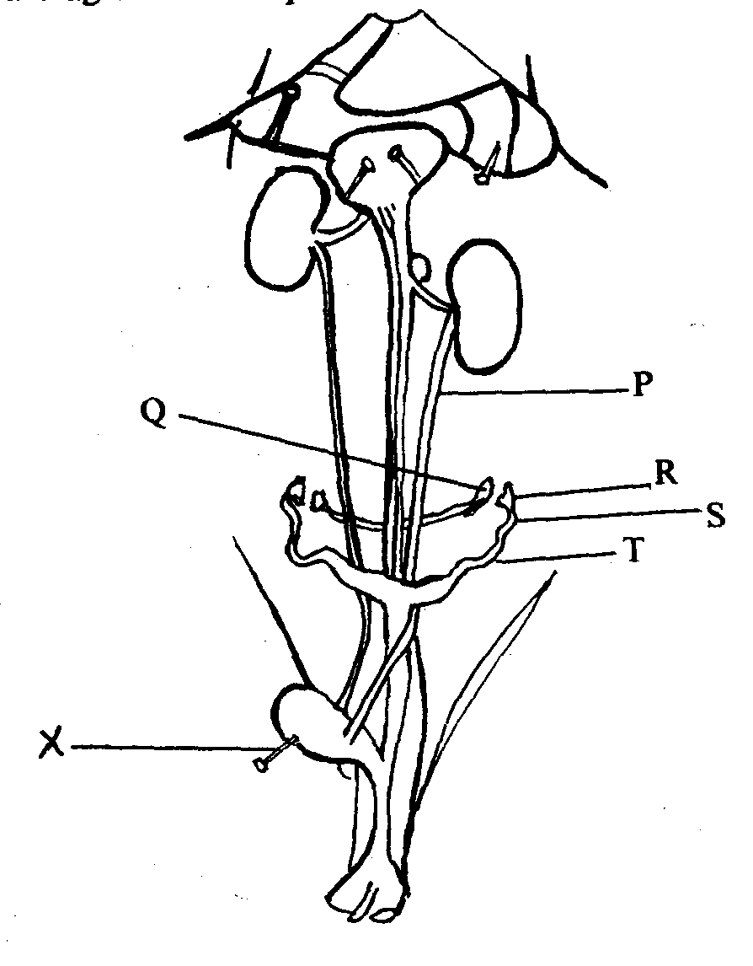2. The following is a diagrammatic representation of a dissection of a rabbit showing the

urinogenital system

a) In the table below, name the structures labeled **P, Q, S** and **T**. For each of the structures,

state **one** function

b) i) Identify the sex of the rabbit that was dissected

ii) Give **two** reasons for your answer in **b(i)** above

c) Name the instrument labeled **x** in the diagram above

3. Study the photographs below and use them to answer the questions that follow;

Anther

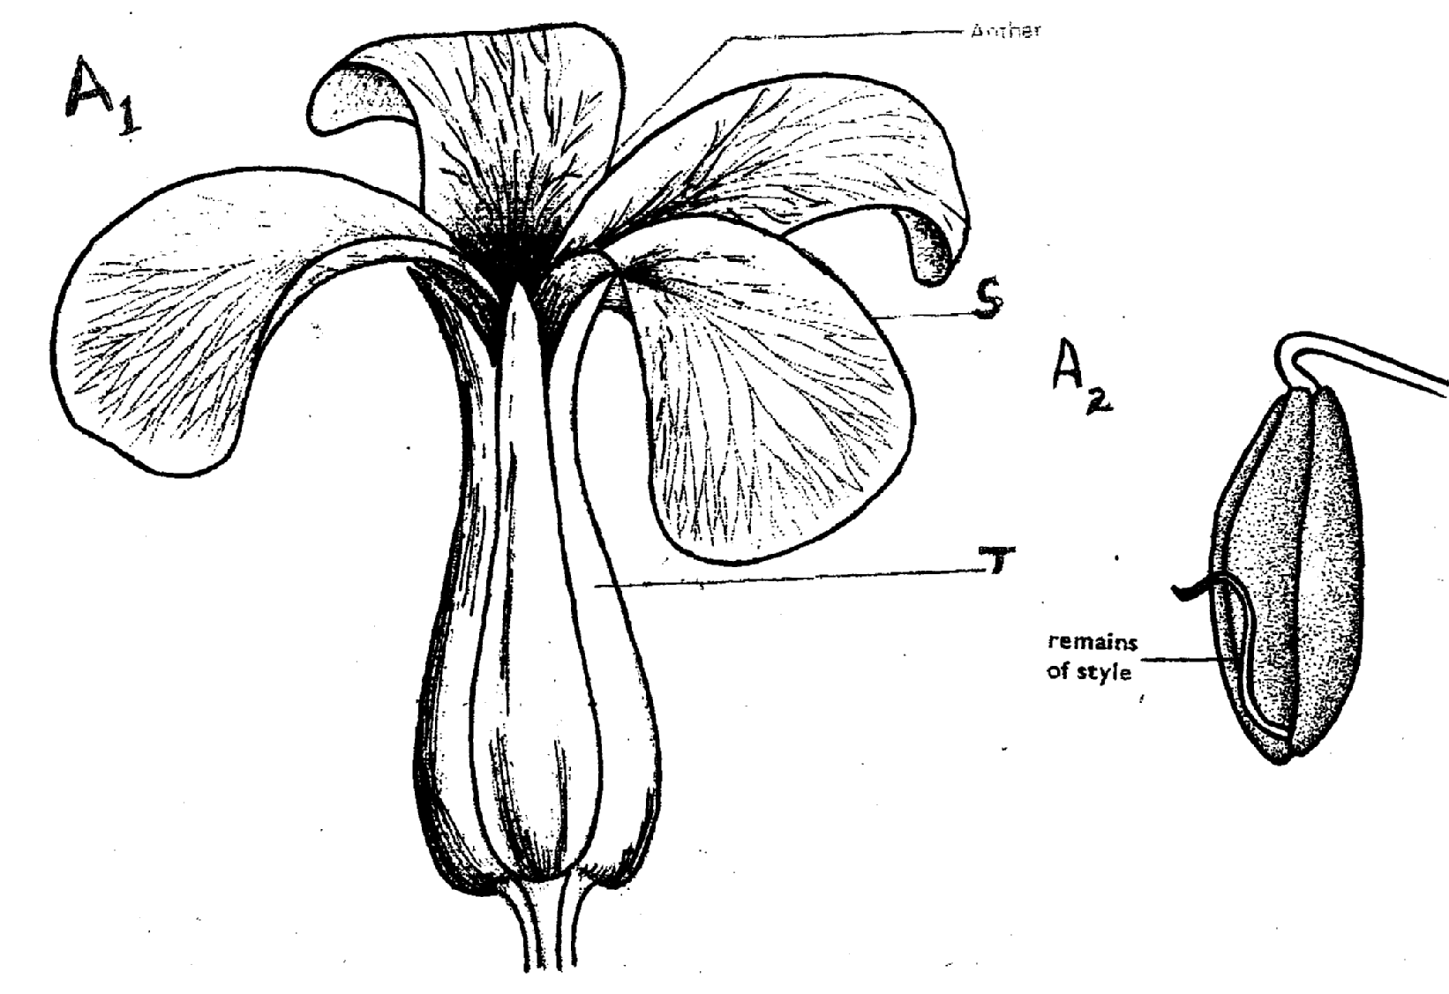

**A1**

**A2**

**S**

**T**

Remains of style

**A2**

a) Using the number of flowers arising from the shoot of each plant, state the flowers

labelled **A1** and **B1**

b) Name the class of the plant from which each of the flowers was obtained. Give a reason

for your answer in each case :

c) Name the parts labelled **S** and **T**

d) What type of ovary is shown in flower **B1**? Give a reason for your answer.

e) i) Name the agent responsible for the process represented by the arrow labelled

**R** in **B2**

ii) Give a reason for your answer in **e (i)** above

iii) List **two** other features (not shown in the photograph) expected of such flowers as **B1**

f) i) Name an agent that brings about a similar process as the one shown by the

arrow in **B2** fo**r** **A1**

ii) Give a reason for your answer in **f(i)** above.

g) What is the likely agent of dispersal of the specimen labelled **B2**?

**CONFIDENTIAL INFORMATION TO SCHOOLS AND PRACTICALS**

**KAKAMEGA EAST DISTRICT**

***Each candidate requires the following:-***

* + - *One large ripe tomato labelled D1*
    - *One ripe orange/lemon fruit labelled D2*
    - *5ml DCPIP (1g of DCPIP dissolved in 1000cm3 of distilled water)*
    - *Four clean test tubes*
    - *Three droppers*
    - *Scalpel blade*

1. Study the diagrams **M, N, O, P** and **Q** below representing organisms in the environment and

use them to answer the following questions:-

**N**

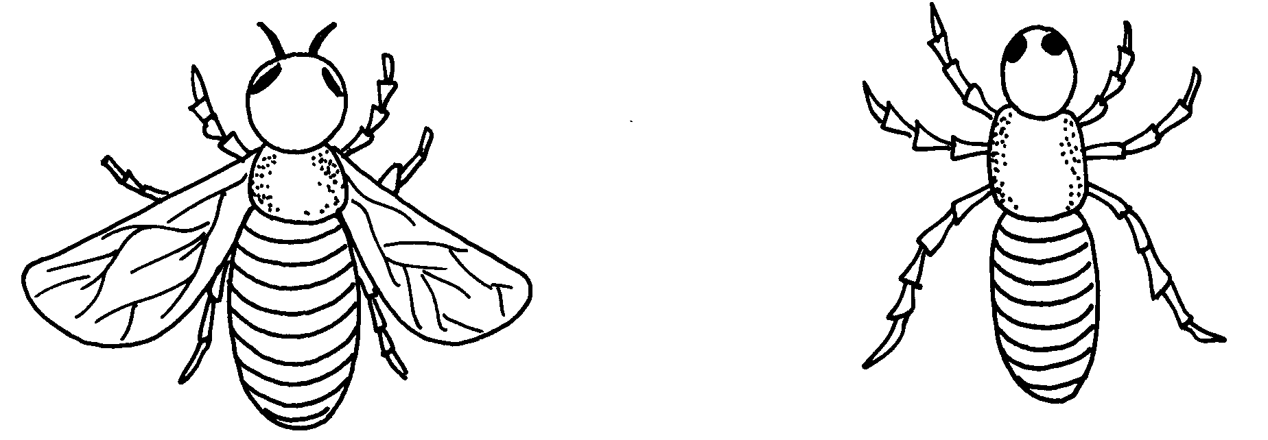

**M**

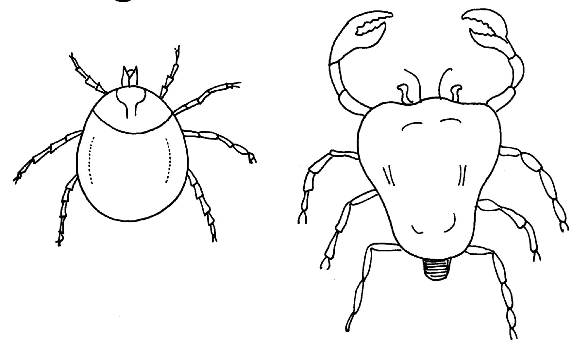

**O**

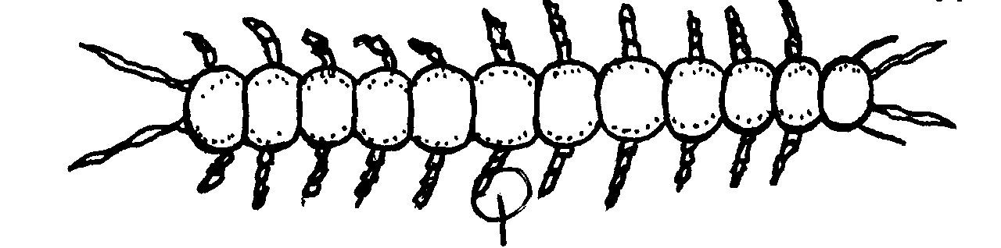

**P**

**Q**

(a) With the reasons, identify the phylum to which they belong:-

(b) Identify the classes of the following organisms:-

**M** ....................................................... **N** .......................................................

**O** .................................................. **P** ......................................................

**Q** ..................................................

(c) Give **two** reasons for identifying the classes of organisms **M** and **P**

(d) What is the economic importance of the class to which **M** belongs?

2. You are provided with specimen **D1**. Make a vertical (*longitudinal section through it to obtain*

*two equal halves)*

(a) (i) Draw and label one half of **D1**

(ii) Calculate the magnification of your drawing (show your working)

(iii) With reasons, identify the type of fruit **D1**

(b) Squeeze juice from **D1**, into a beaker. Label two test tubes **A** and **B.** In each test tube

put 1cm3 of DCPIP

(i) To test tube **A** add the juicedrop by drop shaking well after each drop. Record the number

of drops required to decolourize DCPIP in the table below.

|  |  |
| --- | --- |
| **TEST TUBE** | **No. of drops required to decolourize DCPIP** |
| **A** |  |
| **B** |  |

(ii) Identify the food substance being tested

(iii) Which of he specimens **P1** and **P2** has high of the food substance being tested above?

(iv) What is the value of the food substance above to a growing baby?

(c) Boil the remaining juice extracted from **D1** in the boiling tube for one minute and cool it.

Using a dropper, add the boiled juice into another test tube labelled **B**. Containing 1cm3

of DCPIP. Record the number of drops required to decolourize the DCPIP in the table above.

What is the effect of boiling the juice?

3. The diagram below represents a cross-section of a plant stem. Study it carefully and answer the

questions that follow:-

**A**

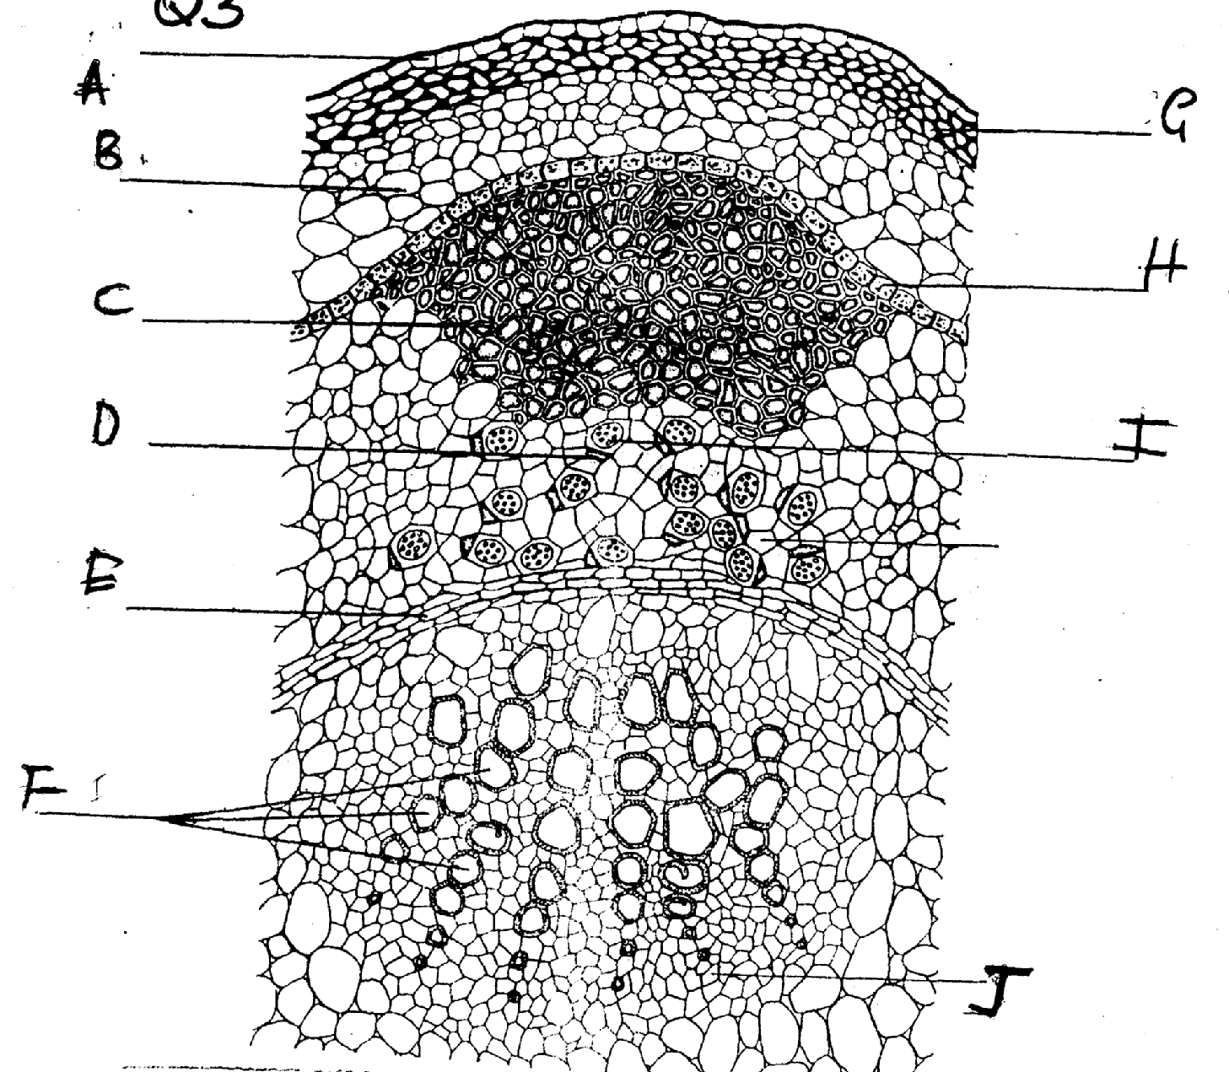

**G**

**G**

**B**

**H**

**H**

**C**

**I**

**D**

**E**

**F**

**J**

(a) Identify letters that represent tissues responsible for support and name the tissues

(b) State **two** ways in which the tissues named in **(a)** above offer support

(c) (i) Identify the part labelled **H** ..........................................................................................**..**

(ii) What is the role of this part?

(d) (i) If the plant from which the section had been obtained was placed in water containing

eosin dye, which part would you expect to be stained with the dye?

(ii) Name **three** forces which help water containing this dye (eosin) to pass through the

dyed tissue

(e) (i) Name the tissues labelled **I** .................................................................................................

(ii) What is the name of the cell **C** seen adjacent to tissue **I**?

(iii) State the function of this cell **C**

**CONFIDENTIAL INFORMATION TO SCHOOLS AND PRACTICALS**

**MIGORI DISTRICT**

***Each candidate should be provided with the following:***

* + - * + *Irish potato (one large one each – N)*
        + *75 ml of conc. brine labelled L1.*
        + *75 ml of distilled water labelled L2.*
        + *Potato borers.*
        + *Six test tubes.*
        + *Iodine.*
        + *Benedict’s solution.*
        + *Sodium hydroxide.*
        + *10% copper II sulphate.*
        + *Means of heating.*
        + *Means of timing.*
        + *A ruler.*

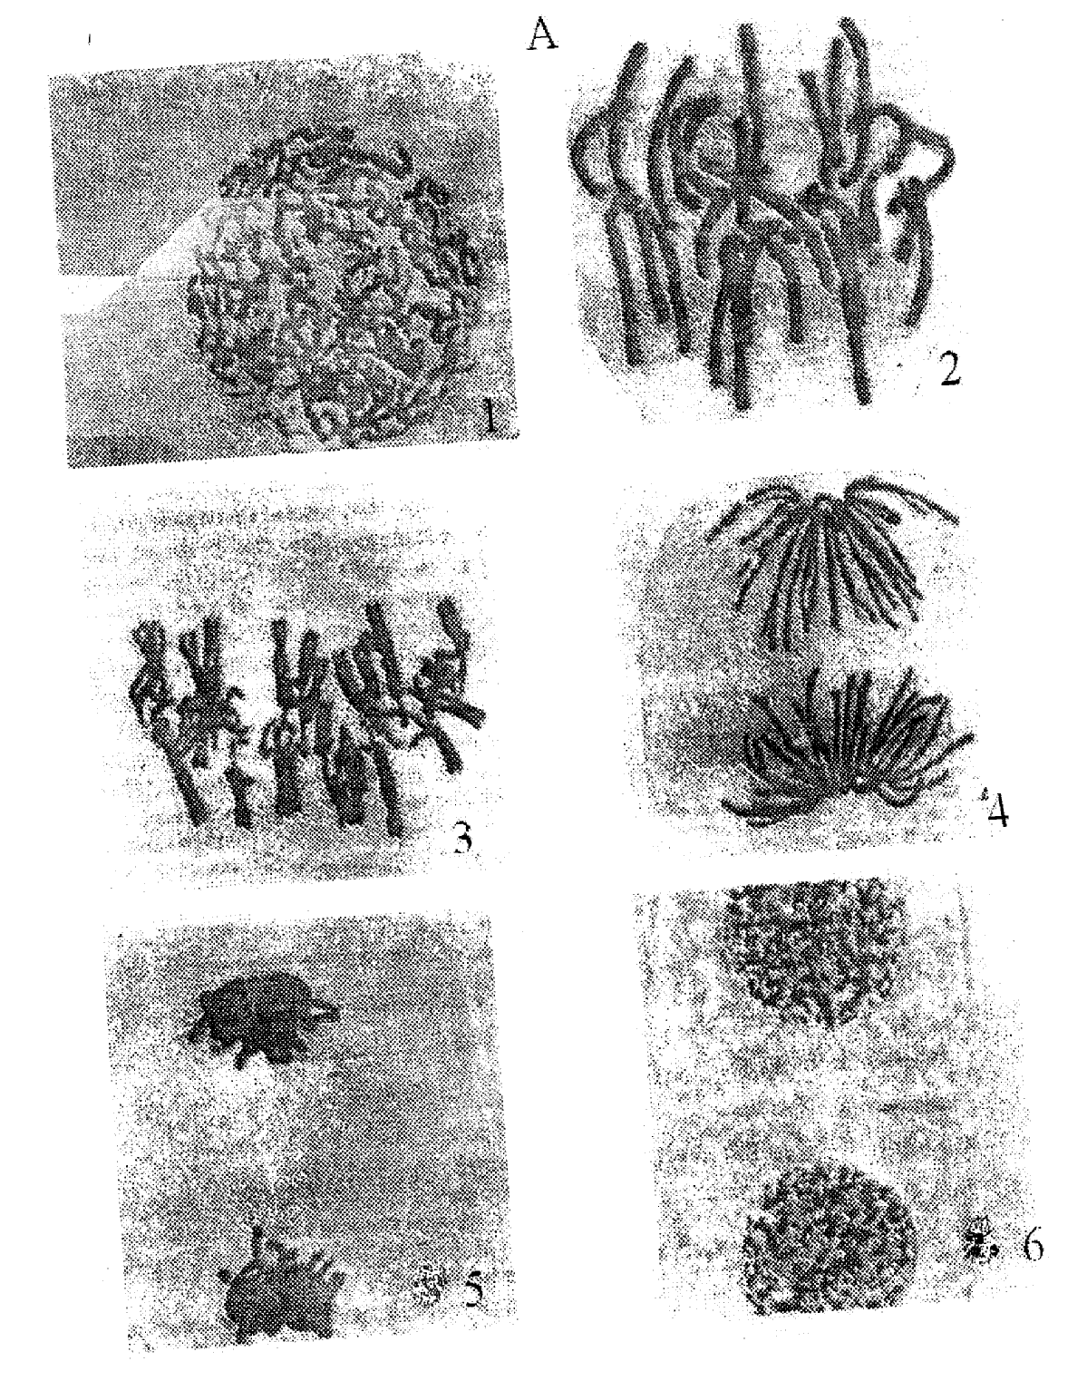**Q.1** Below are two sets of photomicrographs **A** and **B** showing various processes of cell divisions.

Examine them.

**B**

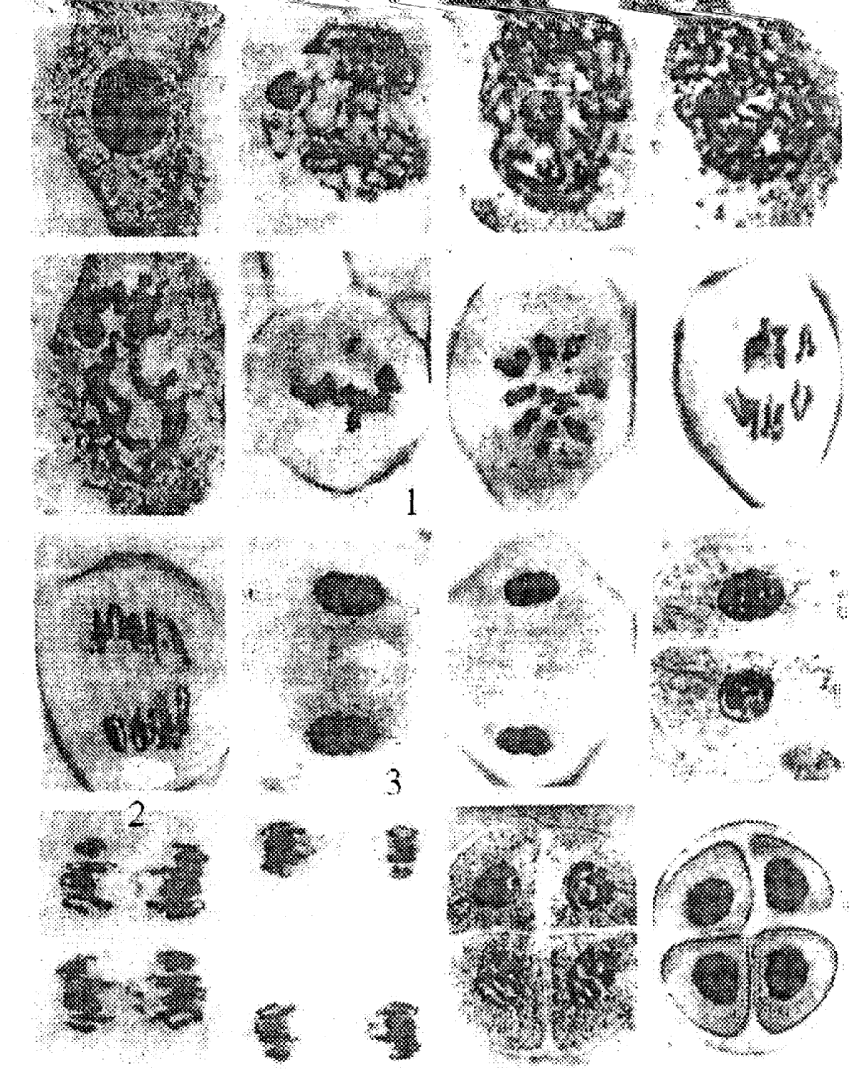

Q. (a) Using observable features only, identify the type of cell division represented by the

photomicrographs in set **A** and set **B**. Give a reason in each case.

Cell division in set **A**

Reason:

Cell division in set **B**.

Reason:

(b) Name the division process represented by number 3 and 4 in photomicrographs of set A and

number 1 and 3 in photomicrographs in set B. **Complete** the table below.

(c) Name **one** region in higher pants where the cell division represented by photomicrographs

set **A** and **B** occurs.

(d) Describe the process that is taking place at photomicrographs set **A** number **3** and

photomicrograph set **B** number **2**.

(e) State the **importance** of each of the cell division in **A**  and **B** in the bodies of living

organisms.

**2.** You are provided with specimen **N.** You have also been provided with a cork borer bore out

three (3) pieces each measuring 5 cm. Take each piece and place into the test tubes labelled

A, B and C separately.

Fill test tube A with solution labelled L1.

Fill test tube **B** with solution labelled **L2.**

Leave test tube labelled **C** empty (**Do not pour anything into it.)**

(a) (i) Remove the pieces and dry each using blotting paper and measure its length. Record in the

table below.

(ii) Account for the observation made in the measurements of each piece after 30 minutes

above.

(b) (i) Crush the remaining tissue into a paste and carry out food tests on it using the reagents

provided.:

(ii) What would imbalances of such food substances cause in the diet?

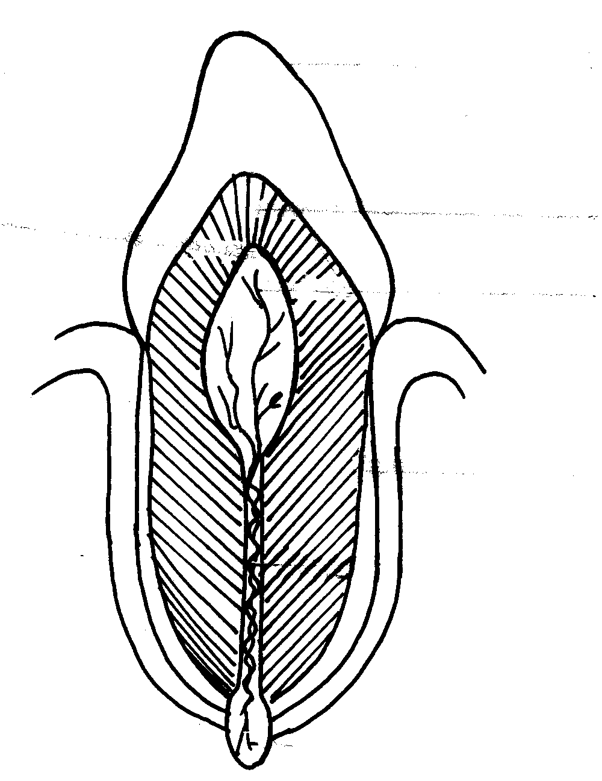 Excess of the foods.

Deficiency of the foods.

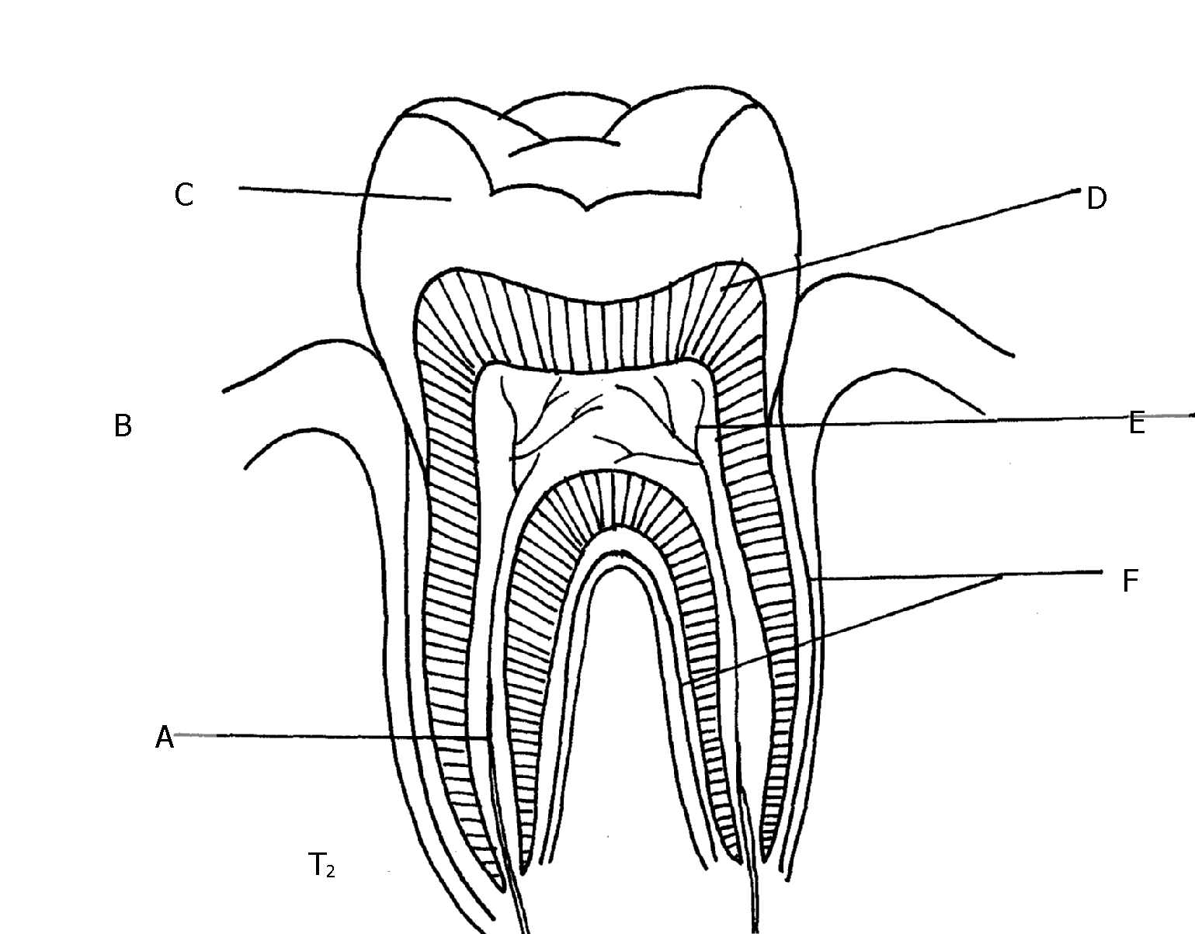

3. Study the photographs provided above and answer the questions below.

(a) Give the identity of **T1** and **T2.**

(b) How is each specimen adapted to its function?

(c) Label the parts of **T2** marked **A** to **F**

(d) State the effect of too much sugar in the diet on specimen **T1** and **T2** in humans.

(e) (i) What is the name of the gap found between **T1** and **T2** in herbivores.

(ii) State the function of the gap named in **e(i)** above.

**CONFIDENTIAL INFORMATION TO SCHOOLS AND PRACTICALS**

**NYAMIRA DISTRICT**

***Each Candidate should be provided with the following:-***

**REQUIREMENT**

* *2 Boiling tubes*
* *2 test tubes*
* *Test tube rack*
* *Means of heating*
* *1% copper sulphate solution*
* *2M sodium hydroxide solution*
* *Iodine solution*
* *Mortar and pestle*
* *Scalpel*
* *20% Hydrogen peroxide solution*
* *Fresh potato*
* *Droppers*
* *100ml beaker*

*Schools should also have ordinary laboratory apparatus in addition to those listed above*

1. You have been provided with specimen **Q** which is a fresh potato, liquid R (Hydrogen peroxide

and reagents 1% copper sulphate, 2M sodium hydroxide and iodine solution. Use them to carry

out the tests below:

1. Using a scalpel, cut two small cubes measuring 1cm x1cm from the fresh potato. Place one

of the cubes in boiling water for 10minutes,then remove the cube and let it cool. Place it in

a boiling tube and label it **A**.

Place the fresh piece of potato cube in another boiling tube labelled **B** and then add equal

amounts of hydrogen peroxide to each test tube at the same time. Write your observations.

**Observations:**

(a) (i) Boiling tube **A**

(ii) Boiling tube **B**

(b) Explain your observations **in (i)** and **(ii)** above

(c) Crush a small piece of the remaining potato in a motar. Add a little amount of distilled water

to make a mixture. Use it to carry out food tests below:

2. **X** and **Y** are specimens obtained from plants. Study them carefully and then use them to answer

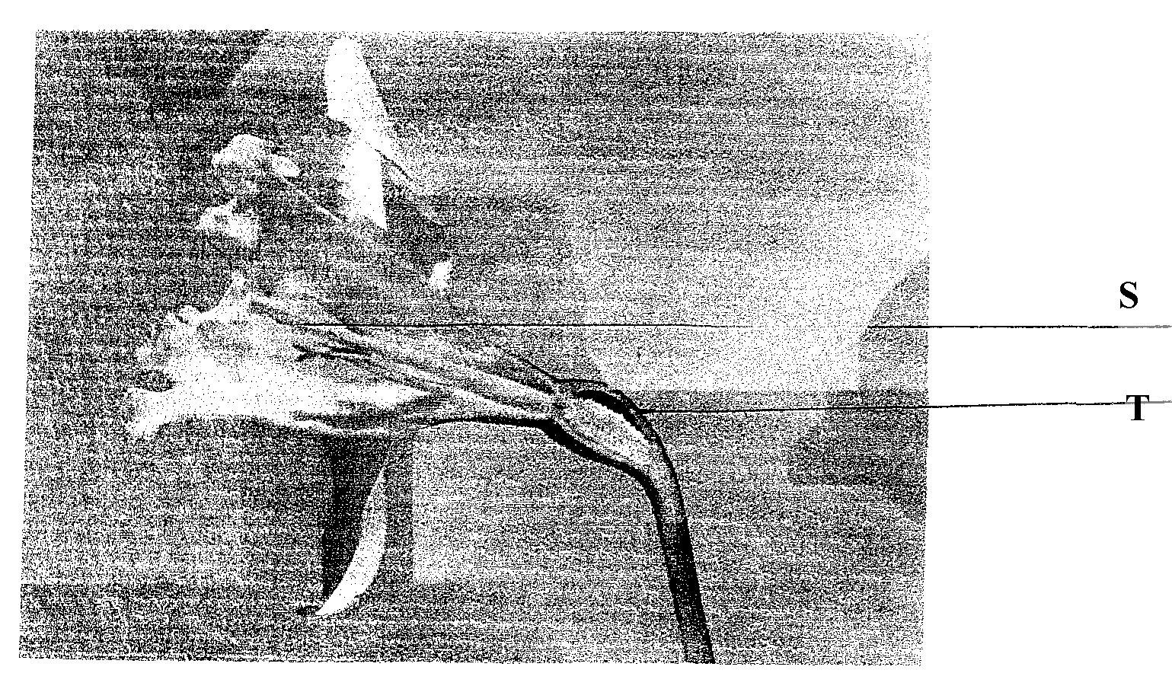 questions that follow:-

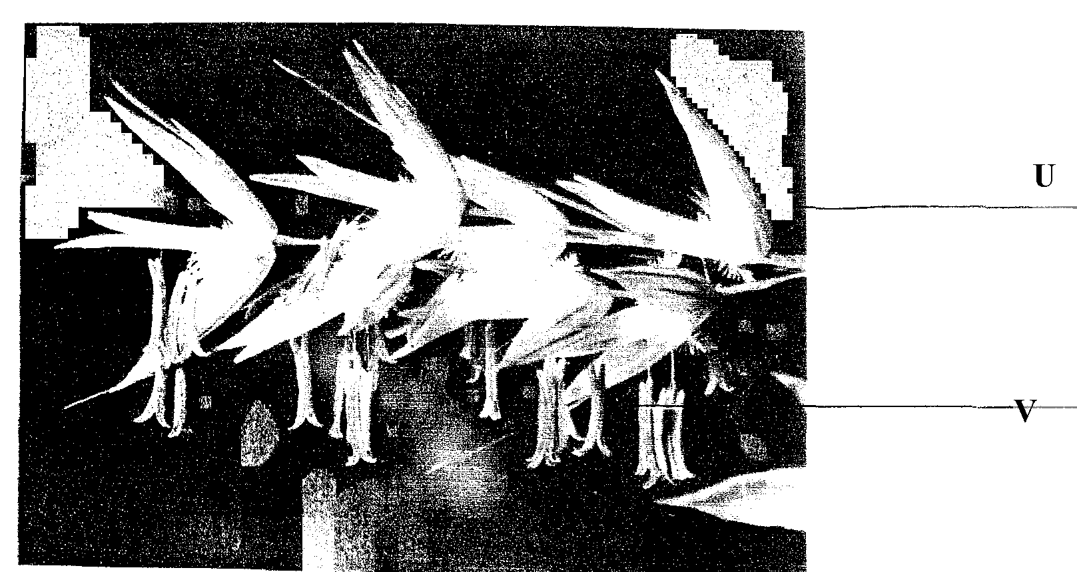

(a) Label the parts:-

**S**................................................ **T**............................................................................

**U**.......................................................  **V**..................................................................

(b) State with reasons the mode of pollination for specimen

**X**

**Y:**

(c) Name the part of specimen **X** that develops into a fruit

3. You are provided with photographs of animals which belong to the same phylum. Study the

photographs and the dichotomous key below to enable you identify the taxonomic group to

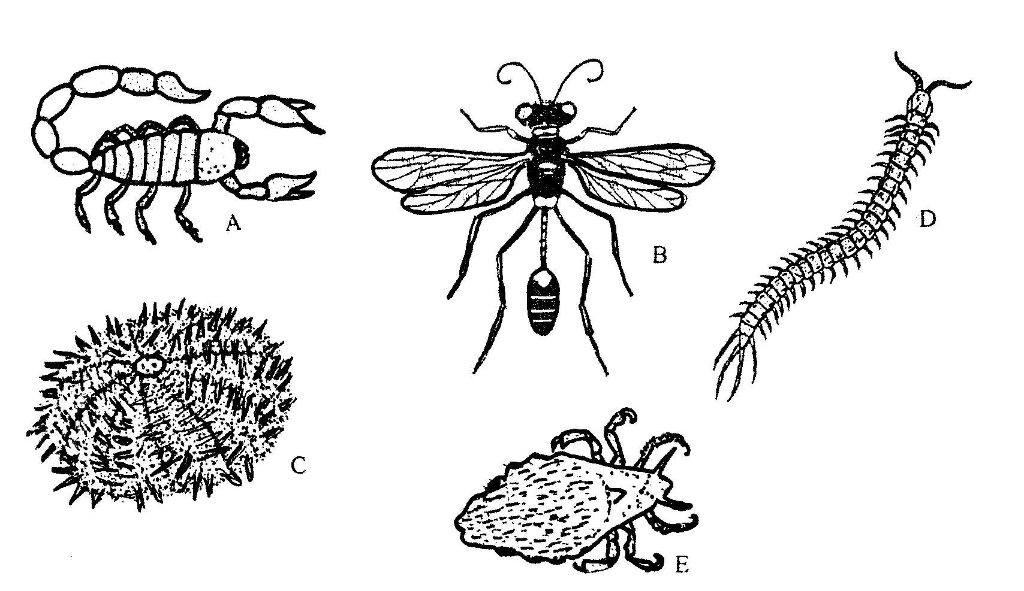 which each animal belongs:-

1. (a) Jointed legs present ........................Go to 2

(b) Jointed legs absent ........................Go to 7

2. (a) Three pairs of legs .........................Go to 3

(b) More than three pairs of legs ..........go to 5

3. (a) Wings present ..............................Go to 4

(b) Wings absent................................***Anoplura***

4. (a) One pair of wings ...........................***Diptera***

(b) Two pairs of wings ..........................***Hymenoptera***

5. (a) Four pairs of legs ............................***Arachnida***

(b) More than ten pairs of legs................Go to 6

6. (a) One pair of legs in each body segment.........***Chilopoda***

(b) Two pairs of legs in each body segment..........***Diplopoda***

7. (a) Body partially closed in a shell ..................***Mollusca***

(b) Body surface has spiny projections .......***Echinodermata***

(a) Using the key, identify organisms **A** to **E** giving the sequence of steps followed to arrive at the

identity of each organism

(b) (i) Using observable features only, state the phylum to which the organisms on the

photograph belong:

(ii) State **one** observable feature that enables you to arrive at the answer in **(b) (i)** above

**CONFIDENTIAL INFORMATION TO SCHOOLS AND PRACTICALS**

**SOTIK DISTRICT – 1ST EXAM**

*1. egg albumen*

*Pineapple juice mixture (10ml) labelled Z*

*Iodine solution*

*Ethanol*

*Distilled water*

*DCPIP*

*Benedict’s solution*

*Source of heat (hot water bath)*

*Four (4) test-tubes*

*2. Bougainvillea leaf –P*

*Kikuyu grass leaf -Q*

*Hand lens*

*3. Hand lens*

*Freshly killed housefly*

*Safety pin/pair of forceps*

1. (a) You are provided with the solution labelled **Z**. Using the apparatus and the reagents

provided, carry out the tests for the various food substances

|  |  |  |  |
| --- | --- | --- | --- |
| **Food** | **Procedure** | **Observation** | **Conclusion** |
|  |  |  |  |
|  |  |  |  |
|  |  |  |  |

(b) State the organ(s) which produce(s) enzyme(s) which are required to digest the contents

of solution **Z** completely

(c) Name the end products of digestion of solution **Z**

(d) Give **two** functions of the products named in **(c)** above in the human body

2. You are provided with the specimens **P** and **Q**:

(a) (i) What is the mode of nutrition for the organisms represented by the above specimens?

(ii) Give a reason for your answer in (**a) (i)** above

(iii) Write an equation for the physiological process involved in the mode of feeding in (**a)(i)**

above

(b) Draw and label specimen **P**

(c) State **three** observable differences between specimens **P** and **Q**

(d) Name the trophic level of the organisms from which the specimens were obtained

in the ecosystem

(e) Explain the role played by the organisms in the ecosystem

(f) Which features adapt specimen **Q** to enabling the organism from which it was detached

to live in its habitat?

3. Using a hand lens, study the specimen provided and answer the questions that follow:

(a) Give the phylum and the class to which the specimen belongs

(b) State **two** characteristics which are unique to members of the class suggested in **(a)** above

(c) Using the observable features only, explain how the specimen is adapted to living in its

habitat.

**CONFIDENTIAL INFORMATION TO SCHOOLS AND PRACTICALS**

**UGENYA - UGUNJA DISTRICT**

***Each student should be provided with the following:-***

* + *Onion bulb*
  + *Iodine solution (5ml)*
  + *Cover slip (1pc)*
  + *Microscope slide (1pc)*
  + *Means of labeling*
  + *Hydrogen peroxide – 5ml per student*
  + *Test tube (4)*
  + *Distilled water*
  + *Saturated sodium Chloride solution – Liquid H – 5ml per student*
  + *Blotting paper (1pc)*
  + *Means of timing*
  + *Pestle and Mortar*
  + *Piece of liver*
  + *Wooden splint*
  + *Benedicts solution – 5ml*
  + *Scalpel blade*
  + *Means of heating*
  + *Boiling tube (1)*
  + *Glass rod*
  + *A pair of forceps*
  + *Microscope (one for a group of five)*

*N/B – Provide a medium power objective lens of x10 and eye piece lens of x10 or x15.*

1. You are provided with a portion of an onion bulb. Remove one fleshy leaf from the onion bulb, peel the epidermis from the inner surface of the leaf and place it on a drop of iodine solution on a glass slide. Place a cover slip on the epidermis. Drain the excess iodine solution by use of a piece of blotting paper from the edge of the cover slip then leave the set up for one minute.

Place a drop of **liquid H** at the edge of the cover slip. Leave the set up for **5 minutes** then drain excess liquid from the opposite of the slip using a blotting paper. Observe under medium power of the light microscope provided.

(a) **Draw** and **label** two neghbouring cells

(b) Account for the results in **(a)** above

(c) Using a pestle and mortar, crush two fleshy leaves of the onion bulb, add 4mls of distilled

water and stir. Decant into a test tube and label the resultant filtrate as **solution J1** and retain

the residue.

Using the reagents provided, carry out food tests on **solution J1** and fill the table below:

|  |  |  |  |
| --- | --- | --- | --- |
| **FOOD**  **SUBSTANCE** | **PROCEDURE** | **OBSERVATION** | **CONCLUSION** |
|  |  |  |  |
|  |  |  |  |

(d) Label one test tube as  **J2** and another as **K** . Add 2mls of Hydrogen peroxide to each of the

test tubes.

(i) Into the test tube labelled **J2**, place the entire residue obtained in (c) above and immediately

introduce a glowing splint. Record your observations in the table below. Into the test tube

labelled **K**, place the piece of liver provided then immediately introduce a glowing splint

into the mouth of test tube and record your observations in the table below.

(ii) Name the enzyme responsible for the reactions in the test tubes above

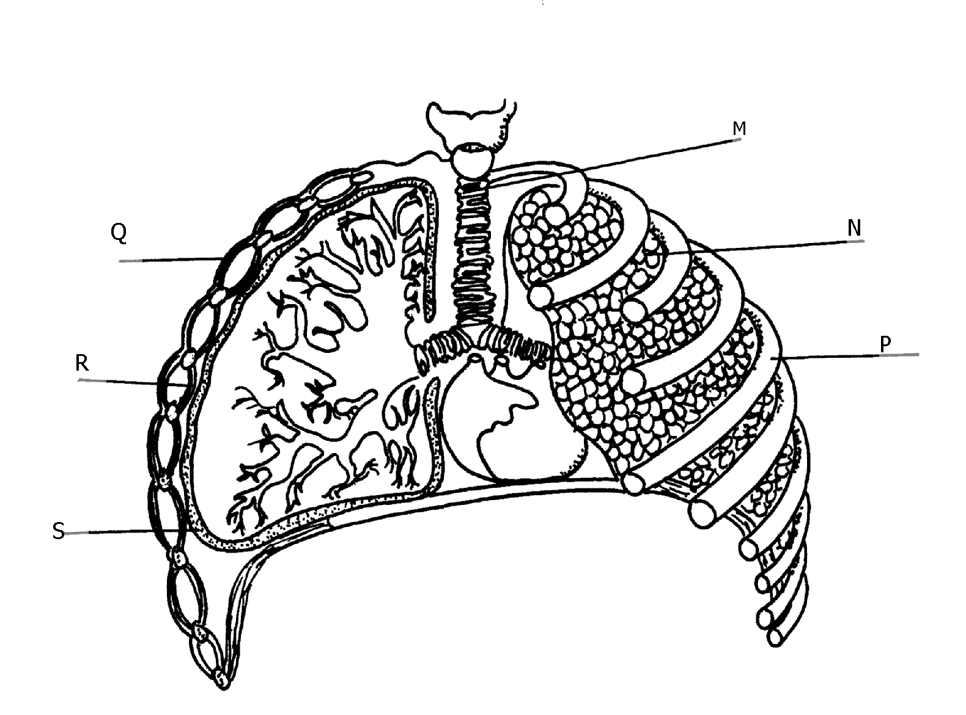 (iii) Explain the significance of the difference in the observations in part (i) above

2.Use the diagram provided to answer questions that follow:

**Y**

(a) Name the bones that articulate with the structure labelled **P**

(i) Dorsally ..........................................................

(ii) Ventrally..................................................................................

(b) Give **three** adaptations of structure **M** to its functions

(c) (i) Name the fluid found within the part labelled **S**

(ii) State the function of the fluid named in (c) (i) above

(d) Identify the parts labelled: **Q** & **R**

(e) State **two** changes that take place in the organ labelled N when the structure **Y** contracts

(f) How is large surface area achieved for efficient functioning of the organ labelled **N**?

3. A student collected a number of invertebrates whose photographs appear below. He constructed a Dichotomous key as shown below to enable him place each specimen into its taxonomic group

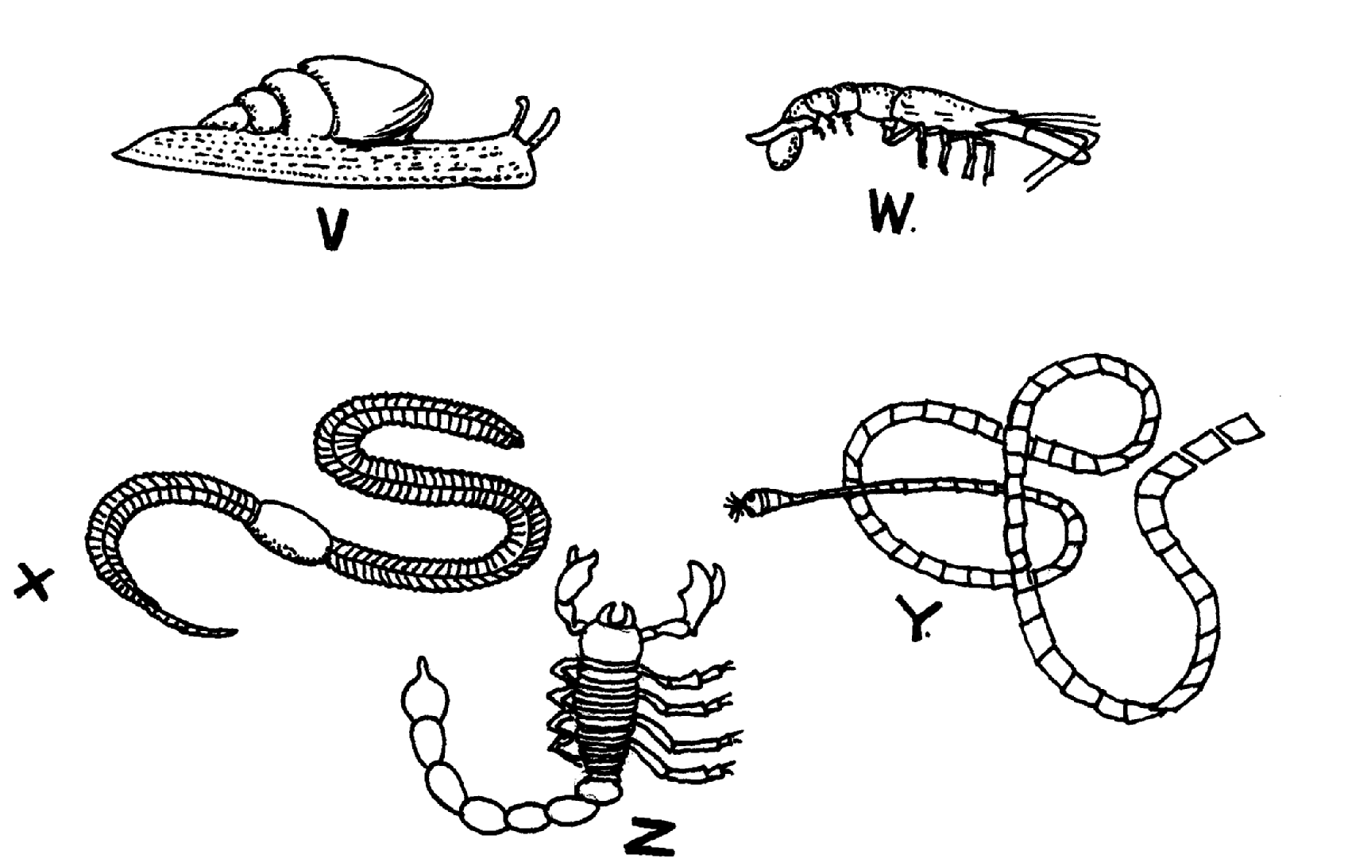**photographs**

**DICHOTOMUS KEY**

1. (a) Organisms with a flat body Go to 9

(b) Organisms without a flat body Go to 2

2. (a) Organisms having a body in a shell ***Mollusca***

(b) Organisms without a shell Go to 3

3. (a) Organisms having a segmented body Go to 4

(b) Organisms with a body not segmented ***Nematoda***

4. (a) Organisms having jointed appendages Go to 6

(b) Organisms without jointed appendages Go to 5

5.(a) Organisms with a long cylindrical body ***Annelida***

(b) Organisms having a short stout body ***Trematoda***

6. (a) Organisms with antennae Go to 7

(b) Organisms lacking antennae Go to 8

7. (a) Organisms with a pair of antennae ***Insecta***

(b) Organisms with more than one pair of antennae ***crustacea***

8. (a) Organisms with pincer-like mouth parts ***Arachnida***

(b) Organisms with sucking mouth parts ***Acarina***

9. (a) Organisms having a ribbon like body ***Cestoda***

(b) Organisms with circular body ***Crinoidea***

(a) Using the dichotomous key, identify the taxonomic group of each of the five specimens

shown in the photographs. In each case show in sequence, the steps in the key that you

have followed to arrive at the identity of each specimen .

(b) Name a pathogen that attacks human beings and is associated with the organism labelled **V**

**CONFIDENTIAL INFORMATION TO SCHOOLS AND PRACTICALS**

**NDHIWA DISTRICT**

***Each candidate will require the following:-***

* *Winged cockroach lablled R*
* *Tick labelled N*
* *Soldier termite labelled P*
* *Adult housefly labelled Q*
* *10ml 20 volume hydrogen peroxide*
* *Pestle and mortar*
* *Spatula preferably a wooden one*
* *Scalpel*
* *Ruler caliberated in centimeters*
* *A medium size irish potato tubers labelled L*
* *Measuring cylinder (to measure up to 4mls)*
* *2 boiling tubes*
* *3 test-tubes*
* *Means of labeling (two each)*
* *A maize seedling with opened coleoptile*
* *Green leaves and should also have remains of grain labelled K seedlings grown in the sand on trays in plastic containers give good specimens*
* *Distilled water*
* *Iodine solution*
* *Benedicts solution*
* *Means of heating*

1. You are provided with specimens labelled **N, P, Q** and **R**. Using the following characteristics and

in the order given only

* Number of legs
* Presence of wings
* Number of wings

a) Construct a three –step dichotomous key. Use the given letters for identification

(Specific names not required)

b) i) Using observable features only, state the phylum to which specimen **R** belongs

ii) Give **three** reasons for your answer in **(b) (i)** above

c) i) Using observable features only, classify specimen **N** in its class

ii) Give **four** reasons for your answer in (**c) (i)**

2. Study the photographs of some hydrophytes shown below. They show various adaptations

they have to overcome problems they are exposed to due to the nature of their habitats

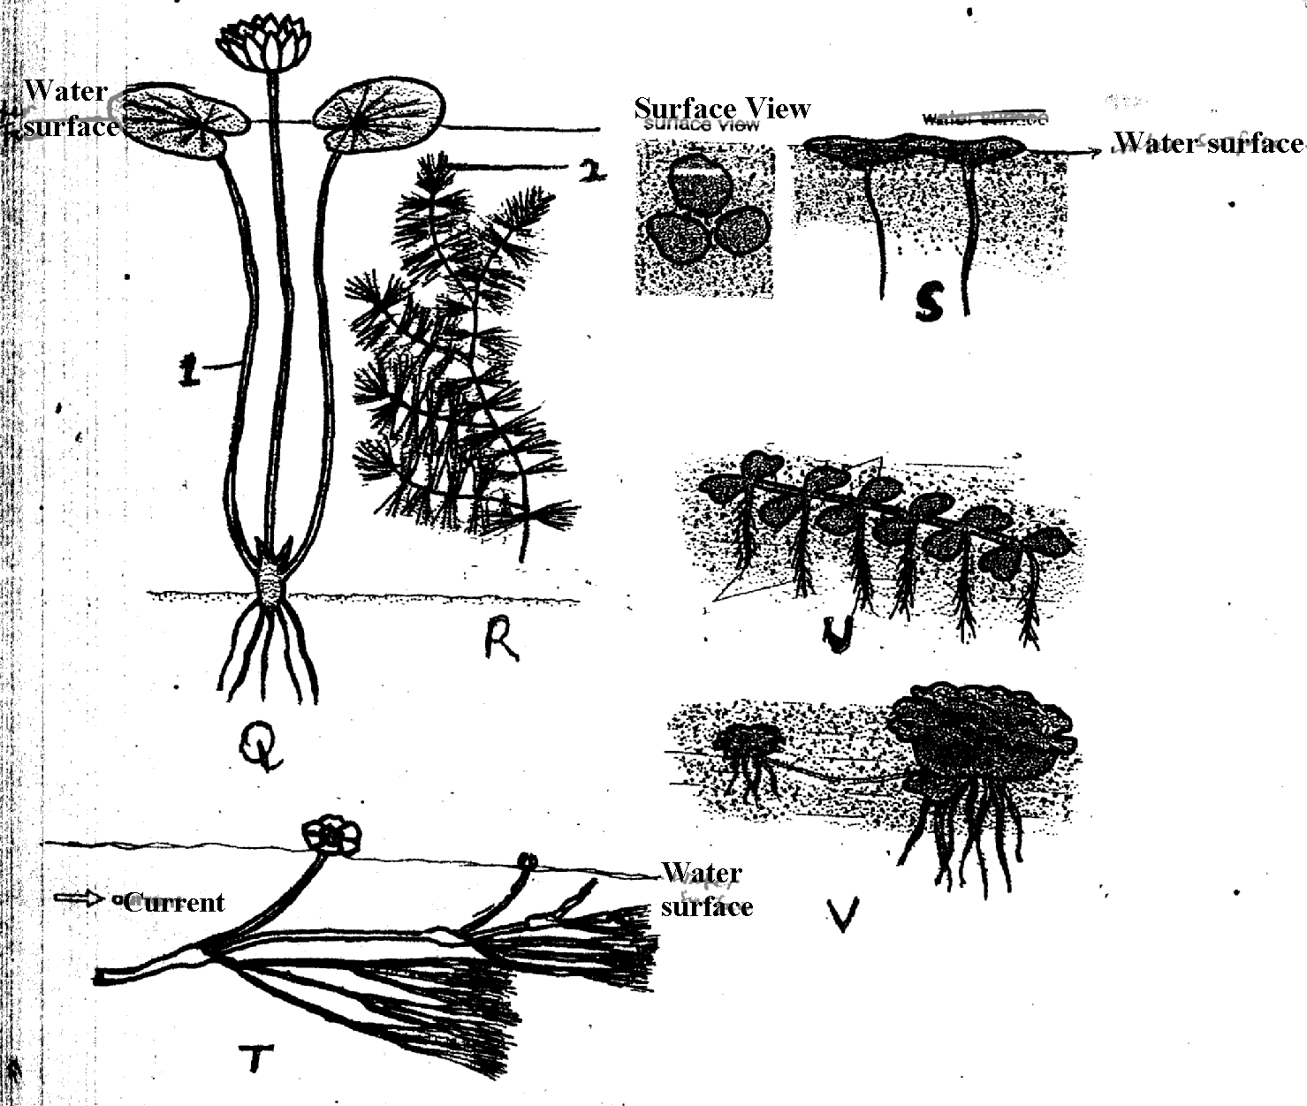

i) What are hydrophytes?

ii) Name the structures of plants labelled **1** and **2**

iii) State **two** problems which hydrophytes are faced with in their habitat

iv) With reference to the photographs, how are the hydrophytes adapted to solve each of the

problems you have stated in **part 2 (iii)** above?

v) State **two** internal adaptive features of the plants not shown in the photographs above

that enables them to live in their habitat

vi) What type of hydrophytes do the following plants represent?

**R** ......................................  **S**......................................

3. You are provided with a specimen labelled **L** and hydrogen peroxide

a) Cut two equal cubes whose sides are about 1cm from specimen **L**. Place one of the cubes into a

boiling tube labelled **A**. Crush the other cube using pestle and mortar. Place the crushed material

in another boiling tube labelled **B**.

To each boiling tube add 4ml of hydrogen peroxide

i) Record your observation

ii) Account for the result in **(a) (i)** above

iii) Write an equation for the break down of hydrogen peroxide

b) You are provided with a specimen labelled **K**. Separate the roots and leaves from the remains

of the grain. Crush the roots, leaves and the remains of the grain separately. To each

crushed materials add 1ml of water. Put the extract from the materials into separate test tubes

and label them using the reagents provided. Test for the food substances in each of the

extracts. Record the procedure, observation and conclusions in the table below:-

c) Account for the results obtained in **(b)** above

i) Roots

ii) Remains of grains

iii) Leaves

**CONFIDENTIAL INFORMATION TO SCHOOLS AND PRACTICALS**

**MUMIAS DISTRICT**

***Requirements :-***

* + - *Unripe pawpaw fruits (one pawpaw- ten students)*
    - *Beaker (4)*
    - *Razor /scalpel*
    - *Ruler*
    - *Solution G – distilled water*
    - *Solution H – salt solution of different concentration namely 10%, 20%, 60%*
    - *Labels*

1. You are provided with specimen **D** and two solution **G** and **H.**

Cut five longitudinal strips of the specimen **D** peelings of approximately 0.5cm width,

0.5cm breadth and 5cm length.

Place one strip in a beaker having solution **G**. Place other strips in separate beakers containing different concentration of solution H as indicated

in the table below:

|  |  |
| --- | --- |
| **Beaker** | **Solution** |
| 1 | **Solution G** |
| 2 | 10% solution **H** |
| 3 | 20% solution **H** |
| 4 | 60% solution **H** |

Leave the set-up for 30minutes

(i) Record your observations in the table below:

(b) Account for the observation in trips **1, 2** and **4**

(c) Suggest the identity of solution **G** and **H**

2. During a biology lesson, students made drawings of invertebrates shown below. Use the dichotomous key provided below to identify the organisms;

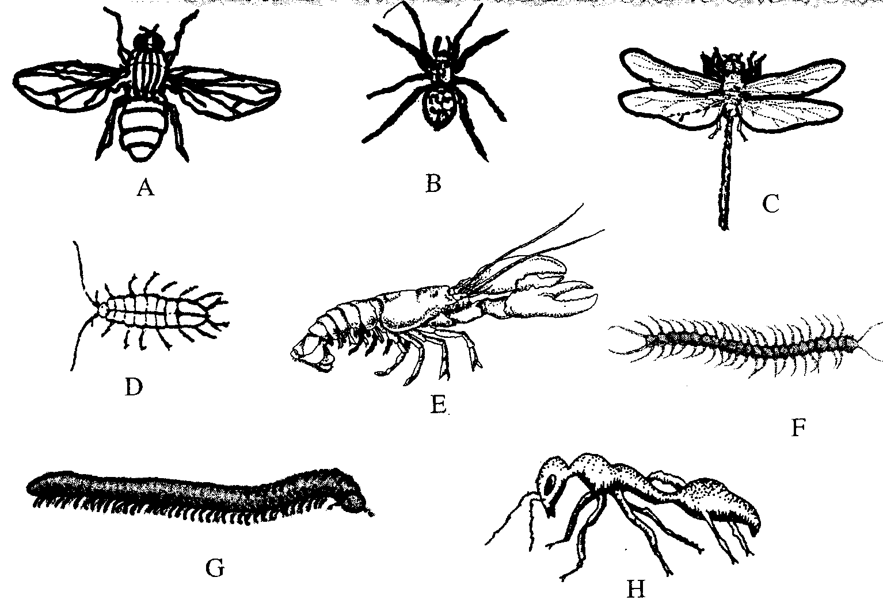

1. a. Animal with wings ……………………………….go to 2

b. Animal without wings …………………………….go to 3

2. a. With one pair of wings……….................................Housefly

b. With pairs of wings ………………………………..Dragonfly

3. a. With three pairs of legs …………………………...Ant

b. With more than three pairs of legs……………..…go to 4

4. a. With four pairs of legs …………………………...Spider

b. With more than four pairs of legs ………………..go to 5

5. a. With two pairs of antennae …………………..…...go to 6

b. With one pair of antennae………………………...go to 7

6. a. With six pairs of legs……………………………..Water slater

b. With ten pairs of legs ………………………….....Fresh water shrimp

7. a. With a body ………………………………..….….millipede

b. With a dorso-ventrally flattened body…………….Centipede

(a) Complete the steps **2(b)** and **7(b)** by filling in the key above

(b) Complete the table to identify the organisms:

(c) State the classes of specimens **B, C, E** and **G**

3. The photograph **Z** below is apart of a plant. Examine it

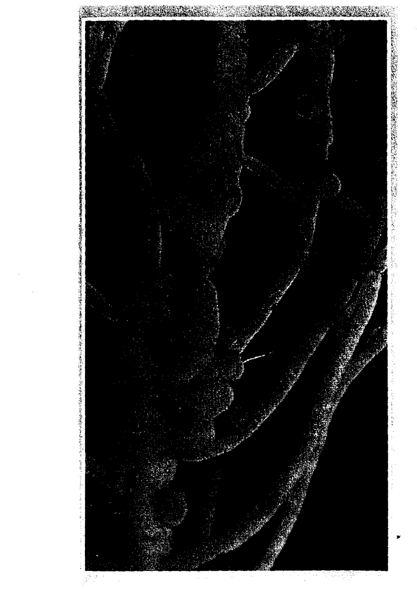

(a) Label any **three** parts of the plant part in photograph **Z**

(b) Name the type of organisms that is associated with this part of the plant

(c) Photograph **Z** was taken from a special type of plant. What is the name of this group

of plants?

(d) Photograph **Z** exhibits a certain phenomenon;

(i) Name the phenomenon

(ii) State the significance of this phenomenon named in **d(i)** above

(iii) What is the product of this phenomenon?

(iv) Name t**wo** organisms that covert the product of the phenomenon in **d(i)** above into

the raw material

**CONFIDENTIAL INFORMATION TO SCHOOLS AND PRACTICALS**

**KISUMU WEST DISTRICT**

***Each candidate should have:-***

* + *Starch suspension labelled Liquid X*
  + *Iodine solution*
  + *Benedict’s solution*
  + *2M hydrochloric acid (1ml)*
  + *2 Droppers*
  + *Measuring cylinder (10ml size)*
  + *Means of heating/Bunsen burner*
  + *5 test-tubes*
  + *Water in a small beaker*
  + *Thermometer*
  + *Test-tube holder*
  + *3 boiling tubes*
  + *Tripod stand and gauze*
  + *3 labels*
  + *White tile*
  + *Water bath*
  + *Diastase/ amylase* **enzyme (0.5g per student)**

**N/B**: -**Liquid X is prepared by dissolving 5g of soluble starch in 50ml of distilled water.**

**Thorough stirring is required whenever it is being used.**

1. You are provided with liquid **X** and substance **Q**

(a) Place three drops of liquid **X** onto a white tile. Add four drops of iodine solution and record

your observation.

(b) Pour 2ml of liquid **X** into a test-tube. Add equal amounts of Benedict’s solution and

boil the mixture. Record your observation

(c) Label three boiling tubes as set-ups **A**, **B**, and **C**. Place 3ml of liquid **X** into each of the set-ups.

Divide substance **Q** into three equal portions.

To set-up **A**, add one portion of substance **Q** and shake.

* Place the second portion of substance **Q** into a test tube. Add 1ml of water to it and boil for four minutes. Add it to set-up **B** and shake.
* To set –up **C**, add the third portion of substance **Q**. Add 8 drops of 2M hydrochloric acid and shake.

Place the three set-ups in a warm water bath maintained at 37oC for 40minutes.

Cool the set-ups by dipping the boiling tubes in cold water

Place 2ml of the contents of each set-up into three separate test tubes. Add equal amount of Benedict’s solution to each of the three test-tubes and boil.

***Record your observations :-***

(d) Account for your observations in the set-ups:-

(e) Give the most likely identity of substance **Q**

(f) Why was the water bath maintained at 37oC

2. During a visit to a museum, students were shown some animals on display. Six of the animals

are shown in the photographs below;

(a) Using observable features only, classify the animals, **A, B** and **E** into their respective classes.

Give a reason for your answer in each case

(b) State **one** morphological difference between **C** and **E**

(c) The dichotomous key constructed below can be used to identify some of the animals viewed in the museum:-

1. (a) Has jointed legs ................................................go to 2

(b) Lacks jointed legs ............................................go to 3

2. (a) Has five or less pairs of legs ............................ go to 4

(b) Has more than five pairs of legs ...................... go t o 5

3. (a) Has bilateral symmetry.......................................................EUNICE

(b) Has radial symmetry...........................................................LUDIA  
4. (a) Has five pairs of legs ..............................................CANCER

(b) Has four pairs of legs ...........................................LACTRODECTUS

5. (a) Has I pair of legs per body segment .....................SCOLOPENDRA

(b) Has 2 pairs of legs per body segment ...................SIGMORIA

Use the dichotomous key above to identify animals labelled **C, D** and **E**. In each case show in

sequence the steps followed (e.g. 1b, 2b, 3a e.t.c.) to arrive at the identity of each animal

3. Below are photographs **I** and **II** of young plants.

**PHOTOGRAPH I PHOTOGRAPH II**

(a) With a reason in each case, name the class to which the plants belong:

(i) Plant in photograph **I** ..................................................................................................

Reason.........................................................................................................................

(ii) Plant in photograph **II** .....................................................................................

Reason.........................................................................................................................

(b) Identify the parts labelled **G, J** and **M**

(c) State **two** functions of the part labelled **H**

(d) (i) Name the swellings that would be developed in the roots of the plant in **photograph I**

later in its life

(ii) Which organism would be found in the swellings in **(d)(i)** above?

(e) (i) State the type of germination exhibited by the plant in **photograph II**

(ii) Give a reason for your answer in **(e) (i)** above

**CONFIDENTIAL INFORMATION TO SCHOOLS AND PRACTICALS**

**TRANS NZOIA WEST DISTRICT**

***Requirements for each candidate:***

* + - *L1- solution of egg albumen – 20ml*
    - *L2 – solution of starch and glucose – 20ml*
    - *Visking tubing (10cm long)*
    - *Thread*
    - *250ml beaker*
    - *Stirring rod*
    - *Iodine solution*
    - *Benedicts solution*
    - *Source of heat*
    - *4-test tubes*
    - *1-boiling tube*
    - *Test-tube holder*
    - *Test-tube rack*

1. You are provided with liquids labeled L1, and L2 and a piece of visking tubing. Spare about

10ml of each of the liquids for part (a) of this question

Using a piece of thread, tightly tie one end using the visking tubing

Open the other end of the visking tubing and half fill it with liquid L1. Tightly tie this end.

Ensure there is no leakage at both ends. Immerse the tubing in a beaker containing liquid L2

a) Using the Iodine and the benedict’s solutions provided, test for the food substances in

liquid L1 and L2. Record your observations in the table below :-

After at least 30 minutes, remove the visking tubing from the beaker and wash the outside of

the tubing thoroughly to remove traces of liquid L2

b) Using the same reagents, test for food substances in liquid L1 in the visking tubing.

Record your observations in the table below:

c) Account for the results obtained after carrying out tests on liquid L1 before and after

immersion into liquid L2

2. Below is photograph **S**

a) i) Name the class to which the organism in the photograph belongs:

ii) Give **three** observable reasons for your answer in **(a) (i)** above

b) State **two** functions of the part labeled **1**

c) Name the fins on the specimen that:

i)Enable the specimen to balance, brake and change direction

ii) Prevent the fish from rolling and yawing

d) Measure in millimeters the length of the:

i) Photograph **S** from the tip of the mouth to the tip of the tail

Length…………………… mm

ii) Photograph **S** from anus to the tip of the tail.

Length………………………..… mm

iii) Using the measurements in **d (i)** and **d (ii)** above, calculate the tails power

iv) State the significance of tail power in specimen **S**

e) Other than structures in **(c)** above, state **two** observations of the animals in photograph **S**

to locomotion in water

3. Study the photomicrograph **M** which shows plants tissues

a) Name the parts labeled **A -G**

b) State the function(s) of tissues labeled **A, B, C**

c) Name the cell types found in parts labeled **D** and **G**

d) How are sderenchyma cells adapted to their function?

e) Distinguish between the section above and the one from the root of the same plant

**CONFIDENTIAL INFORMATION TO SCHOOLS AND PRACTICALS**

**RACHUONYO DISTRICT**

*Each school will need 20g of yeast powder for every to candidates picked and sealed in polythene*

*papers and labeled substance K.*

*To schools - Substance K is to reach school on the morning of the examination packed substance ‘K’ delivered to schools on the day of Biology examination*

*Each candidate will require the following:-*

* + *4 test-tubes with tightly fitting corks*
  + *6ml of 10% glucose in a test tube*
  + *3 labels per candidate*
  + *6ml of distilled water in a test tube*
  + *Source of heat*
  + *2cm by 2cm liver piece*
  + *Dilute hydrogen peroxide (20 volumes)*
  + *About 2g of substance K*
  + *Substance K to be provided by RAEC on the morning of examination day)*

1. During a visit to a museum, students were shown ten specimens of invertebrates on display.

The teacher provided a dichotomous key to enable them classify each specimen on display.

Five of the specimens are shown in the photographs below:

**DICHOTOMOUS KEY**

1. a. Animal with flattened body Go to 9

b. Animal without flattened body Go to 2

2. a. Animal with body in shell Mollusca

b. Animal without shell Go to 3

3. a. Animal with segmented body Go to 4

b. Animal with body not segmented Nematoda

4. a. Animal with jointed appendages Go to 6

b. Animal without jointed appendages Go to 5

5. a. Animal with long and cylindrical body Annelida

b. Animal with short stout body Trematoda

6. a. Animal with antennae Go to 7

b. Animal without antennae Go to 8

7. a. Animal with one pair of antennae Insecta

b. Animal with more than one pair of antennae Crustacea

8. a. Animal with pincer like mouth parts Arachnida

b. Animal with sucking mouth parts Acarina

9. a. animal with long ribbon like body Cestoda

b. Animal with circular body Crinoidea

(a) Use the dichotomous key to identify the taxonomic group of each of the five specimens in

the photographs. In each case, show the sequence of steps e.g. 1a, 2b, 7b e.t.c. in the key

that you followed to arrive at identity of each specimen

(b) State the phylum to which animal **G** belong

(c) Apart from jointed appendages, state 2 other distinguishing characteristics of the phylum

named in **B** above

2. The photomicrograph below represents parts of 2 adjacent cells as seen under an electron

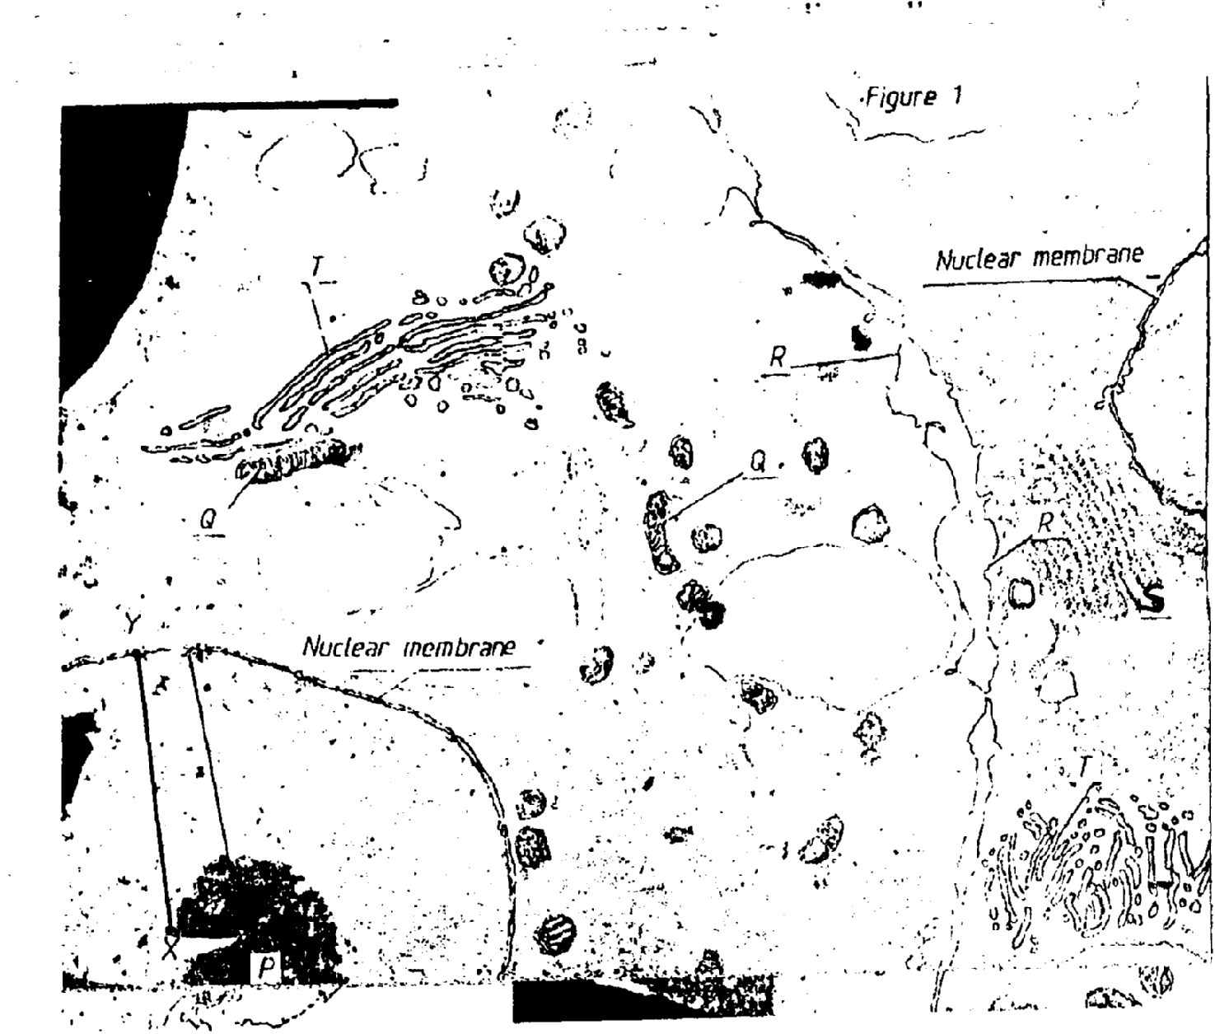 microscope. Study it and answer the questions that follow:-

(a) Use the table below to name **P, Q, R, S** and **T.** For each organelle, state one function

(b) The magnification of the cells in this micrograph is x 10,000. Use a ruler to measure the

radius of the nucleus between **X** and **Y** in millimeters. Calculate the actual radius of the

nucleus before magnification in mm

Length………………………………………mm

Actual radius of nucleus

3. You are provided with 10% glucose solution and substance **K.** place equal amounts of the

glucose solution in test tubes labeled 1, 2 and 3. Divide the substance **K** into 3 equal portions.

To one portion, add 2ml of water and boil, cool it down. Pour this mixture into test tube 1

Add another portion of substance **K** to test-tube 2 and shake.

Put 2ml of distilled water in test tube 3. Close the 3 test-tubes tightly using well fitting

corks, and allow the set-ups to stand for at least 20 minutes

(a) Record your observation: (i) Test tube 1 (ii) Test tube 2 (iii) Rest tube 3

(b) (i) Name the process being investigated in the experiment

(ii) Write down an equation for this process

(iii) In which organelle does the process take place

(c) (i) Suggest the identity of substance **K**

(ii) Account for the results in test-tube 1

(d) Cut a small piece of liver 2cm by 2cm. drop it into the test tube containing dilute

hydrogen peroxide. Leave for 2 minutes

(i) State your observation

(ii) Account for your observations

**CONFIDENTIAL INFORMATION TO SCHOOLS AND PRACTICALS**

**KAKAMEGA NORTH DISTRICT**

***Each candidate to be provided with:***

* + *Scalpel blade*
  + *A ripe tomato labelled specimen Q.*
  + *A mortar and a pestle*
  + *Filter paper,*
  + *Means of heating*
  + *DCPIP*
  + *3 droppers*
  + *50cm3 beaker*
  + *4 A freshly killed soldier termite labelled specimen R*
  + *4 A freshly killed maize weevil labelled specimen. S*
  + *4 A hand lens.*

1. You are provided with specimen labelled **Q**. Examine it and;

(a) (i) Name the part of a plant specimen **Q** is

(ii) Give a reason for your answer in **(a)(i)** above

(b) (i) Name the likely mode of dispersal of specimen **Q**

(ii) Give **two** reasons for your answer in **(b)(i)** above

(c) Make a transverse section through specimen **Q** to obtain two equal halves

(i) Draw and label one of the halves of specimen **Q**.

(ii) Crush one f the halves of specimen **Q** in a mortar using a pestle to obtain a paste. Gently

decant the juice into a boiling tube.

d) Using the reagents provided test for the food substances present in the juice extracted.

Record your procedures, observations and conclusions in the table below.

|  |  |  |  |
| --- | --- | --- | --- |
| **Food substance** | **Procedure** | **Observations** | **Conclusion** |
|  |  |  |  |
|  |  |  |  |

2. You are provided with specimens labelled **R** and **S.** Examine then;

(a) (i) Name the phylum to which the specimen **R** and **S** belong

(ii) Give **three** reasons for your answer in **(a)(i)** above.

(b) (i) Name the class to which specimens **R** and **S** belong

(ii) Give **three** reasons for your answer in **(b)(i)** above.

(c) State **two** observable differences between specimens **R** and **S**.

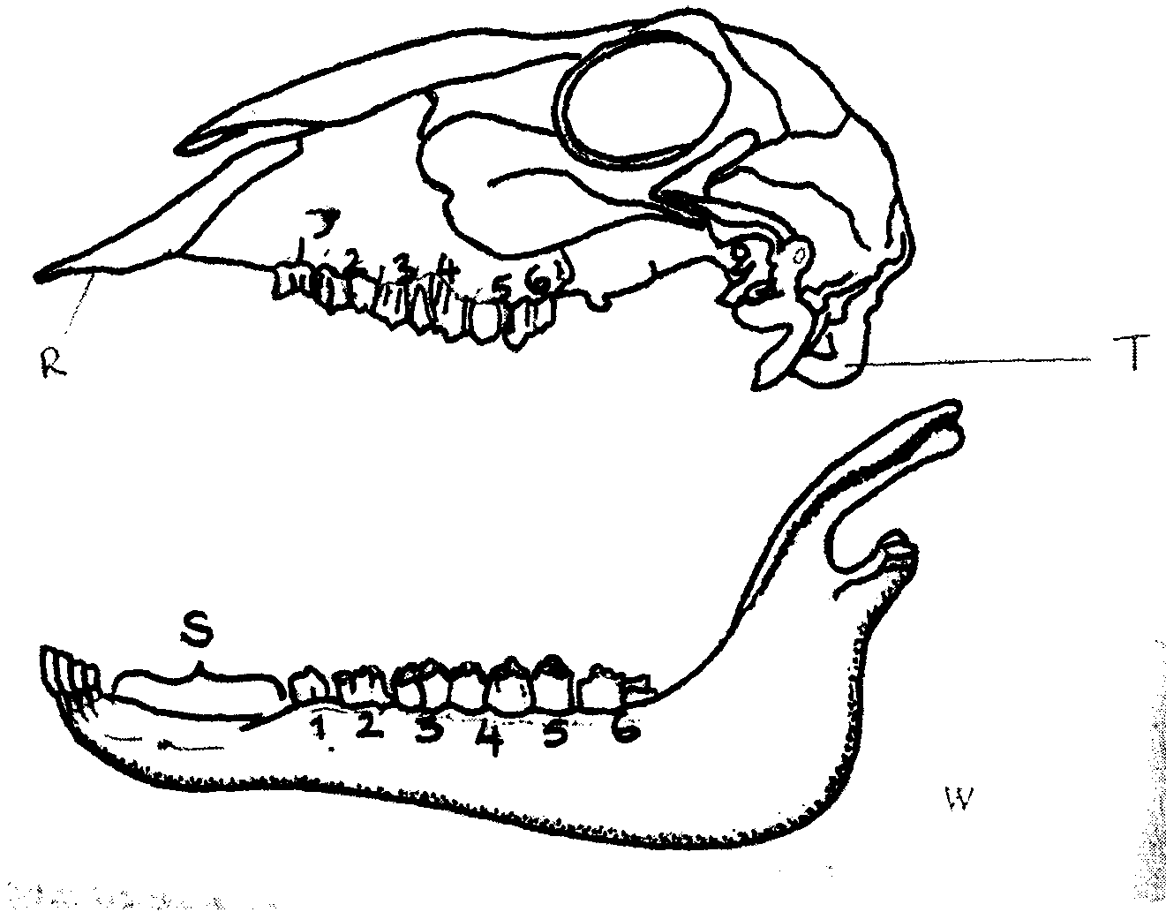3. The drawings below illustrate two skulls **V** and **W** obtained from **two** different mammals.

Examine them.

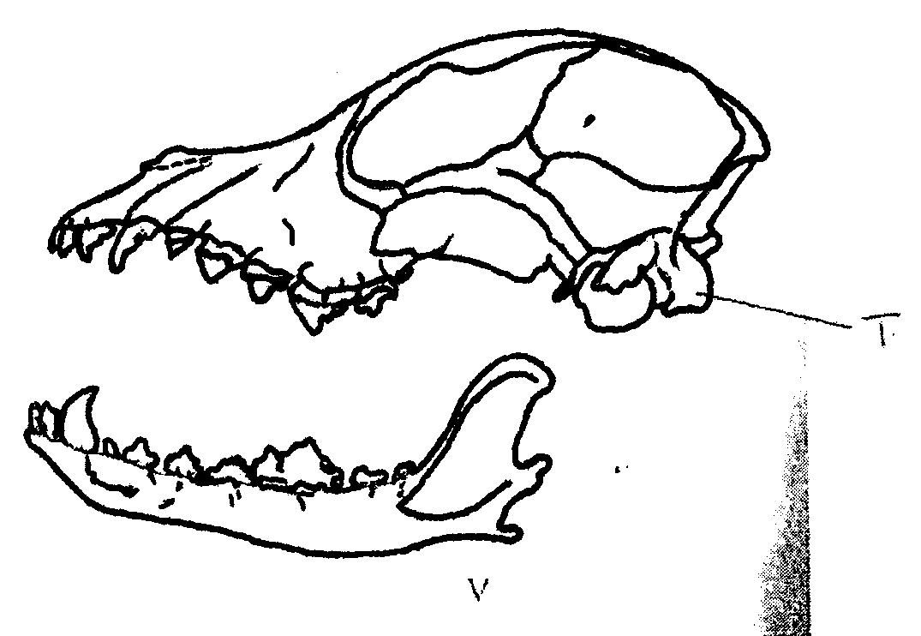

**R**

**T**

**T**

**W**

**V**

(a) State the mode of feeding of the organism from which each of the skulls was obtained.

Give **two** reasons in each case.

(b) Label canine on drawing **W** and carnassial teeth on drawing **V**

(c) State the function of each of the following labelled parts on the drawing **R & S**

(d) Write down the dental formula of the organism from which skull **W** was obtained

(e) State **four** observable differences between the skulls **V** and **W**.

(f) (i) Name the part labelled **T**

(ii) Name the vertebra that articulates with the part labelled **T**.

**CONFIDENTIAL INFORMATION TO SCHOOLS AND PRACTICALS**

**SOTIK DISTRICT- 1ST EXAM**

1. You are provided with two pieces of plant material labelled specimen Q. Using a scalpel cut two

slits half way to obtain four flaps through the middle of each piece as shown in the diagram

below:-

Place one piece in the solution labelled **M1** and the other in the solution **M2** . Allow the set up to stand for 30minutes

(a) After 30minutes remove the pieces and press them gently between the fingers

(i) Record your observations M1 M2

(ii) Account for the observations in A above

(b) Examine the pieces

(i) Record other observations besides those made in (a) (i) above

(ii) Account for the observations in (b)(i) above

2. You are provided with specimen labelled **K**

(a) (i) Name the class to which the specimen belongs

(ii) Give **three** reasons for your answer in a (i) above

(b) What term is used to describe the shape of the specimen?

(c) Name and draw the fins on the specimen that;

(i) Enable the specimen to balance, brake and change direction

(ii) Prevent the fish from rolling and yawing

3. You are provided with a specimen labelled

(a) (i) What part of a plant is specimen **T?**

(ii) Give a reason for your answer in a(i) above

(b) (i) Cut a transverse section through specimen **T** (i) Draw and label one of the cut surfaces (ii) State the magnification of your drawing

(iii) State the type of placentation of specimen **T**

(c) Name the agent of dispersal of specimen **T**

(d) State how specimen **T** is adapted to its mode of dispersal

**CONFIDENTIAL INFORMATION TO SCHOOLS AND PRACTICALS**

**BUTERE EAST DISTRICT**

***Each candidate should be provided with the following material/apparatus for the practical:-***

* + *Medium sized Irish potato (1 piece each) labeled Q.*
  + *Mortar and pestle.*
  + *Scalpel*
  + *Distilled water*
  + *Cotton thread (20 cm long).*
  + *Visking tube 15 cm long.*
  + *100 ml beaker.*
  + *Stirring rod.*
  + *Iodine solution.*
  + *Means of timing.*
  + *Photomicrographs labeled M and N.*
  + *Transparent ruler graduated in mm*
  + *Specimen K – Medium sized orange (should be moderately ripe and juicy)*
  + *Test tubes (3 per candidate) in a test tube rack.*
  + *DCPIP solution.*
  + *Iodine solution.*
  + *Benedicts solution.*
  + *Means of heating water bath.*
  + *Test tube holder.*
  + *3 droppers.*
  + *10 ml measuring cylinder.*

*© SIJE - 2010 Form 4 Biology 231/2 Turn Over*

*4*

1. You are provided with a specimen labeled Q. Slice off about 2 cm thick disc from the

specimen. Peel it. Place the piece into a beaker and mash it into a paste using pestle and mortar.

Add 20 ml of distilled water and stir. Tie one end of the transparent visking tubing provided.

Decant the extract into the tubing and tie the other end tightly.

Ensure there is no leakage at both ends of tubing. Rinse the outside of tubing with water.

Immerse the tubing with its contents in a 100 ml beaker containing iodine solution. Allow to

stand for 20 minutes..

a) Record your observations in the table below.

(b) Account for the results obtained from (a) above.

(c) What is the significance of the process being investigated to plants?

2. Study the micrographs M and N show forms of a sexual reproduction in a certain group of

organisms. Study them and answer questions that follow.

(a) (i) State the kingdom to which the two specimens belong.

(ii) Give reason for your answer.

(b) (i) What types of asexual reproduction are represented by the two specimens?

(ii) State an example in each case of an organism that uses the type of reproduction named

above.

(c) Consider the point marked X and Y. Measure the distances between the two in cm.

(i) Distance ___________________________________ cm

(ii) If the magnification of N is x60 of the actual specimen. What is the size of the actual

specimen in micrometers? (Show your working)

What is the economic importance of the activities of **M** and **N**?

3. You are provided with the specimen labeled **K**. Make a transverse section of the

specimen

(a) Draw and label the transverse section of the specimen.

(b) Which type of fruit is specimen **K**?

(ii) How is the specimen adapted for dispersal by the agent named in c (i) above?

(d) Squeeze the juice from the specimen **K** into a small beaker. Using the reagent provided to

test for the food substances in the juice. Record the substances, procedures, observations and

conclusions in the table below.

**CONFIDENTIAL INFORMATION TO SCHOOLS AND PRACTICALS**

**TRANS MARA DISTRICT**

***Each student should be provided with:-***

1. *Specimen P – fresh piece of mammalian lungs*

*Specimen Q – fresh piece of mammalian trachea*

* *Petri dishes –*
* *A white tile*
* *A scalpel blade*
* *A hand lens*
* *Ruler*

*2. Specimen R – fresh peas in a pod (Legume)*

*Specimen S – An orange/lemon (ripe)*

1. (a) You are provided with specimen **P** and **Q** which were obtained from the same animal.

Examine them carefully and answer the questions that follow:

(b) Which organ system were the specimen **P** and **Q** obtained from

(c) State the functions of **P** and **Q** in the organ system named in (b) above

(d) State **four** adaptations in each one of specimen **P** and **Q** to their functions

(e) Using a scalpel cut and draw a well labelled transverse section of specimen **P**

2. You are provided with specimen labeled **R** and **S**. Use them to answer the questions that follow:

(a) State the type of fruit labelled **R** and **S**

(b) (i) Draw a plan diagram of the longitudinally cut surface of specimen **R**

(ii) Work out your magnification

(iii) State the placentation of specimen **R**

(c) (i) State the method of dispersal of specimen **R** and **S** giving reasons for each case.

Fill your answers in the table below

(ii) Give **one** advantage of the method of dispersal of specimen **S** and one disadvantage of

dispersal of specimen **R.**

3. You are provided with photographs of specimen **K, L, M, N** and **P.** using observable features

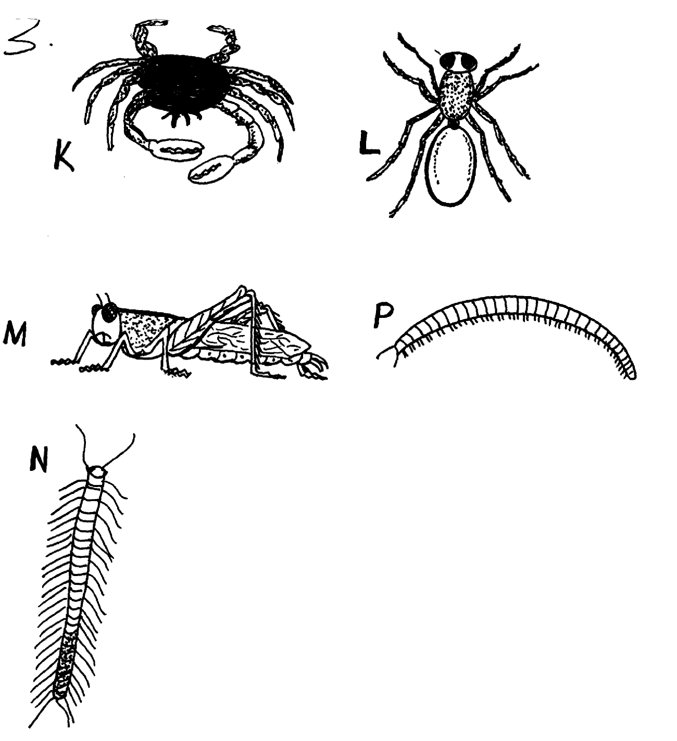 only, answer the questions that follow:

(a) (i) State the phylum of the organisms

(ii) Give **two** reasons for your answer in (a) (i) above

(b) With reasons give the class of :

(i) Specimen **K**

Reason

(ii) Specimen **N** .

Reason

(c) (i) State **two** ways by which specimen **M** is adapted to locomotion

(ii) Identify the type of growth that occurs in members of specimen **M**

(iii) Name the hormone responsible for metamorphosis in specimen **M**

(d) State **two** economic importance of specimen **P**

**CONFIDENTIAL INFORMATION TO SCHOOLS AND PRACTICALS**

**SOTIK DISTRICT**

*1. Each candidate should have one fruit of;*

* + *Black jack labeled P*
  + *Tomato (ripe one – money maker variety) labeled Q*
    - *Bean/pea (mature one) labelled R*
  + *Sonchus /fleabane/dandelion labeled S*

*2. Each candidate should have access to :-*

* + *DCPIP solution*
  + *Ethanol*
  + *Benedict’s solution*
  + *Iodine solution*
  + *Hot water bath*
  + *Clean water*

*N/B Use clean droppers where applicable to minimize contamination of reagents.*

*3. Each candidate should be provided with;*

*(i) 4 test-tubes in a test tube rack.*

*(ii) Razor blade (or they can be asked to bring theirs).*

1. You are provided with specimens labeled **P, Q, R** and **S**

(a) State the type of fruits represented by each of the specimens

(b) Explain how specimens **R** and **S** are adapted to their agents of dispersal

(c) Cut the specimen **Q** transversely in the middle. Draw a well labeled diagram of the

face of the cut surface of one of the halves

(d) State the placentation of specimen **Q**

2. (a) Wash of the halves of specimen **Q** and place it in a mortar and grind it using the pestle to

obtain its juice. Then add clean water enough to fill a test tube and shake. Then decant the

juice into a clean test tube. Using the apparatus and the chemicals provided subject

(b) Explain how digestions of the components of the food sample are digested in the ileum

of a mammal (c) What is the importance of specimen **Q** in the human diet?

3. The photographs **W** and **Z** below are of plants obtained from different habitats 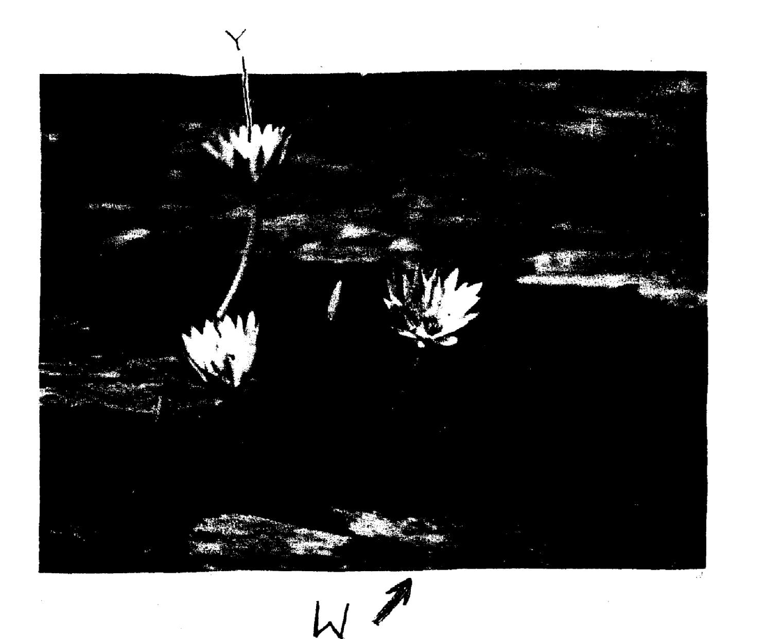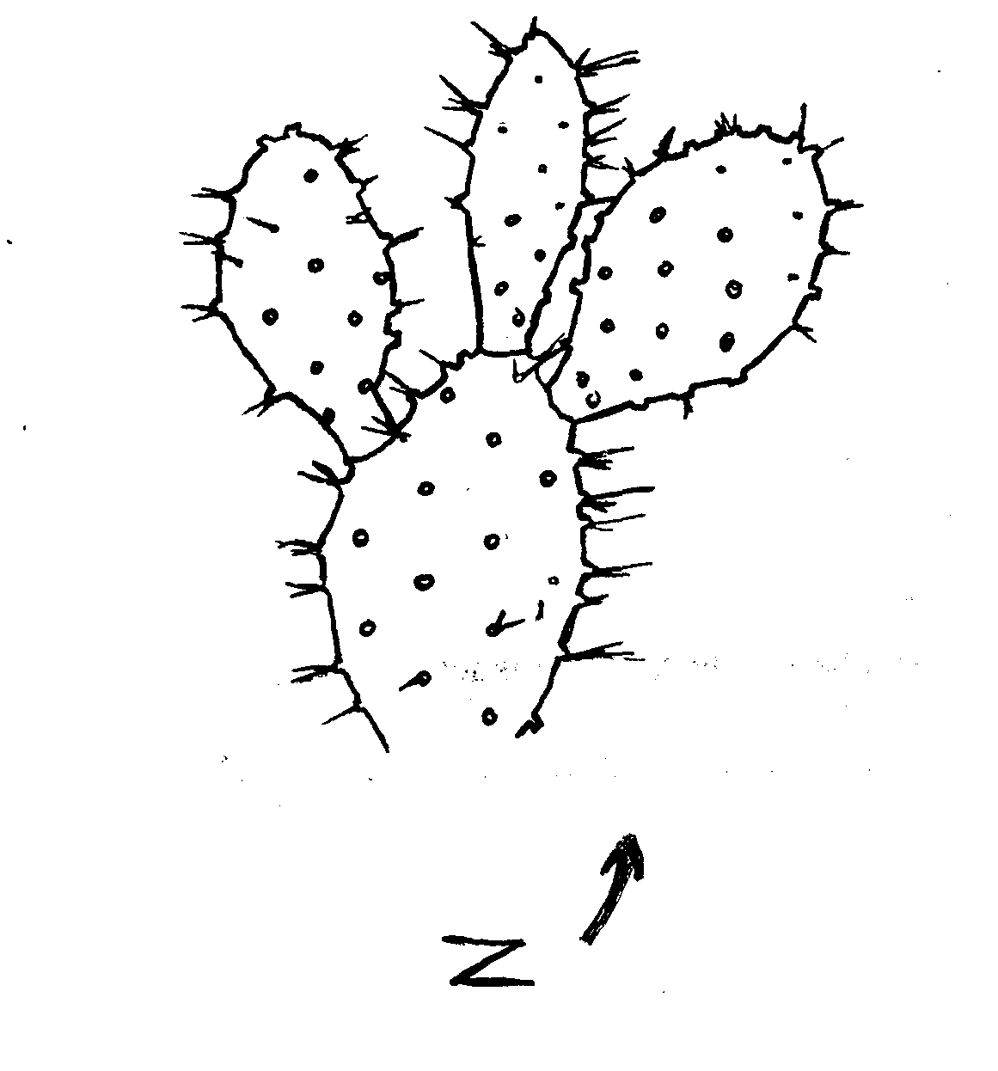

**Y**

**Z `W**

**Z**

**W`W**

(a) Suggest the possible habitat of specimen **W**

(b) (i) Name the structure labeled **Y** in specimen **W**

(ii) State the function of the structure named in **(b) (i)** above

**SECTION III- MARKING SCHEME**

***KAKAMEGA CENTRAL DISTRICT***

1. (a)

|  |  |  |  |  |
| --- | --- | --- | --- | --- |
| **Food substance** | **Solution** | **Procedure** | **Observation** | **Conclusion** |
| Reducing sugar | V | To 1 ml of food substance add 1 ml of benedicts solution. Place in a warm/ hot water bath/ heat boil; | Blue colour retained; | Reducing sugar absent; |
|  | W |  | Blue- green –yellow- orange;  Acc – brown  - final colour | Reducing sugar present |
| Non- reducing sugar | V | To 1 ml of food substance add 3 drops of dilute hydrochloric acid. Boil cool add sodium hydrogen carbonate till fizzing stops. Add 1 ml of Benedicts solution and place in a warm/ hot water both/ heat/ boil | Blue- green yellow- orange  Acc- final colour only  - brown  - Reject brick red | Non reducing sugar present; |
|  | W |  | Blue colour retained; | Non-reducing sugar absent |

b) Solution W;

Reason – it is a reducing sugar that is absorbed directly and used in respiration to produce

energy

2. a)

|  |  |  |
| --- | --- | --- |
| Structure | Name | Function |
| P | Ureter | Transports urine from kidney to urinary bladder |
| Q | Ovary | Oogenesis/ formation and release of ova i.e. ovulation |
| S | Fallopian tube/ oviduct | Passage of ova |
| T | Uterus | Pregnancy ACC implantation/ development of the embryo |

b) i) Female;

ii) – Has ovaries/ oviducts

- Has uterus

- has a vestibule

- has a clitoris

c) Dissecting pin;

3. a) A1 – solitary

B1 – Inflorescence

b)

|  |  |  |
| --- | --- | --- |
|  | Class | Reason |
| A1 | Dicotyledonae | Has four petals |
| B1 | Monocotyledonal | Has three stamens |

c) S – Petal

T- Sepal, Accept Calyx

d) Type – superior;

Reason – above receptacle;

e) i) Wind;

ii) Feathery stigma; (to increase surface area for trapping pollen grains from the air)

iii) Small, light pollen grains

- Flower not scented;

- Inconspicuous flower; Mark first 2

f) i) Insects

ii) Tubular/ bell shaped corolla

Accept large petals

g) Animal;

**KAKAMEGA EAST DISTRICT**

1. (a) (i) Arthropoda; (Rej. Antrhopoda/Arthropods)

(ii) Have segmented bodies;

* Have appendages;
* Have exoskeleton;

(b) M – Insecta; rej. Insects

N – insecta;

O – Arachnida; rej arachnids

P – Crustacea; rej. Crustacean

Q – Chilopoda;

(c) M – 3 pairs of limbs;

- body divided into three parts/head thorax and abdomen);

- Has a pair of wings;

P – Body divided into two parts/celaphalothorax, abdomen;

- Have carapace/hard outer shell);

- Have two pairs of antennae;

- Have a specialized limb for feeding/defence/chelicera; (any two marks)

(d) – Vectors of disease causing micro-organisms /pathogens;

- bee make honey;

- are pollinating agents;

- destroy timber e.g. termites

- Crop pests e.g. weevils

2. a (i)

(ii) Magnification = length of drawing

Length of image

x ½ upto x 1½ ;

(iii) Berry – many seeds

- Endocarp fleshy/juicy; (any one)

(b) (i)

|  |  |
| --- | --- |
| A | 40; |
| B | Numerous  Not decolourite DCPIP; |

(ii) Ascorbic acid/vitamin C;

(iii) Prevents scurvy/bleeding of gums hence weak teething

(c) Boiling vapourises the vitamins/vitamin C;

3. (a) U – scelerenchyma

F- xylem tissues;

D – phloem tissues;

AT- parenchyma tissue J

(b) D – carry substances hence remain turgid; to offer supper

F- are strengthened with lignin;

T- remain turgid to outer supper (any two)_

U – provide rigidity of the (2mks) stem;

(c) (i) H – Endodermis

(ii) Demarcates cortex from central cylinder;

(d) (i) F;

(ii) Root pressure;

Transpiration pull;

Capillarity/cohesion and adhesion; rej adhesive and cohesive

(e) (i) Phloem (tissue);

(ii) Companion cell;

(iii) has mitochondria which provide energy for translocation n the phloem;

**MIGORI / NYATIKE DISTRICT**

1. (a) Set A Mitosis;

Reason:- Two (daughter) cells formed;

Set B Meiosis

Reason-Four (daughter) cells formed;

(b) A 3 Metaphase;

4 Anaphase;

B 1 Metaphase 1;

3 Telophase1;

(c) Set A – shoot tip/root tip/cambium /flower buds/apical meristems/cambium meristems;

Set B – Anther /ovary;

(d) Set A; number 4- Chromosome align at the equator

Set B: - number 2: Homologous chromosomes separate and move (migrate towards the

opposite poles;

(e) Set A- Results in growth;

Set B- Gamete formation/gamete variation

2. (i) A = 3mm;

B = 7mm

C = 5mm;

(ii) A- The solution (L1) is hypertonic to the cell sap of the potato tissue; water is drawn

out of them by osmosis; the cells become plasmolysed and flaccid and they shrink

/decreases in length;

B- The solution L2 is hypotonic to the cell sap of the potato tissue; they gain water by

osmosis; and become turgid. They cause the tissue to increase in length; C - No change; control experiment

(b)

|  |  |  |  |
| --- | --- | --- | --- |
| **FOOD SUBSTANCE** | **PROCEDURE** | **OBSERVATION** | **CONCLUSION** |
| STARCH | Add 3 drops iodine. Solution to food substance to be tested | Colour changes to blue-black (black) | Starch present |
| REDUCING SUGAR | Add on equal amount of Benedict’s solution to the food substance and heat to boil | The colour changes from blue to green to yellow to orange and brown precipitate formed | Reducing sugar present |
| PROTEIN | To about 2cm3 of food substance add 1cm3 of NaOH solution . Add 1-2 drops of copper sulphate | Purple or violet colour formed | Proteins present |

(b) Obesity;

Marasmus in children and muscle wasting in adults

3. (a) T1 – incisor; (tooth)

T2 – Molar; (tooth)

(b) Incisor (T1) – sharp /wedge-shaped; for cutting;

Molar (T2) – broad surface with cusps; for grinding

(c) A – Nerve

B- Pulp cavity

C – Enamel

D – Dentine

E – Blood vessel

F – Periodontal membranes

(d) Cause bacteria to grow and produce acids which cause tooth decay;

(e) (i) Diastema;

(ii) Allows movement of tongue when cutting grass and turning food in the mouth

NYAMIRA DISTRICT

1. (a) (i) No gas produced

(ii) Gas produced

(b) (i) In boiled potato cube, enzyme catalase is denatured hence no reaction when

(ii) Fresh potato cube had an enzyme catalase which broke/decomposed hydrogen

peroxide to water and oxygen, hence production of gas.

(c)

|  |  |  |  |
| --- | --- | --- | --- |
| Food substance | Procedure | Observation | Conclusion |
| Starch | To fold substance add iodine solution | Blue colour formed | Starch present |
| Proteins | To food substance as sodium hydroxide and copper II sulphate solution | Light green mixture | Proteins absent |

1. (a) S – Style T – Ovary

U – Anthens V – Petal

(b) X – Mode- Insect

Reasons – Brightly coloured to attract insects.

Anthers inside the flower to be reached by pollinating agent. Stigma is above the anthers to pick pollen from the incoming pollinating agent

Y- Mode –wind

Reasons:- Long anthers exposes outside the flower to be easily reached by the

flower for pollen grain to be easily blown by wind.

1. (a)

|  |  |  |
| --- | --- | --- |
| Organism | Steps followed | Identify |
| A | 1a, 2b, 5a | Arachnida |
| B | 1a, 2a, 3a, 4b | Hymenoptera |
| C | 1a, 7b | Echinodermata |
| D | 1a, 2b, 5b, 6a | Chilopoda |
| E | 1a, 2a, 3b | Anaplura |

(b) (i) Arthropoda

(ii) Segmented body

SOTIK DISTRICT 2ND EXAM

1(a)

|  |  |  |  |
| --- | --- | --- | --- |
| FOOD | PROCEDURE | OBSERVATION | CONCLUSION |
| STARCH | To 2mls of Z is added 2 drops of  iodine solution | The colour of the  mixture  remained brown | The solution does not  contain starch |
| REDUCING  SUGAR | 2ml of solution Z is mixed with  2ml of benedict’s solution and  heated | The colour of the  mixture  turned blue | Absence of reducing  sugar |
| VITAMIN C | 2ml of DCPIP is placed in a  test tube and solution Z  is added drop wisely | The DCPIP is decolorized  loses its colour | Vitamin C is present |
| LIPID | 2ml of solution Z is put in test  tube and ethanol added until it  clears then distilled water is added | White colour develops | Lipids present |

NB/ -exact quantities must be mentioned

-correct order of chemicals -correct colours

b) Pancreas reject pancrease

c) Fatty acids and glycerols (Reject if one is missing

d)-can be broken down; to liberate energy; for cellular functions

-can be used to synthesize; structural components of the cell; OWTTE

2. a) i) autotrophic (nutrition)- (1mk) Reject. Antotropism

ii) They are green hence has chlorophyll for photosynthesis;

iii) Carbon (iv) oxide+ water sunlight glucose +oxygen

Chlorophyll

6 CO₂+6 H₂O C₆H₁₂O₆+6 O₂

NB.-chemical symbols must be correct

-the equation must be balanced

b) NB.-all rules for drawing apply

-1 mark for accuracy (1x1=1mk)

-max of 3 correctly labelled parts (3x1=3mks)

|  |  |
| --- | --- |
| P | Q |
| i)has broad lamina  ii)has hairless lamina  iii)lamina has network of veins | -has narrow lamina  -has hairy lamina  -lamina has parallel veins  OWTTE |

3. a)Phylum :Arthropoda. Reject. Anthropoda/Arthropod

Class: insecta. Reject insect

b)-the body has 3 pairs of leg (jointed legs/6(jointed legs)

-the body is divided into 3 clear body parts (i.e. head, thorax and abdomen)

Reject if no mention of distinguished parts

ACC. Any other correct feature max

c)-has very large compound eyes; for spotting; food, enemies, mates etc

-has (6) muscular legs; for efficient locomotion; in search of food, mates etc

-proboscis; for efficient sucking of liquid food; OWTTE STK

UGENYA- UGUNJA DISTRICT

1. a)

D – 1 ½ P - 1

Mag: x100 or x150 L – 4/2 Cl – ½

Mag – ½

b) Liquid H is hypertonic/ highly concentrated; to cause a high osmotic pressure; water

molecules are drawn from the onion epidermal cells by osmosis; excess water loss results in

the plasma membrane detaching from the cell wall/ hence the cell is plasmolysed; (OWTTE)

c)

|  |  |  |  |
| --- | --- | --- | --- |
| FOOD  SUBSTANCE | PROCEDURE | OBSERVATION | CONCLUSION |
| Starch  P | - Place 2 ml of J1 in a  test-tube.  - Add 2 – 3 drops of  P  iodine solution.  - Shake and observe. | * Solution changes from Brown to Blue-black /Black   P | * Starch present.   P |
| Reducing Sugar  P | - Place 2 ml of J1 in a test-  tube.  P  - Add equal amount of  Benedict solution.  - Heat to boil. | * Solution changes from blue, green, yellow then brown.   P | * Reducing sugar present.   P |

d) i)

|  |  |
| --- | --- |
| TEST TUBE | OBSERVATIONS |
| J2 | - Glowing splint does not rekindle/ relight; or glowing splint relights /rekindles slowly; √1 |
| K | - Glowing splint relights/rekindles faster; √1 |

ii) Enzyme catalase;

iii) The liver has more catalase enzyme; since it undertakes the role of detoxification

in mammals;

3. i)

|  |  |  |
| --- | --- | --- |
| ORGANISM | STEPS FOLOWED | IDENTITY |
| V  W  X  Y  Z | 1b, 2a;  1b, 2b, 3a, 4a, 6a, 7b;  1b, 2b, 3a, 4b, 5a;  1a, 9a;  1b, 2b, 3a, 4a, 6b, 8a; | Mollusca;  Crustacea;  Annelida;  Cestoda  Arachinida; |

ii) Schistosoma sp / S. haematobium / S. japonicum;

rej. – when not underlined separately.

- Wrong spelling.

- Lower case “S” for 1st letter.

NDHIWA DISTRICT

1. (a) With six legs ..............go to 2

(b) With eight legs .............N

. (a) With wings ............go to 3

(b) without wings .............P

(a) With one pair of wings ..............R

(b) With two pairs of wings ....Q

(b) (i)Arthropoda

(ii) – Presence of exoskeleton

- Segmented body

- Jointed appendages/legs, limbs )

(c) Arachnida

- 8 legs /4 pairs of legs

- Two body parts

- Lack of wings

-No antenna

2. (i) Plants which normally grow n fresh water/plants which normally grow in very we places

(ii) Part 1 – leaf stalk

part 2 – leaves

(iii) - Low O2 concentration

- Low light intensity

- Low mineral salt concentration content

- A lot of water

- Waves and currents

(iv) – Some (emergent) have broad leaves with numerous stomata on the upper surface to

increase transpiration

* Highly dissected leaves to increase surface area for absorption of maximum light CO2

for photosynthesis and gaseous exchange

* - Flowers are raised above the water to allow pollination
* - Some (floating ) have log fibrous roots to absorb mineral salts
* - Long leaf stalk to expose the eaves above water for photosynthesis

(v) - Many stomata on the upper surface to increase transpiration

- Numerous and sensitive chloroplasts that photosynthesize at low light intensity

- Large air filled issues /aerenchyma for buoyancy and gaseous exchange (store

O2 for respiration)

- Poorly developed vascular bundles to discourage water absorption

(vi) R -Submergent

S- Floaters

3. (a) (i) A - less/few bubbles/slow effervescence/fizzing/froth/foam

B- Rapid fizzing / bubbles

- (award 1mk for bubbling /effervescence in both A and B- Reject if bubbling

only appears in either A or B)

P

P

(ii) Large surface area in B than in A for enzymatic activity in

* + Part (iii) tied to (i)
  + Bubbles due to enzymatic activity (award only 1mk)

Hydrogen Peroxide water + Oxygen

* + Chemical symbols alone or words alone
* Wrong enzyme, means wrong commitment

Accept:-H2O2 + catalase H2O O2 + Catalase

(b)

|  |  |  |  |
| --- | --- | --- | --- |
|  | Procedure | Observation | Conclusion |
| Roots | Add one 2/3 drops of iodine (soln.)  Accept add iodine or any other measurements | No color change/colour of iodine / brown /yellow colour | Starch absent |
| To 1m of extract , add 1/2ml /equal amounts of  P | Blue to green | Traces of reducing sugars |
| Benedict’s solution heat to boil | Yellow – orange/brown | Reducing sugar present ICCP simple sugar |
| Remains of grains | Add drops of iodine |  | Starch present |
| Add drops of Benedict’s solution | Green to yellow to orange/brown | Reducing sugar present |
| Leaves | Add iodine | No change | Starch absent |
| Add Benedict’s | - Green to yellow to orange to brown | Reducing sugars present |

rej. – if for starch is written under procedure

– brick red

(c) Roots- Presence of reducing sugars translated from the remains of grain/as leaves; for

P

P

provision of energy /respiration/growth & development /metabolic activities e.g.

active transport;

- Absence of starch because roots are not storage organs.

Remains of grains

P

* + Presence of reducing sugars translocated from the leaves/ hydrolyzed starch;

P

* + Presence of starch because grain is a storage organ/some starch had not been hydrolyzed for germination /growth;

Leaves - Presence of reducing sugars due to photosynthesis; -Absence of starch because reducing sugars has not been converted to starch;

P

P

MUMIAS DISTRICT

1. a) Observations

|  |  |
| --- | --- |
| Strip in beaker | Observation |
| 1 | Inside of the peeling curves outwards |
| 2 | Remained straight |
| 3 | Inside of the peeling inwards |
| 4 | Inside of the peeling curves inwards, more than in 3 |

b) Accounting for 1, 2 and 4

1: The cells of the inside of the peelings have cell sap which is hypertonic to solution

S; hence draws in water by osmosis; and (swells up to) become turgid; leading to

more increase in length of that side and curvatime on peeling sides

2: The cells of the inside of the peeling have cell sap which is atomic solution H; hence

no net osmosis 3: The cells of the inside of the peeling have cell sap which is hypotonic to solution H,

and lose water by osmosis to become flaccid; this side shrinks hence curvature

inwards

c) Solution G – Distilled water

Solution H – Concentrated solution

2. a) steps

2b – two

7b- cyndrical

b)

|  |  |  |
| --- | --- | --- |
| specimen | steps | Identify |
| A | 1a, 2a | Housefly |
| B | 1b, 3b, 4a | Spider |
| C | 1a,2b | Dragon fly |
| D | 1b, 3b, 4b, 5a, 6a | Waters/ ater |
| E | 1b,3b, 4b, 5a, 6b | Fresh water shrimp |
| F | 1b, 3b, 4b, 5b, 7b | Centipede |
| G | 1b, 3b, 4b, 5b, 7a | Millipede |
| H | 1b, 3a | Ant |

c) Class

B Arachnida

C Insecta

E Crustacea

G Diploda

3. a) Legume stem;

Roots

Nodule

b) Rhizobium bacteria bacteria/ nitrogen fixing bacteria

c) Leguminous plants

d) i) symbiosis

ii) Rhizobium bacteria which lives in the root nodules of leguminous plants fix free

nitrogen in the soil into nitrates ; which are absorbed by plants to make plant

proteins; bacteria benefit from shelter and carbohydrates provided by the plants;

this relationship enables plants to thrive on nitrogen deficient soils

iii) Nitrate

iv) Pseudommonas denitrificans

Thiobacillus denitrificans

KISUMU WEST DISTRICT

1. (a) Blue black/black dark blue colour is formed

(b) No colour change/colour of Benedict’s solution remains;

Rej: No change /no reaction/ no observation /nothing happens

(c) Set-up A- colour changes from blue to green to yellow to orange/brown;

Set-up B: No colour change/ colour of Benedicts’ solution remains;

Rj- No change/no reaction/no observation/nothing happens

Set-up C- No colour change/colour of Bendict’s solution remains;

Rj- No change /no reaction/ no observation/ nothing happens

(d) Set-up A – Enzyme amylase/diastase/invertase (in Q); digests /hydrolisis/breaks down/

converts starch (in liquid X); to reducing sugar/maltose;

Set-up B: boiling denatures/destroys enzymes amylase/diastase/invertase; henc starch is

not converted to reducing sugar/maltose;

Set up C:- Hydrochloric acid provides unfavourable PH for enzyme amulase

diastase/invertase; hence starch is not converted to reducing sugar/maltose;

(e) Enzyme amylase/diastase/invertase;

(f) To provide optimum temperature for reaction of enzyme amylase/diastase;

2. (a) (i) Chilopoda; Rj wrong spellings of classes but award marks for reasons

Reason – One pair of legs per body segment;

-Dorsoventrally flattened body; (consider first one only)

(ii) Insecta;

Reason- Body is divided into three parts/regions;

- Three pairs of legs;

- presence of wings;

(iii) Arachnida;

Reason:- Four pairs of limbs/legs;

C E

* 5pairs of legs 4Pairs of legs
* Has antennae Lacks antennae
* Lacks chelicerae /pedipalps Has chelicerae/pedipalps
* Has carapace Lacks carapace

(c)

|  |  |  |
| --- | --- | --- |
| ANIMAL | STEPS FOLLOWED | IDENTITY |
| C | 1a, 2a, 4a; | CANCER; |
| D | 1, 2b, 5b; | SIGMORIA; |
| E | 1a, 2a, 4b; | LACTRODECTUS; |

3. (a) (i)Dicotyledonae; Rej; wrong spellings of classes

Reason: - Net-veined leaves

- Tap root system; Rj: tap roots (Mark first one

(ii) Monocotyledonae;

Reason :- Parallel –veined leaves;

-Fibrous root system; Rj – Fibrous roots (mark first one)

(b) G – Epicotyl; Rj wrong spellings

J- Hypocotyl;

M – Prop roots;

(c) Stores food during germination

- turns green and carries out photosynthesis;

(d) (i) root nodules;

(ii) Rhizobium bacteria

(e) (i) Hypogeal germination;

(ii) Cotyledon remains in the soil;

TRANS NZOIA WEST DISTRICT

1. a)

|  |  |  |  |  |
| --- | --- | --- | --- | --- |
| Liquid | Food substance | Procedure | Observation | Conclusion |
| L1 | Starch  Reducing sugar | To 2ml of L, in a test tube add afew drops of iodine solution; Reject if heating is done  To 2 ml of L, in a test tube add an equal amount of Benedicts solution and heat/ immerse in a warm water bath | No observable color change  No observable color change | Starch absent  Reducing sugar absent |
| L2 | Starch | To 2 ml of L in a test tube add a few drops of iodine solution | Color changes to blue- black | Starch present |
|  | Reducing sugar | To 2 ml of L add an equal amount of Benedicts solution and heat/ immerse in a water bath | Color turns from blue – green – yellow – orange/ red | Reducing sugar present |

b)

|  |  |  |  |
| --- | --- | --- | --- |
| Food substance | Procedure | Observation | Conclusion |
| Starch | To 2 ml of L, in a test tube add a few drops of iodine solution | No observable color change | Starch absent |
| Reducing sugars/ simple sugar | To 2 ml of L in a test tube add an equal amount of Benedicts solution and heat/ immerse in a warm water bath | Color turns from blue – green – yellow to orange/ red | Reducing sugars present |

For procedure and food substance mark once

c) - On immersing the visking tubing containing L1 into solution L2, a concentration

gradient was created

* The reducing sugars/ simple sugars in L2 moved by diffusion; through the visking tubing into L1, due to their small size; hence their presence in L1, at the end

Starch absent in L1, because the molecules are too large to pass through the tiny

pores of the visking tubing

2. a) i) Pisces; Reject Pieces/ fish

ii) - Presence of scales

* Presence of fins
* Presence of operculum

b) - Protection of gills

- Gaseous exchange

c) i) 2 / pectoral fins

3 / pelvic fins

ii) 4 / dorsal fin

5 / candal fin

6 / anal/ ventral fin

d) i) 64 mm

ii) 29-30 mm

iii) Length from anus to tip of tail = 30/29 = 46.9% / 45.3%

Length from tip of mouth to tip of tail 64% must be there to score

iv) The high tail power creates enough force to enable the fish to push forward

e) - Streamlined body for easy movement/ reduce water resistance

* Scales on the body overlap facing the posterior end for easy movement/ to reduce resistance from the water
* Massive head prevents the fish from being deflected from its oath when swimming

3. a) A– Phloem

B. – Vascular cambium

C. – Xylem

D. – Cortex

F. – Collenchyma

G. – Epidermis

H. – Pith

b) A – Trans location

B – Divides to give rise to new tissues (for secondary growth)

C – Transport of water; and mineral salts

c) Parenchyma

d) - Cell wall thickened with lignin; for strengthening/ mechanical support

e)

|  |  |
| --- | --- |
| Root | Stem |
| Star- shaped Xylem with phloem in the arms | Vascular bundles arranged in a ring |
| No pith | Pith present |
| Presence of root hairs | Absence of root hairs |

RACHUONYO DISTRICT

1. a)

|  |  |  |
| --- | --- | --- |
| ANIMAL | IDENTIFY | STEPS |
| E  H  J  M  N | Mollusce  Annelida  Cestoda  Insecta  Arachnida | 1b, 2a  1b,2b,3a,4b,5a  1a, 9a  1b,2b,3a,4a,6a,7a  1b,2b,3a,4a,6b,8a |

Each correct identify 1mk

Each correct step 1mk

Reject wrong order of steps

Reject wrong spelling for identify

Identify tied to steps (if steps is wrong then reject identity)

b) Arthropoda√ 1mk Rj wrong spellings

c) Segmented body√/ Exoskeleton (made of chitia)√

2 a)

|  |  |  |
| --- | --- | --- |
| ORGANELLE | NAME | FUNCTION |
| P | nucleolus√ | Manufacture ribosomes |
| Q | Mitochondrion√  Acc.mitochondria | Site for respiration √ |
| R | Cell membrane/plasmolemma/ √plasma membrane | Control entry and exit of √  material into cell |
| S | Rough endoplasmic reticulum√ | Transport proteins√ |
| T | Golgi body/apparatus√ | Packaging and transport of glycol Proteins√ |

Rj. Wrong spelling for name but mark function of right

b) Length – 31mm

c) actual radius = photomicrograph length

Magnification

=31 √

10,000

= 0.0031mm√

3. a) i) No bubbles/no effervescence/no observable change

ii) Bubble/effervescence/foam/increase in warmth

iii) No bubbles/no effervescence/no observable change

b )i) fermentation (anaerobic) respiration

ii)C6H12O6 2C2H5OH +CO2 +Energy

Glucose ethanol +carbon (iv) oxide +energy

iii) mitochondrion/mitochondria

c) i) yeast/enzyme/catalyst (

ii) Boiling denatures yeast/enzyme; hence glucose not broken down/respired; to

produce Carbon (IV) oxide gas (which forms bubbles)

d) i) bubbles/effervescence/foam

ii) Catalyst (in liver); breaks down hydrogen peroxide; to form water and oxygen

(which forms bubbles);

SOTIK DISTRICT – 1ST EXAM

1. (a) (i) M1 – stem firm/hard/stiff/rigid/tough

M2- stem soft/flexible/flabby Reject flaccid/weak

(ii) Solution M1 is hypotonic (to cell sap) /cell sap is hypertonic (to L1)

Solution M1 is less concentrated/more dilute than (cell sap; hence water moved into the

(stem) cells/osmosis occurs; cells become turgid

M2- Solution M2 is hypertonic/more concentrated than cell sap more dilute/cell sap

more dilute/ cell sap less concentrated (than L2); water moves out of the

cell/osmosis occurs; makes the cell flaccid

(b) (i) M1 (slit opens wider/widens/strip separates; and the bends/outwards or backwards or

curved; M2- strips) remains closed together/slits remains closed/strips shrinks or shrunk;

(ii) In M1 cells in inner surface/cut surface /cutical cells enlarge more/; because they took in

more water (by osmosis) than outer cells /outer surface/epidermal surface (which have

cuticle) OR

M2 Cells of inner surface/cut surface/cutical cells shrunk; because they lost more water

(by osmosis) than outer cells/epidermal cells which have cuticle

N/B mark only once i.e. for M1 or M2

2. (a) Pisces reject- spelling mistakes

* + Pisces/fish or pisces(fish)

(ii) Presence of scales

* presence of fins
* - presence of lateral line
  + -presence of gills
  + Presence of operculum

(i) is tied to (ii), so if (i) is wrong reject reasons even if correct

(b) Streamlined;

(c) (i) pectoral fin

right identity-

Right drawing-

pelvic fin

N/B - Reject wrong drawing if identity is wrong

- Reject wrong fins among the right ones

- The shape should be continuous

- Accept spines are single lines e.g.

(ii) Dorsal fin N/B- Spines must be present to award a mark

Anal fin(Ventral fin)- Right identity-

-drawing

Caudial (Tail fin) N/B- The identity must be correct to award drawing mark

3. (a) (i) Fruit;

(ii) Two scars/point of attachment at receptacle and to the remains of style;

(b) (i) Drawing -3maks Mark clockwise

Label 5/2 = max 2

drawing mark 1

Given when there is continuous double outline of epicarp

drawing mark 2

Given when endocarp with seeds is present

loculi with juice sac is present

drawing mark 3

When placenta is centrally located and not shaded

(b) (ii) x ½ - x 3; N/B Reject X , x signs

(iii) Axial/Axile/Central; Reject mistakes- free central

(c)Animal, accept- man, human being

Reject- human alone, animal dispersal

(d) - Seeds are hard/slimy/slippery (coat) to prevent digestion;

- It is scented /sweet smell to attract the agent;

- It is brightly coloured to attract the agent;

- It is succulent / juicy to attract the agent; Mark any three correct

BUTERE EAST DISTRICT

1. a)

|  |  |  |
| --- | --- | --- |
|  | Extract Inside tubing | Iodine solution outside the tubing |
| Before experiment | White suspension | Brown /Yellow. |
| After experiment | * Blue/ Black /Blue – black colour observed * The level increased/size of Viking tubing increased. | * Brown colour of iodine retained. * Level of iodine reduced. |

b) – The extract inside the tubing contains starch, A blue – black was observed due to

diffusion of iodine from the beaker across the Viking tubing membrane; since iodine

has a low molecular size; -

Iodine solution retained the brown colour because starch molecules in the extract are

large; in size and could not pass through the pores of the viking tubing membrane;

into the beaker.

c) i) Gaseous exchange;

ii) Transpiration;

iii) Translocation of sugars;

2. a) i. Fungi

ii. Reproduce asexually by budding or sporulation.

b) i) M - Budding

N – Sporulation

ii) M – Yeast

N – Rhizopus / Bread mould/mucor.,

c) i) 8.7 cm

ii) Linear Magnification = Linear dimension of the Image

Linear dimension of actual object

Linear dimension of Image = 8.7 cm x 10000 μm = 8700 μm

X60 = 8700 μm

x

x = 8700 μm

60

X = 1450 μm

d) M – Used in baking Industry and brewing Industry.

N – Causes decay of dead organisms releasing nutrients. -

Causes food decay.

3. a)

b) A berry/ hesperidium.

c) i) Animal dispersal.

ii) – Succulent endocarp/Juicy endocarp.

- Scented

- Bright colour exocarp.

- Seeds resistant to digestion.

d)

|  |  |  |  |
| --- | --- | --- | --- |
| Food Substance | Procedure | Observation | Conclusion |
| Reducing sugar | * Put test substance in the t. tube * Add benedict soln. * Boil | - Colour changes to yellow/orange/red | - Reducing sugar present |
| Vit. C  Ascorbic acid | * Put 2cm3 of given vol. of DCPIP in t. tube. * Add juice/test substance. | - DCPIP decolourised | - Vit. C present. |
| Protein | * Put cm3 of juice in a t. tube. * Add 2 cm3 of NaOH * Add 2cm3 of CuSO4 | - No colour change | - Protein absent. |

TRANS MARA DISTRICT

1. (a) P – Part of mammalian lung

Q – Part of mammalian trachea

(b) Respiration/breathing system

(c) P- This is where diffusion/gaseous exchange occurs

Q – Allows passage of air into the lungs

(d) - It is elastic to allow stretching or expansion

- Has numerous blood vessels to facilitate efficient transportation of gases

- Presence of bronchiole for passes of air in and out

- Presence of pleural membrane that produces pleural fluid thus reducing friction - Presence of spongy air spaces /alveoli to increase the surface area for gaseous exchange

Q – Rigid, firm/hard rings of cartridge to prevent collapsing/keeps it open to allow passage of air.

- Presence of muscles between the rings/cartilage to allow for movement

- Mucus living to trap foreign particles/filter air

- Cartilage rings are C-shaped to allow room for expansion

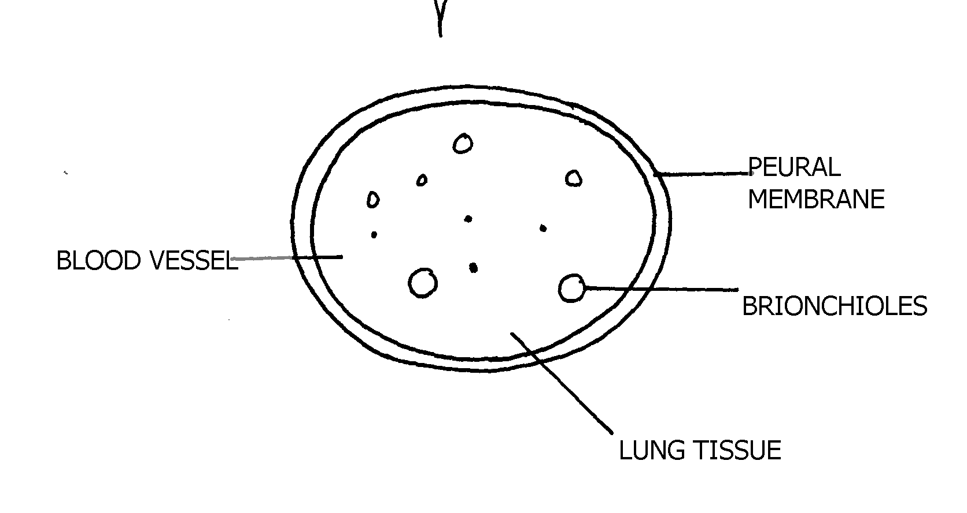 - To score a mark; the feature is tied to a function

N/B- The score for the drawing – the drawing should have continuous outline (double) no

shading and proportional in pencil.

- To score the label mark, the label line should not cross, no arrows

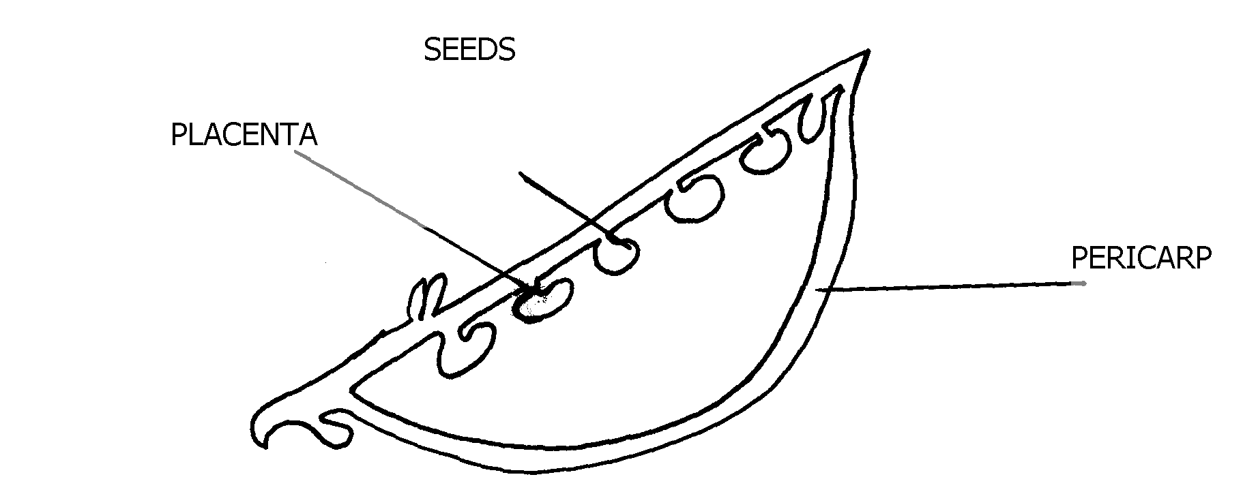2. (a) specimen – R- Legume, S-Berm

(b) (i)

(ii) Magnification = length of drawing

Length of specimen

= X

Y

(iii) Marginal placentation

(c) (i)

|  |  |  |
| --- | --- | --- |
| Specimen | Method of dispersal | Reasons |
| R | Self explosion | * has line of weakness * splitting line |
| S | Animal/man  Reject: bird | - has brightly coloured skin to attract animal |
|  |  | * succulent * has sweet smell scent |

(ii) S – Can be dispersed over a long distance hence low chances of overcrowding

R- Dispersed over a short distance hence high changes of overcrowding

3. (a) (i) Phylum arthropoda

(ii) – Have segmented bodies

- Posses jointed limbs and appendages

(b) (i) K – cross – crustaceae

Reasons – has two pairs of antennae

- has forked appendage

(ii) N – class –chilopoda

Reason – All many segments with one pair of legs per segment

(c) (i) – Has two pairs of using for flying

- Has powerful (muscular) hind limb for hopping/jumping

- Intermittent growth

(ii) – moulting/ecdysome hormone

(d)- Enhance nutrient cycling/humus

- Aeration of soil

SOTIK DISTRICT

1. a) SPECIMEN TYPE OF FRUIT

P Cypsella

Q Berry

R Legume

S Cypsella

b) **R** has two lines of weaknesses (sutures) along which it splits; to release seeds by explosive

mechanism;

Accept Self dopersal for explosive mechanism

Reject self explosion or self explosive mechanism

Agent = 1 mk, adaptation = 1 mk; reason = 1 mk

**S** is very small; with pappus; making it light; to float easily to be dispersed by wind;

Agent = wind 1 mk Any one adaptive feature & explanation

Adaptation = 1 mk Reason = 1 mk

c)

d) Axile placentation

2. a)

|  |  |  |  |
| --- | --- | --- | --- |
| FOOD | PROCEDURE | OBSERVATION | CONCLUSION |
| Lipids | 4cm3 of food sample mixed with 4cm3 of ethanol then add clean water( 1 mk) | No change in colour | Absence of lipids |
| Reducing sugar | 2cm3 of food sample in mixed with 2cm3 of Benedicts solution and heated in the hot water bath(1mk ) | The colour changes from blue to brown  1mk | Presence of reducing sugar  1 mk |
| Ascorbic acid (Vitamin C) | 2cm3 of DCIP is put in a test tube. Add food sample droplisively (1mk) | The DCIP is decolorized (1mk) | Ascorbic acid (Vitamin C) present(1 mk) |
| Starch | 2cm3 of food sample placed in a test tube and four drops of iodine solution added (1 mk) | The colour of the solution turned brown 1 mk | Starch is absent  1 mk |

b) Since a carbohydrate is present, maltase; acts on maltose; producing glucose; or lactase;

acts on lactose; into galactose and glucose; i.e. enzymes in ileum; product;

c) Provides simple carbohydrates e.g. glucose which can be broken down in body cells to

liberate energy; or it is a source of vitamin C which is necessary for proper development

of epithelial tissues controlling scurvy; OWITTE Any two fully explained answers

3. a) i) W – Aquatic (water)

ii) Z – Desert or semi- desert or dry land

b) i) Y- Flower

ii) Sexual reproduction Reject reproductive alone

c) Observable features apply i.e. has thick succulent stem; for storage of water; and

respiratory; its leaves are reduced into spines; to lower the SA for transpiration; or for

protection against herbivores